EDITORIAL: NEW PLATFORM, AND OTHER NEWS

This issue marks the first JASO publication on the Open Journal Systems (OJS) platform, part of a Bodleian Libraries initiative to support small journals across Oxford University. For most readers this change concerns behind-the-scenes technicalities and will not affect the steady provision of articles and book reviews that JASO continues to offer.
Two developments are worth highlighting. First, JASO articles will now automatically receive DOI reference numbers, and DOIs have been retrospectively assigned to the full JASO archive. Second, the journal is now included in the Oxford Research Archive (ORA), ensuring a secure digital future for all JASO publications. We are also pleased to note that JASO has recently been included in the SCOPUS index. This will enhance the journal’s visibility and increase the discoverability of our authors’ work.
Alongside these developments, this issue brings together a wide range of contributions that reflect the diversity of contemporary anthropological work. The articles explore subjects including reflections on collaborative publishing, kinship and belonging in Eastern China, the entanglements of geontology, illness and resistance in Amazonia, Andean precolonial ceramics at the Pitt Rivers Museum, perspectives on sacred landscapes in Siberia, sensory practices in movement and music therapy, and racial dynamics and belief in the Parisian banlieues. These pieces illustrate the methodological and ethnographic breadth that continues to characterise JASO.
Looking ahead, we are planning several special issues for 2026. These will draw on JASO’s flexibility as an autonomous collective, allowing us to publish work that continues the experimental and intellectually curious tradition established in the early 1970s by the pioneering group of students who founded the journal along with Edwin Ardener. More announcements will follow in due course.

December 2025
The JASO Editorial Collective

REFLECTIONS OF A GUEST EDITOR: WHAT DOES IT TAKE TO PUBLISH A SPECIAL ISSUE WITH JASO?

WESAM HASSAN

Taking responsibility for the JASO special issue, Survivance and Uncertainty: What Remains After the Crisis (Volume XV, 2023), gave me hands-on and collaborative experience in editing a special issue of an academic journal. I envisioned the theme as a call for experimentation. I was inspired by the prospect of expanding theoretical boundaries and adopted the concept of ‘survivance’ from Critical Native American Studies to be applied in conversations with ethnographic research conducted in different parts of the world. I utilised this concept as a heuristic device that signified not only survival but also the proactive affirmation of life and agency in the face of adversity while acknowledging past struggles and life’s calamities. The nuances of the term, along with the inquiry into ‘what remains’ post-crisis, appeared crucial in a world where crises, conflicts, systemic violence, pandemics, and economic turmoil are frequently the norm. I realised that the issue’s theme could offer not only an academic contribution but also a framework for navigating periods of crisis and their aftermath. The issue theme could inspire researchers and their participants as they confront ongoing uncertainties with introspection, resilience, and a sense of historical and cultural continuity, while showcasing ethnographic work from diverse contexts that illustrate the adaptability of anthropologists and their participants.

The inspiration behind the theme

At the time of the global COVID-19 pandemic, I recalled Virginia Woolf’s words, ‘I meant to write about death, only life came breaking in as usual’ (Woolf 1978: 167). Woolf explains in her diaries that she continued to capture the immediacy of life amid her personal crisis and struggles. Her words inspired me to see how life insistently disrupts despair, revealing the resilience that animates the mode of survival and opens the door to survivance. The pandemic impacted many lives in ways that were never anticipated. Life was on hold yet care, family obligations, and research demands were simultaneously pressing. I was struggling between continuing my fieldwork, writing, and sustaining a sense of ‘the normal while trying to carve out moments of fun and vitality within the cracks of the pandemic’s restrictions.
Another inspiration came from Albert Camus’s absurdist novel The Plague, which I read while confined by the COVID-19 lockdown in my home. It had uncanny parallels with the present at that time. Camus’s portrayal of the fictional epidemic in Oran, Algeria, conjured a sense of alienation and trials of survival that resonated with the isolation, anxiety, and fragmented digital connections with family members overseas that I was experiencing during the pandemic. It reads almost like the work of an anthropologist, who narrates how the epidemic and colonialism reshaped lives and relationships at that time. However, Camus’s portrayal of the epidemic and the experience of the colonised in Oran was also in tune with my readings of Native American scholars, particularly Gerald Vizenor, who brought the notion of survivance into a sharper focus (2008). Vizenor explained that survivance is not only about endurance but also about acknowledging adversity, reclaiming agency, and embracing life’s fullness. In The Plague, Camus offered one model; in Vizenor’s work I found another: an approach that resists subjugation and asserts presence through agency, memory, creativity, and resilience.
The notion of survivance, thought of as the living that goes beyond mere survival, felt enticing as an essential framework for grasping the resilience and adaptability of those living through ‘vertiginous times’ (Knight 2022). Thinking about my fellow anthropologists stitching together research plans, developing creative methods, and navigating the pandemic’s new regulations, I realised that the pandemic sparked a process of acknowledging, adapting, repairing, and continuing forward in one way or another. Survivance became, for me, a way of understanding how we might acknowledge loss and grief without being overcome by them, a way of recognising the hardships in life and, at the same time, finding reasons to persist. It is not just survival, I realised, but a persistent insistence on noticing life breaking through.

Initial dialogue with JASO’s editorial team and launching the call for papers

By July 2022, the idea for this special issue had taken shape after pitching it along with the call for papers to the JASO editorial team. I hoped to have a collection of articles that would initiate academic discussions on the theme and present how people from different parts of the globe dealt with different uncertainties and moments of crisis while celebrating the tenacity of ethnographers working under extraordinary constraints of travel bans and experimenting with digital methods to conduct ethnographies. The call for papers marked the beginning of many rewarding conversations on the theme. It took over a year and a half to publish the issue from its inception in July 2022 until publication in December 2023. The issue contains thirteen articles in addition to the introduction. Receiving the responses from the issue’s contributors was intriguing and it quickly became apparent that the idea of ‘survivance’ chimed with the contributors, in light of the ethnographic research that they had completed during COVID-19 travel bans and pandemic restrictions.
There was an underlying uncertainty that I felt when issuing the call for papers: Would it attract enough contributors? Would scholars feel compelled to engage with the theoretical experimentation it proposes? The call for papers was disseminated widely across various platforms, including the department’s website and the JASO homepage. I posed a set of questions to act as prompts designed to inspire submissions that explored both the vulnerability and resilience involved in navigating crises and uncertainty. When expressions of interest began to arrive in my email box, with nearly 19 responses, it became clear that the theme resonated with anthropologists working across different contexts.
As the submissions began to arrive, I followed up with the potential contributors to make sure they submitted their final articles on time. I met with some of them online to discuss the theme. I also read early drafts of proposed articles. These conversations were immensely satisfying: shaping a thematic special issue that allowed for brainstorming and collaboration under a common theme while preserving the distinct perspectives of each article. The contributors were keen on academic discussion even if it was not certain that their articles would be published, as all the submissions had to go through a double-blind peer review process.

The peer review process

After receiving the final articles in February 2023, I started sorting out the submissions, ensuring that they were anonymised, and inviting different academics to act as peer reviewers. Each article had two peer reviewers who provided detailed feedback and recommended the following steps: whether to review and resubmit or reject the article. It was quite a challenging experience to find peer reviewers, especially during term time and busy schedules of academic work. I followed up with each reviewer to ensure that the timeline of the publication was on track. As the guest editor, I acted also as a mediator between the feedback received from the peer review process and the contributor, making sure that the feedback was constructive and well received. In fact, the peer review process showed the strength of academic collaboration as the reviewers provided invaluable feedback that sharpened each article’s arguments and discussion.

Editorial rounds and collaboration with the editorial team

Perhaps one of the most exciting parts of the process was writing the introduction of the special issue, especially after finding the common threads that I traced through the diverse articles included in it. Some articles captured emergent forms of solidarity and resistance, while others traced the continuity of certain practices or carving new paths through environmental devastation or political displacement. Each article, in its own way, reinforced the idea that ethnography remains a vital, flexible tool for documenting and interpreting human resilience in diverse contexts.
The close collaboration and communication with JASO’s editorial team: David Zeitlyn, Morgan Clarke, and Chihab El Khachab, brought clarity and structure to the editorial process from the start until the final editorial rounds. We worked to establish a foundation for clear communication, realistic planning, and a timeline. After finalising the peer review process and receiving the revised submissions, they reviewed and proofread all the submissions and made sure they were edited properly and according to JASO style. Their thoughtful and constructive feedback not only strengthened individual articles but also ensured the special issue was published on time. We celebrated its publication with a public event at the School of Anthropology and Museum Ethnography.

Finally…

Balancing my doctoral research and writing the thesis with the demands of curating this special issue required delicate sensitivity to both my time and a motivated passion to complete my writing projects and publish on time. For me, this experience highlighted how academic work itself acts itself as a form of survivance: a way to make sense of the world, forge connections, and push disciplinary boundaries. Each step, from conceptualising the theme to refining the language and final editing phase, reflected the passion and academic rigour of the editorial team, the authors, and the peer reviewers. This publication represents, for me, more than the sum of its articles, which present various ethnographies. It also represents a testament to the adaptability of ethnographers and ethnography, even in precarious times.

Bibliography

Camus, Albert. 2012. The plague. Vintage.

Knight, Daniel 2022. Vertigo and urgency: affective resonances of crisis. Social Anthropology/Anthropologie Sociale 30/4, 37-53. https://doi.org/10.3167/saas.2022.300404.

Vizenor, Gerald 2008. Survivance: narratives of Native presence, Lincoln: University of Nebraska Press.

Woolf, Virginia 1978. The Diary of Virginia Woolf Volume 2. 1920-24, Anne Olivier Bell (ed.), London: Hogarth Press.

This work is copyright of the author. It has been published by JASO under a Creative Commons Attribution-NonCommercial-NonDerivatives ShareAlike License (CC BY NC ND 4.0) that allows others to share the work with an acknowledgement of the work's authorship and initial publication in this journal as long as it is non-commercial and that those using the work must agree to distribute it under the same license as the original. https://creativecommons.org/licenses/by-nc-nd/4.0/)

KINSHIP AND FICTITIOUS KINSHIP IN EASTERN CHINA:
SOME ASPECTS OF THE CULTURAL SEMANTICS OF BELONGING

GÖRAN AIJMER

An ethnographic account of 1936 from a village in Jiangsu Province, eastern China, reports that one feature of social life there was the extensive use of kinship terms to designate almost everyone living in the village, despite a lack of genuine biological bonds. It is suggested that this comprehensive use reflected a shallow cult of ancestry that drew on a cultural semantic complex, a figuration combining rice, ancestral land and the dissolving and subsequent absorption of the dead into the sphere of divinity. It also reflected a fragmentation in ownership of land. Through this metamorphosis of the dead, separate lines of agnatic kinship were fused into unity. The combination of kin and land into a notion of common local belonging provided a grammar for marriage, women, funerals and celebrations for village people. By internalizing ‘agnatic matter’ (rice) from iconically coalesced land, people were turned into quasi agnatic relatives and acted accordingly in their daily discourse. Kinship in the real world was openly paralleled by an iconic imagery of kinship in a possible world.

Keywords: Eastern China, kinship, social discourse, cultural semantics, ancestry, land, rice

Introduction

In vain I have struggled. It will not do. My curiosity will not be repressed. I must be allowed to return once more to Fei Xiaotong’s classical ethnographic description of the village of Kaixiangong, situated in the province of Jiangsu near Lake Tai in eastern China. This farming settlement is found in what is known as the ‘water country’, a stretch of land in which the relatively flat landscape is criss-crossed by waterways connecting lakes. In an earlier period its teeming population was mainly occupied in the cultivation of rice and the production of silk. Fei’s careful ethnographic observations from about a hundred years ago still excite our curiosity by sometimes being records of social ‘heterodoxy’. Such notes invite us to try and reach some novel understandings of Chinese social conventions. By using anthropological thought experimentally, we may hope to illuminate some hidden aspects of pre-modern southern Chinese society.
Fei informs us that this riverine village consisted of eleven areas locally called yu. This was the local term for a unit of land surrounded by water. Each yu also had its own specific name. The size of a yu depended on the distribution of streams and therefore varied a great deal. Yus had no clear boundaries. The residential area of the community was a cluster of buildings found at the confluence of three streams, and the houses were distributed on the margins of four of these yu. Two temples were found on the outskirts of the residential area (Fei 1939: 20 f). There were altogether 360 houses (pp. 38 ff.). In 1936 the population of Kaixiangong was estimated to be 1,458 (p. 22).
It is reported that these villagers had three characteristic features that set the local population of Kaixiangong apart from those of surrounding areas. One was their peculiar language articulation, a second the circumstance that women did not do any work on the farm, and the third that the women always wore skirts (p. 24).
Fei’s work was conducted in the mid-1930s at a time when rapid change occurred in the countryside he investigated, especially with regard to the local production of silk. However, in some important respects Fei’s account reflects the features of pre-modern society in this part of China. This present re-reading of Fei’s data constitutes an attempt in the realm of historical anthropology, and it has been made with the ambition to throw fresh light on a ‘traditional’ society of the past.
My focus will be on the social articulation of belonging. I will try to learn what configurations in cultural semantics were at work in the generation of social discourses of togetherness in this village. The ethnographic starting point for my enquiry is Fei’s account of this village, where he describes Kaixiangong local kinship, a report that contains this particular observation: All the terms for relatives on the father’s side, with the exceptions of those for father, mother, grandfather and grandmother, are used for addressing fellow villagers according to their sex and age and the consanguinity and affinity to the village. The terms for mother-side relatives, with the exception of mother’s parents, are used for addressing the people in the village of mother’s parents in similar manner. This type of usage of kinship terms serves the function of classifying local and age groups, and defines the different types of social relation towards each of them by that derived from the existing kinship relation (p. 90).
My question is: Why should people in Kaixiangong do this? Fei, writing in the spirit of his teachers Bronisław Malinowski and Raymond Firth, suggests that the function of classifying is also the meaning, sociologically and psychologically, of the act. And yet, we are not really told why people thought that this type of ‘false’ classificatory labels was important in their application in social life and why people accordingly created a nebulous sort of fictitious kinship system, which did not at all reflect actual biological kinship ties. We may note that this extension of a fictitious kinship domain embraced the residents of one’s own village, as well as the inhabitants of one’s mother’s original settlement, but not the villagers in the locality from which one’s bride had been recruited. So there was a difference involved in this. This extended social, but somewhat ‘frivolous’ use of kinship terms is something I wish to discuss in this paper. I believe it is a matter of some importance.
Historical anthropology is often regarded as a hybrid activity. The general anthropological world view is essentially built around the experiential process of fieldwork in actually existing places and situations. Anthropological field investigations imply a keen awareness of a myriad of details that are relevant in themselves and in their interrelation. There are so many features of social life to be observed and recorded for further analysis and synthetic generalization. When anthropologists turn to history in their search for interesting ethnographic data, they will find that existing accounts from the past seldom provide a compatible abundance of detailed information; rather, these sources of data and evidence appear as derived ‘from that great dust heap called “history”’ (Birrell 1884: 10); accordingly, any anthropological endeavour to deal with such dusty historical data will necessarily suffer. However, in the present case we are fortunate to have access to an early anthropologist’s vivid report on a society that no longer exists, and through him to learn about a lost way of life. In his account we read about customs which were later thoroughly transformed.
It is of course true that anthropological leanings vary a great deal, but at least some of us favour an ontological positioning which promises to open up new perspectives. The fieldwork lesson has brought about a holistic world view among anthropologists that may contradict many more conventional ways of thinking about human life. The approach implies an investigative spirit which favours synthesis rather than analysis, and that often puts system and structure before causality. It proposes interim understandings rather than positive vindication. This is not the place to venture into a detailed argument, but a few points may be made for purposes of guidance.
In this article, I will approach a body of historical ethnographic data in light of a theoretical position that allows ontological pluralism (see Aijmer 2001). It proposes that human beings use several cognitive strategies simultaneously in order to embrace the world they experience. An ontology should be understood as a kind of general grammar for the strategic cognizance of world phenomena (Harré 1998: 47 f.). People live with several different yet parallel ontologies, each of which is a particular way of coding emerging information. The anthropological approach also holds the view that the world should not just be seen as a bundle of parallel but ontologically differently natured spheres of existence. We must understand that each such cognitively defined universe may in turn dissolve into many modalities, each modality conditioned by conventionally held pre-suppositions. The stream of life provides alternative and equally acceptable forms of social morphology.
In this attempt at writing historical anthropology I shall be making use of three main and parallel analytical perspectives. One of these perspectives implies an exploration of data in terms of a realist ontology in a study of the ‘operational order’ of the community. This research contains a strictly sociological strategy for the formation of groups around practical tasks — processes that in turn give rise to activity-orientated and economically purposeful social landscapes (e.g. Rivers 1924, Verdon 1991, Ingold 1993).
I shall also take advantage of the two other ontological perspectives, which are differently construed one from the other. In the discussion below, an exploration of these two dissimilar realms will bring attention to relevant phenomena of both discursive and iconic origins. The study of the ‘discursive order’ concerns the intentional performative acts of men and women in a society and their ongoing conversation about themselves and their experiences. As a wide and multifaceted field of social pragmatics, this order implies an attempt to come to terms with indigenous language games in constructing and construing worlds. The ontology involved is a pragmatically conceived universe that emerges in the communicative interaction of an array of people using language and language-like codes (e.g. Baumann 1996, Harré and Gillet 1994, Potter 1996).
Whenever it seems profitable, issues relating to non-verbal visionary symbolism will be included in the discussion. The iconic order is a little understood field of symbolic displays, the expressiveness of which works beyond language and linear causality and is thus without truthful reporting or referential meaning. Language and iconic imagery are entirely different sorts of code, neither being instrumental in reaching into the other. Together icons form universes that are essentially separated from the world of everyday living in that, as they are composed, they create their own realities. That is, they are grounded only in themselves and their construction — some symbols are used to buttress other symbols. Compositions of the iconic order make manifest possible worlds that are essentially different from realist day-to-day existence.
As already mentioned, the narratives that are generated and carried by discursive and iconic kinds of symbolism are all modal in character. A ‘cultural modality’ thus implies the possibility of a world being construed, not as one universe, but as one of a series of alternative narratives. The actually experienced world is always understood in a contrastive togetherness with what is suggested but unrealized. What it alludes to is what is not.
It may not be so easy for the observer in the field to perceive the different actualities of diverging cultural orders directly — phenomena are not tagged ‘discourse’ or ‘imagery’ when observed. When as I do here, we deal with historical data, a great many of these data will appear to belong to the discursive order. The ontological differences implied in their making only become evident through anthropological exploration and accounting. To add to the confusion, we find that, on occasion, many cultural modalities may be enacted simultaneously within the same episode of social performance. Only a careful analysis of their symbolic constitution can tell them apart.
With these few points in mind, we may now approach some aspects of village social life in republican eastern China, Fei Xiaodong’s ethnographic account of a Jiangsu village he visited in 1936. The question is: Why did the villagers of Kaixiangong use an array of kinship terms to address biologically non-related people in their own village and in their respective mothers’ villages in a systematic manner?

Family and kinship

Fei’s discussion of kinship in the village he studied takes its starting point in the unit of the jia. Jia家is generally translated vaguely as ‘family’, but Fei understands this basic social cluster, which characterizes village life, as an ‘expanded family’ (p. 27). Exploring a realist universe, he sees the foundation of the unit essentially as a physical family combination (parents and young children), but he adds that the jia often included the sons, including when they had grown up and married. The jia would then include the wives and children of these sons as well. In the pragmatics of social life, there could often be additions of other ‘patrilineal relatives’ according to circumstance. With additions of unrelated persons, the unit would earn the status of being a ‘household’. We learn that the jia possessed a house of its own, thus forming a domestic group. However, in ethnographic reality the majority of the Kaixiangong jia were not extended (‘expanded’ in Fei’s terms) in this way but were made up of just four individuals or so. Fei lists a number of functions he ascribes to the jia, including common property, a common budget, labour co-operation, and the care and education of children born to its members (pp. 27 ff.).
Obviously this restriction of the ‘expanding’ jia to a single house could only be temporary because of this expansion. The jia was split when the building could no longer provide a measure of discreteness to the participating subgroups. Married sons were prone to start their own jia clusters. In this context, Fei points to the opposing forces of integration and disintegration (p. 28).
Fei states in a general way (p. 83) that kinship was the fundamental bond uniting the members of the jia, but kinship did not confine itself within this cluster. It extended to a much wider circle and formed the principle of association of larger social units.
From the description of Kaixiangong, we therefore learn that the village also contained wider combinations of kin of this sort, social morphs resulting from the repeated attention given to a certain founding father and his descending sons through time. This larger agnatic kinship cluster was an amalgamation in which members had preserved to a certain degree the relations that originated in the context of a particular jia cluster after it had split. It is noted that the divided units did not separate from each other entirely, although they were often spread around in the terrain. In the longer perspective these clusters with historical connections were only related in a subdued way, not sharing any property and being independent economically. Each newly formed jia was marked by having its own stove for cooking and, correspondingly, its own inscription of the Stove God. Nonetheless such split clusters were tied together by a bundle of social obligations. Some jia lived in adjacent houses and continued to share the space of the original house’s large front room for various tasks. There was then a fair amount of mutual co-operation and intercourse (pp. 60, 83 f., 165). The intensity of co-operation varied with differing degrees of proximity between houses. It also grew weaker with the continuous additions of new collateral lines and the remoter generations that emerged from them (pp. 84 f.).
The jia clusters were further regulated by a principle of rigid exogamy, the women involved in the affinal inclusion were always recruited so that they were socially distanced by a clear difference between the two marriage parties’ long-term agnatic belonging. The wives who were incorporated into a jia were thus outsiders to the set of men (fathers and sons) that gave it structure. The choice of a daughter-in-law was always a parental obligation (p. 30). Daughters were also agnatic relatives, but later in life were married away and absorbed by other foreign clusters. Daughters could not inherit property from their parents (pp. 30, 40 ff.).
Marriages were thus arranged according to rules of exogamy that would exclude women of the same wider kinship cluster that the bride-takers belonged to, but they would not as a matter of principle leave out candidates that shared the same family name as the groom. This feature seems to have been rather unusual in the broad context of southern Chinese society (p. 86). Fei reports that there was a marked preference for village territorial exogamy, but the rule was not mandatory, and Kaixiangong villagers could marry each other, but this was not common. It seems that most wives were from other villages (p. 86).
It was mentioned above that over time many jia clusters that had split off came to form a network of units that could trace their common ‘splitting history’ back through the generations and follow their agnatic ascending links up to a point where, in principle, they encountered a founding male ancestor and his wife. This network, based on the participants’ analysis of agnatically ascending kinship, formed a recognized higher-order cluster called a zu族. In Kaixiangong the search for earlier ancestry was limited to five generations back in time. This rule of a generational limitation prevented the formation of very wide-ranging zu clusters and instead promoted the establishment of a plurality of such from one another distinguished ‘clans’. These zu clusters were independent but had a then completely erased togetherness in the past. They would still share their old family name. My use of the term ‘clan’ here should be seen as an attempt to avoid confusion. The anthropologically much used term ‘lineage’ is not applicable here, as these Kaixiangong clusters did not share any corporate property. Fei himself translates the term zu as ‘clan’, and I follow his usage (pp. 57, 300). What we meet in the ethnography is a local discursive notion, zu, signifying an agnatic cluster of common belonging of five generations’ depth.
There were twenty-nine surnames in the village in Fei’s time. Fei notes that there was a tendency towards a spatial concentration of kinship-related clusters, a feature that indicated a close relationship between residence and kinship relations. In other words, there was a tendency for the various jia bearing the same surname — probably because of formerly lost kinship ties — to have lived in adjacent residential areas. There were at the time 359 clan clusters in the village, 98 of which wore the family name of Zhou, but the latter were dispersed over four yu settlements in the village. However, there was a dense agglomeration in one of these places (p. 49), and in another two neighbourhoods there were two more condensations of Zhou people. Two more Zhou zu lived in yet another settlement. However, we also learn that the number of surnames in the village and their spatial dispersal in the terrain indicated a multitude of smaller clan clusters and a low correlation of consanguineal and local ties (p. 92 f.).
We learn that, in the pragmatics of village life, keeping a strict genealogical account of clan clusters was not so important. There were no written documents tracing genealogical links. People’s memory of ascent and descent was not very exact. Actually, sets of ‘family trees’ were kept by the ‘priests’ in the two temples, but they were not used for tracking kinship ties between living villagers, but rather to keep a record of the relevant ancestors to whom sacrifices were due. Siblings were not introduced into these lists of spirits. The enumerated ancestors were removed from the family tree after five generations, so more remote connections could not be traced at all. Fei adds that if these restrictions had been followed closely, there would have been one division for each zu for each generation, and that did not happen. The zu was in fact seldom divided. It was rare for a zu to spill over into other settlements, and Fei did not find any zu with members in other villages (p. 85). It was said that at the time of his investigation the average size of a local zu was some eight jia (pp. 84 ff.).
Fei devotes a long Appendix (pp. 287-296) to a structural and functional analysis of Chinese relationship terms that are relevant for his account, terms which he stresses should be understood in their sociological and psychological perspectives. In the present context we need not be concerned with this issue.
I have referred earlier to the systematic use of kinship terms between villagers who were not relatives, and between people of different villages who were connected by established uterine cum agnatic ties. This discursive use of terms in the construction of a fictitious kinship system is the theme of the article. This broad habit did not have any truthful realistic references but was entirely conventional. Later we shall be looking for possible iconic underpinnings for this conformist use of ontologically realist falsehood.
Fei’s view of this fictitious kinship system is that it provided an extension of kinship-based emotional attitudes to embrace persons who were not actually related, as the words imply. This usage did not necessarily involve an extension of specific privileges and obligations. However, Fei maintains that there was a more definite purpose in this extended use of relationship terms. Each term carried certain psychological attitudes corresponding to the intimate relationship it was originally devised for. This may well have been the case, but I suggest that there were other factors at play that, from a holistic perspective, could provide a somewhat more satisfactory explanation of this phenomenon of a system of fictitious kinship.
This kinship system embracing non-related people existed as a discursive reality in many ways, creating a fictive, large kinship group on a village basis (pp. 90 f.). This assumed level of kinship clustering was also expressed in the almost obligatory application of village-based exogamy (p. 52). This discursive convention of the exclusion of possible local marriage partners was not supported by true kinship considerations, which would, in principle, accept women from any foreign zu, even if these carried the same family name or lived in the same village (p. 86).
The structural duality of the foundation of a jia cluster (agnatic/affinal) implied a measure of social contradiction. I have addressed this dynamic paradox in marriages in Kaixiangong elsewhere (Aijmer 2005) and shall not repeat my detailed suggestions there in this paper. Some rough pointers may nonetheless be of use. My understanding of the jia relies on an exploration of the iconic use of symbolism in the construction of alternative yet parallel worlds. In discursive terms the various jia were each dominated by men linked by agnatic ties, incorporated women in marriage becoming sort of absorbed by their husbands. While this view was recognized in social conversation, it was also true in another sense, especially when, as was customary, systematic cross-cousin marriages were favoured, women formed another kin cluster within the jia, as all wives were agnatically related. In pragmatic social life there was some variation here, but the female cluster within was always there and was articulated in symbolic acts. This duality was also expressed in terms of a clear division of economic activities: women produced silk, men cultivated rice.
Women had a double generative power, giving birth to new children and transforming raw foodstuffs into consumable food. This double generative capacity (children + food) was not allowed to compete with the corresponding generative force intrinsic in the grains of rice plants and grains embedded in the fields. This sphere was men’s work. Rice was agnatic matter and a gift of the dead ancestors. To consume ‘agnatic rice’ from the inherited family fields in togetherness created a community of agnatic relatives. It was a paradox that it was the outsider women who transformed rice grains into edible rice with the help of heat. This was a parallel to the notion that a new-born child belonged to its mother and was only later taken possession of (‘consumed’) by its biological father. While women were ritually organized around the Stove God in the kitchen, men combined with their ancestors in the front room of the house.

Ancestors

In an earlier study of the Kaixiangong material, I examined in some detail the ancestral cult that prevailed in the village (Aijmer 2015). In the present context I will only give a brief outline of my previous suggestions regarding this topic. Ancestral tablets were kept in the main hall of a house for five generations back in time and were placed in a shrine on the north wall facing south. It was also in this room that a dead person received a tablet and so became an ancestor. Here too the dead were coffined and mourned. After the coffin had been removed to a new tomb, the presence of the dead was marked by another tablet featuring the deceased’s name. The tablet was placed on the ancestral shrine, where it would receive offerings at festivals, as well as on the relevant dates of birth and death. After passing through a time depth of five generations the ancestor was erased, his or her tablet being taken away without further consideration.
It was found that the relationships between the living descendants and the spirits of their ancestors were not clearly or systematically formulated by the people themselves. The general discursive view was that the spirits lived in a world that was very similar to theirs. Economically they were partially dependent on the sacrificial gifts of their descendants (p. 30). The deceased were supposed to have a controlling function within the domestic group (pp. 30 f., 76, 102).
Five generations of deceased members of the jia were worshipped at home on a domestic shrine. Additions to the set of tablets would inevitably lead to older tablets being removed and, apparently, destroyed. The data suggest that these erased forebears were lost for good. What happened then to the actual physical tablet is not known. Ancestors denied further social existence left behind a sort of metaphysical vacuum. The same fate awaited the dead in their other version of physical remains in a coffin placed in a tomb among the mulberry trees on the dykes of the rice fields. After five generations these tombs too were abandoned, the coffin being reburied by outside charities elsewhere and in anonymity and irrelevance. The tombs were ritually exposed twice a year, at the sowing of rice and again after the harvest. As elsewhere in southern China, the dead in their graves were associated with the rice crop (Aijmer 2003: 155-63), but there was a difference in Kaixiangong in that the coffins were kept above the ground in sheds so that the decaying bodies did not become a part of the earth that was cultivated (see further Aijmer 2023). Nonetheless they were placed among the rice fields, as well as among the mulberry trees linked with silk production.
Written lists of the dead were kept in the two temples, which were situated on the outskirts of the village territory. The village inhabitants were each orientated towards one of these local temples, going to the one of their choice to sacrifice intermittently and at festivals. Each house in the village directed exclusive attention to one temple, but this would not necessarily be the temple that kept their lists of the dead. The lists were composed to keep track of obligations to worship and were based on the idea of ascent in a single line. They gave no information that was not also found on the domestic tablets. It seems that these ‘family trees’ had a ritual importance in their own right. The lists had to be deposited outside the village proper. They were subject to the five-generation rule and its consecutive process of elimination and were handled by some ritual officiant who was not really part of the village scene. The two temples did not function as alternatives to ancestral halls. It could be that the temple lists of dead, seen as a limited accumulation of names, gave shape to an iconic collective. This assembly in death was known through written characters, the resulting text signifying a period of transformation. Ethnography is vague here, and so is its interpretation.
My reading of the Kaixiangong scene suggests that all these ritual displays should be seen together as a cluster of iconic imagery that carried a symbolic story line, understood in the following direction:
The listed dead featuring in a text kept in a temple were physically removed in space from their former social sphere of existence. Inside the temple, their ancestry was transformed into divinity. After five generations they had become drawn up into a deity and become part of it. This transfer, I have suggested, was between two spheres of non-human existence, and as a process it was not so dissimilar to what takes place in such forms of ancestral worship, where all the descendants are drawn up into a first lineage founder and worshipped as integral aspects of him (e.g. Aijmer 1967). In the Kaixiangong case the ancestral de-individualization took place only after a period of respite, at a point when no one living would remember the now evaporating dead. The dead were transformed from being ancestors into becoming part of the divine sphere. The best suggestion that could be made on the basis of the available data is that the dead of the village became integrated parts of the two major gods in the Kaixiangong temples.
The beneficial symbolic force of the dead was channelled through the two deities, this also being an energy that concerned the cultivation of rice in irrigated fields. In earlier phases of their death careers, the domestic ancestors would have maintained some social control through social discourses but, predominantly using iconic means, they were helpful in constructing social continuity by way of promoting future children.
In their tombs they also protected the mulberry trees, and thus the silk business. Seemingly, somehow they also reached out to the rice fields with their blessings. Although being buried above ground on the dykes, they were still among the fields. Whereas in other southern Chinese communities the dead in their underground graves created rice directly, in Kaixiangong this process of creation was only achieved in a roundabout way of long duration. This latter path implied the complete extinction of the ancestors as ancestors and their survival in eternity as components of a god (cf. Aijmer 2019).
The two Kaixiangong gods were thought to be responsible and provided blessings for the fields of rice, being brought out from their temples and celebrated in the open in grand rice rituals, including theatrical performances. These two gods were thus essentially the containers of the absorbed dead of the village community, celebrated in togetherness, and without any obvious kinship discriminations.

Rice

In our search for an explanation for the use of kinship terms between non-relatives, it is now time to broaden the enquiry by drawing on a holistic perspective. We now proceed to examine the features of the cultivation of rice in the village of Kaixiangong. All over ‘traditional’ southern China rice was the staple food that sustained the people. In a realistic worldview, rice was a builder of continuity in that the basic consumption of rice carried society physically through time into the future. For their foodstuffs people in Kaixiangong were entirely dependent on the produce of their own farms. The cultivation of rice was everywhere surrounded by many rituals, often linked to the work of the ancestors. These symbolically intensified events appeared according to the passage of time indicated by the moon and sun calendars and were celebrated as important festivals, mobilizing communities into action in ritual episodes. We must examine the situation in Kaixiangong as it was recorded in the 1930s (pp. 154-73).
The land was mainly, but not exclusively, used for the cultivation of wet rice. In the winter supplementary crops of wheat and rapeseeds were grown on higher land. The rice cycle started in the month of June, when the nurseries were prepared and sown. There was no ritual ceremony at the beginning of the agricultural labour and no particular given landmark for starting the work. The main fields were under preparation, while the nurseries produced shoots. The soil was made ready for planting, and irrigation systems were geared up. Transplantation of the young shoots from the nursery farm to the main field was a major part of rice cultivation and followed about one month after sowing. After this work was completed, there followed a period of weeding, often under heavy rains. In the early part of September the rice blossomed, and at the end of that month it bore fruit. During the latter part of October, harvesting started and continued up to December. Then followed threshing. The grains were first hulled in a wooden mill, after which there was another process of refined husking with a mortar and pestle. After that the grain was ready for consumption. In this village animals were not used in the work, everything being carried out with human labour. The tool was a long-shafted hoe, and ploughs were not used.
Although actual ownership of land, seen as a mapping of rights at the time of the investigation, are not of concern in this essay; according to the local theory of land tenure, land was divided into two layers, the surface and the subsoil. The owner of the subsoil was the land’s title-holder (p. 177). Ownership of the land was always held by a jia cluster, which supplied its male members to the work on the farm (p. 178). A single plot might be owned by several persons, these obviously representing different jia, and each of these persons held a part in it. All the farms were divided between jia for cultivation. The full owners, lessees and tenants did not form clear-cut or water-tight classes. The same jia might possess all the rights to some parts of its land, but it might have leased another part from or to others, parts of which might belong to absentee landlords (p. 192).
There were no dykes separating the parts owned by different persons. The boundaries of holdings did not necessarily coincide with the dykes constructed for the regulation of water. They were immaterial demarcations, and were marked only by planting two trees at each end of the plot on the dykes. The boundaries of individual holdings became very complex as the result of successive divisions upon inheritance. The farms were divided into narrow belts, with a width of a few tens of metres (pp. 175, 194).
Fei notes that the non-contiguity of farms was widely observed in China, and this was also the case in Kaixiangong. According to Fei, the frequency of land division should not be taken as the origin of this mosaic, but it definitely intensified the scattering of holdings. The size of the farm was small, and the holding of each owner was scattered widely in separate places. Each jia possessed several plots of lands widely separated. The plots were small, and each jia had three to seven of them. In a single plot there might be several owners, each of whom was responsible for his own patch (pp. 159 f., 195 f.). The village land as a unit was thus seen as an intricacy of interwoven plots of land which in some ways defined belonging. There were no stretches of corporate ownership singling out any particular zu as special.

Iconic imagery

At periods of natural disaster — flooding, drought, locusts — it was customary for villages in the area to call in the magistrate from the magistracy capital to perform ‘magical’ acts and organize ritual processions against the evil. This was a sort of standard pattern in southern China, where the representatives of the state were called on to restore natural imbalances that had occurred in the realm. There was no conventional local resource for fighting the unexpected. The magistrate, resident in the prefectural capital, also performed such services in Kaixiangong (p. 167).
Apart from this official involvement in restoring the natural order, locally there was a concern with more existential matters. It was not only that land in general had a particular value to the people, but that the property inherited by the members of a jia had a very specific value for it. Men inherited their land from their fathers. The Kaixiangong sentiment regarding land has been understood as originating in this agnatic kinship relation, a bond reinforced by ancestor worship. This attitude was manifest in the personal attachment felt towards a jia’s particular plots of land. ‘Religious’ belief in the importance of the continuity of family descendants found its concrete expression in the continued holding of ancestral land. To sell a piece of land inherited from one’s father offended the ethical sense (p. 182). Local land was something that produced local rice, which was a manifestation of the dead of a local kinship-defined group. This latter point is somewhat evasive in Kaixiangong, as their dead were not buried in the earth but placed in sheds among the mulberry trees. The associative connection between ancestors and rice cultivation was more complex in this region than in other parts of southern China (see Aijmer 2023).
Everywhere in the south the cycle of rice cultivation was reflected in the annual calendars of festivals, some of these feasts appearing in the solar sequence, some in the lunar sequence. In the spring, in the Qing Ming solar period, in April, people usually went to their ancestors’ graves to sacrifice to them and engage in commensality with the dead. This event served as an invitation to the dead to make a return visit to their living progeny later in the summer. This ritual phase was correlated with the sowing of rice in the nurseries. The dead were given rice in a double form, at the graves and (as seeds) into the agricultural ground.
Also in Kaixiangong, people visited their dead in their tombs on the dykes. We have no description of this event, but possibly it was regarded as a ‘rejoicing feast’ (p. 152). The connection with the sowing of the nurseries should have been somewhat vague, as the latter event did not happen until the month of June, rice here obviously being a late variety. Fei also notes that ‘[t]here is no ritual ceremony at the beginning of the agricultural work and every household is free to determine its own time for starting’ (p. 162). Obviously he does not link the Qing Ming events with the sowing of rice. However, villagers might still have experienced such a connection.
Whether the dead in Kaixiangong actually made a return visit to their living progeny is somewhat doubtful. In the general scheme of things, this social call should have occurred in or around the Duan Wu festival, generally celebrated on the fifth day of the fifth moon (around midsummer), after the transplantation of the rice shoots. Fei describes the Duan Wu event as a ‘rejoicing feast’, including a sacrifice to the Kitchen God. There is no mention of the spectacular dragon-boat races that characterized this period in other parts in the south. Perhaps this reflected the fact that there were no corporate lineage organizations in the village to keep boats, nor were there any lineage founders around to be celebrated in special ancestral halls. The dragon-boat races were generally intuited as bringing blessings to the coming crops, and they concerned both transplantation and weeding (Aijmer 1964). So perhaps the Kaixiangong villagers could not count on this sort of transcendental help. It should also be noted that transplantation did not take place here until, it seems, early July and thus much later than the Duan Wu festival.
It could also be mentioned that there was a sort of harvest feast on the first day of the tenth moon. This is described as ‘[s]acrifice to ancestors’ first rice’ (p. 152). This date, given by Fei, may refer to his mentioning a harvest-linked festival involving theatricals and the display of images of the two gods among the audience watching the public dramas (pp. 101 f.).
It has already been mentioned that rice was agnatic matter and a gift of the dead ancestors. This was an iconic figure of thought and a common cultural intuition that existed all over southern China (Aijmer 2003: Ch. 21). To consume ‘agnatic rice’ from the family fields in togetherness created a community of agnatic relatives. Kinship constellations like jia and zu were not only really biologically defined groups, but also, simultaneously and iconically, they were seen as clusters of ‘co-eaters of agnatic rice’. In Kaixiangong there was a marked reverence for rice. Rice should not be trampled underfoot or be wasted. Even sour rice should not be carelessly thrown away. The proper manner was to eat all rice that had been cooked. If this could not be done, it must be thrown into the river in order to feed the fish. Fei notes that the ‘rice taboo’ gave rise to a vague feeling of fear of supernatural interference in daily life (p. 100).
People in Kaixiangong ate their own sacrosanct rice cultivated in their own fields inherited from their ancestors, but unlike what was current in other areas, we have noted here that there was no obvious and direct link between calendrical ancestral worship and the production of rice. We have also noted that there were no corporate estates found in relation to the tenure of village land, but instead a mixture of ownership in constant change, mainly by splitting inheritance. In Kaixiangong the ‘agnatic source’ that was land, so important in southern Chinese metaphysics, was, as a variant, not directly connected with extended families or clans/lineages. Instead the idea of land as a source of social continuity was tied here to the village as a whole, including a multiplicity of clans. In an iconic universe the terrain was cultivated by peasants sharing the same belonging, not by way of biological kinship relations, but by ties to a bounded locality. Sharing by compacting the manifold potential of ancestral sources of land into one, as a locally conceived collective matter without distinctions, had further iconic and discursive consequences.

Discussion and suggestions

Symbols, so far as we know, occur in clusters with systemic interrelationships. The systemic nature of iconic symbolism, which we must take for granted—in fact there is not much option— allows us to impute from the ethnography analytically retrieved iconic significance back into the given data, like the reading of a rebus. In this way, anthropologists will produce a vision of a possible society and will do so by borrowing the historical realist facts and dressing them up in their own special knowledge of iconic processes. The explanatory force of this forthcoming narrative will rest on their ability to account for all the given data, leaving aside as few inexplicable ‘exceptions’ as possible. What is requested is that their elucidations of ethnographic information should not only account for all the given data, but also, their suggestions must be capable of accommodating all possible new data that might emerge from future diligence in the ethnographic or historical fields. The more data the explanation accommodates, the stronger is its exegetic power. The present essay in historical anthropology has explored these symbological methods. It has dealt with a complex material drawn from an anthropological investigation made about one hundred years ago. It aims at an explanation that also accommodates a vision of the unceasing variation that is characteristic of the Chinese social landscape.
The discursive use of kinship terms in Kaixiangong drew on two abstract sources, one to be found in the body of concepts relating to a realistic ontology, the other existing in a visionary iconic ontology that produced a figure of symbolic association between [rice — land — death].
The systematic linguistic kinship terms in Kaixiangong were used to signify various categories of relatives and were derived from a world understood from a realistic perspective in which there were sets of people who were known to be united by way of biological bonds and chains of such bonds, combined with the fact that people generate people. Fei sorts the words used into classes indicating address, reference and direct description (pp. 288-96). Here in our present context we need not engage in this particular empirical discussion. What is interesting in this enquiry is that, in their discursive use, the terms denoting the agnatic father/son relationships were pragmatically loaded with notions of conventional dominance. Differing and generationally marked labels were in social use to indicate chains of fathers in an ascending line that stretched back in time to form a span of four generations. On the mother’s side, the corresponding terminology comprised three generations back in the mother’s agnatic line of ascent.
The mother would, of course, originally have been of a different clan. There were also other female, but tacitly subsumed kinship clusters within a domestic group, the results of the favoured and common cross-cousin marriages (MoBroDa, rarely FaSiDa). Discursively these clusters were totally unrepresented, but found an iconic expression in the cult surrounding the Stove God (Aijmer 2005: 54 f.). Women (wives, but also daughters) were alienated from any work with agricultural land. Apparently their foreignness (present or future) and their female capacity to generate (birth, food, silk) could in an iconic, agnatic and puristic understanding contaminate the generative force of death in the ancestral land that was devoted to rice. Women instead engaged in the production of silk. A ‘sheet’ of especially good moth eggs were provided by their own mothers after their marriage into another clan. The mothers had also conveyed to them a set of particular skills. Thus the trade of silk was passed on along a line of foremothers. Agnation connected with rice, uterinity with silk. Agnatic links of females combined in tacit clusters, iconically associated with the female generation of food [grain ⇒ food] and also the production of children. In a case of birth the new mother was assisted by her own mother and her own agnatic relatives, and it was only later that the father took possession of his newborn child.
The kin terms for ‘realist’ relatives also appeared in an iconic universe where they were applied to sets of people who were only intuited as ‘agnatically related’ because of their regular consumption of locally grown rice, harvested from the ‘pluralistic’ local land, which in turn was connected with the collective of the local community’s dead. It was the ancestral correlation in iconic semantics [forefathers = land] which made the rice grains agnatically loaded and so special that they actually created shared kinship among those who consumed them. The eaters of this rice nearly consumed their ancestors, thus forming a sort of internalized unity with the past. This iconic collective of anonymous ancestors was formed out of the mixing and integration of clan belongings, something that had come about by the dead being equally absorbed into unity, that is, into the beings of the two local gods.
What was special about Kaixiangong was that the ancestors were not, as in most other areas of southern China, buried in the ground, but remained in tombs above the land, but still placed among the fields. After five generations of worship all recollections of the dead were erased and, as mentioned, the deceased were ‘drawn up’ into two local gods, gods that were seen as responsible for the harvest of rice. This unorthodoxy in ancestral worship, its limitations and temporality, certainly reflected a confusion in the distribution of landholdings in the community. The lack of collectively owned landed property because of its fragmentation over time by inheritance had led to the formation of clans rather than landed lineages. All villagers who ate the local common rice cultivated in the village domain were by way of the inherent, collective agnatic force of rice turned iconically into relatives of a sort. What should have been a plurality of agnatic forces, each going with a special estate, were here mixed into a blend of what was intuited as general ancestral power. To protect this particular and embracing iconic order, the dead were not actually sunk into graves dug into the land. The individuality of the dead must disappear; as real persons they must not be part of the agricultural soil. The dead must be collectivized, losing all traces of personality, before being allowed as common village dead to influence the growth of rice in the village fields. The improvised fictitious kinship system was a sort of counterpoint to the very thoroughly structured grand patrilineal lineages of southeastern China (Freedman 1958, 1966).
Kaixiangong’s fictitious system of kinship was translated into symbolic action in at least two important spheres. One was village exogamy, which was not mandatory but existed with a strong tendency to seek brides in other villages. Wives were from abroad, but mostly they came from places with which one had had earlier affinal relations — cross-cousin marriages were common. So kinship terms denoting relatives on the mother’s side were also extended to embrace people in general in those villages that earlier had acted as bride-givers. In contrast to this extension, Kaixiangong’s fictitious kinship system was not employed to embrace the village people from which ego had got his wife. They remained outsiders. There is an ethnographic problem here. If male ego’s bride and his mother came from the same foreign village — the result of cross-cousin marriages — there would be a contradiction in practice. The social practice of distancing in this regard could perhaps be seen more as reflecting a conventional discursive definition of bride-givers as outsiders.
Our conclusion is that people in Kaixiangong talked to, or about, their fellow villagers as relatives because their iconic intuitions told them that what they ate in a sort of togetherness—agnatically loaded rice—created kinship. They differentiated between the two modalities of ‘real kinship’ and ‘iconic kinship’, and there are no signs that the two were ever mixed up, or led to any confusion. As Fei suggests, the only effect of a translation from the real to the iconic sphere may have been of a psychological kind, and it may have promoted a good neighbourliness. But this possible effect cannot be seen as the origin of the discursive practice.
We have now reached an answer to the question which has motivated this essay in historical anthropology. As long as this answer remains unchallenged by some better suggestions or new ethnographic data, it will serve as an explanation for a social phenomenon that was part of the building of southern Chinese systems of belonging. ‘Traditional’ China was an ocean of family resemblances, and ultimately it will be our understanding of this ever occurring variation that will allow us to approach and explore the ‘underlying’ principles of its social grammar.

Bibliography

Aijmer, Göran 1964. The dragon boat festival on the Hupeh-Hunan plain, central China: a study in the ceremonialism of the transplantation of rice, Stockholm: The Ethnographical Museum of Sweden.

--- 1967. Expansion and extension in Hakka society, Journal of the Hong Kong Branch of the Royal Asiatic Society 7, 42-79.

--- 2001, The symbological project, Cultural Dynamics 13/1, 66-91.
https://doi.org/10.1177/092137400101300104

--- 2003. New Year celebrations in central China in late Imperial times, Hong Kong: The Chinese University Press.

--- 2005. Women, kitchen and belonging in Eastern China: idioms of continuity in Kaixiangong, Sociologus 55/1, 39-59.

--- 2015. Erasing the dead in Kaixiangong: ancestry and cultural transforms in Southern China. Cambridge Journal of China Studies 10/2, 38-52. https://doi.org/10.17863/CAM.1519

--- 2019, Ancestors and Zhejiang New Year: fragments of historical ethnography and cultural semantics, Cambridge Journal of China Studies 14 (1): 1-23.

--- 2023. Earth, death and fire in Eastern China: musings on an ethnographic note of 1868, Anthropos 118/2, 479-91.

Baumann, Gert 1996. Contesting culture, Cambridge: Cambridge University Press.

Birrell, Augustine 1884. Obiter dicta, London: Elliot Stock.

Bloch, Maurice 1989. Almost eating the ancestors, in Ritual, history and power: selected papers in anthropology, 166-186. London: Athlone Press.

Chang, Xiangqun 1999. ‘Fat pigs’ and women’s gift: agnatic and non-agnatic social support in Kaixiangong village, in Jackie West, Zhao Minghua, Chang Xiangqun and Cheng Yuan (eds.), Women of China: economic and social transformation, 156-174. New York: St. Martin’s Press.

Estévez, Joseba 2023. Conquering the mountains and taming demons: the ritual roles and the Lanten priests and masters, Westfälischen Wilhelms-Universität zu Münster: Ph.D. thesis.

Fei Hsiao Tung [Fei Xiaotong] 1939. Peasant life in China: a field study of country life in the Yangtze valley, London: Routledge and Kegan Paul.

Fei Hsiao Tung [Fei Xiaotong] 1983. Chinese village close-up, Beijing: New World Press.

Freedman, Maurice 1958. Lineage organization in Southeast China, London: Athlone Press.

Freedman, Maurice 1958. Chinese lineage and society: Fukien and Kwangtung, London: Athlone Press.

Geddes, William R. 1963. Peasant life in communist China, Ithaca, NY: Cornell University Press.

Gonzales, Nancie L. 1983. Household and family in Kaixiangong: a reexamination, The China Quarterly 93, 76-89.

Harré, Rom 1998. The singular self: an introduction to psychology of personhood, London: Sage Publications.

Harré, Rom and Grant Gillett 1994. The discursive mind, Thousand Oaks: Sage.

Ingold, Tim 1993. The temporality of the landscape, World Archaeology 25/2, 132-74.

Potter, Jonathan 1996. Representing reality: discourse, rhetoric and social construction, London: Sage Publications.

Rivers, William H. R. 1924. Social organisation, edited by W.I. Parry, London: Kegan Paul, Trench, Trubner & Co.

Verdon, Michel 1991. Contre la culture: fondement d’une anthropologie sociale opérationnelle, Paris: Éditions des archives contemporaines.

This work is copyright of the author.

It has been published by JASO under a Creative Commons Attribution-NonCommercial-NonDerivatives ShareAlike License (CC BY NC ND 4.0) that allows others to share the work with an acknowledgement of the work's authorship and initial publication in this journal as long as it is non-commercial and that those using the work must agree to distribute it under the same license as the original. https://creativecommons.org/licenses/by-nc-nd/4.0/)

SPOILED BY COVID-19:
GEONTOLOGY, PATHOGENESIS, AND RESISTANCE AMONG THE AKAWAIO

JAMES ANDREW WHITAKER AND DANIEL G. COOPER

This article examines notions of disease and geontology among the Akawaio people of Guyana within the context of COVID-19. It begins with an ethnographic encounter that one of the authors experienced at the height of the COVID-19 pandemic and examines its ramifications through an in-depth analysis of Akawaio concepts concerning pathogenesis in contexts of malevolent human and other-than-human agency, as well as Akawaio histories of resisting encroachments and predations by Europeans and other outsiders in the broader region. Centred around local notions of ‘spoiling’ through sorcery-related interventions or infractions against certain ethical norms, the article considers ontologies that framed and contextualised the COVID-19 pandemic for many Akawaio people in the Upper Mazaruni River basin of Guyana.

Keywords: Akawaio, COVID-19, Guyana, pathogenesis, sorcery

Introduction

This article examines notions of disease and geontology among the Akawaio people of Guyana within the context of COVID-19. Centred around local notions of ‘spoiling’ through sorcery-related interventions or infractions against certain ethical norms, the article considers ontologies that framed and contextualised the COVID-19 pandemic for many Akawaio people in the Upper Mazaruni River basin of Guyana.
Since the COVID-19 pandemic came to global attention in early 2020, it was often met with misinformation campaigns fuelled by fringe groups promoting conspiracies and anti-vaccine beliefs. In Europe and the United States, scepticism towards COVID-19 was and continues to be frequently seen as a proxy for certain political views (often from the political right). However, even as the pandemic waned, related ideas spread globally and were encountered in a variety of contexts. Often spread through social media, websites, and sometimes religious groups, these ideas at times combined with traditional concepts and notions in some areas and took on new meanings and uses. This paper examines one such case in the Akawaio region of Guyana in relation to longstanding geographies, histories, and ontologies. It begins with two ethnographic encounters that point to such intersections of the global and the local.
Soon after arriving in Kamarang Village in September of 2021, one of the authors (Whitaker) met and had dinner one evening with a family that was visiting Kamarang from Phillipai Village for a multi-village meeting. As they were finishing eating, the mother raised the topic of the COVID-19 pandemic and the vaccine. She claimed that she knew of cases in which taking the vaccine had caused people to become paralyzed or unable to sleep and work. She said that she would certainly not be taking the vaccine. In contrast, the daughter told her mother that she (the daughter) had taken the vaccine and experienced no negative effects. However, the mother pointed out that the daughter was still eating after everyone else had finished and that she kept wanting to eat more and more now. In local understandings among some Akawaio people, this could point to malevolent ‘blowing’ or to a case of excessiveness often referred to in terms of monstrosity or oma. In relation to this, she said to her daughter: ‘See, you get spoiled’ and then laughed quietly. The notion of spoiling, as described below, most often refers to sorcery and intentional harm. The daughter said nothing and they quickly changed topics.
Not long after this encounter, Whitaker was visiting a local Alleluia church one Saturday on the Warawatta side of the river. He was wearing a mask, as he always did in Kamarang and Warawatta. Towards the end of the church service, one of the male church members (not the primary church leader) stood up and explained that Jesus Christ was his vaccination against COVID-19 and that there was no need to wear masks. This man then gave an Alleluia prayer that he said would protect everyone present against the virus. Although Whitaker later learned that not all of the church members shared this man’s views on masks, this episode reveals that it was not only evangelical churches that adopted COVID-sceptical positions. Notably, the mother in the story above grew up in the Alleluia church, but later converted to Pilgrim Holiness.


Figure 1. The outside of the Warawatta Alleluia Church. Photograph by James Andrew Whitaker (2021).


Figure 2. The inside of the Warawatta Alleluia Church. Photograph by James Andrew Whitaker (2021).

In general, Whitaker encountered multiple situations across the village involving scepticism towards COVID-19 and related opposition towards masks, vaccines, etc. On various occasions, he was told that the vaccine is the ‘mark of the beast’, a vector for malevolent ‘chips’, a tool for population reduction, and/or a sinister plot by ‘elite’ figures. These suspicions varied in relation to whether Guyanese and/or foreign actors were suspected. While he was there, a group of village leaders from across the region met together at a conference of toshaos in Kamarang and decided not to travel to Georgetown for a national meeting because such travel would require vaccination and many refused to be vaccinated. He also heard claims that masks actually cause (rather than help to prevent catching) the virus, that nasal-swab testing is harmful, and that patients are given oxygen in the hospital to kill them. This last claim seems to have been amplified after a local youth was hospitalised with severe head injuries, subsequently contracted COVID-19, and died on oxygen. On the other hand, there are local Akawaio people, such as the daughter mentioned above, who willingly chose to receive the vaccine and who supported the vaccination programme. There are also Akawaio people who work as healthcare providers and medical personnel in Guyana who seem to differentiate between animist and naturalist ontologies in relation to pathogenesis and vaccination. Responses to COVID-19, as well as the vaccination programme, varied among the Akawaio and other Indigenous people in the region. Such differences sometimes existed both within and across villages. In this paper, which is based on ethnographic fieldwork by both authors in different villages across the Upper Mazaruni River basin, we examine scepticism and resistance concerning the COVID-19 vaccine, which was evident among some in Kamarang and Warawatta, in relation to past and present contexts and geontologies among Akawaio people in Guyana. We consider what it means to be ‘spoiled’ by COVID-19 and related vaccination.

Life during the COVID-19 pandemic in Kamarang and Warawatta

As in other areas of Guyana, the COVID-19 vaccination programme in Kamarang and Warawatta was largely facilitated by the national government, which was also the source of many of the other related public health measures. When Whitaker first arrived there, very few people were wearing masks and some even responded negatively to others wearing them. He was criticised for wearing a mask on a few occasions and was once asked to remove it during a religious service. Opposition to masking among some villagers came to a head during a community-wide market day in Kamarang when a local official announced to everyone that the government was requiring the use of masks in public and that the police would begin issuing fines to people not in compliance. Verbal opposition to this was expressed by some villagers. Subsequently, Whitaker observed a small uptick in mask usage, but most still did not wear masks on a regular basis. Many villagers claimed that there had been no deaths from COVID-19 in the Upper Mazaruni region, where Kamarang and Warawatta are located, and speculated about nefarious intentions on the part of the government and international entities. Some claimed that the vaccine was actually riskier than the virus. Traditional remedies (e.g., herbal teas) were often emphasised as preventative measures or as treatments (see also De Souza et al. 2021: 74).
A mood of fear, resentment, suspicion, and distrust emerged among many in Kamarang and Warawatta in relation to COVID-19. A middle-aged Akawaio man in Kamarang said that:

What is happening now is that the people are getting vaccinated and the ones getting vaccinated are dying more than those not vaccinated. A little girl at 13 get vaccinated here and she paralysed and they hiding it from the people. And there is something going up with the vaccine. And now the government make it to where you have it to go and buy or work.

These cases of alleged injuries from the vaccine were unverifiable and involved second-hand information that many villagers saw as evidence of a conspiracy. Another middle-aged man in Kamarang provided a starkly contrasting view on COVID-19:

I personally understand how serious it is because I listen to news, BBC, CNN, and we get information about COVID. And we personally said that this thing is nothing to play with. And [the] thing I didn’t understand is how you affected because they said you can get it from other people. And it’s in the air and you can get it from people sneezing or coughing. And I was confused about [it], but now I understand how it spreads and so. And I didn’t make any joke when vaccine come out. And we [i.e., he and his wife] were like the first people to take the vaccine. You can get sick if you get the vaccine, but you wouldn’t get as bad and it wouldn’t affect you as much. I go to Georgetown and come back, but I try to keep my distance and wear mask and so. But some of the people just don’t care and haven’t seen somebody suffering with it here in Kamarang. And they keep sporting and sporting [i.e., partying] and you can hear the jukebox playing until 4:00 or 5:00 in the morning. And now with the internet some people hearing that COVID vaccine is not good and so. And some people now won’t go get the vaccine. How true it is I don’t know, but I been vaccinated and I still here today. COVID is not something to play with as far as I am concerned.

It was around the same time as the public announcement about enforcement of masking that the regional toshaos decided not to attend the national meeting in Georgetown due to opposition to being vaccinated. This decision represented a collective resistance to COVID-19 vaccination. However, as indicated by the quotation above, not all of the villagers (or even toshaos) were in agreement. A middle-aged Akawaio woman in Warawatta who had received the vaccine and was concerned about the impacts of the toshaos’ decision told Whitaker that many villagers:

[…] believe it’s just the government trying to make them do this [i.e., get the vaccine]. I said just because you don’t like PPP [i.e., People’s Progressive Party] government or if it was APNU [i.e., A Partnership for National Unity] government. And I say that it is the world and they trying to help us [through the vaccination programme]. But I know for a fact that 99% of villagers here don’t believe in COVID. And I heard it right there in the meeting [of toshaos]. All the villagers saying they don’t have no [COVID] and that it won’t kill us.

Although there was disagreement among the Akawaio about the public health measures taken by the government in response to COVID-19, the general tendency was towards resistance and suspicion based on opposing views concerning these measures and the intentions behind them.
Although Whitaker was not able to ascertain the exact sources of vaccine supply and distribution, he learned that much of the information about vaccination was provided through the hospital in Kamarang. Social media, particularly Facebook, was also a source of information, as well as misinformation, for some villagers about COVID-19 and related public health measures. Information derived from the internet often contrasted with information disseminated by public health leaders and workers. An older Akawaio woman from an upriver village called Phillipai told Whitaker in Kamarang that government health workers had first arrived in her village in December of 2020 to inform villagers about the COVID-19 pandemic. She indicated that the government had also distributed leaflets about the virus and advised people to go to their ‘backdams’ (i.e., farming areas) in order to socially distance. Like many local villagers, she thought that COVID-19 was really just a version of a seasonal cold or flu syndrome. She expressed strong opposition to the vaccination and also to nasal-swab testing. She also mentioned a case where the vaccine had allegedly caused paralysis. Overall, local perceptions about the national government’s handling of the pandemic, as well as fears about restrictions on employment, travel, and access to social spaces (e.g., businesses and churches), seem to have led to scepticism and opposition to the public health measures.
Whitaker was told by a few villagers that it was mostly vaccines developed by Russia and China that were being used in the Upper Mazaruni. Some villagers were concerned about this and thought that Indigenous people were not being given the best types of vaccines. A non-Akawaio man who worked in mining in Kamarang told Whitaker he had been informed that he needed to get re-vaccinated because the Sputnik V vaccine he was recently given was allegedly from a defective batch. The nature of the alleged problem was unclear, but this man (who had previously been somewhat supportive of the vaccination programme) was very angry about it and blamed the Guyanese government for potentially putting him at risk. An Akawaio leader from Phillipai Village also mentioned reports of alleged problems with this particular vaccine.
While in Kamarang, Whitaker conducted an interview with a prominent member of the National Assembly of the Parliament of Guyana and member of an opposition party from the Upper Mazaruni about the COVID-19 pandemic and responses to it. She explained that:

[…] people are very much afraid and hearing that they cannot get access to the government services. Hearing that they can’t get services if they don’t have a blue book [vaccination card], as it’s called. And it’s troubling their lives. And they say that people haven’t died from COVID-19 in [another local Akawaio village]. And they have a belief in their herbal medicines. And they use a lot of ginger and lemon grass to bathe [which is a traditional remedy among the Akawaio]. I believe it too because recently I had dengue and they tell me to bathe with seven leaves and so. And they have a strong resistance up to now against the COVID vaccination. And to worsen it, the government now is mandating the vaccine when it should be their choice. What they need is education and encouragement and I think that is what is getting them annoyed. I think that is what is missing in these Indigenous communities. And what they [are] scared about is these different vaccines they don’t know about.

This account is largely consistent with what Whitaker heard from many other villagers in Kamarang and Warawatta. However, it must be seen within the context of the broader political situation in Guyana at the time. Local tensions concerning COVID-19 and related vaccination emerged within an environment of heightened politics, stemming from a contentious no-confidence vote in 2018 against the APNU government, which subsequently refused to cede power until 2020. This provides a national political context in addition to the broader historical relations and ontological frameworks around which this article is centred and to which we will now turn.

Pantoni and geontology

To understand local responses to COVID-19, it is necessary first to consider Akawaio conceptualisations of knowledge and life. Among the Akawaio, knowledge is frequently contained in cosmological accounts known as pantoni (or panton in the singular). Such narratives are often conceptualised as independent beings with human ‘owners’ and specific locations within the landscape. Pantoni become ‘grounds of being’ that constitute geontological foundations for local conceptualisations of illness and pathogenesis among the Akawaio.
Among the Akawaio and their Indigenous neighbours, some pantoni centre around cosmological narratives involving special brothers, who are often called Makunaima and Chikɨ. These brothers are said to be offspring of the Sun (known as Wei) and a mother made of clay (known as Aromadapuén) (see Armellada 1964; Cooper 2015: 95). Although sometimes referred to with different names, stories about such brothers recur in a variety of forms among Makushi, Patamona, and Pemon groups, as well as several other regional Indigenous groups (see Whitaker 2016a, 2021a and b, 2025b). In some cases, these brothers are grouped together (as a pair or larger set) as ‘the Makunaima’ (Butt Colson and Armellada 1989; Cooper 2015: 22). According to Cooper’s fieldwork data with the Akawaio:

In each of the stories, the older Makunaima often represents stasis – a constant timeless given – and greed. The youngest of the children, Chikɨ/Anike is an unattractive agitator, meddler and trickster, curious about the world around him and wishing to alter things and help others. (2015: 96)

Despite variations, which contrast and sometimes conflict across the region, these stories generally depict the brothers as creation heroes who shaped the landscape of the Akawaio. They are particularly associated with certain geontological features (e.g., rocks and waterfalls). The origins of most things (including illnesses) are often explained in relation to these brothers.
In one well-known panton, the brothers decided to chop down the Waiaka, a ‘tree of life’ (Cooper 2015: 57, 60). The flood resulting from this tree’s fall is associated with the origin of rivers and the dispersal of the tree’s bounty of food. Afterwards, only a mountain-like stump remained, which the Akawaio call Waiaka Piapɨ. This event is associated with the ‘spoiling’ of the world that resulted from the actions of the brothers (see Armellada 1964). For the Akawaio, the emergence of illnesses and the concept of spoiling, as recounted in the opening vignette and described in further detail below, find their origins in this pivotal event, which occurred during the original time (called pia’atai in Akawaio). Afterwards, relations between human and other-than-human beings became predatory and diseases emerged (see Cooper 2015: 96-97).
Illness is understood among the Akawaio in relation to conceptual frameworks concerning bodies, inner being, and energy. Both the landscape and physical bodies contain two contrastive types of energy (Cooper 2015: 89). The first type is called akwa and is associated with energy that indexes both the sun and a person’s inner being (Butt Colson 1976, Butt Colson and Armellada 1989, Fox 2003: 70). The second type of energy is called ewarupʉ and is broadly associated with darkness and a kind of underworld (Fox 2003: 70). Illness emerges as a consequence of imbalances with these forms of energy.
As to the basis of illness, the Akawaio term ewan generally refers to a ‘vital centre’ and related foundations from which things ontologically originate and rest, which is often described in terms of things that are rested upon, such as a ‘stool’ or ‘bench’ (Butt Colson and Armellada 1989: 18, Cooper 2015: 89-90, 251, Cooper 2019b: 41). This ‘stool’ or ‘bench’ is called yapon among the Akawaio and dapón among Pemon groups (Lewy 2011). This term references the ‘seat’ or grounding of a variety of ontological forms (including illnesses). It can also refer to a womb or to other specific body parts, each of which has an ewan containing akwa energy. An ewan is located and returned by an Akawaio piaiman (i.e., a shaman) when it is missing (see Butt Colson and Armellada 1989; Cooper 2015, 2019b). Resonating with the human body, the landscape contains personhood and a multitude of these. Alleluia religious songs and prayers evince how the concept of ewan relates to the broader landscape and its fertility. For example, an Alleluia prophetic leader (called a pukena’ in Akawaio) asks God (papa) in heaven (hepun) for a good harvest and fertile soil filled with akwa to generate life (Butt Colson 1976; Cooper 2015: 90; Cooper 2019b: 41).
We will now consider a few examples (based on Akawaio pantoni) concerning how the landscape and its beings relate to the broader theme of pathogenesis within ethical contexts involving relations between humans and other-than-humans in the landscape. These ontologies and frameworks underpin understandings of COVID-19 among many Akawaio people.

Ownership and pathogenic reprisal within the landscape

During fieldwork in Phillipai Village, an Akawaio elder told Cooper a panton about a group of people who were travelling between Phillipai and Chinowieng villages many years ago. They observed a being near the surface of the ground that appeared to have the head of a savannah deer and the tail of a snake (anaconda) (Cooper 2015: 91-92; Cooper 2018: 18; Cooper 2019b: 41). When they looked closer, they eventually realised that it was actually a snake consuming a deer and pulling it down into a hole. The place where this occurred is now called waiken yen (meaning savannah deer cave). The Akawaio term yen refers generally to a contained space, enclosure, or ‘increase site’ within the geontological landscape (see Butt Colson and Armellada 1989; see also Oakley 2020). Multitudes of animals are contained, concealed, and released from these caves.
The exact location of waiken yen is a secret in Phillipai and access is restricted to elderly and knowledgeable hunters. Activating the yen facilitates enhanced access to game animals. Unauthorised or inappropriate usage may result in pathogenic reprisal from a non-human ‘master’ or ‘owner’ being, which is often called a siwɨn in Akawaio. A piaiman or sometimes an elder can engage with the siwɨn to modulate the presence of animals in the area. For example, it can be used to reduce the animal population if they are harming gardens, or to increase them in times of need. The siwɨn contains or releases beings under its guardianship and control. To activate the yen, a stick is used to actively penetrate it, which results in animals emerging (Cooper 2015: 91-92). However, Cooper was told that ‘troubling’ the yen would result in the owners bringing sickness and possibly the destruction of the world. This connects the concept of yen to geontological pathogenesis, since yen are ‘increase sites’ in the landscape tied to masters or owners who can cause illnesses (Cooper 2015, 2018, 2019a, 2019b). Such potentially harmful beings are common within the Akawaio landscape.
In Akawaio pantoni, a significant siwɨn is linked to the white-lipped peccary (Tayassu pecari) and called Arimɨ (Cooper 2015: 149). This siwɨn frequently appears as a diminutive humanoid being with peccary hooves and a special walking stick. This stick is shaken by a piaiman or elderly man to call to Arimɨ when they want peccaries to be released. Arimɨ is notable for his use of special charms (called muran in Akawaio). In one panton, which was told to Cooper, Arimɨ instructs a young man in using muran to hunt tapir and indicates that he should leave the first few animals killed for the muran itself. If he violates this rule, either the muran or a ‘master’ of tapirs called amaiyko’ may cause illness for the hunter or his family. Such notions of pathogenesis centre around animistic relations within the landscape as described in pantoni.

Pathogenesis and healing

As evinced in the pantoni above, illness and death (or post-human transformation) among the Akawaio are often seen as the result of various human and other-than-human agencies (see also Vilaça 2020a, 2020b). In contrast to Western models of illness, which are based on ontological naturalism and theorise disease as stemming from viruses, germs, or other impersonal physical vectors causing infections, or from genetic, environmental, or lifestyle origins, many Akawaio people view the causalities of pathogenesis as being personal, relational, and based in the intentions of one or more other beings. As described below, this extended for many people in Kamarang and Warawatta to COVID-19 (see also Vilaça 2020a).
Although there are ‘health posts’ practicing Western medicine in Akawaio villages today, traditional responsibility for healing and curing unwell persons falls under the remit of a specialised shamanic healer, as described above, who maintains allied relations (initially formed during training under an experienced practitioner) with other-than-human beings within the landscape and deploys these allies to affect healing, as well as sometimes to cause illness. Despite the current absence of such a healer in Kamarang and Warawatta, these notions remain common there. As such, both illness and healing occur within a relational nexus and ‘spoiling’ is often seen as the result of adverse actions taken by one or more actors within this context. A diagnosis of illness then centres around identifying the human being(s), i.e., sorcerer(s), who caused the illness and their related motivation, which might range from jealousy and envy to a perceived slight or offence. Pathogenesis can also centre around other-than-human actors. For example, the term siwɨn, as described above, refers to ‘owner’ or ‘master’ beings that are often said to cause illnesses if their domains are damaged or extracted from without permission or positive forms of reciprocity.
Across Amazonia, shamanic concepts of other-than-human ‘ownership’ or ‘mastery’ within the landscape, as found among the Akawaio in Guyana, have long been documented among Indigenous communities (see Allard 2019; Brightman et al. 2016; Costa 2010, 2017; Descola 2013; Fausto 2012b). For example, the Akawaio often mention ‘little people’ known as poito’ma or amaiyko’ who are sometimes owners or masters. These beings are dangerous and generally associated with the forest, especially with areas called potawa where hunting and farming are disallowed. Cooper was told that you should leave an area if such beings become visible or else they will make you sick with their poison darts (see Whitaker and Daly 2025).
Humans can be ‘owners’ in various senses that include kinship (e.g., fatherhood), politics (e.g., village leaders), familiarisation (see Erikson 1987, Fausto 2012a), and bodiliness (see Butt Colson and Armellada 2001, Costa 2017). Owners lead and guard their wards and exact reprisals on humans who overly prey upon their domain or who fail to maintain proper relations with the owners. Hunters, fishermen, miners, and others who ‘take’ from the landscape are expected to give something (e.g., tobacco or alcoholic drinks) to the poito’ma. At a minimum, they should talk to them and inform them of their plans and intentions. Failure to do so may result in illness to oneself or one’s family members among various other negative repercussions (see also Whitaker 2020a, 2020b). In this context, illness results from imbalanced relationships with various agencies within the landscape and often requires shamanic intervention for full recovery. As such, pathogenesis derives from improper relations with other-than-humans.
Another vector of pathogenesis comes from human agency through the use of what are called taren (sometimes spelled talen) and muran (often called bina) among the Akawaio and their Indigenous neighbours (see Whitaker 2016a). Taren refers to spell-like magical incantations based on pantoni that centre around early creation time, which is sometimes referenced in terms of pia’atai (indicating ‘a time of origin’) (Cooper 2015: 96). This original time relates to the stories of the two brothers, as discussed above. Taren are used in a variety of contexts that range from hunting and weather magic to healing and sorcery. In the latter context, its effects emerge after the human user of taren (often called a ‘blowman’) invokes special words and thus ‘blows’ the person (Butt 1956). Muran have overlapping efficacy, but they take the form of charms that people make primarily from plant and animal materials (Cooper 2015: 98). They also have a broad range of uses and can be deployed to cause illness. In cases of ailments caused (or suspected to have been caused) by taren and/or muran, Akawaio people often say that the person has been ‘spoiled’ by someone. Similar concepts are present among the Makushi and other Indigenous groups in the region (see Daly 2015, Whitaker et al. 2024). The term ‘spoil’ is important here because it implies that someone or something has somehow inserted, injected, or otherwise placed something (whether physical or verbal) into the victim which has disrupted their life-force, created imbalance within them, and altered their being. This seems to be part of the context behind the local resistance among some Akawaio people to accepting the COVID-19 vaccine.
Mentioned and alluded to in writings since at least the early nineteenth century, the most well-known anthropogenic cause of illness and death in the Guianas is kanaima (see Hancock 1835; Hilhouse 1825; Whitehead 2002). Often called e’toto or itoto (meaning enemy) among the Akawaio, this refers to a practice (combining taren, muran, and physical assaults) that targets an individual and results in their physical death (Butt Colson 2001). Sometimes referred to as ‘dark shamanism’ (Whitehead 2002; Whitehead and Wright 2004), in contrast with the work of shamanic healers, this phenomenon in somewhat similar forms has been widely documented among Indigenous groups in the Guianas (see Whitaker et al. 2025), such as the Akawaio (Butt Colson 2001, Cooper 2015, 2025), Ingarikó (Amaral 2019, 2024), Makushi (Daly 2015, Whitaker 2016a, 2017, 2021b, 2025b), Patamona (Janik 2018; Whitehead 2002), and Pemon (Lewy 2018, 2025). In summary, it involves one or more disguised kanaima practitioners attacking a person while alone through assault and poisoning. It often involves piercing the tongue with snake fangs and inserting herbal substances into the rectum. The agency of kanaima also involves an intentional placement of something into the body that creates illness (through poisoning) and eventual death.
It is important to highlight that in relation to taren, muran, and kanaima, as well as illnesses stemming from affronted owners or masters in the landscape, the intentions and actions that cause harm are often believed to come from outside the victim’s immediate group and generally outside their community. As such, illnesses and death are mostly associated with outsiders or other hostile beings as ‘enemies’ who seek to do harm to local people – often for violating ethical norms involving generosity or reciprocity. These conceptualisations and practices of illness took on new significance among the Akawaio with the COVID-19 pandemic and the related vaccine. Both are associated by some Akawaio people with outsiders and involve the insertion of substances into the body. Being an outside object, the vaccine has uncertain ownership from the perspective of many Akawaio people and as such has often drawn suspicion. Although they know that outsiders say it helps to prevent illness (i.e., COVID-19), they frequently suspect that it will ‘spoil’ them in ways that strongly overlap with traditional notions of sorcery and the causation of illness through the malevolent agencies of outside human and other-than-human beings. While local perspectives concerning these connexions vary and some Akawaio people (including many Indigenous healthcare providers) support COVID-19 vaccination, as indicated above, there are many Akawaio people who see parallels between the vaccine and traditional practices of sorcery. This provides broader context for the related reference to ‘spoiling’ that was narrated in the opening vignette.

Histories of pandemics and resistance

Resistance to public health measures concerning COVID-19 is also related to historical contexts of resistance against outside control. Akawaio people have a long history of interactions with outsiders in the circum-Mount Roraima region. During the eighteenth century, some Akawaio groups were allies of the Dutch colonial regime and aided in the suppression of revolts and attempts at freedom by enslaved persons of African descent – they were also involved in slaving raids (along with some Carib or Kariña groups) against other Indigenous people (Hilhouse 1825: 37, Whitaker 2016a, 2016b, 2017, Whitehead 1988). During the early nineteenth century, Akawaio people emerge as potential allies of the British (Hilhouse 1825; see Burnett 2002: 25-26), but with a secretive means of resistance (similar to the Makushi) in a form of kanaima practice called e’toto or itoto in Akawaio (Hancock 1835: 44; see Whitaker 2017). After the initial abolition of slavery in British Guiana in 1834, their relations with outsiders often centred around missionisation. However, in the past and present, they have aimed primarily for autonomy in relation to outsiders and have resisted perceived territorial and societal incursions.
One of the most notable aspects of this resistance emerges in the context of the Alleluia movement, which arose out of attempts at missionisation in the broader region (Butt 1960, Cooper 2015). During the 1830s and 1840s, Anglican missionaries formed attraction points in the Bartica and Rupununi regions that drew in many Indigenous groups, including Akawaio people (Whitaker 2016a). However, these points also created spaces where epidemics often emerged and spread (see Whitaker 2025a). For example, by June of 1835, a measles epidemic had begun at the Bartica Grove mission, which at the time was drawing in some Akawaio and Makushi persons (Whitaker 2016a: 115-116). By August, accusations of sorcery (involving poisoning) had emerged. In 1840, at a subsequent mission called Waraputa, the Anglican missionary Thomas Youd mentions recent deaths from an apparent epidemic and casually notes what appears to have been a death threat that was seemingly made against him by an Akawaio group (Whitaker 2016a: 139). This threat was likely in response to a rise in illness and suggests the use of sorcery as a means of countering pathogenic threats perceived to be coming from Europeans. For example, Youd was sometimes suspected by local people of causing the epidemics (see Bernau 1847: 82). Later, in July and August of 1841, Youd mentions a whooping cough outbreak at Waraputa and implies that recent illnesses had been attributed by some Indigenous people to sorcery in the form of kanaima (Whitaker 2016a: 146-147). Youd’s untimely death in 1842 was also interpreted by some as resulting from sorcery-related poisoning (Bernau 1847; Im Thurn 1883: 34).
Several prophetic leaders and movements began to emerge concurrent with regional missionisation (Bernau 1847: 200-207; Posern-Zieliński 1978; Vidal and Whitehead 2004; Whitaker 2016a: 155). Many of these movements involved revitalisation (see Cooper 2015, 2020). With the introduction of Christianity, many Akawaio and other Indigenous villages converted and new religious movements started to emerge. The most institutionalised and documented such movement in the region is Alleluia. Along with its precursors and offshoots, it has been documented since the 1950s (see Abreu 1995, Amaral 2019, 2024, Butt 1954, 1960, Butt Colson 1971, 1985, 1998, Cooper 2015, 2020, 2024; Henfrey 1964; Lewy 2011; Staats 1996, 2009; Whitaker 2021b, 2025a; Whitehead 2002). Although similar movements had previously been recorded in the region, perhaps the first European encounter with Alleluia occurred in 1884 when Everard Im Thurn (1885: 266) witnessed a group of Indigenous people near Mount Roraima repeatedly shouting ‘Hallelujah! Hallelujah!’ (see Butt Colson 1985: 107; Whitaker 2016a: 254).
Concerning the origins of Alleluia, according to Akawaio oral history, there was a Makushi prophet called I’siwon (also known as Bichiwung and by other names) (Butt 1960, Butt Colson 1985, Cooper 2015: 216-217). I’siwon started out as a Makushi piaiman, but later became an Alleluia prophet after a trip to England and an encounter with God through dream visions. He founded Alleluia (Butt 1960), which provided a means for appropriating the religious authority, ritual practices, and objects of the European colonists and using these against colonisation (Posern-Zieliński 1978), as well as for self-transformation and revitalisation (Cooper 2020, Whitaker 2016a, 2021b, 2025a). Although Alleluia reportedly began among the Makushi in the Guiana lowlands, it moved to the Guiana highlands where it is still practiced (Cooper 2015: 227, 2020). It is also found in some Makushi, Patamona, Pemon, and Ingarikó communities in Guyana, Brazil, and Venezuela.
Reflecting their historical origins in the era of colonisation and missionisation, Alleluia churches among the Akawaio today continue to be focal institutions in efforts to resist outside influence and control. Adherents of Alleluia have historically often emphasised themes of resistance and autonomy (see Posern-Zieliński 1978, Staats 1996: 171). These themes are grounded in local history, as well as facilitated through highland geography (Cooper 2020). They are sometimes intertwined with conceptualisations of pathogenesis (including associations with COVID-19) as being rooted in human agency and malevolent intentions. This history helps to further clarify the apprehension toward the COVID-19 vaccine, masking, and related public health measures that Whitaker encountered among some Akawaio people in Kamarang and Warawatta during fieldwork in 2021.

Discussion

Akawaio pantoni depict a geontological landscape with animistic relations and normative ethics between human and other-than-human beings. Within the nexus of these relations, illness emerges as a potential consequence of pathogenic offences, agencies, and ethical ruptures. Although likely influenced by outside sources of information, as suggested by references to ‘chips’ and the ‘mark of the beast’ in local discourse, resistance to COVID-19 mitigation efforts among some Akawaio people is consistent with perspectives stemming from ontological understandings of the landscape, pathogenesis, and the potential malevolency of outsiders and other-than-human beings. It is also consistent with histories of Akawaio resistance to colonial and post-colonial intrusions. Ontologies and histories of resistance collide in opposition to vaccines and masks.
This article has shown how these contexts relate to local conceptualisations of pathogenesis through the agency of owners and masters who provide retribution for offences against the animals, plants, and other aspects of the landscape that constitute their wards, as well as notions of pathogenesis stemming from human applications of taren, muran, and kanaima (e’toto) to affect illness and death. Similar to these forms of pathogenesis through the insertion of foreign substances into the body, the vaccine is often perceived locally as a vector not of wellbeing but of illness and death. As such, it resonates with imbalances in akwa caused by other penetrating objects and substances, such as the darts, poisons, and fateful words of human malefactors and other-than-human beings. Attempts to counteract these agencies sometimes involve Alleluia leaders’ and members’ efforts to use prayers and songs to ward off infection. Attempts also involve efforts by some individuals, such as the Akawaio mother described in the opening vignette, to guard themselves and others against what they often view as being ‘spoiled’ by the very things meant to prevent or mitigate against COVID-19.
The resistance and fear of being ‘spoiled’ by the COVID-19 vaccine that Whitaker encountered during his fieldwork in Warawatta and Kamarang among the Akawaio is also echoed in the region in the Arekuna (Pemon) village of Paruima. As explained by Audrey Butt Colson in an email correspondence (January 2022):

I am told by a Pemon informant who spent a year in Paruima that when a medical team arrived at Paruima the whole village refused to be vaccinated. They said that they knew people in general in the world needed the vaccine, so why were they getting it? So they reasoned it must be a plot to kill them. I think they must have heard about past nefarious practices in Brazil (e.g., clothes impregnated with smallpox, etc., which was the occasion for the foundation of ‘Survival International’). I suppose they were not told the reason for mass vaccination everywhere.

Whitaker similarly heard about resistance among some people in Paruima from Arekuna villagers visiting from there during his fieldwork in Kamarang and Warawatta in 2021. For example, a leader from Paruima told him:

[…] we definitely doesn’t want the vaccine. We doesn’t know the facts, but what we believe [it] is something that is trying to control the world. We don’t know exactly as what, but we know it’s something further than that with the vaccine. People who make this COVID-19, they have a vision of what they doing. They have plans. So we [are] very sceptical now because of the vaccine.

The fact that many Pemon people similarly opposed and resisted the COVID-19 vaccine suggests that such resistance was not isolated to the Akawaio and Alleluia practitioners, but that it was likely widespread among some Indigenous communities in the circum-Mount Roraima region with its shared history of exploitation, violence, and epidemics. Many Indigenous groups in the region share similar histories and animist geontologies with the Akawaio.
Indigenous responses to epidemics, including the survival strategies and public health measures associated with COVID-19, have also been documented in connexion with Indigenous agency in other contexts in lowland South America. Indigenous voices have been critically important in the regional literature on COVID-19 (see Munduruku and Chaves 2020, see also De Souza et al. 2021). Indigenous experiences of confronting and coping with the challenges of COVID-19 are broadly comparative despite many differences in local circumstances and strategies concerning the pandemic (see Espinosa and Fabiano 2022). The broader significance of these encounters and the continuing impacts of historical colonisation in the region must be considered (see Vilaça 2020a). This article further highlights these themes with a specific emphasis on the concepts through which Indigenous people (in this case the Akawaio) have engaged with COVID-19 and the public health measures associated with it (see also Lagrou 2020, Vilaça 2020b).
Although Indigenous people in Amazonia have been hard hit by COVID-19, responses to the pandemic have varied across the region. Some of the more positive outcomes involved intentional efforts at intercultural communication and working in partnership with Indigenous leaders and organisations (see Ramos et al. 2022). Some of the worst outcomes occurred in the Brazilian Amazon, which stemmed in part from the Bolsonaro government’s reckless approach to the pandemic (Ferrante and Fearnside 2020). Areas of relative neglect, such as the Akawaio territory, have fallen in-between. Indigenous groups in some places had to create their own means of coping with the pandemic, which varied considerably in form and outcome (see Carvalho et al. 2021, Palacios 2021). Some scholars have broadly contextualised experiences and responses to COVID-19 within regional histories of epidemics, public health, and colonialism across lowland South America (see Espinosa and Fabiano 2022, Vilaça 2020a). Building upon this growing literature, this article has highlighted the intersections between the experiences and responses of many Akawaio people concerning COVID-19 and relevant local histories and geontologies. Given the lack of scholarship that specifically focuses on Akawaio histories with pandemics and vaccination, this article represents a significant and original contribution.
There remains a need for further research concerning how Indigenous peoples in the region variously conceptualise and engage with COVID-19 and other pandemics, epidemics, and related public health measures, as well as how these measures may be understood and responded to within the framework of regional geontological and historical contexts. There is also a need for further research to highlight specific contexts and diverse understandings, as well as to identify potential pathways for effective intercultural communication during crises. Such work demonstrates the value of anthropology and its focus on local understandings and experiences. This article contributes to this goal with a specific focus on some Akawaio understandings of COVID-19 and related public health measures within the contexts of historical colonisation, missionisation, and animist geontologies within the landscape of the Upper Mazaruni River basin of Guyana.

Acknowledgements

We would like to begin by thanking all of our Akawaio friends and interlocutors. We would also like to thank the two anonymous reviewers, whose comments greatly strengthened the article, and the JASO Editorial Team. Whitaker’s fieldwork among the Akawaio was conducted during a postdoctoral fellowship with the Centre National de la Recherche Scientifique (CNRS) at Laboratoire Ecologie, Evolution, Interactions des Systèmes Amazoniens (LEEISA) in Cayenne, French Guiana. This fieldwork was funded by the CNRS/LEEISA, Labex CEBA (CEBA: ANR-10-LABX-25-01), and a MOPGA Fellowship (2021-2022) from the French Government. He would like to give a special thanks to Guillaume Odonne at CNRS/LEEISA. Cooper conducted fieldwork among the Akawaio in 2012-2013 before completing a D.Phil. degree in 2015 through the School of Geography and the Environment, the Environmental Change Institute, St. Antony’s College, and the University of Oxford. Our final acknowledgement goes to Audrey Butt Colson who conducted doctoral and postdoctoral fieldwork among the Akawaio in the 1950s.

Bibliography

Abreu, Stela Azevedo de 1995. Aleluia: o banco de luz, Universidade Estadual de Campinas: Master’s thesis.

Allard, Olivier 2019. Amazonian masters in theory and in practice, Journal de la Société des américanistes 105, 125-41. doi: 10.4000/jsa.16997.

Amaral, Virgínia 2019. Os Ingarikó e a religião Areruya, Universidade Federal do Rio de Janeiro: Ph.D. thesis.

--- 2024. Areruya and Indigenous prophetism in northern Amazonia, London: Bloomsbury.

Armellada, Cesáreo de 1964. Tauron paton, Caracas: Ediciones del Ministerio de Educación.

Bancroft, Edward 1766. An essay on the natural history of Guiana, in South America, London: Becket and De Hondt.

Bernau, John Henry 1847. Missionary labours in British Guiana, London: J.F. Shaw.

Brightman, Marc, Fausto, Carlos and Vanessa Grotti 2016. Introduction: altering ownership in Amazonia, in Marc Brightman, Carlos Fausto and Vanessa Grotti (eds.), Ownership and nurture: studies in native Amazonian property relations, 1-35. Oxford: Berghahn.

Burnett, D. Graham 2002. It is impossible to make a step without the Indians: nineteenth-century geographical exploration and the Amerindians of British Guiana, Ethnohistory 49/1, 3-40. doi: 10.1215/00141801-49-1-3.

Butt, Audrey J. 1954. Systems of belief in relation to social structure and organization: with reference to Carib-speaking tribes of the Guianas, Oxford: D.Phil. thesis.

--- 1956. Ritual blowing: taling – a causation and cure of illness among the Akawaio, Man 56, 49-55. doi: 10.2307/2793660.

--- 1960. The birth of a religion, Journal of the Royal Anthropological Institute 90/1, 66-106. doi: 10.2307/2844219.

Butt Colson, Audrey 1971. Hallelujah among the Patamona Indians, Antropológica 28, 25-58.

--- 1976. Binary oppositions and the treatment of sickness among the Akawaio, in Joseph Buist Loudon (ed.), Social anthropology and medicine, 422-99. London: Academic Press.

--- 1985. Routes of knowledge: an aspect of regional integration in the circum-Roraima area of the Guiana highlands, Antropológica 63-64, 103-49.

--- 1998. Fr. Cary-Elwes S.J. and the Alleluia Indians. Georgetown: Amerindian Research Unit/University of Guyana.

--- 2001. Itoto (kanaima) as death and anti-structure, in Laura Rival and Neil L. Whitehead (eds.), Beyond the visible and the material: the Amerindianization of society in the work of Peter Rivière, 221-33. Oxford: Oxford University Press.

Butt Colson, Audrey and Cesáreo de Armellada 1989. The economic role of the shaman and its conceptual basis among the north Kapon and north Pemon of the Guiana highlands, in Juan Bottasso (ed.), Las religiones amerindias: 500 años después, 53-90. Quito: Ediciones Abya-Yala.

--- 2001. The Pleiades, Hyades, and Orion (Tamökan) in the conceptual and ritual system of Kapon and Pemon groups in the Guiana highlands, Archaeology and Anthropology 13, 8-46.

Carvalho, Patricia, Benitz, Tabatha, da Silva Vieira, Ercília and Fabio Pereira dos Santos 2021. O descaso e o esquecimento com os indígenas são antigos, não começou com o Covid-19, Maloca: revista de estudos Indígenas 4, 1-30. doi: 10.20396/maloca.v4i00.13878.

Cooper, Daniel G. 2015. Under Mount Roraima: the revitalization of a shamanic landscape and practice, Oxford: D.Phil. thesis.

--- 2018. Romancing the stone: Ka’pon and Pemon perspectives of Guyana’s mineral landscape, Archaeology and Anthropology 22, 4-24.

--- 2019a. Beyond Ka’pon and Pemon ritual ant envenomation: the medicine, magic, and metaphor of landscape, Archaeology and Anthropology 23, 47-66.

--- 2019b. The spiritual geography of landscape, PRism 15/1, 34-49.

--- 2020. Alleluia and the Akawaio: the spiritual geography of a highland revitalization movement, in Walter Leal Filho, Victor T. King and Ismar Borges de Lima (eds.), Indigenous Amazonia, regional development and territorial dynamics: contentious issues, 239-55. Cham: Springer.

--- 2024. A spiritual history of Alleluia and the Pakaraima Mountains, in Elsie Elder, Rebecca Lee and Kay Siebler (eds.), Sage research methods: diversifying and decolonizing research. SAGE Publications.

--- 2025. Kanaima (e’toto) and the ecology of violence in the circum-Mount Roraima landscape, in James Andrew Whitaker, Matthias Lewy and Tarryl Janik (eds.), Sorcery in Amazonia: a comparative exploration of magical assault, 103-123. Berlin: Ibero-Amerikanisches Institut.

Costa, Luiz 2010. The Kanamari body-owner: predation and feeding in western Amazonia, Journal de la Société des américanistes 96, 169-92. doi: 10.4000/jsa.11332.

--- 2017. The owners of kinship: asymmetrical relations in Indigenous Amazonia. Chicago, IL: University of Chicago Press.

Daly, Lewis. 2015. The symbiosis of people and plants: ecological engagements among the Makushi Amerindians of Amazonian Guyana, Oxford: D.Phil. thesis.

De Souza, Alexandre Aniceto, Lizardo Salgado, Liliane, da Silva Rodrigues, Ozaias and Thiago Mota Cardoso 2021. Testemunhos etnográficos da pandemia: a COVID-19 entre povos indígenas e quilombolas na Amazônia, Revista wamon 6/2, 71-88. doi: 10.29327/217579.6.2-7.

Descola, Philippe 2013. Beyond nature and culture, translated by Janet Lloyd, Chicago, IL: University of Chicago Press.

Erikson, Philippe 1987. De l’apprivoisement à l’approvisionnement: chasse, alliance et familiarisation, Techniques & culture 9, 105-40. doi: 10.4000/tc.867.

Espinosa, Oscar and Emanuelle Fabiano (eds.) 2022. Las enfermedades que llegan de lejos: los pueblos amazónicos del Perú frente a las epidemias del pasado y a la COVID-19, Lima: Fondo Editorial, Pontificia Universidad Católica del Perú.

Fausto, Carlos 2012a. Warfare and shamanism in Amazonia, Cambridge: Cambridge University Press.

--- 2012b. Too many owners: mastery and ownership in Amazonia, in Marc Brightman, Vanessa Grotti and Olga Ulturgasheva (eds.), Animism in rainforest and tundra: personhood, animals, plants and things in contemporary Amazonia and Siberia, 29-47. Oxford: Berghahn Books.

Ferrante, Lucas and Philip M. Fearnside 2020. Protect Indigenous peoples from COVID-19, Science 368/6488, 251. doi: 10.1126/science.abc0073.

Fox, Desrey 2003. Variants of Akawaio spoken at Waramadong, Rice University: Ph.D. thesis.

Hancock, John 1835. Observations on the climate, soil, and productions of British Guiana, London: Richard Taylor.

Henfrey, Colin 1964. The gentle people: a journey among the Indian tribes of Guiana, London: Hutchison & Company.

Hilhouse, William 1825. Indian notices, printed by Hilhouse.

Im Thurn, Everard F. 1883. Among the Indians of Guiana, London: Paul, Trench, and Company.

--- 1885. Roraima, Timehri IV/2, 256-67.

Janik, Tarryl 2018. A return to dark shamans, University of Wisconsin-Milwaukee: Master’s thesis.

Lagrou, Els 2020. Nisun: a vingança do povo morcego e o que ele pode nos ensinar sobre o novo coronavírus, Blog da Biblioteca Virtual do Pensamento Social. https://perma.cc/RK32-SP3P (accessed on 15 December 2024)

Lewy, Matthias 2011. Die Rituale areruya und cho’chiman bei den Pemón (Gran Sabana, Venezuela), Freie Universität Berlin: Dr.Phil. thesis.

--- 2018. Los cantos de kanaima, ILHA 20/1, 90-115. doi: 10.5007/2175-8034.2018v20n1p89.

--- 2025. Kanaimaton and the sound of violence in the circum-Roraima region, in James Andrew Whitaker, Matthias Lewy and Tarryl Janik (eds.), Sorcery in Amazonia: a comparative exploration of magical assault, 83-102. Berlin: Ibero-Amerikanisches Institut.

Munduruku, Alessandra Korap and Kena Azevedo Chaves 2020. ‘Precisamos estar vivos para seguir na luta’: pandemia e a luta das mulheres Munduruku, Mundo Amazónico 11/2, 179-200.

Oakley, R. Elliott 2020. Demarcated pens and dependent pets: conservation livelihoods in an Indigenous Amazonian protected area, Journal of Latin American and Caribbean Anthropology 25/2, 248-65. doi: 10.1111/jlca.12479.

Palacios, Cynthia Cárdenas 2021. A agência indígena amazônica na pandemia de covid-19 no Peru, Revista Wamon 6/2, 89-107. doi: 10.29327/217579.6.2-8.

Posern-Zieliński, Aleksander 1978. Religious ferment among the Indians of British Guiana at the turn of the 19th century, Estudios Latinoamericanos 4, 97-125.
doi: 10.36447/Estudios1978.v4.art4.

Povinelli, Elizabeth A. 2016. Geontologies: a requiem to late liberalism, Durham, NC: Duke University Press.

--- 2020. The virus: figure and infrastructure, E-flux architecture. https://perma.cc/8DW6-6X4E (accessed on 23 December 2024)

Ramos, Danilo Paiva, Shankland, Alex, Barreto, Domingos and Renato Athias 2022. Indigenous leadership, anthropology and intercultural communication for COVID-19 response in the Rio Negro Indigenous territory, Brazilian Amazonia, Anthropology in Action 29/1, 32-46. doi: 10.3167/aia.2022.290105.

Staats, Susan K. 1996. Fighting in a different way: Indigenous resistance through the Alleluia religion of Guyana, in Jonathan Hill (ed.), History, power, and identity: ethnogenesis in the Americas, 1492-1992, 161-79. Iowa City, IA: University of Iowa Press.

--- 2009. Historical perspectives on Areruya communicative ideology, in Neil L. Whitehead and Stephanie Alemán (eds.), Anthropologies of Guayana: cultural spaces in northeastern Amazonia, 124-34. Tucson, AZ: University of Arizona Press.

Vidal, Silvia and Neil L. Whitehead 2004. Dark shamans and the shamanic state: sorcery and witchcraft as political process in Guyana and the Venezuelan Amazon, in Neil L. Whitehead and Robin Wright (eds.), In darkness and secrecy: the anthropology of assault sorcery and witchcraft in Amazonia, 51-81. Durham, NC: Duke University Press.

Vilaça, Aparecida 2020a. Morte na floresta, São Paulo: Editora Todavia.

--- 2020b. COVID-19, malaria and animal spirits: a few intercultural metaphors, Social Anthropology/Anthropologie sociale 28/2, 378-79. doi: 10.1111/1469-8676.12835.

Viveiros de Castro, Eduardo 1998. Cosmological deixis and Amerindian perspectivism, Journal of the Royal Anthropological Institute 4/3, 469-488. doi: 10.2307/3034157.

Whitaker, James Andrew 2016a. Continuity and perdurance among the Makushi in Guyana, Tulane: Ph.D. thesis.

--- 2016b. Amerindians in the eighteenth century plantation system of the Guianas, Tipití 14/3, 30-43. doi: 10.70845/2572-3626.1220.

--- 2017. Guns and sorcery: raiding, trading, and kanaima among the Makushi, Tipití 15/2, 158-72. doi: 10.70845/2572-3626.1268.

--- 2020a. Climatic and ontological change in the Anthropocene among the Makushi in Guyana, Ethnos 85/5, 843-860. DOI: 10.1080/00141844.2019.1626466.

--- 2020b. Strategic alliance and the Plantationocene among the Makushi in Guyana. Social Anthropology/Anthropologie sociale 28/4, 881-896. DOI: 10.1111/1469-8676.12784.

--- 2021a. Totemic outsiders: ontological transformation among the Makushi in Guyana, Religion and Society 12, 70-85. doi: 10.3167/arrs.2021.120106.

--- 2021b. Sorcery and well-being: bodily transformation at Beckeranta, Anthropology & Medicine 28/1, 78-93. doi: 10.1080/13648470.2020.1807726.

--- 2025a. The shamanism of eco-tourism: history and ontology among the Makushi in Guyana, Cambridge: Cambridge University Press.

--- 2025b. Armas y brujería: robo, intercambio y kanaima entre los Makushi, translated from English by Claudia Cornejo Simbala, in James Andrew Whitaker, Matthias Lewy and Tarryl Janik (eds.), Sorcery in Amazonia: a comparative exploration of magical assault, 29-60. Berlin: Ibero-Amerikanisches Institut.

Whitaker, James Andrew and Lewis Daly 2025. On Amazonian magical darts, Folklore 136/4,
759-781. doi: 10.1080/0015587X.2025.2550866.

Whitaker, James Andrew, Lewy, Matthias and Tarryl Janik (eds.) 2025. Sorcery in Amazonia: a comparative exploration of magical assault. Berlin: Ibero-Amerikanisches Institut.

Whitaker, James Andrew, Tamboli, Vikram, Daly, Lewis and Matthias Lewy 2024. Assault and attraction: plant agency in traditional practices and extractive frontiers in the Guianas, Journal of Ethnobiology 44/4, 347-359. doi: 10.1177/02780771241277618.

Whitehead, Neil L. 1988. Lords of the tiger spirit: a history of the Caribs in colonial Venezuela and Guyana, 1498-1820, Providence, RI: Foris Publications.

--- 2002. Dark shamans: kanaimà and the poetics of violent death, Durham, NC: Duke University Press.

Whitehead, Neil L. and Robin Wright (eds.) 2004. In darkness and secrecy: the anthropology of assault sorcery and witchcraft in Amazonia. Durham, NC: Duke University Press.

This work is copyright of the authors.

It has been published by JASO under a Creative Commons Attribution-NonCommercial-NonDerivatives ShareAlike License (CC BY NC ND 4.0) that allows others to share the work with an acknowledgement of the work's authorship and initial publication in this journal as long as it is non-commercial and that those using the work must agree to distribute it under the same license as the original. https://creativecommons.org/licenses/by-nc-nd/4.0/)

REIMAGINING MOCHE VESSELS:
ENGAGING AND (RE)PRESENTING PRECOLONIAL CERAMICS AT THE PITT RIVERS MUSEUM

MACARENA PÉREZ SELMAN

Museums are increasingly challenged to address the legacies of colonialism in their collection and exhibition practices, particularly for archaeological objects crafted in worlds unfamiliar with post-colonial and post-Enlightenment realities. This paper examines the case of the precolonial Moche to explore how their perspectives can inform the interpretation and display of Moche vessels in European ethnographic museums, specifically, the Pitt Rivers Museum of the University of Oxford. By adopting a newly constructed ontologically informed embodied (OIE) approach – one that considers the socio-material interconnections between humans, objects, and Earth – this research reveals novel insights into the status of other-than-human entities, specifically Moche vessels, as not only mere artifacts but also subjects. It demonstrates how understanding Moche concepts of personhood and materiality, and the centrality of exchange and transformation within their ontology, can serve as a starting point to analyze museum exhibitions and inspire innovative display strategies that move beyond traditional, object-focused narratives. This approach contributes to broader discussions of museum decolonization and indigenization, offering pathways for creating intercultural spaces and representing the heritage of non-Western groups with greater relevance, awareness and sensitivity.

Keywords: Moche, museum decolonization, ethnographic museums, archaeological objects, interculturality

Introduction: meeting the vessels

Inside a Victorian glass case located on the ground floor of the Pitt Rivers Museum (PRM), are ceramic vessels crafted by the Moche, who inhabited the arid deserts of the North Coast of present-day Perú between 100-800 CE (Bone 2023) [see Figure 1]. Their iconography, carved figures, shapes, and colors drew me to visit them weekly when I was in Oxford. However, the vitrine that stood between us prevented a full appreciation of their three-dimensionality and interactive dimensions. Imagining them in motion, I began thinking about how they had participated in ceremonies at burial sites involving encounters with humans and non-humans, the living and the dead. I also knew from past visits to Perú that some of these ceramics even produced sound when in contact with water—qualities imperceptible within the confines of a display case.
Considering that museum exhibitions are not neutral and construct a specific narrative by highlighting certain qualities of objects and hindering others (Evans et al. 2020), and that the PRM’s original display was organized typologically, I started to wonder how the creators of these vessels would perceive their current exhibition. How would the Moche react to the glass case that renders them static and emphasizes only their visual qualities? In what ways could their perspectives contribute to the interpretation of these artifacts and inform their current display? Moreover, could these perspectives be accessed through the vessels themselves?

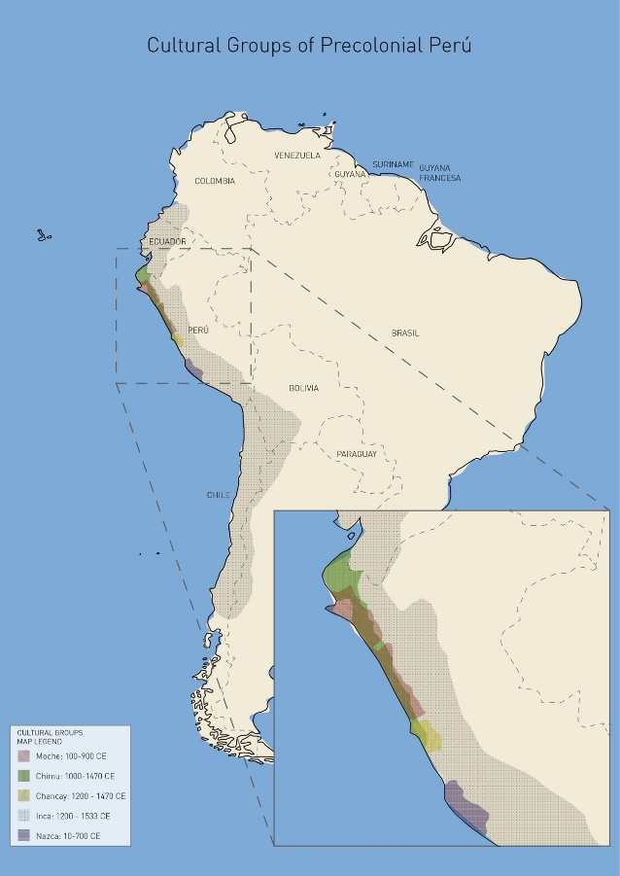
Figure 1. Geographical map illustrating the precolonial groups’ temporal and spatial locations in South America. The geopolitical nation-state borders provide a sense of orientation. Image created by José Hassi and author.
An ontologically informed embodied approach

The Moche have captivated scholars through the rich and complex material remnants they left behind (Alaica 2018). In the absence of a written language, researchers have relied on the forms and iconographic depictions of ceramic vessels to gain insights into the Moche world (Espinosa et al. 2023, Quilter 2020). While these studies have proven enlightening, interpretations of these precolonial objects frequently stem from perspectives that universalize modern Western dichotomies such as natural/supernatural, culture/nature and subject/object (for instance, Chapdelaine 2011, Woloszyn 2008). Interestingly, a substantial body of research has revealed that these divisions find no grounding in the Moche world (Alaica 2018, Benson 2012).
In stark contrast with studies examining Moche ceramics that normalize these dualisms, this article builds upon the framework of the ontological turn in anthropology. This theoretical and methodological position challenges fundamental assumptions about the subject of anthropological inquiry. Rather than assuming fixed categories of being, the ontological turn explores different constitutions of what reality is (Holbraad and Pedersen 2017). Applying this approach to the analysis of a museum context, I ask whether modern categories used to study and present ‘objects’ are congruent with a Moche perspective. This inquiry not only sheds new light on the transformative and dynamic world of the Moche and their vessels, but also offers a critical perspective for assessing the processes of collection, acquisition, interpretation, and exhibition of precolonial objects in European museum settings.
Previous works have highlighted the indivisibility of the natural and social and the absence of subject/object categories within certain contemporary Indigenous worlds across the Americas (Blaser and De la Cadena 2017, De la Cadena 2020). Within this framework, entities are not isolated but are constituted through their interconnections with other beings, including humans, flora, fauna, mountains and rivers. In this sense, all entities coexist and interact as part of a shared social world, emerging through praxis – understood as transformation through ongoing relations – as described by Viveiros de Castro (2019).
The author traces a distinction between poiesis and praxis, with the former belonging to a paradigm of production that aligns with a modernist view of culture shaping raw nature. In contrast, praxis emphasizes an exchange-oriented paradigm where forms arise from the dynamic interplay of forces and matter. As such, rather than being produced through an initial act, entities emerge and continually take shape through processes of exchange with others – human and non-human – in which every act is a response. This emphasis on exchange and interconnectedness directly challenges dominant anthropocentric paradigms by establishing a symmetry between human and non-human entities. Consequently, this perspective provided a fertile ground for an ontologically informed exploration of Moche vessels as socio-material entities engaged in transformative relations.
The Western dualisms previously mentioned, alongside the mind/matter divide, have also significantly influenced sensorial approaches to the vessels. Scholars have predominantly focused on discrete, visual aspects of the pots, concentrating on either their iconographies, form, or material composition (Weismantel 2021). These approaches often disregard how these vessels ‘were made to be seen, held and set in motion, filled and emptied’ (Weismantel 2021: 139). Additionally, they overlook their status as dynamic and interactive entities that have the capacity to generate, sustain and mediate social relationships (Gell 1998).
Recognizing the contributions and limitations of these approximations, this article builds upon Weismantel’s (2021) work, proposing an embodied approach that extends her treatment of Moche vessels as active and relational entities. This notion involves a deliberate emphasis on the relationship between flesh body and the clay bodies, which facilitates a comprehensive exploration of the pots beyond visual means, encompassing kinetic and tactile dimensions.
This research also seeks to explore how these vessels have been interpreted and exhibited within the ‘Pottery and Pottery Making’ case at the PRM from the 19th century to the present day. To do this, a decolonial/dewestern lens, working in complement with an ontologically informed embodied (OIE) approach, becomes crucial. Current theoretical positions have critically evaluated museums’ often Eurocentric interpretations and displays of Indigenous objects. Several attempts at decolonizing these institutions have been made, including considering the museum as a ‘contact zone’ (Clifford 1997), collaborating with source and descendant communities (Kreps 2020, Peers and Brown 2003), repatriating objects (Okubadejo 2022), and including Indigenous perspectives in the care for collections (Wali and Collins 2023). However, these approaches have not been without their critics. Some argue that museums maintain intellectual and material control over objects (Boast 2011), and it is important to question whether simply incorporating Indigenous ways of knowing into the museum’s pre-existing dominant framework establishes a truly symmetrical, intercultural system. Contrary to the notion of adding Indigenous voices into the museum, this study aims to propose alternative interpretation and exhibition strategies that create a space where the Moche ontology and the institutional perspectives can meet.
I argue that by adopting an OIE approach to analyze the vessels under study, new insights can be gained into their socio-material significance, and more broadly, into the Moche world that birthed them. Additionally, this framework offers a mechanism to critically evaluate the exhibition of the pots within museum contexts from a decolonial and intercultural perspective, opening pathways towards more innovative forms of display.
What follows is a discussion based on research conducted at the PRM between June and August 2023, where I sketched, photographed, filmed and ‘played’ with five Moche vessels displayed in the ‘Pottery and Pottery Making’ case [Figure 2], bringing forward their tactile and interactive aspects. According to the PRM’s collection database (2025), the museum currently holds 26 Moche objects, seven of which are exhibited. However, during my research, I found that many of the vessels on display lacked proper classification by cultural group. I employed the visual methods previously mentioned to identify the Moche pots and make selections for my study. By cross-referencing my observations with artifacts in other museum online collections, I was able to determine that certain pots of unknown origin were Chimu, and that others labelled as Chancay were actually Moche. After confirming my observations with Dr Hugo Ikehara, I notified the museum of these findings.
I also consulted archival materials to investigate the vessels’ historical interpretation within the PRM and examined their display case through the visual methods listed before. In this article, I will first delve into the collection itself by focusing on the vessels as representations and dynamic interactors. This will not only reveal insights into the Moche conceptions of personhood, materiality, exchange and continuity, but also the significance of the vessels as socio-material entities that both portray and engage in processes of transformation, rather than being inanimate objects. Building upon the findings of the first section, the second part of this paper will explore the treatment, classification and display of the vessels within the museum from the 19th century onwards, as well as propose new ideas for their exhibition. This way, we will be able to reach conclusions pertaining to the difficulties that emerge when considering precolonial Amerindian perspectives in the interpretation and display of pre-Hispanic objects within European ethnographic museums.

Some insights into the Moche and their pots: a world of mutability, exchange and interconnection

The Moche had a circulatory ontology, wherein liquid substances carry a vital force that moves across all bodies. Flowing unceasingly and open-endedly through the skies, rivers and oceans, fluids traverse human and non-human entities alike. These bodies act as channels through which liquids transform from one state into another (Cummins and Mannheim 2011, Weismantel 2021). In essence, all entities are integrated and integral parts of a wide and continuous circulation that is crucial for the regeneration and sustenance of life.
Seen in this way, the ocean serves as the origin of all beings—deities, animals, plants, and humans alike (Weismantel 2021). In their nascent state, bodies are considered wet and malleable – qualities that materialize in the very fabrication of ceramic vessels – transitioning over time to a dry and rigid state, a process referred to as ‘mineralization’ (Weismantel 2021: 121). As portrayed in Figure 3, to highlight these damp, formative qualities, the Moche depicted human and non-human infants with intentional softness, avoiding the elaborate carvings and details that typically define adult or supernatural figures (Woloszyn 2008).
In the process of mineralization, the body’s ability to be molded diminishes. Nonetheless, moving away from malleability does not entail moving away from the potential for transformation. The Moche perceived the life cycle of bodies as a continual state of metamorphosis within a context of interconnected relationships that extend beyond the body’s boundaries (Weismantel 2021).

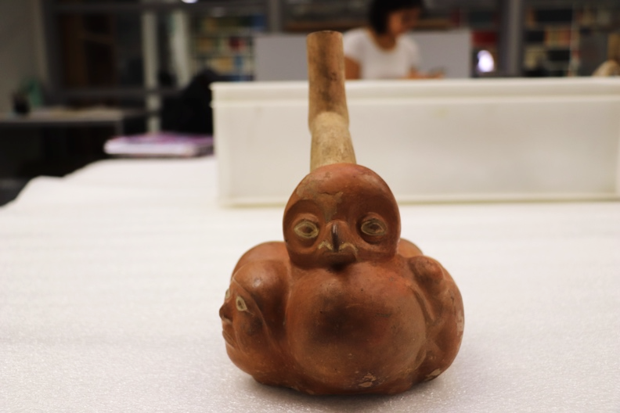A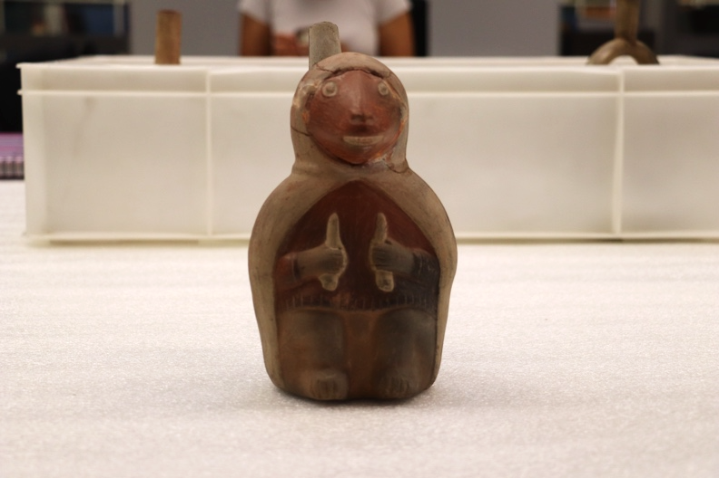B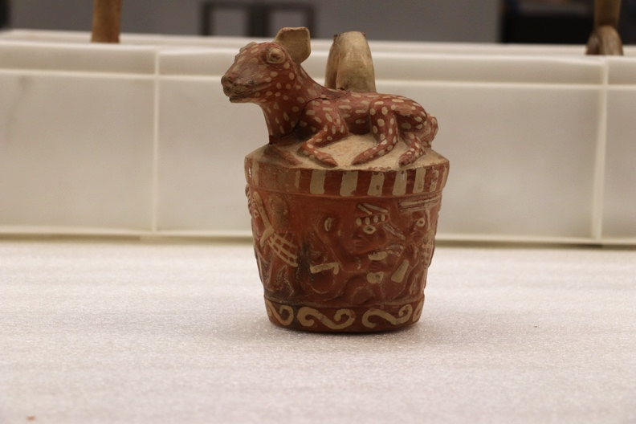C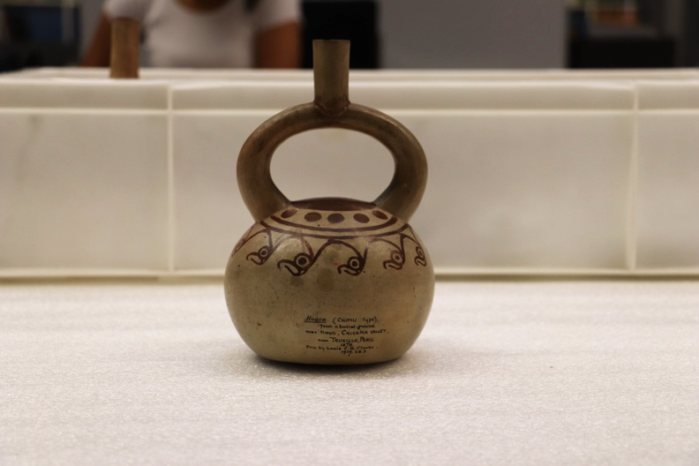D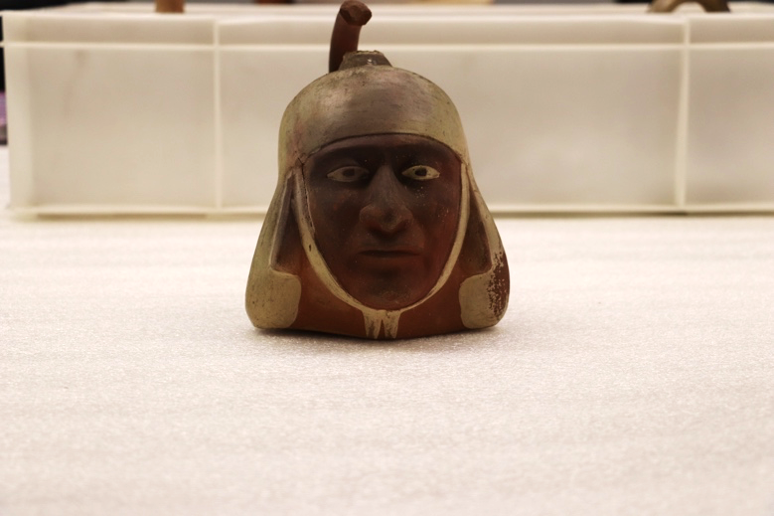E
Figure 2. Front view of the five Moche vessels (A-E, details in tables 1 and 2) chosen for the study. Images captured by the author.

To delve further into this, it is important to draw upon the ethnographic insights from present-day Indigenous worlds, particularly those where relationality operates as an ontological axis, not to claim direct continuity but to illuminate comparable logics of transformation. The Wari’, residing in the Amazonia region of Brazil, perceive that achieving personhood revolves around developing distinct physical attributes through the connections forged and upheld through sharing substances such as food and body fluids. These attributes materialize in ornamentations that make each body unique. Essentially, the Wari’ become persons within networks of interlinked bodies that develop similar points of view through sharing substances (Conklin and Morgan 1996, Vilaça 2005). These connections encompass not only humans, but also domestic plants and animals, who are considered kin as substances are exchanged with them (Viveiros de Castro 2019).

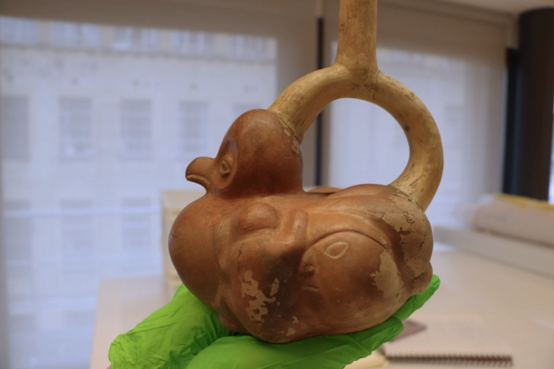A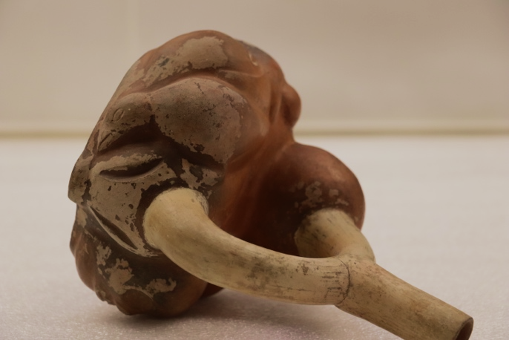A
Figure 3. Two sideview images of Vessel A, showcasing a human infant (left) and a young bird (right). Images captured by the author.

Rather than dividing the universe into humans and non-humans, a division is formed between persons and non-persons. In this paradigm, personhood is not an attribute exclusive to humans, but a status of similarity, or a shared perspective, acquired through physical proximity and consubstantiality. Yet, those designated as non-persons are still subjects – persons within other sets of relations – that apprehend reality from different points of view (Viveiros de Castro 2019). This perspective offers an interesting framework for interpreting the figure portrayed on Vessel B.
Within the Moche world, a distinction is drawn between domestic and wild animals. While domestic animals are usually depicted in a ‘naturalistic’ style, numerous wild animals are anthropomorphized, as exemplified by the wild camelid on Vessel B. Scholars propose that this difference in depictions arises from an association between wild animals and the supernatural realm, reflecting a Moche desire to personify their qualities of strength, agility and potency. In this sense, wild animals – or those who are not consubstantial – ‘were understood as animated beings that had important roles in their own ecosystems’ (Alaica 2018: 870).
However, this becomes more complex when examining other portrayals of wild animals, such as the figure on Vessel C. As the vessel turns, a scene of a deer hunt by Moche hunters comes to life. In contrast to the anthropomorphized wild camelid on Vessel B, this deer is depicted in a ‘naturalistic’ form. This difference can be understood through the notion of exchanging perspectives between hunter and prey.
The anthropomorphized camelid of Vessel B, which appears alone, could be a form of abstract subjectification of the ‘other’, understanding it as a person within its own systems of relations. However, when wild animals are portrayed alongside Moche hunters, they appear as ‘prey’. The deer on Vessel C assumes a ‘naturalistic’ form that responds to how it is seen from the embodied perspective of a Moche hunter – in effect, as a non-person liable to being killed. Following Viveiros de Castro’s notion of perspectivism (2019), the status of personhood depends on the observer’s standpoint rather than being a fixed quality.
Although the deer may appear as a non-person to a Moche hunter, it is still a subject which, in different contexts, could even assume the role of the hunter. Why, then, hunt deer? Because the animal is recognized as a subject within other sets of relations, ritual hunting becomes an opportunity to exchange perspectives, enabling mutual transformation through an intimate understanding of others and their attributes. Subjectivity thus becomes a necessary condition for participating in the reciprocal exchange of perspectives. As interactions with ‘non-persons’ facilitate the acquisition of attributes that contribute to the development of a unique physical composition, bodies remain in an ongoing transformation revealing their inherent instability.
The mutability of entities is not confined to the representations on the pots but extends to the interactions with them, as in the case of Vessel D, which is highly transformative in interaction [Figure 4]. As the vessel moves around, what appears to be birds from one perspective, gradually mutates into ocean waves and a burning sun. Moreover, when placed upon a flat surface, it wobbles, producing sounds akin to a rattle when filled with water. As the pot reveals ‘the capacity of clay to become lively flesh’ (Zuidema 1967, quoted in Weismantel 2021: 78), the Moche conception of body transformation proves to be multifaceted.

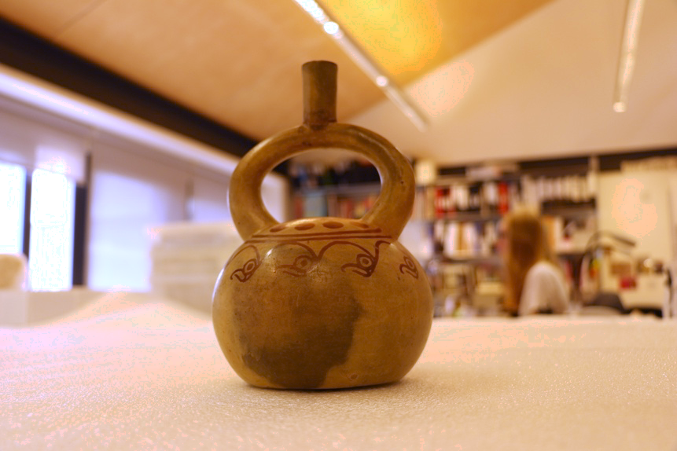D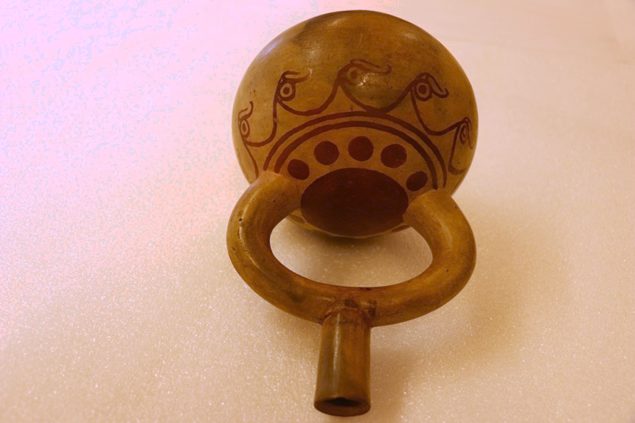D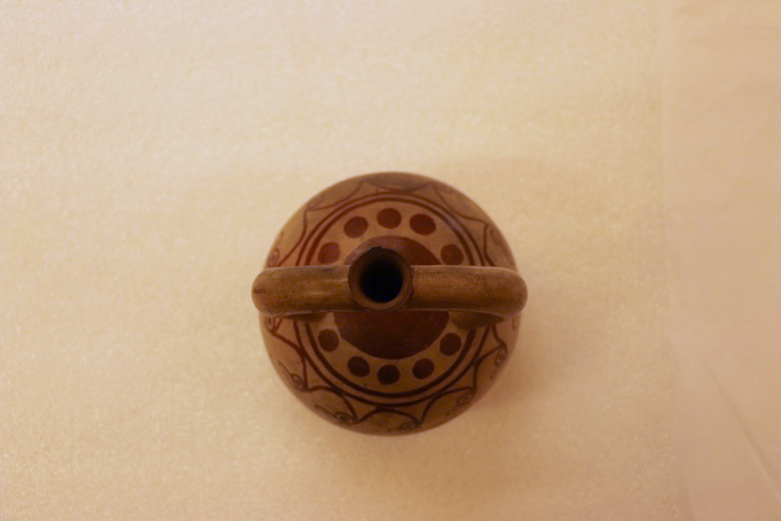D
Figure 4. Three images illustrating how the same painted imagery of Vessel D transforms in different positions. In the first picture, where Vessel D stands upright, the depictions appear as flying birds. In the second, with the vessel lying down, the same motifs resemble sea waves. In the third image, viewed from above, the iconography forms a sun. Images captured by the author.

Firstly, clay and flesh bodies transform diachronically, commencing as wet and malleable and advancing towards hardness. Secondly, solidified bodies continue to mutate through exchange with others, evidencing their incompleteness. In these exchanges, ‘personhood’ is built and maintained by acquiring certain traits from others. Notably, an entity’s position within the exchange is never stable, thus, solidification does not equate stability. As bodies engage in different sets of relations, they constantly re-emerge, being an open-ended process of transformation.
However, this process is not confined to self-transformation alone. Bodies actively participate in the transformation of other entities. This extends beyond beings engaged in exchanges, also encompassing the substances exchanged themselves. By holding and pouring liquids, vessels participated in the circulation and transformation of liquids and corporeal forms (Weismantel 2021).
This can be clearly seen in the participation of the pots in funerary rituals. The five vessels under study were originally crafted for these instances. Evidential remnants indicate that while certain vessels were never utilized for the consumption of liquids, instead serving as offerings for the dead, others bear traces of having been used for sharing chicha – a type of corn beer prevalent among precolonial societies of the Americas – with the deceased. Either as offerings or vessels, the pots assumed an active role in ritual practices, facilitating the exchange of substances between Moche people and their ancestors (Weismantel 2021).
As Muro (2022) underscores, ancestors and deities were active participants in the social world. They were perceived as powerful entities responsible for facilitating the circulation of vital substances and safeguarding the collective welfare of the living community. In exchange, the living would revere and feed them, orchestrating elaborated ceremonies. In this dynamic, the vessels played a significant role, steering transitions from one state to another and contributing to the establishment and perpetuation of connections with entities of the supernatural world (Weismantel 2021). Nevertheless, only certain persons had access to the tombs and participated in these substance-sharing rituals, as exchanges with powerful ancestors granted exceptional qualities that few could attain.
One such figure is Vessel E, a Moche portrait vessel of a priest with a ‘twin’ in the Ethnologisches Museum, Berlin (Ethnologisches Museum 2023). The employment of molds for crafting these portraits has puzzled researchers, given that standardized reproductions cannot capture the distinctive facial traits – eyes, mouth, or nose – typically associated with individual identity. Ethnographic work with the Wari’ offers a useful interpretative lens for analyzing these understandings of the body and personal identity. As Conklin and Morgan (1996) note, distinctiveness among the Wari’ is not necessarily articulated through facial features but through bodily marks that materialize the relationships a person maintains through exchanges. Seen in this way, the contrast between Vessel E and its twin – and the humans they presumably represent – becomes more significant.
Archaeological interpretations suggest that differences in ornamentation – in this case, the twin’s application of black pigment details post-firing (Donnan 1965) – indicate hierarchical ranks (Donnan 2004, Woloszyn 2008). Yet, much like the Wari’ society, these ornaments might also reflect the interconnections through which a person becomes constituted. For the Wari’, personhood is not fixed but exists in varying degrees, with social value related to the extent of one’s social ties (Conklin and Morgan 1996: 672). Following this logic, ornamentation is not merely a marker of rank but an expression of the distinct relational processes through which each body is constituted. Through ongoing exchanges with powerful ancestors, each priest – and perhaps each pot – could acquire distinct attributes, such as vitality or fertility, that were then materialized on the body. In this way, the differences between Vessel E and its twin do not only illustrate social hierarchy but also the transformative potency of ongoing interactions within the tomb.
These findings reveal the material articulation of identity and the body were materially articulated, as well as how burials were sites of activity and exchange (Muro 2023). Moreover, they show that within the Moche world, death was not merely an endpoint, but rather a threshold – a transformation in both matter and meaning that did not exclude the deceased from participating in social life. Nonetheless, the notion of the dead as the source of vitality may appear paradoxical. As is the case in many societies around the world, ancestors remain ‘alive’ within social relations, while their bodies undergo a transition from flesh to bones. Consequently, death assumes a dual role – a transformation in social relation and an ongoing mineralization of the body.
As dead bodies transition from flesh to bones, they integrate into the ‘geologic time spans’ of the planet (Weismantel 2021: 122). Essentially, ancestors become part of the Earth and its systems. As Earth serves as the very foundation of existence, these ancestors need to be honored and fed. Consequently, death entails a transformation in power, as ancestors, once humans, serve as the wellspring of the flow of vital forces.
In this context, we can perceive the ‘circulatory ontology’ of the Moche not solely as the flow of vital forces within liquids, but also as an encompassing concept that includes the minerals enriching the soils and providing materials for crafts. Therefore, there are two distinct cycles – water and mineral. The relation between these two cycles can be apprehended as a dynamic interplay of complementary opposites, where each defines and relies upon the other in a reciprocal manner. It is precisely the qhariwarmi (Dean 2007: 504), the fruitful intersection of these two cycles, that births all life on Earth as we know it.
In summary, according to this reconstruction of Moche ontology, akin to Viveiros de Castro’s (2019) concept of multinaturalism, the distinctive nature of each entity lies in its body. However, all bodies originate from the same source and ultimately become minerals that compose the Earth. Echoing the design of a stirrup spout [Figure 5], it might be possible to interpret that terrestrial beings follow a rhythm of 1-2-1, that commences in unity, unfolds in differentiation, and concludes in oneness. Thus, all beings are simultaneously the same and different. Entities are ontologically inseparable and exist in relation to others; therefore, all bodies are ‘inherently-with-others’ (De la Cadena 2019: 40). Figures like Vessel A [Figure 5] not only embody the circulating dynamics of life and death, but whilst in motion, also manifest principles of continuity and interconnectedness between mineral, human, animal, and vegetal forms. Conversely, as distinct physical manifestations, entities are differentiated beings actively participating in exchanges with their surroundings. The vessels, then, are not only active participants in ceremonies, but also incarnate the vitality that emerges from the (re)productive encounter between liquids and minerals.

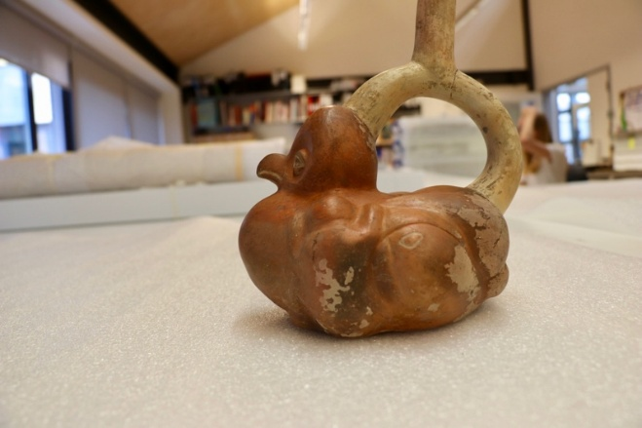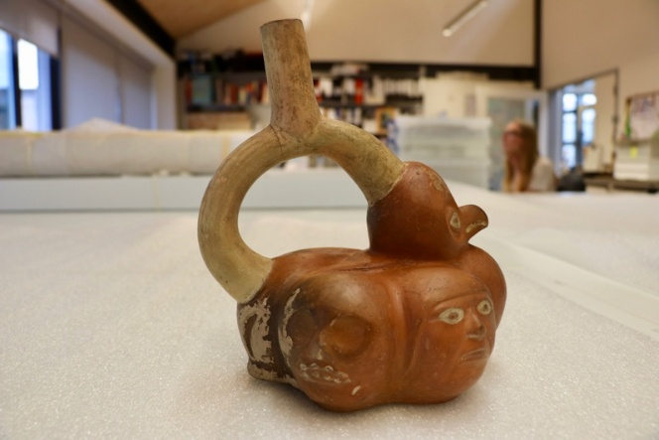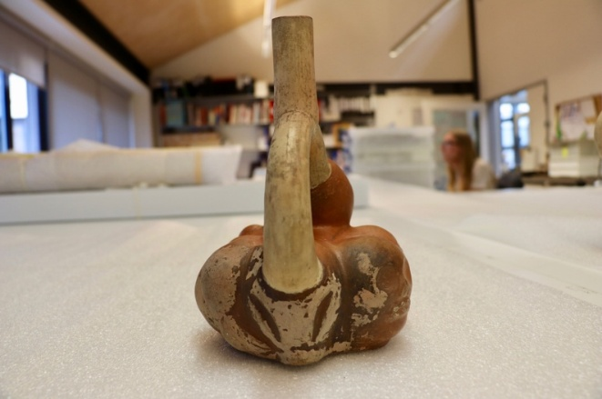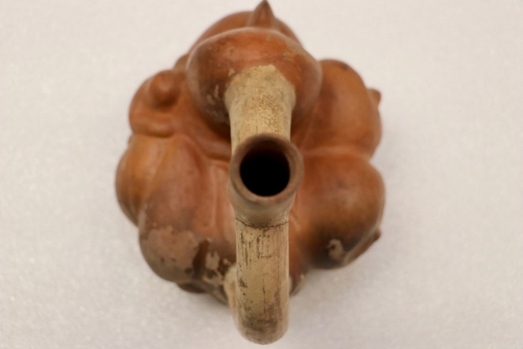
Figure 5. Four different perspectives on Vessel A, which capture its mutability and multiplicity. Images captured by author.

The pots and the Pitt Rivers Museum: processes of acquisition, interpretation and display

After approximately a millennium within the confines of tombs, many vessels – now housed in museums around the globe – resurfaced as a result of huaqueo (grave robbing) (Benson, 2012). After looting, a significant void was created as these objects were decontextualized from the burial sites and their spatial arrangements. The emergence of these pots through illicit means was certainly the beginning of an afterlife characterized by gaps of information. Furthermore, their presence in the contemporary world has triggered a range of issues concerning the interpretation and treatment of these ‘acolonial objects’ (Weismantel 2021).
Determining the precise moment when the five investigated vessels were looted remains a challenge, yet there is information regarding their acquisition processes. The PRM’s online collections database (2023) suggests that the vessels became entangled ‘in Western economic processes of the acquisition and exchange of wealth’ (Stocking 1985: 5) towards the end of the 19th century and the beginning of the 20th century. It remains uncertain whether these pots were directly purchased from looters or obtained through local markets, auction houses or even excavations.
As shown in Table 1, the identity of the field collector for vessels B, C, D and E remains unknown, and significant gaps persist regarding the vessels’ collection sites (PRM 2023). This deficiency has notably undermined the accurate recognition of the ‘cultural group’ responsible for their crafting. For instance, the PRM database designates the geographical provenance of vessels B and C as the Lima Region or Trujillo Province (PRM 2023). The presumption that these vessels were collected in Lima has led to their incorrect association with the Chancay world.

Table 1: Systematization of data from the PRM online catalogue regarding collection and acquisition. Table devised by the author using available online object label information.
Vessel (Object number) | Date Collected | Collector | Place collected | Date acquired | Mode of acquisition
A (1947.7.9) | 1884-1901 | William Maxwell Ogilvie of Dundee | Unknown – South America | 1947 | Donated by Frederick and Heneage Ogilvie (sons of collector)
B (1902.83.29) | Unknown | Unknown | Lima, Perú | 1902 | Purchased from George Fabian Lawrence
C (1902.83.28) | Unknown | Unknown | Lima, Perú | 1902 | Purchased from George Fabian Lawrence
D (1919.28.3) | 1878 | Unknown | Valley of Chicama, Trujillo, Perú | 1919 | Donated by Louis Colville Gray Clarke
E (1884.67.9) | 1874 | Unknown | Tumbes, Ecuador-Perú. | 1884 | Donated by Augustus Henry Lane Fox Pitt-Rivers

In their journey into the PRM, the clay bodies have continued to accumulate markings that attest to the varied social relations in which they have been involved. After their acquisition in 1902, Henry Balfour, the first curator of the PRM, inscribed ‘Trugella, Peru’ in black ink onto vessels B and C [Figure 6]. This becomes interesting given that the Moche inhabited what is today known as the Trujillo region and considering the numerous people intertwined in the afterlives of the pots. To the best of our understanding, collector and antiquarian George Fabian Lawrence acquired vessels B and C around 1902, from Stevens’ Auction Rooms in London (PRM 2023). These inscriptions likely represent instances of misheard oral transmission concerning the pots’ origins. As such, they are the evidence and testimony of the vessels’ ‘fragmented biographies’ (Basak 2011: 108).

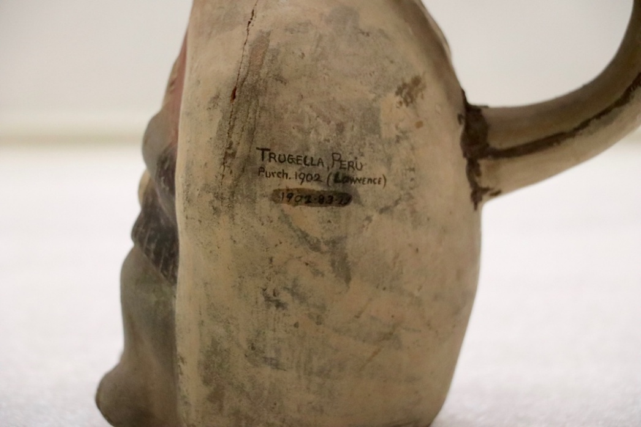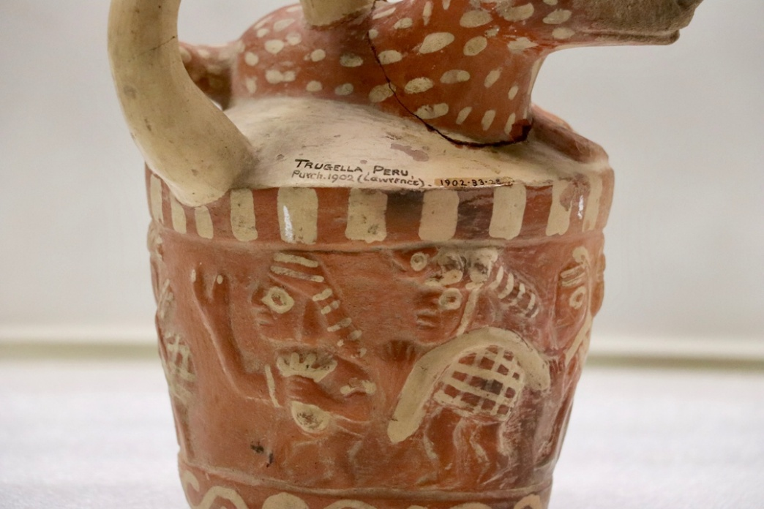
Figure 6. Close-up view of the inscriptions ‘Trugella, Peru’ on the bodies of vessels B and C. Images captured by the author.

Vessel E was donated by Augustus Henry Lane Fox, otherwise known as General Pitt-Rivers, as part of the Founding Collection. Its documentation as collected in Tumbes – a borderland shared by Perú and Ecuador – has led to a classification dilemma [Table 1]. While primary records seemingly indicate an Ecuadorian origin of this pot, the PRM’s classification encompasses both Ecuador and Perú as potential provenances (PRM 2023). This dual classification has been misleading in the accurate sociocultural attribution behind its creation. Upon finding a twin vessel at the Ethnologisches Museum, it was possible to confirm that this vessel indeed is Moche.
The lack of information on the specific social group that crafted these vessels has considerably hindered their interpretation within the museum context. As illustrated in Table 2, the PRM’s database offers scant information into the vessels’ affordances, forms and iconographies (PRM 2023). Having initially emerged within the Victorian evolutionist paradigm that materialized in typological exhibitions (Chapman 1985), the PRM has primarily emphasized the classification of these entities ‘in terms of externally defined formal or functional qualities’ (Stocking 1985: 8). Entities that once were active social actors have been grouped alongside other ‘artifacts’ with which they bear physical resemblances according to a certain viewpoint. As museum objects, the vessels have been constrained by reductionist interpretations that tend to silence their past lives and interactive potentials.

Table 2: Compilation of data from the PRM online catalogue and research findings regarding cultural group and form/depictions. Table devised by the author using available online object label information and research findings.
Vessel | Previous information on cultural group | Findings on cultural group | Previous information on form/depiction | Findings on form/depiction
A (1947.7.9) | Moche | Moche | Ceramic vessel.  Stirrup spout jar in the form of a bird | Stirrup spout vessel. From the front: owl head and body. From the sides: Anthropomorphic and zoomorphic vessel depicting the processes of life and death of humans and birds (birth, adulthood, death). From the top: a fruit or vegetable, potentially resembling a potato.
B (1902.83.29) | Chancay | Moche | Ceramic vessel in the form of an animal holding corn cobs | Stirrup spout vessel. Possibly an anthropomorphic wild camelid, sitting down and holding artifacts in its hands. The cape suggests it might be resembling a priest.
C (1902.83.28) | Chancay | Moche | Ceramic vessel. Animal lying down, at sides people carrying burdens | Stirrup spout vessel. Scene of the ritual of deer hunting. At the top, a male deer lays down. On the sides, seven human hunters carry nets and pouches. Two of them are hybridized anthropomorphic figures with the arms of a crustacean. The spout connects the hunters and the deer when the vessel is tilted.
D (1919.28.3) | Chimu or Moche | Moche | Ceramic vessel with painted decorations of birds’ heads | Stirrup spout vessel. Bottle spout upwards: bird, possibly a cormorant. Bottle spout downwards: ocean waves. Spout facing holder: sun. Notably, the vessel’s base is not flat, but rather undulates, wiggling when placed on a surface.
E (1884.67.9) | Unknown maker | Moche | Human face | Spout and handle vessel. A figure, likely a priest or a shaman, is depicted wearing a distinctive headdress.

Owing to the emphasis on functionality, the crafting techniques and iconographies of the vessels were initially regarded as insights into the evolution of form (Pitt-Rivers 1891). Today, these attributes continue to be subjected to function, seen as sources of superficial descriptive details. In their online object information label (PRM 2023) the five pots have been described as ‘ceramic vessels’, occasionally accompanied by limited notes about their depictions. These descriptions underscore the importance given to functionality, overlooking the fact that, as shown earlier through the example of Vessel E, ornamentation constitutes a fundamental element of the pots’ unique body composition. Moreover, they use a static conceptualization of the pots. As evidenced in Table 2, the descriptions reflect a fixed and singular view of the pots, operating under a logic of either/or. This perspective deviates from the Moche logic of and/with, that becomes materialized in the vessels’ multiplicity, transformation and ever-emergence.
Within these descriptions, the limitations and rigidity of monolithic Enlightenment-rooted categories come to the forefront. Vessel A has been described as ‘in form of a bird, round whose body are modelled a human face and a skull on one side and on the other a bird, part of a human face and an animal (?)’ (PRM 2023, 1947.7.9). This characterization does not encompass the full spectrum of sensations, forms and images that emerge in the engagement with the vessels. However, it sheds lights on the challenges that arise in the ontological encounter between entities from different worlds. The vessel challenges us to describe a plural and kinetic entity – a being that, in terms of De la Cadena (2019) is not only a pot and certainly, whose clay body is not only what it appears to be from a singular viewpoint.
As an entity that is one and many (a mineral and an owl and a human and a skull and a young bird and a human infant and a vegetable), Vessel A appears as alien and unfamiliar to the ‘grammar that transforms entities into individual bodies’ (De la Cadena 2019: 48). Despite the predominance of the modern Western logos in their classification and description, ‘the pots evince a stubborn insistence on communication – albeit in their own terms’ (Weismantel, 2011: 304). Emanating as dynamic, multiple and mutable entities, the Moche vessels resist and exceed the museum’s categories, underscoring the challenges arising from the intersection of two worlds.
The classification of objects based on their form and function rather than their ontological provenance materializes in the exhibition of the vessels within the ‘Pottery and Pottery Making’ display [Figure 7]. Following the pattern of other cases in the museum, this wood and glass case has four sides which feature various immobile ceramic entities from different cultural groups. Generally, the objects are arranged by geographic provenance, with approximately one third of the case dedicated to 20th-century pottery from the Pacific Islands, while the rest showcases precolonial vessels from diverse parts of Abya Yala (the American continents). Despite the spatial and temporal distances between these objects, they are gathered together to convey a narrative of ‘different cultural solutions to common problems’ (Gosden et al. 2007: 3).

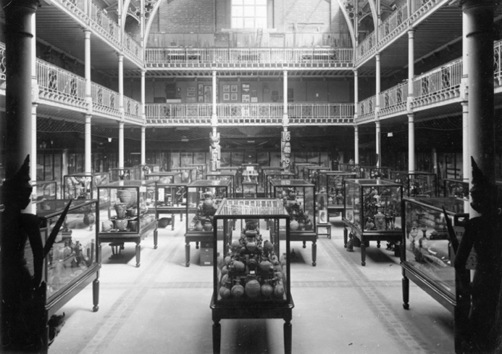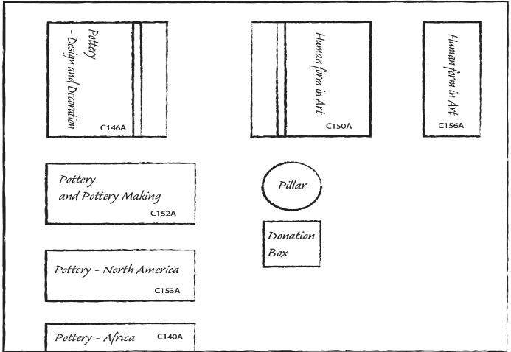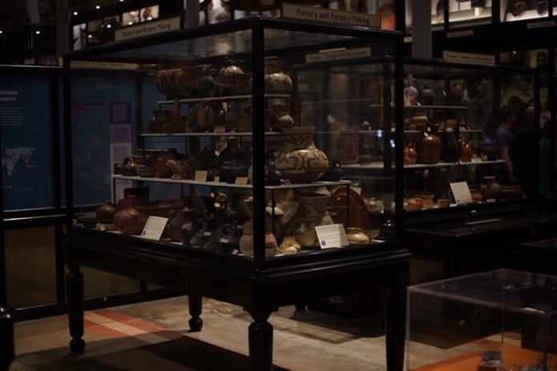
Figure 7. Three images depicting the case’s location. The first is from the late 19th century, sourced from the PRM online photograph collection (1998.267.95.3). The second is a sketch by Raimundo Pinto and the author, showing adjacent cases. The third is a photo taken by the author in 2023.

As mentioned earlier, the PRM initially adhered to a typological display. Within this classificatory system, artifacts from non-Western cultures stood as evidence of their evolutionary stages along a unitary linear scale, stretching from ‘simple’ and ‘savage’ groups to ‘complex’ and ‘civilized’ societies. At the pinnacle of this ladder stood 19th-century British Victorian Society (Van Keuren 1989, Kuper 2023). Victorian scholars were interested in the evolution of form, as illustrated by the work of British anthropologist and the PRM’s first curator, Henry Balfour, in his study of ‘Peruvian pottery’ [Figure 8]. Employing a ‘scientific scheme’, they categorized objects from various times and spaces into different types, such as pottery, tools, weapons and textiles.

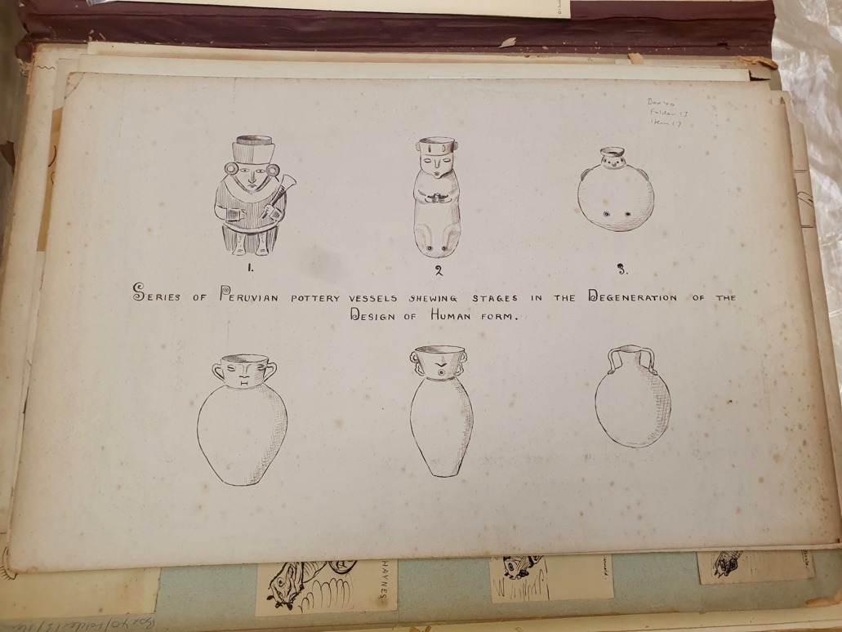
Figure 8. Balfour’s iconographic analysis sourced from the PRM archives (Mss.Balf.40.13.17). The caption states ‘series of Peruvian pottery vessels showing stages in the degeneration of the design of human form’. Image captured by the author.

Constructing the history of different forms posed a complex challenge. As noted by Pitt-Rivers himself (1891), ‘actual evidence’ pertaining to the dates of ‘prehistoric’ or ‘savage’ objects was scarce. This deficiency prompted the arrangement of objects in a manner that showcased ‘how one form has led to another’ (para. 5). Objects were identified, classified and systematically arranged by European scholars situated within a specific sociohistorical context. Within this framework, the collected pieces, whether of archaeological or ethnographic origin, were grouped indistinctively. This practice reinforced Eurocentrism and imperial dominance, valuing objects in their capacity to be fitted into predetermined categories (Basak 2011). Today, the PRM has departed from an evolutionary mindset. As expressed by Van Broekhoven (2018), the current Director of the PRM, the displays are now a ‘celebration of human creativity’ and the museum has been confronting its problematic inheritances, addressing its colonial past and becoming part of healing processes. However, the arrangement of objects based on their type, and consequently, the grouping of archaeological and ethnographic items, persists. This could likewise be interpreted as a manifestation of ‘historical othering’ (Fabian 2014), wherein modern Euro-American scholars perceive Indigenous ‘others’ as static, timeless and disconnected from history.
The focus on typology, coupled with the absence of information regarding sociocultural provenance, has resulted in a display that is not organized by ‘cultural group’, and Moche vessels being spread across different sides of the container. Instead, the display is based on aesthetic conventions rooted in Euro-American formalism, privileging certain colors, shapes and sizes. For instance, Vessel A rests on the third layer of one side, situated next to a beige hen-shaped vessel of similar dimensions and unverified provenance [Figure 9A]. This side of the case features pottery from the Fiji and Solomon Islands, alongside items that are Chimu, Chancay and Inca, as indicated by four small labels. On the right side, various black pots are grouped together, while the pots on the left side predominantly exhibit different shades of brown and beige. The accompanying information sheet highlights the origins of the pots on the right side, with particular emphasis on the black vessels, the use of molds for their crafting and their distinctive whistling features. These descriptions underscore the formal qualities of the vessels rather than their ontological aspects.
9C
9B
9A
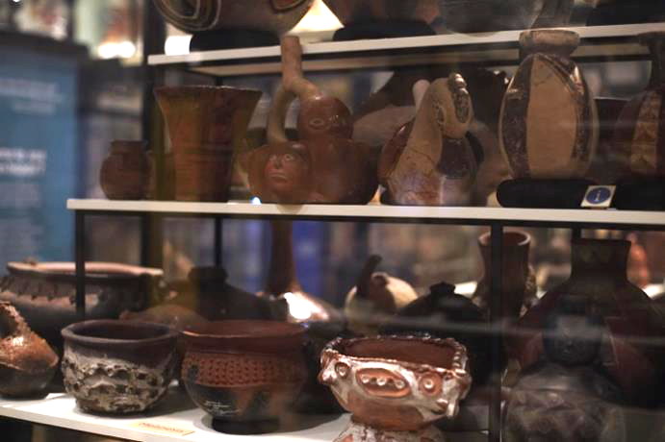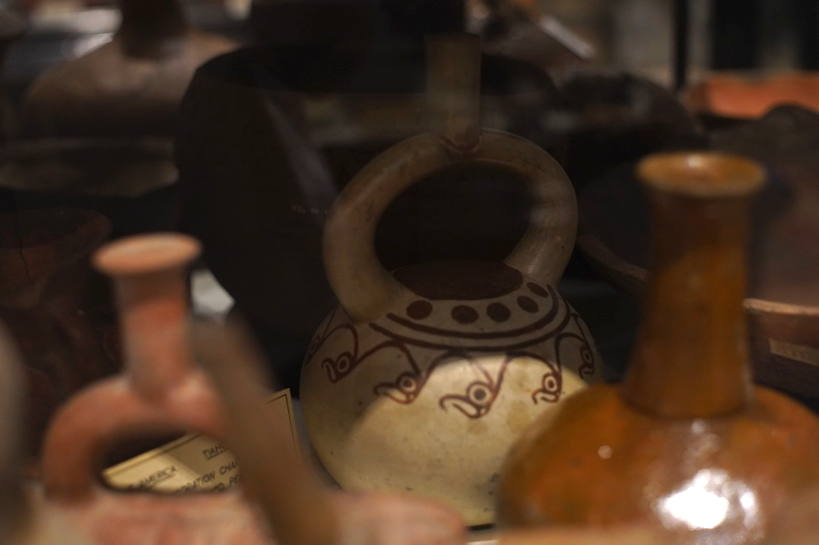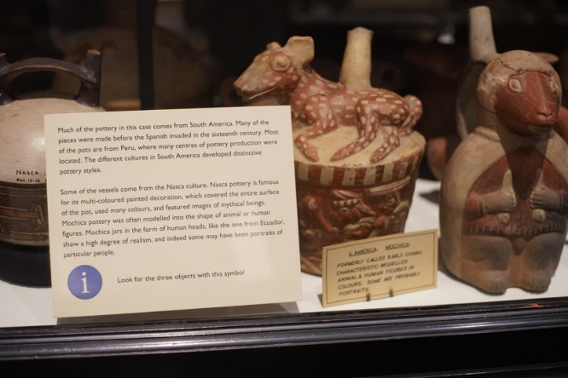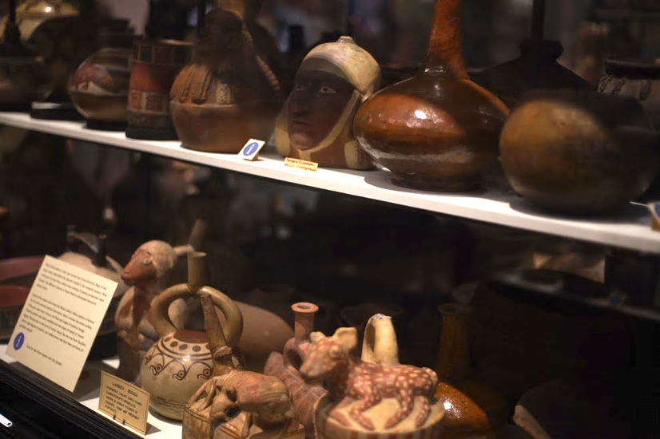
9D
Figure 9. Photos showing vessels A, B, C, D and E resting on the case, accompanied by the informational sheet. Images captured by the author.

On the parallel side of the case, vessels B and C occupy the front part of the bottom layer, positioned near other pots shaped like animals and plants [Figure 9B]. Vessel D rests on the darker rear area, less visible, and is surrounded by similarly geometrically shaped pots in shades of red [Figure 9C]. A small label designates these pots as Tiawanaku. Next to Vessel C, an informational sheet explains that many of these pots originate from precolonial South America, particularly Perú. The placard offers formal details about the Nazca and Moche pottery, emphasizing the ‘characteristic’ use of colors and animal forms in these pottery styles. Noted in the placard as a figure displaying a ‘high degree of realism’, Vessel E appears on the second layer of this side, positioned beside brown and red pots of similar dimensions and colors, that are shaped geometrically and anthropomorphically [Figure 9D]. Overall, this side predominantly features orange and red objects of Nazca, Ica and Diaguita origins, among others previously mentioned.
The arrangement of the vessels based on a specific visual aesthetic rather than cultural provenance underscores the dominance of a modern European perspective. Prioritizing qualities like color, shape and size in the display over cultural origin is a consequence of what Stocking has termed a ‘process of aestheticization’ (1985: 6). This process emerges from the universalization of European aesthetic norms and from the recontextualization of objects originating from other ontologies in the museum setting. The vessels, once dynamic entities with various social roles within the Moche world, have been distilled into an aesthetic criterion that emphasizes their visual attributes while downplaying their affordances and transformative qualities.
The result is the presentation of museum objects that are meticulously curated and grouped with other objects on display to convey a specific worldview and classification system (Larson 2007: 107). The museum continues to assign value to the vessels based on their type and their suitability to be fitted into preordained categories. Consequently, the Moche ontology is not being (re)presented; rather, what is being showcased is an interpretation that positions these entities as technological artifacts crafted by the ‘other’.

An intercultural museum: proposals to enhance museological communication and experience

The original intention of the PRM was for objects to be both research and educational tools to generate knowledge about distant others (Gosden et al. 2007). Displays were meant to be spaces in which the objects could visually communicate meanings easily and transparently to visitors (Conn 2010). However, as assessed through the OIE approach, museums are not neutral, and displays are not transparent. This dynamic is effectively depicted by Peruvian artist Sandra Gamarra in her artwork ‘Expositor’ (2021), where the arrangement of vessels becomes a conduit for a Eurocentric narrative. Gamarra’s work reveals the seemingly impartial glass case as a power device. By painting different precolonial objects onto the case surface, she highlights how, inside the case, the vessels lose their three dimensionality and appear as isolated fragments (Stanford DLCL 2021). Similar to Hallam’s (2019) concept of objects and spaces as co-constituting each other and Dudley’s notion of an object-information package (2010), Gamarra’s artwork underscores the absence of distinction between the display case and the objects when the exhibition framework narrates from a dominant perspective.
The ontological mediation in the presentation of the vessels collapses, rather than controls, the ‘equivocation’ (Viveiros de Castro 2004), reducing the possibilities of what the entity might be from alternate perspectives to a singular reading. This generates an unbalanced relation between the Western and the Moche perspectives within the museum setting. Addressing these issues does not entail silencing the museum’s perspective, but rather recognizing it as a ‘partial truth’ (Clifford 1986: 6). Consequently, there is a dire need to balance the representation of what these entities are by creating an intercultural space, where the Moche perspective, previously accessed through an OIE approach, can engage in dialogue with a Western one.
This can be achieved through aligning with what de Sousa Santos (2010) has articulated as an ‘ecology of knowledges’ and Zeitlyn (2023) has termed ‘sparse anthropology’, both of which emphasize communication through difference. Under these lenses, different perspectives are not assimilated into the dominant framework. Instead, the absence of consensus and the inherent incompleteness of entities are seen as enriching. Employing these frameworks, the vessels emerge as spaces of convergence and co-existence for diverse ontologies, engaging in a horizontal dialogue that transcends the constraints of either/or.
As previously seen, the Moche’s kinetic universe highly differs from the current static placement of the vessels within the display case. Following an interactive exploration with these entities, questions emerged: How does one categorize an entity that transforms within interaction? What criteria determines its position and which side should be showcased? As proposed by Howes and Classen (2006), integrating interactive experiences such as multimedia technologies and replicas holds significant potential. Given that sensory experiences and perception emerge from the entire body’s engagement with the environment (Ingold 2000), incorporating videos showcasing the vessels in motion and photographs capturing their various sides presents an opportunity to convey the vessels’ transformative nature while enhancing the sensory encounter.
Procuring replicas crafted by Peruvian artisans (Peruvian Whistling Bottles Vitancio 2023) and utilizing 3D printers to produce reproductions of the vessels on display could facilitate tactile, haptic and auditory interaction with the pots. Visitors could engage in movement and listen to the sounds produced when water is poured onto the vessels, either through handling or sound kiosks. This approach would offer a dynamic embodied exchange, allowing visitors to experience the vessels’ relational attributes and witness their transformations.
While visitors are active co-creators of meanings as they engage with museum objects, their sensory experiences are culturally and historically mediated (Howes and Classen 2014). Hence, it becomes essential to offer visitors an ontological and sociohistorical context for the objects they are interacting with. The assumption that objects communicate transparently had consequences, as evident in the scarcity of labels and explanations in the current display. Additionally, these few labels predominantly emphasize the vessels’ formal attributes, reflecting a modern museological perspective. Considering that contemporary museums aim to ‘tell people about things they may not know or never learned’ (Conn 2010: 18), it is imperative to provide information about the ontological framework behind the creation of these pots – what could be understood as a Moche perspective – as well as their afterlives as collection and museum objects – what might be called an institutional voice. This contextualization should encompass the pots’ existence within the Moche world, including labels that detail their social roles, transformative qualities and interactive nature. Furthermore, labels ought to encompass the historical and social frameworks that have marked their lives as museum objects (Gosden et al. 2007). These labels could explore the interesting intersections between the life of the pots within the Moche world and within the museum. For instance, they could highlight the crafting process and discuss how Balfour replicated crafting techniques to gain insights into the forms and functions of other pottery items (Gosden et al. 2007) [Table 3].
To achieve this, it may be helpful to arrange the objects according to their cultural provenance, or at the very least, employ distinct colors to signify different cultural groups. Currently, the information sheets feature a blue sign reading ‘look for the objects with this sign’ when addressing Chimu, Moche, Chancay, Nazca and Pacific Islands objects alike. This uniform marker may lead to confusion, as objects from different spaces and times share the same information marker. Employing color-coded distinctions could greatly enhance clarity.
While distinguishing cultural groups may risk reifying or essentializing them, it might also help illuminate their material and technical diversity, as well as wider aspects, such as human-environment relations and cross-cultural exchange. Moreover, the Pacific Islands objects in this case are ethnographic rather than archaeological, underscoring the importance of clarifying their provenance and avoiding conflating distinct cultural and historical contexts. Any visual differentiation should therefore be understood not as a fixed taxonomy, but as a curatorial strategy to help visitors appreciate these material and contextual differences.
In addition, to provide insights into the geographical and environmental context in which the pots originated, it would be valuable to incorporate maps offering temporal and spatial information, such as the one presented at the beginning of this paper. These maps could also serve as an opportunity to illustrate that precolonial groups were not sealed off from each other, but rather interacted and influenced one another, as Figure 10 suggests.

Table 3: Proposed labels for the ‘Pottery and Pottery Making’ case, tracing the vessels’ journeys from their original context to the present. Table devised by author using research findings.
Label focus | Associated vessel(s) | Interpretive aim
Are these just vessels? Among the pots in this case are Moche ceramics, made over a millennium ago in the deserts of today’s north coast of Perú. They were created by mixing water and minerals, yet these were not simply raw materials. For the Moche, liquids carry a vital force, while minerals emerge from long processes in which the bodies of powerful ancestors decay and become earth. These vessels also played funerary roles, used to share chicha (corn beer) with the dead or offered in their honor. As such, they form part of a broader and interconnected system. | Moche vessels (general) | Introduce the significance of the vessels within the Moche world.
Look for the map. The ceramics in this case come from different parts of the planet and diverse times. Some are 20th-century pottery from the Pacific Islands, while most are from pre-Hispanic South America. If you look closely at the pre-Hispanic vessels, you will notice differences in shape, iconography and color, as well as shared features that point to cross-cultural exchange. Crafted to be set in motion, many vessels, including Moche, Inka and Chimú, produce sound when liquids are poured. Would you want to listen? Scan the QR code. | Vessels in the ‘Pottery and Pottery Making’ case (general) |   Highlight cross-cultural exchanges and provide details on the vessels’ interactive qualities, incorporating the map shown in Figure 10 and a QR code.
Look for the white vessel with painted red bird heads. What do you see? Try looking from a different angle. Do the birds transform? Transformation was central in the world of the Moche. Not only did bodies change in time – like ours! – but the world itself was perceived as dynamic. When this vessel is in motion, the birds become ocean waves (upside down) and a sun (top view). | Vessel D | Foreground the transformative qualities of Vessel D whilst engaging visitors.
For centuries, these pre-Hispanic vessels rested in sacred huacas (burial sites). During the 19th and early 20th centuries, many were removed from tombs and entered global networks of power and exchange. Looting and collecting created major gaps in knowledge about their origins. The Pitt Rivers Museum acquired these ceramics through donations and purchases during this period. Originally, the museum followed a typological approach, organizing objects along a linear, evolutionary scale in order to show the evolution of form. Today, it seeks instead to reveal distinctions and parallels across cultures, recognizing these ceramics as responses to shared human challenges. | Precolonial ceramics in the ‘Pottery and Pottery Making’ case (general) | Explore how the vessels were unearthed and eventually arrived at the PRM.
The original intention of this museum was for objects to be both research and educational tools for generating knowledge about distant others. During the late 19th and early 20th centuries, within an evolutionary framework, Henry Balfour, the first curator of the Pitt Rivers Museum, employed a range of methods to study the evolution form. For example, through illustration, he proposed an evolutionary scheme tracing changes in ‘Peruvian pottery’. He also replicated crafting techniques to gain insights into the forms and functions of various pottery items. | Precolonial ceramics in the ‘Pottery and Pottery Making’ case (general) | Discuss early museum interpretations (Balfour), drawing on figure 8.

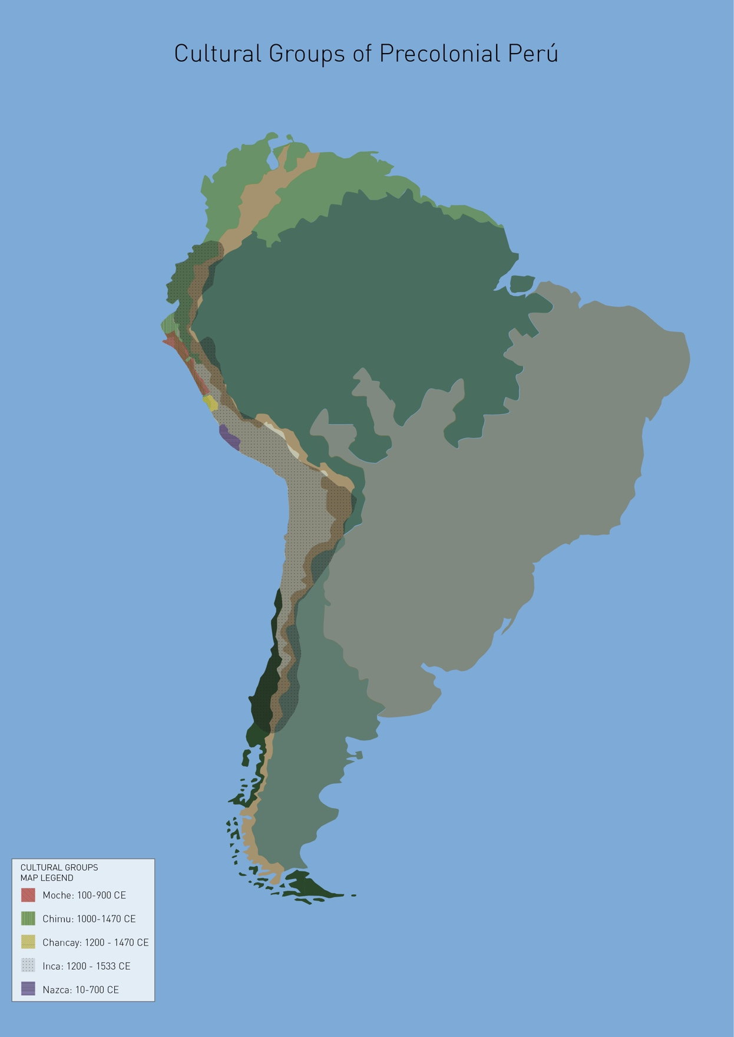
Figure 10. Geographical map indicating the temporal and spatial locations of ‘cultural groups’ in South America without borders. Although maps are an abstraction, this map offers insights into environmental aspects of the South American territory and how it might have been experienced in the past. Image by José Hassi and author.

Certainly, the proposed ideas have limitations. The vessels remain within a physical and representational structure constructed from a European perspective, hindered by epistemological and linguistic barriers. Words like ‘culture’, ‘object’, ‘artifact’, and even words such as ‘vessels’ and ‘pots’, are labels tied to particular meanings and imaginations (Mignolo and Walsh 2018). These labels shape and confine our comprehension of entities, which widely differs from the way in which the Moche understood and experienced these ceramic entities. Considering that these ‘Western’ words facilitate communication and knowledge transmission, it might be more effectively illustrated how the Moche perceived the pots as socially interconnected ‘subjects’ rather than aiming for a complete embodiment of this viewpoint. Within the museum, the vessels stand as representations of the ‘cultural traits’ of the Moche world. Reimagining them as entities that not only illustrate the principles of multiplicity, transformation and interconnectedness, but also, as beings that, like ourselves, are ontologically indivisible and emerge through praxis – exchange relationships – remains a challenge.

Final thoughts

In this paper, I explored how an ontologically informed embodied approach can provide insights into the assessment of five precolonial vessels and a critical evaluation of their presentation— and further, the representations of the Moche — at the PRM. Challenging interpretations of precolonial ceramics that rely on Western categories and thus reduce their roles to mere objects, I argued that incorporating ideas from the ontological turn within museum practice can better approximate the rich social lives these vessels held within their context of origin. Moreover, this approach provides valuable insights into the Moche world, such as the transformative and cyclical characteristics of their ontology. On the other hand, utilizing more-than-human studies as an analytical framework, I examined their current lives at the PRM and the difficulties that arise when entities from different worlds intersect. I focused on the influence of Enlightenment-rooted perspectives in the interpretation and presentation of the vessels, and the inherent resistance the pots pose to such categorizations. Through the findings of the first and second section, I illustrate how an OIE approach provides a platform to think about new forms of exhibition that align with the PRM’s efforts to create a space for dialogue, collaboration and innovation.
This approach holds significant potential contributions for museum studies. While the field has made notable efforts to ‘incorporate’ Indigenous knowledge and decolonize museum spaces (Lewis 2024, Duarte 2024), these initiatives often fall short of addressing the broader structural constructs that shape such encounters. Consequently, these endeavors risk aligning with what Walsh (2009) calls ‘relational interculturality’, which prioritizes individual contact between Indigenous and Western peoples while neglecting the socio-political and epistemological structures that perpetuate power imbalances. Integrating the ontological turn into museum anthropology advances the indigenization of museums, that is, ‘revisioning, rethinking and restructuring’ these institutions (Phillips 2022: 126). As such, it offers a lens to understand artifacts beyond ascribed meanings, revealing alternative ways of being that diverge radically from our own. What if vessels were considered socially agential entities in curatorial practice? Furthermore, applying ontological perspectives to the analysis of museum collections and exhibitions fosters the development of a genuinely intercultural approach to museum studies, one that considers ‘the transformation of structures, institutions, and social relations, and the construction of different conditions of being, thinking, knowing, learning, feeling, and living’ (Walsh 2009: 4, my translation). This does not entail silencing the museum’s perspective, rather, its aim is to create an ‘and/with’ space, where different ontologies coexist.
Attempting to integrate a Moche perspective while fostering a horizontal and collaborative dialogue with a museum perspective presents challenges. These challenges are rooted in the fact that the clay entities exist within a framework identified as the ‘colonial matrix of power’ (CMP) (Mignolo and Walsh 2018), signifying their location within the modern world. This CMP operates within the museum context, wherein the hegemonic perspective that designates these entities as individual and static objects in the form of pottery is shared by all of us – the institution, staff, scholars and visitors. However, being crafted within the Moche ontology, the Moche perspective exists not only externally, but also within the vessels themselves.
To address these issues, the difference between viewing the pots as fragments versus seeing them as fractals could serve as a departing point. Regarded as fragments, the clay entities stand as individual pieces within a larger puzzle. For scholars, approaching the Moche world from this angle involves a laborious reconstruction, where each piece must be meticulously deciphered to assemble a coherent narrative. From a museum’s perspective, considering the pots as fragments implies using them as representations that illustrate the Moche perspective. This approach could convey how the pots depict Moche principles and were crafted to exchange chicha with the deceased.
In contrast, when we consider the pots as fractals, the very idea of a puzzle dissolves. As Strathern (2004) suggests, fractals revolve around the notion of scale, wherein entities simultaneously respond to specific and broad values. As fractals, these clay entities are not solely viewed as crafted within the Moche ontology, but as integral parts of that ontology, which is embedded in their bodies. Perceiving them as fractals involves transcending our own epistemic categories and customary ways of understanding and engaging with the world. It entails learning to know beyond objectification, but as in Amerindian universes, by subjectification – that is to say, knowing through an embodied interaction with non-human entities that communicate beyond verbal means. Interacting with these vessels as entities akin to ourselves facilitates the exchange of perspectives, offering more proximity to a Moche perspective.
In this light, an OIE approach can assist scholars, museums and museum visitors in comprehending the Moche ontology by providing a space for the vessels to communicate through interaction. This process extends beyond conventional knowledge transmission; perhaps it entails an embodied process of ‘feel-thinking’ (Escobar 2014). Positioned on a spectrum between the Western and Moche views, embracing this embodied approach aligned with the Moche ontology could bring us closer to the latter. Furthermore, it offers a pathway to perceive, feel and experience beyond the limitations of our colonial modern lens.

Acknowledgements

My heartfelt thanks go to my MSc supervisor, Professor Elizabeth Hallam, whose consistent support created an enriching environment for my exploration of anthropology. I am also grateful to the lecturers of the VMMA program, as well as to Dr Chris Morton and curator Bryony Smerdon at the Pitt Rivers Museum. I owe special thanks to Dr Hugo Ikehara, who generously helped me in identifying the museum’s pots. I am thankful for the reviewers’ valuable feedback, and to Dr Chihab El Khachab and Professor David Zeitlyn, whose observations were crucial to the final version of this paper.

Bibliography

Alaica, Aleksa 2018. Partial and complete deposits and depictions: social zooarchaeology, iconography and the role of animals in Late Moche Peru, Journal of Archaeological Science 20, 864-872. doi: https://doi.org/10.1016/j.jasrep.2018.02.002.

Basak, Brishnupriya 2011. Collecting objects: situating the Indian collection (1884-1945) in the Pitt Rivers, Oxford, Studies in History 27/1, 85-109.
doi: https://doi.org/10.1177/025764301102700105.

Benson, Elizabeth 2012. The worlds of the Moche on the north coast of Peru, Austin, TX: University of Texas Press.

Blaser, Mario and Marisol De la Cadena 2017. The uncommons: an introduction, Anthropologica 59/2, 185–193. doi: https://doi.org/10.3138/anth.59.2.t01.

Boast, Robin 2011. Neocolonial collaboration: museum as contact zone revisited, Museum Anthropology 34/1, 56-70. doi: https://doi.org/10.1111/j.1548-1379.2010.01107.x.

Bone, Kaitlin 2023. Class distinctions between Moche warriors: an illustration in ceramic vessels, The University of New Mexico: Undergraduate thesis.

Chapdelaine, Claude 2011. Recent advances in Moche archaeology, Journal of Archaeological Research 19/2, 191–231. doi: https://doi.org/10.1007/s10814-010-9046-6.

Chapman, William 1985. Arranging ethnology: A. H. L. F. Pitt Rivers and the typological tradition, in George Stocking (ed.), Objects and others: essays on museums and material culture, 15-48. Madison, WI: University of Wisconsin Press.

Clifford, James 1986. Introduction: partial truths, in James Clifford and George E. Marcus (eds.), Writing culture: the politics and poetics of ethnography, 1-26. Berkeley, CA: University of California Press.

--- 1997. Museums as contact zones, in Routes: travel and translation in the late twentieth century, 188-219. Cambridge, MA: Harvard University Press.

Conklin, Beth and Lynn Morgan 1996. Babies, bodies and the production of personhood in North America and a Native Amazonian society, Ethos 24/4, 657-94. doi: https://doi.org/10.1525/eth.1996.24.4.02a00040.

Conn, Steven 2010. Do museums still need objects? Philadelphia, PA: University of Pennsylvania Press.

Cummins, Tom and Bruce Mannheim 2011. The river around us, the stream within us: the traces of the sun and Inka kinetics, RES: Anthropology and Aesthetics 59/60, 5-21. doi: https://doi.org/10.1086/RESvn1ms23647779.

Dean, Carolyn 2007. The Inka married the Earth: integrated outcrops and the making of place, The Art Bulletin 89/3, 502-518. doi: https://doi.org/10.1080/00043079.2007.10786358.

De la Cadena, Marisol 2019. Uncommoning nature: stories from the Anthropo-Not-Seen, in Penny Harvey, Christian Krohn-Hansen and Knut G. Nustad (eds.), Anthropos and the material, 143-160. Durham, NC: Duke University Press.

--- 2020. Cosmopolítica indígena en los Andes: reflexiones conceptuales más allá de la ‘política’ [Indigenous cosmopolitics in the Andes: conceptual reflections beyond the ‘political’], Tabula Rasa 33, 273-311. doi: https://doi.org/10.25058/20112742.n33.10.

De Sousa Santos, Boaventura 2010. Decolonizar el saber, reinventar el poder [Decolonizing knowledge, reinventing power], Montevideo: Trilce Extensión Universitaria.

Donnan, Christopher 1965. Moche ceramic technology, Ñawpa Pacha 3/1, 115-134. doi: https://doi.org/10.1179/naw.1965.3.1.004.

--- 2004. Moche portraits from ancient Peru, Austin, TX: University of Texas Press.

Duarte, Alice 2024. Can we accept today that the museum continues to convey colonial ideology? An analysis of two fundamental European instruments to decolonize museums, Collections 20/4, 617-642. doi: https://doi.org/10.1177/15501906241263502.

Dudley, Sandra 2010. Museum materialities: objects, engagements, interpretations, London: Routledge.

Escobar, Arturo 2014. Sentipensar con la tierra: nuevas lecturas sobre desarrollo, territorio y diferencia [Feel-thinking with the Earth: new readings on development, territory and difference], Medellin: Ediciones UNAULA.

Espinosa, Alicia, Druc, Isabelle, Millaire, Jean-François, Prieto, Gabriel, Bracamonte, Edgar and Walter Alva 2024. The chaîne opératoire as an approach to distinguish between the ceramic production of the Viru and the Moche polities on the north coast of Peru, Latin American Antiquity 35/3, 672–693. doi: https://doi.org/10.1017/laq.2023.40.

Ethnologisches Museum 2023. VA 17901 [Online object collection catalogue]. https://perma.cc/7KH4-UPJF (accessed 10 Nov 2025).

Evans, Henry, Nicolaisen, Line, Tougaard, Sara and Marianne Achiam 2020. Perspective: museums beyond neutrality, Nordic Museology 29/2, 19-25. doi: https://doi.org/10.5617/nm.8436.

Fabian, Johannes 2014 [1983]. Time and the other: how anthropology makes its object, New York: Columbia University Press.

Gamarra, Sandra 2021. Expositor [Oil and mirror painting on glass]. https://perma.cc/LHD9-3KC9 (accessed 10 Nov 2025).

Gell, Alfred 1998. Art and agency: an anthropological theory, Oxford: Oxford University Press.

Gosden, Chris, Larson, Frances and Alison Petch 2007. Knowing things: exploring the collections at the Pitt Rivers Museum 1884-1945, Oxford: Oxford University Press.

Hallam, Elizabeth 2019. Object-spaces? Sensory engagements and museum experiments, in Peter Bjerregaard (ed.), Exhibitions as research: experimental methods in museums, 109-127. London: Routledge.

Holbraad, Martin and Morten Axel Pedersen 2017. The ontological turn: an anthropological exposition, Cambridge: Cambridge University Press.

Howes, David and Constance Classen 2006. The museum as a sensecape: Western sensibilities and Indigenous artifacts, in Chris Gosden, Ruth Phillips and Elizabeth Edwards (eds.), Sensible objects: colonialism, museums and material culture, 199-222. Oxford and New York: Routledge.

--- 2014. Ways of sensing: understanding the senses in society, New York: Routledge.

Ingold, Tim 2000. The perception of the environment: essays on livelihood, dwelling and skill, London: Routledge.

Kreps, Christina 2020. Museums and anthropology in the age of engagement, London: Routledge.

Kuper, Adam 2023. The museum of other people: from colonial acquisitions to cosmopolitan exhibitions, New York: Pantheon Books.

Larson, Francis 2007. Anthropology as comparative anatomy? Journal of Material Culture 12/1, 89-112. doi: https://doi.org/10.1177/1359183507074563.

Lewis, Kara 2024. Toward centering Indigenous knowledge in museum collections management systems, Collections 20/1, 27-50.
doi: https://doi.org/10.1177/15501906241234046.

Mignolo, Walter and Catherine Walsh 2018. On decoloniality: concepts, analytics, and praxis, Durham, NC: Duke University Press.

Muro, Luis 2022. Sex, death, and life regeneration in the Moche world, 200-900 CE, in Patrick Ryan Williams, Gary M. Feinman and Luis Muro (eds.), Beyond death: beliefs, practice, and material expression, 61-64. Oxford: BAR Publishing.

--- 2023. Moche deathscapes: performance, politics, and the creation of myth in Huaca La Capilla–San José de Moro (AD 650–740), Journal of Social Archaeology 23/3, 243-263. doi: https://doi.org/10.1177/14696053231184697.

Okubadejo, Adeola 2022. Decolonization through repatriation: a new global heritage museum for Africa, University of Maryland: Ph.D. thesis.

Peers, Laura and Alison Brown (eds.) 2003. Museums and source communities: a Routledge reader, London: Routledge.

Peruvian Whistling Bottles Vitancio 2023. Vasijas silbadoras Moche [Website selling contemporary replicas of Moche whistling vessels]. https://perma.cc/BMV7-4URV (accessed 10 Nov 2025).

Phillips, Laura 2022. Teaching decolonizing and indigenizing curatorial and museum practices, Museum Worlds 10/1, 112-131. doi: https://doi.org/10.3167/armw.2022.100109

Pitt-Rivers, L. G. 1891. Typological museums, as exemplified by the Pitt Rivers Museum at Oxford, and his provincial museum at Farnham, Dorset, Journal of the Society of Arts 40, 115- 122.

Pitt Rivers Museum (PRM) 2023. 1947.7.9 [Online object collections catalogue]. https://perma.cc/W86R-CYFR (accessed 10 Nov 2025).

Pitt Rivers Museum (PRM) 2023. 1902.83.29 [Online object collections catalogue]. https://perma.cc/3JCF-ZCC5 (accessed 10 Nov 2025).

Pitt Rivers Museum (PRM) 2023. 1902.83.28 [Online object collections catalogue]. https://perma.cc/X8Z9-JACT (accessed 10 Nov 2025).

Pitt Rivers Museum (PRM) 2023. 1919.28.3 [Online object collections catalogue]. https://perma.cc/SX7S-C27G (accessed 10 Nov 2025).

Pitt Rivers Museum (PRM) 2023. 1884.67.9 [Online object collections catalogue]. https://perma.cc/7BNJ-CUMH (accessed 10 Nov 2025).

Quilter, Jeffrey 2020. Moche pottery: forms, functions, and social change, Ñawpa Pacha 41/2, 187–209. doi: https://doi.org/10.1080/00776297.2020.1844424.

Stanford DLCL 2021. Materia: ‘Engaging the Moche sex pots’ with Mary J. Weismantel & Sandra Gamarra, November 16, 2021 [YouTube video], uploaded on December 17, 2021. https://perma.cc/95U7-B9YG (accessed 15 Aug 2023).

Stocking, George (ed.) 1985. Objects and others: essays on museums and material culture, Madison, WI: University of Wisconsin Press.

Strathern, Marilyn 2004. The whole person and its artifacts, Annual Review of Anthropology 33, 1-19. doi: https://doi.org/10.1146/annurev.anthro.33.070203.143928.

Van Broekhoven, Laura 2018. Calibrating relevance at the Pitt Rivers Museum, in Jill Pellew and Lawrence Goldman (eds.), Dethroning historical reputations: universities, museums and the commemoration of benefactors, 65-79. London: University of London Press.

Van Keuren, David 1989. Cabinets and culture: Victorian anthropology and the museum context, Journal of the History of the Behavioral Sciences 25/1, 26-39.
doi: https://doi.org/10.1002/1520-6696(198901)25:1<26::AID-JHBS2300250103>3.0.CO;2-J

Vilaça, Aparecida 2005. Chronically unstable bodies: reflections on Amazonian corporalities, Journal of the Royal Anthropological Institute 11/3, 445-464. doi: https://doi.org/10.1111/j.1467-9655.2005.00245.x.

Viveiros de Castro, Eduardo 2004. Perspectival anthropology and the method of controlled equivocation, Tipití: Journal of the Society for the Anthropology of Lowland South America 2/1, 3–22. doi: https://doi.org/10.70845/2572-3626.1010.

--- 2019. Exchanging perspectives: the transformation of objects into subjects in Amerindian ontologies, Common Knowledge 25/1-3, 21-42. doi: https://doi.org/10.1215/0961754X-7299066.

Walsh, Catherine 2009. Interculturalidad crítica y educación intercultural. Ampliación de la ponencia presentada en el Seminario “Interculturalidad y Educación Intercultural” [Critical interculturality and intercultural education. Expanded version of the paper presented at the seminar “Interculturality and Intercultural Education”]. Instituto Internacional de Integración del Convenio Andrés Bello, La Paz, 9-11 March 2009.

Wali, Alaka and Robert Collins 2023. Decolonizing museums: towards a paradigm shift, Annual Review of Anthropology 52, 329-45. doi: https://doi.org/10.1146/annurev-anthro-052721-040652.

--- 2011. Obstinate things, in Barbara Voss and Eleanor Conlin (eds.), The archaeology of colonialism: intimate encounters and sexual effects, 303-320. New York: Cambridge University Press.

Weismantel, Mary 2021. Playing with things: engaging the Moche sex pots, Austin, TX: University of Texas Press.

Woloszyn, Janusz Z. 2008. Los rostros silenciosos: los huacos retrato de la cultura Moche [Silent faces: the portrait huacos of the Moche culture]. Lima: Fondo Edición de la Pontificia Universidad Católica del Perú.

Zeitlyn, David 2023. An argument for sparsity, Journal of the Royal Anthropological Institute 29/2, 347-362. doi: https://doi.org/10.1111/1467-9655.13915.

This work is copyright of the author. It has been published by JASO under a Creative Commons Attribution-NonCommercial-NonDerivatives ShareAlike License (CC BY NC ND 4.0) that allows others to share the work with an acknowledgement of the work's authorship and initial publication in this journal as long as it is non-commercial and that those using the work must agree to distribute it under the same license as the original. https://creativecommons.org/licenses/by-nc-nd/4.0/)

THE HIDDEN FACE OF BAIKAL: PATHOGENICITY OF THE SACRED LAKE IN THE LAND OF THE SIBERIAN BURYAT

MARYAM PIRDEHGHAN

The Buryat venerate Lake Baikal as a sacred site believed to possess healing powers and to be the home of divine entities who safeguard the local population from diseases and suffering. This worldview remained intact so long as the lake’s ecological balance was perceived as unaltered. However, the Russian media's diligent endeavours to create new stories emphasizing the lake’s pathogenic potential in order to promote environmental awareness have resulted in a transformed perspective of this sacred bioregion among the Buryat. This article therefore asks what is the new symbolic image of Lake Baikal and its curative ability in the collective memory of the Buryat community, and what influence has the media exerted on it. The study utilizes ethnographic research conducted on Olkhon Island and in Ulan-Ude in Siberia and employs indigenous narratology to reach the conclusion that, by emphasizing the taboo associated with ‘pollution’ in both objective forms (carrion and faeces) and subjective forms (decay and contagion) media narratives not only challenge the prevailing perception of nature's ability to heal, they also depict it as a source of evil. Consequently, in the absence of any inherent spiritual significance, Buryat society is not only becoming detached from the ethical principles linked to Lake Baikal, it also deliberately refrains from acknowledging the lake’s pollution.

Keywords: Buryat, Lake Baikal, healing, pollution, taboo, narrative

Introduction

In 2022, during my year of fieldwork in Siberia, Russia, I faced a complex issue related to the cultural interpretation of pollution in Lake Baikal, which is considered sacred in the nature-based culture of the Buryat ethnic group, which integrates Buddhism and shamanistic beliefs. Most of the indigenous inhabitants and the shamans who proliferate in this region displayed a lack of interest in or outright denial regarding the contamination of the lake and any associated health issues, although they readily engaged in discussions on other topics. At a higher level of formality, the interview I was scheduled to do with the chief shaman of the Tengri Organization in Ulan-Ude, an institution providing shamanic services in Buryatia, was abruptly ended upon the receipt of my inquiries, some of which pertained to the issues of the lake’s contamination (хиртүүлгэ) and of associated diseases (убшэн) (Figure 1). The day prior to the interview, I received a written notification informing me that, not only had the appointment been cancelled, but I was also explicitly banned from entering Tengri and its public spaces by order of the chief shaman.

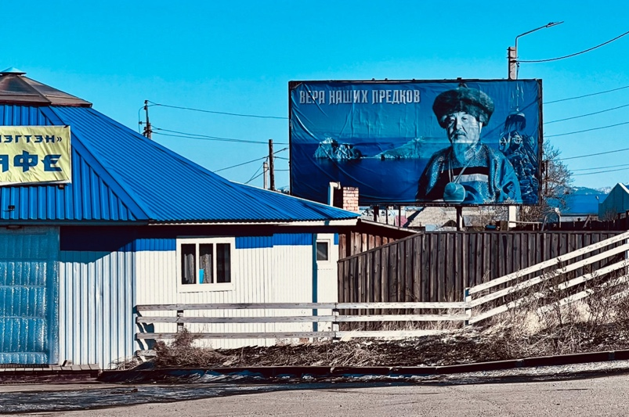
Figure 1. The picture of the Great Shaman on the entrance of the Tengri organization in Buryatia. Two images are positioned behind him: Lake Baikal, accompanied by the sacred rock, and a monument commemorating the divine rescue of Buryatia from fire. A substantial inscription in the corner of the image translates as ‘The faith of our ancestors.’ Photograph by the author.

I found this behaviour puzzling because there were numerous scholarly studies and debates on pollution in the sacred lake that were officially acknowledged by the Russian authorities themselves. The topic has even been extensively discussed by Russian activists, leading to the establishment of certain policies aimed at safeguarding the lake, a series of policies characterized by a tumultuous history.
The effort to establish these policies originates in the Soviet era, during which period omul and other fish were considered the lake’s communal resources, rather than being monopolized. In fact, emerging social organizations, such as fishing sovkhozy and kolkhozy, coupled with motorized boats and drift nets, altered predator–prey dynamics by enabling humans to extract substantial quantities of fish from the lake itself, rather than relying on fishing from the shore and waiting for fish. This altered the dynamics from predator–prey relationships to farmer–livestock interactions (Losey et al. 2008, Sukhodolov et al. 2021).
Furthermore, industrialization and pollution adversely affected fish populations in the 1950s, the Irkutsk Hydroelectric Dam serving as a principal factor by elevating Baikal’s average water level and submerging shallow spawning habitats, resulting in diminished fish yields. Moreover, some research demonstrates that global warming has exacerbated this vulnerability, endangering the population's limited aquatic habitat and territory. These conditions are also impacting lake pinnipeds, potentially resulting in the accumulation of organochlorines and heavy metals, which pose risks to both humans and ecosystems (Nakata et al. 1995, Iwata et al. 1995). Consequently, in the late 1960s, Soviet officials and scientists restricted all fishing activities in the lake to subsistence levels.
This prohibition continues, albeit with some modifications (Breyfogle 2013). As a result, the government emphasizes the preservation of Baikal and has issued Government Resolution of the Russian Federation N 435, amended by Resolution N 643 of 30 August 2001, which provides a list of prohibited activities or events within the central ecological zone (coastal strip) of Baikal’s natural hinterland:

1. Redevelopment of businesses without water-use management.
2. Provision of buildings and infrastructure for forestry, carpentry, pulp and paper, glass, porcelain, printing and construction materials.
3. Disposal and incineration of new hazardous wastes.
4. Illegal landfills.

The local population now abides by these rules, and the issue is no longer regarded as a secret in any way.
Obviously, however, just raising the issue of the sacred water being pathogenic generated widespread fear among the general public. I noticed this issue more prominently when one of my Buryat interviewees, who had a strong connection to Olkhon Island (renowned as the Mecca of shamanism), did not respond to my inquiries regarding the diseases he had witnessed surrounding the lake. Instead, he presented two images: he crafted a replica of Lake Baikal using seed shells and sent it to me, along with a note inscribed ‘the sacred lake before’ and ‘the sacred lake after’ (Figure 2). Suddenly, I became preoccupied with a question: What is the true cultural interpretation of the disease resulting from the lake’s pollution among those who avoid acknowledging or confronting it?

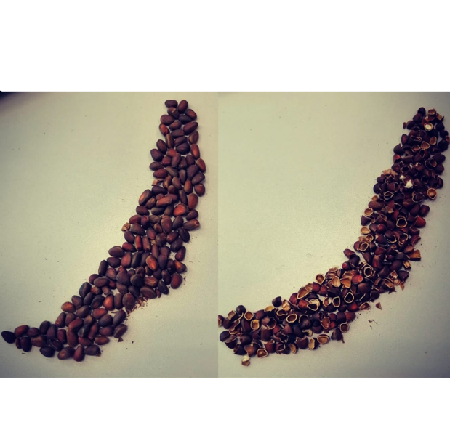
Figure 2. The interviewee created two depictions of the sacred lake, one before pollution (left) and one after (right), using seed shells, instead of providing responses to the questions.

Methodology: cognitive narratology

This study investigates the influence of the recognition of disease and the pathogenicity of the sacred lake on the Buryat community. The goal is to identify the underlying patterns that prevent the Buryat from confronting the issue.
I use cognitive narratology as a specific methodology for exploring these issues. This methodology was chosen because of a particular sociological pattern based on Peter Berger’s discussion in The Sacred Canopy (1967). According to Berger, a kind of order emerges when a specific world is created by the activities of human beings in an intertwined social and individual process he calls nomos. This order forms a normative universe in which a world of right and wrong, lawful and unlawful, valid and void, is constantly created and maintained (Cover 1982), so that actions are understandable only in relation to it. In traditional societies, the nature of nomos makes it dependent and defined on the basis of ‘religious expression’ (Berger 1967: 52). Reference to it in any form guarantees the predictability and stability of that particular society, thus maintaining a normative world standard. Religious expression is the criterion of ‘giving meaning’ to relationships and actions in the normative world. Consequently it is the main agent in shaping a definite and predictable future for the redemption of society.

However, although I draw generally on Berger’s nomos, for clarity and precision the scope of the definition of religious expression in this research is reduced to what Robert Cover (1982) recognizes as a ‘narrative’ that is inclusive of language and myth, leading to the creation of certain canons. In this account, the normative world stays on a definite and permanent path when the content and doctrines of narratives upon which that world is founded are preserved (ibid.: 4). What can cause narrative logic and structure to fail and thus disrupt nomos is called ‘anomie’. This breaks the bonds of the narratives on the basis of which actions find their meanings and, as a result, terror and chaos infiltrate all layers of society.
Adopting such a model to examine the Buryats' nature-based religious society reveals a pattern in which nomos is constructed according to the prevailing narratives of the region. Cognitive narratology was chosen as the methodology for this study because it serves as a transmedial basis for exploring the relationship between the narrative and the Buryats’ mind (Felodernik 1996).
This methodology involves ‘the study of aspects related to the mind in the act of storytelling’ and aims to construct a model of the human narrative mind’s functioning (Herman 2013). Its primary concerns are: a) the cognitive processes which lead to narrative understanding and that enable the reader (viewer or listener) to construct his or her own mental model from the world the story creates; and b) how narratives function as a means of creating meaning and as a way to structure and understand situations and events, thereby providing a framework for comprehending and interpreting the world. In this context, the process of meaning-making comprises two courses of actions: 1) constructing mental spaces; and 2) mapping relations between them. Identifying the narrative space by considering the two actions mentioned above represents the micro-level of cognitive analysis, which subsequently enables macro-level analysis through integration, ultimately resulting in the emerging story (Dancygier 2008, 2012).
Therefore, this methodology aims to elucidate the evolving narratives within Buryat society in order to portray the transition from nomos to anomie accurately. However, when discussing indigenous and nature-based societies, it is important to acknowledge that these societies prioritize ecology in their world views; that is, their ecology/nature/environment (their home) is considered a lived religion. As a result, the preservation of their normative world order is achieved through the narratives and myths that are associated with their distinct bioregion. That is why Robert Innes argues that academics must employ Indigenous narratives as theoretical frameworks to clarify the perspectives, cognitions and motivations of Indigenous populations. This approach is essential for gaining a deeper comprehension of their historical and current situations (2010). Hence, this study examines the prevalent narratives in Buryat society to uncover the disrupted order, rather than replicating them within existing frameworks.
In addition, the research utilized two approaches to data collection to characterize comprehensively the meaning of disease and healing prior to and following environmental changes, namely ethnography and media content analysis. In this regard, the optimal locations for participatory research and fieldwork concerning this issue were identified as Khuzhir on Olkhon Island and Ulan-Ude city in Buryatia, whose residents are called the Eastern and Western Buryats respectively (Figure 3). In this regard, the main stories of the sacred lake that make direct reference to the issue of healing were gathered, first, by examining books of folk and oral narratives pertaining to Baikal. The most important of these books were: Бурятские народные сказки )1973); Бурятские народные песни: песни хонгодоров (Фролова, 2002); Сказания бурят, записанные разными собирателями (1890); Сказки сибирских народов/Fairy-Tales of Siberian Folks (1992); Мифы бурят (Осиповн, 1980); Мифы и легенды о Байкале (Гудкова, 2019); Хозяин Ольхона. Байкальские сказки. Стародумов Василий Пантелеймонович (Стародумов, 2016); Девочка-лебедь и другие северные сказки (2017); Байкала-озера сказки (1988, 2 volumes).

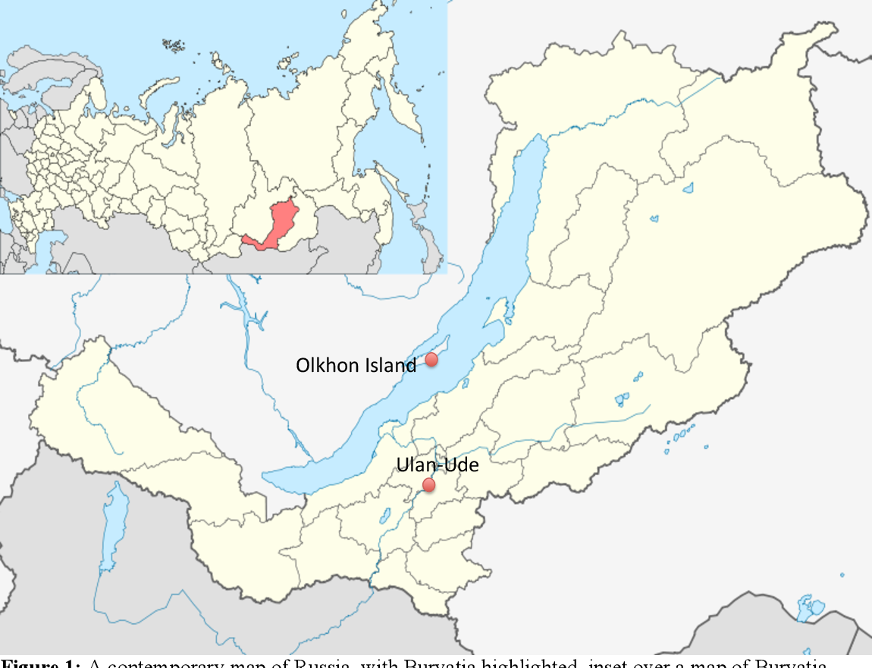
Figure 3. A modern map of Russia, featuring Buryatia highlighted, and showing Ulan-Ude and Olkhon Island, two geographical areas examined extensively in this paper.

Secondly, I evaluate the present prevalence of these stories and their cultural interpretation through in-depth and semi-structured interviews conducted with twenty ordinary shamanic–Buddhist Buryat in the region. Unlike the formal interviews referenced below, these interviewees were not chosen through prior planning. For instance, they were individuals with whom I embarked on brief excursions, employees of a restaurant I regularly patronized and, in certain instances, vendors or attendees at the residences of shamans or Buddhist temples during the ceremonies I attended. Upon categorizing the interviews and identifying those most pertinent to the research topic, I ended up with thirteen male interviewees and seven female.
Consequently, during the initial phase, ten narratives were selected from various books and collections. These choices were based on their repetition in books and interviews. Subsequently, four narratives that were particularly favoured by the Buryat community were picked. It is noteworthy that there was disagreement among them over whether the body of water being described in the narratives explicitly refers to Lake Baikal or other rivers and springs in this region. However, the majority of the interviewees believed that, irrespective of the particular characteristics of the bodies of water mentioned in the stories, there exists an inherent and significant association between Lake Baikal and the region’s bodies of water in the minds of the Buryat.
Furthermore, I conducted interviews with six shamans and energy healers, as well as sixteen lamas and specialists, in order to investigate the meaning of healing and its underlying objective.
Given the rise in reports of the lake’s deterioration, which is linked to the growing awareness of environmental issues in the current era, this study has been undertaken by analysing the media, which has a significant role in providing knowledge, manipulating memory and shaping a new social structure. Hence, a total of seven newspapers were scrutinized, including the following widely popular Russian publications: Argumenty i Fakty, Kom-somolskaya Pravda, Nezavisimaya Gazeta, Novaya Gazeta, Rossiyskaya Gazeta, and Izvestia and Lyudi Baikala (baikal-journal.ru). Important in the selection of media was their popularity ratings, regardless of their political, economic or social affiliations. Through these media, it was possible to trace the lake’s most often repeated and dominant images. Moreover, as different types of newspapers were examined, it is clear that almost all types of audience were represented. I researched the contents of newspapers published from 1 January 2015 to 1 January 2020. The research focused on these media’s images of Lake Baikal, regardless of the type of news or advertisement. Most of the newspaper content came from searching newspapers’ websites. A total of 135 pieces from newspapers were eligible for coding and analysis.

Research limitations

After extensive correspondence with the Department of Tibetan and Mongolian Studies at St. Petersburg University, I obtained permission to conduct research in Russia, specifically Siberia, for one year as a visiting researcher. Consequently, as the most effective method of acquiring objective information involved residing in the community and engaging directly with local religious organizations, I relocated to Ulan-Ude, Republic of Buryatia, with support from the dean of the Mongolian section of the Peter the Great Museum of Anthropology and Ethnography at St. Petersburg (Kunstkamera). Due to the Russo-Ukrainian war, working in the region was fraught with difficulty and danger, especially for a researcher from a Swiss university that had been blacklisted by the Russian government.
The main problem pertained to the robust affiliation between Buddhist and shamanist organizations and academic centres in the region and the Russian central government (Figure 4). The most illustrative example of this robust relationship with the central government is Ivolginsky Datsan (Иволгинский Дацан), where the lamas exhibit significant engagement with the Russian government’s political decisions in order to maintain their status as one of the four official religions of Russia, thereby safeguarding their authority. The emphasis on this relationship was so pronounced that this Datsan was the sole location in Buryatia to feature a large banner of Putin (Figure 5). Indeed, both Putin and Medvedev were bestowed with divine titles by a Grand Lama. The significance lies in the fact that, contrary to common belief, Buryatia is a religious republic not merely in appearance but also in mentality, which directly influences individuals' actions and interpretations of political and social events, as well as their subsequent adaptation of other perspectives. As a result, all matters pertaining to the war, even indirectly, rendered them circumspect in their responses.

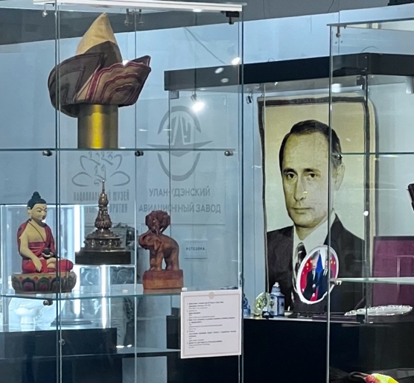
Figure 4. The National Museum of the Republic Buryatia’s History comprises two sections: socio-political history, and religion. This photograph encapsulates the history of the Republic of Buryatia, featuring a young Putin alongside the republic's Buddhist identity.
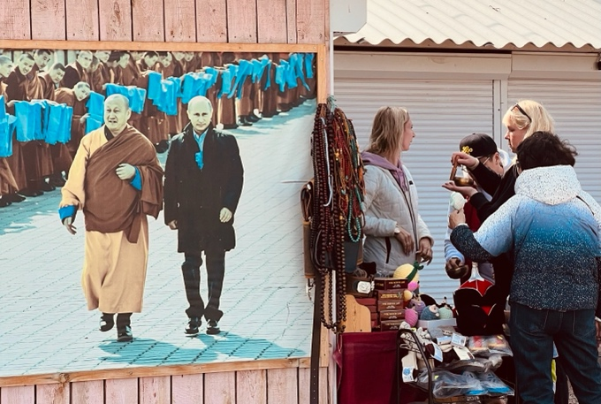
Figure 5. Banner commemorating Putin’s visit to Ivolginsky Datsan. Photograph by the author.

In addition, some specialists in Buryat culture, both at the National Museum of Buryatia and the university (though not all), declined to grant me an interview, despite direct communications from St. Petersburg University and the Konstantin Museum. The rejections of my requests exhibited a consistent theme, namely that when the war with Ukraine ends, they will greet me with open arms. Therefore, although I had written authorization to access the primary locations for my study, ethnographic research in those locations was somewhat intricate.

Background

The pathogenic nature of the water in Lake Baikal, situated in eastern Siberia and designated a UNESCO World Heritage Site in 1996, is a longstanding concern that originated approximately two decades ago, although the history of contamination extends even further back (Brown 2018, Weiner 1999). In this regard, two pathogenicity-related concerns have been identified at different levels, although they are aligned with each other within Buryat society:
First, a multitude of scientific publications in recent years, particularly since 2017, have demonstrated substantial alterations in the findings of prior research conducted in the early 2000s. Initial research has highlighted that the presence of pathogenic viruses and bacteria in surface water is negligible, and data on the fluctuation of enteroviruses throughout the year suggests that they are not present in Lake Baikal’s surface waters. This suggests that bacteria and virus particles have not accumulated in the Sacred Lake for an extended period of time (e.g., Maksimov et al. 2003). However, recent research focusing particularly on the southern region of the lake, a popular tourist destination, has documented the presence of bacteria on both the lake’s surface and bottom. This has resulted in widespread microbiological and hydrochemical pollution in various areas. Of particular concern is the detection of two hazardous and disease-causing bacteria, Enterococcus and E. coli, in the waters along the shore. These bacteria can lead to respiratory issues and bloodstream infections in both humans and animals (e.g., Pliska 2021, Zemskaya et al. 2020, Butina et al. 2019).
Secondly, through extensive interviews conducted with Buryat and Tibetan doctor-lamas in the ‌Baikal region (Figures 6 and 7), as well as traditional doctors in Ulan-Ude, a correlation has been established between the lake’s pollution and the presence of medicinal plants. Based on the findings of these doctors, who do field research in various natural sites around Baikal to gather medicinal plants, certain plants have ceased to grow due to the presence of pathogenic bacteria and the changing environment in the region, a problem that is progressively worsening each year. The significance of this stems from the coexistence of two distinct medical systems, namely the western medical system, which relies on compound drugs and chemicals, and the traditional medical systems rooted in Buddhist and Tibetan medicine.

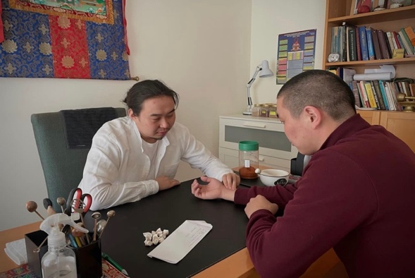

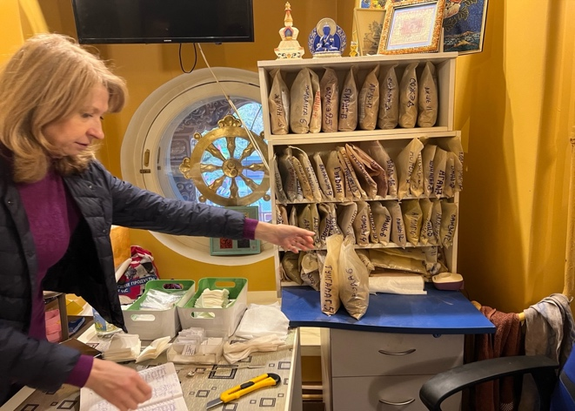
Figure 6. One of the interviewed doctor-lamas treating a lama in Ulan-Ude, Buryatia.
Figure 7. Classification of herbal remedies brought from Buryatia to the St. Petersburg Gunzechoyney Datsan. Photograph by the author.

This coexistence gives this region a profound historical significance. In fact, the traditional healing system in the Buryat region is primarily the responsibility of doctor-lamas, who promote Indo-Tibetan medicine as a vital element of Buddhist teachings and as a unique facet of the eastern heritage. According to the description of the Buddhist collection in the Museum of the History of Buryatia, this medicine flourished and developed in Transbaikalia during the mid-nineteenth century, being closely linked to the lamas. More precisely, Atsagatsky Datsan, situated in Buryatia, was the inaugural Buddhist medical institution in Russia, where the earliest texts on Tibetan medicine were produced.
Notably, in contrast to many regions globally, this traditional medicine did not arise in opposition to modern medicine but rather interacted with it from the beginning. Lamas in this traditional medical school had a professional interest in European medicine. In the early twentieth century, they made numerous visits to medical institutions and tackled many complex cases using traditional Tibetan methods, while simultaneously collaborating and sharing knowledge with various scientists and physicians throughout Russia.
This tradition of coexistence, which is fundamental to the medical school, endures in Buryatia as a strong tradition to this day. The traditional system, now with a modern appearance, is on a par with the western system, and individuals have confidence in it. Therefore, the ecological degradation of Lake Baikal and the ensuing scarcity of medicinal plants may adversely affect the long-term efficacy of the region’s secondary medical system, which is closely linked to the local population’s religious and philosophical beliefs.
Here, in relation to disease and pathogenesis, and drawing on comprehensive research conducted by anthropologists and historians specializing in infectious diseases, two overarching views have emerged. From an initial perspective, as pathogens are intricately connected to human social realms, comprehending social or cultural existence is crucial for understanding diseases. This means that, contrary to a purely biomedical perspective, it is insufficient to explain pathogenesis and infection solely through biology. Instead, one must take into account the cultural and social environments in which individuals reside (e.g., Barrett and Armelagos 2015, Singer 2014). The second perspective examines the sources of disease and contagion. It involves connecting the biological events that occur within the body to external social events, structural relationships and environmental conditions. It establishes a connection between these factors and the broader realm of economic and political forces that influence the incidence of disease. In other words, as Nancy Krieger (2021) explains in her Ecosocial theory, embodied truths, and the people’s health, disease often arises from factors such as discrimination, exploitation, injustice, prejudice and geographical factors and should not be considered a wholly natural phenomenon. (WHO 2008: 1)
Consequently, the majority of research focuses on either the impact of social and economic conditions on the understanding of diseases and their resulting suffering within the cultural context, or the interplay between biological and social factors in outbreaks of disease. However, in this region, the case shows itself from a different perspective, beyond the two approaches just mentioned. Here, the concept of disease has placed individuals in a challenging predicament when discussing their environment. Put simply, the question is how the emerging disease, as is widely reported in the media, is altering the cultural perceptions of the local population towards their sacred environment.
This issue is of particular significance within the realm of indigenous studies, as the concepts of ‘environment’ and ‘home’ fundamentally underpin the Buryats’ worldview. This nature-based worldview can be effectively summarized in terms of four principles: (1) Nature is considered the ‘other’, and everything within it is seen as ‘others’, rather than being viewed as absolute objects (Bahr 2004: 19). This implies that, drawing inspiration from Martin Buber’s philosophy (Buber 1970), the connection between Indigenous peoples and nature is founded on an ‘I-thou’ relationship, where both parties are subjects, as opposed to an ‘I-it’ relationship, where one is a subject and the other is an object. According to this correlation, it is believed that indigenous individuals attribute personhood to all entities and have a deep reverence for living beings, including plants and animals, considering them as equals to humans. (2) This helps us understand how these individuals have formed their beliefs and daily routines by engaging in a dialogue with the natural world: they are not familiar with the concept of monologue, which involves viewing the world as an object of experimentation. (3) According to this perspective, a culture of land has evolved as a unifying concept for Indigenous society, where identity and spirituality are shaped through the interaction between individuals and the land or nature. This approach places a strong emphasis on the well-being of the land and on water as a central focus. This perspective serves as the fundamental basis of the indigenous law that governs their communal existence. (4) Consequently, nature is perceived as an inherent right (Nelson 2017: 144) that serves as a foundational principle for establishing rules with incentives and penalties, rather than being a basis for advancing moral reasoning (Tucker and Grim 2017: 11).
Prior to moving forward, it is essential here to elucidate the term ‘nature-based’ in relation to religion and spirituality. This term is a general concept pertaining to indigenous religions, elaborated upon in my article ‘Transforming home: the religious heritage of Indigenous society in the age of environmental problems,’ published in Nature and Culture (2024). In summary, within the indigenous perspective, nature, regarded as a living heritage, is equivalent to home and worldview, serving as a foundation for cognition and delineating the unique spirituality of indigenous communities rooted in their respective bioregions. This does not merely signify the veneration of nature as the focal point of their religion and spirituality. Instead, it depends more on the notion that nature is viewed as a means and a pathway to attain the transcendent, in contrast to the Abrahamic religions, which are focused on events and history.
This issue is exemplified in Buryat shamanism through its principal symbol, the shamanic tree, which signifies the mental and subconscious journeys of the Buryat shaman. Upon examining the elements and symbols of this tree, it becomes evident that the indigenous fauna, specifically the seal and local otter of the Baikal region, are employed to access what is termed the ‘other reality’ for ancestral communication and the acquisition of healing remedies (Figure 8). Alternatively, consider the coat of arms of the Republic of Buryatia or the national arms which are associated with the imagery of nature and Baikal and elements of nature (Figures 9, 10 and 11). This means that the primary shamanic principle and peoples’ Buddhist identity are intrinsically linked to their particular region, which influences their spirituality accordingly.

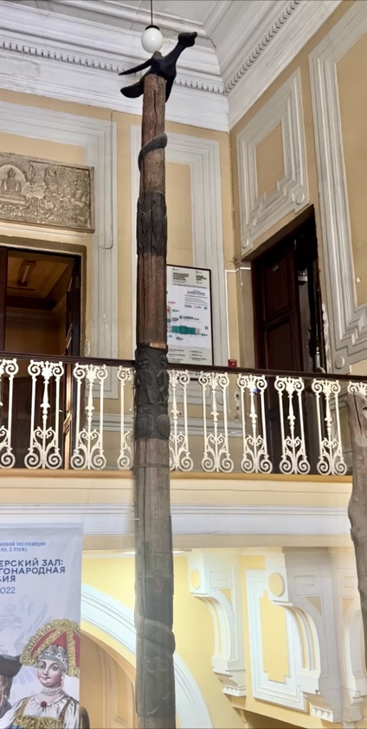
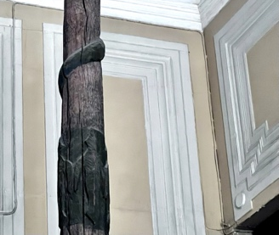
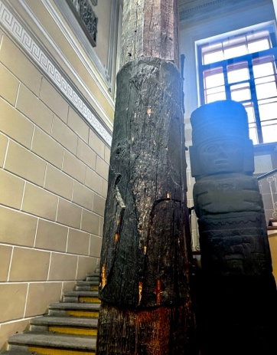
Figure 8. Buryat shamanic tree located at the Museum of Anthropology in St. Petersburg. This tree symbolizes the shaman’s transition from the mundane realm to another reality, accompanied by the animals that assist him/her on his/her journey. Native Baikal fauna, including Eurasian otter and seal, serve as the shaman’s aides on this expedition. Photographs by the author.

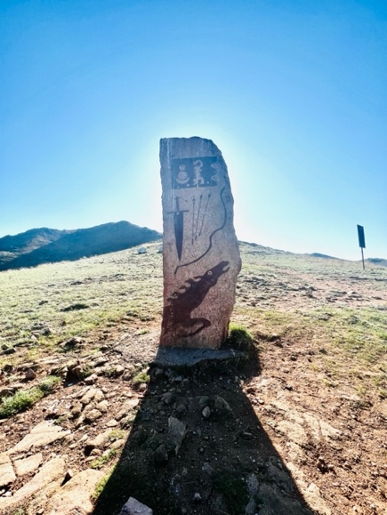

Figure 9 (left). The coat of arms of the Republic of Buryatia.
Figure 10 (middle). Moon, sun and fire emblem on a shamanic monument located in Buryatia, dating back ninety years.
Figure 11 (right). Tattoo of the moon, sun and fire on the neck of a young girl in Ulan-Ude, which she asserts symbolizes her identity. Photographs by the author.

Moreover, the article shows that that the introduction of other great religions or ideologies into an Indigenous region does not result in a singular dominant faith, but rather fosters an eclectic spirituality among the local population that preserves its indigenous essence. This applies equally to the predominant Buddhism in this region; this means that, while the Buryats engage with an international Buddhism that is characterized by clear doctrines at the government level, Buddhism in its pure form is not widespread among the Buryat.
After elucidating this study’s interpretation of the term ‘nature-based’, it is important to acknowledge that each culture has a unique perception of nature. The Buryats' understanding of nature is based on the term Baigali (байгал/ᠪᠠᠶᠢᠭᠠᠯᠢ in traditional Mongolian script), which they share with the Mongolian language. It has a linguistic connection with Lake Baikal and, as Caroline Humphrey (1999) argues, is closely associated with the term ‘baidal’, which signifies the state of existence or the way things are. Moreover, in this context, the myths of this region, in contrast to the western tradition that highlights the human stewardship of nature, portray humanity as descending from the Earth Mother and nature (Baigali), both revered as powerful forces that offer maternal protection to humans.
What is crucial here is to recognize that, fundamentally, the Baigali concept of nature includes humans, unlike the western tradition that separates between humans and nature. Essentially, humans are fundamental to the interactive system of nature, the western concept of which is aligned not with Baigali but with опчин in the Buryat language, signifying an environment devoid of human presence. As a result, the issue of the contamination and pathogenicity of nature itself, intertwined with the religious doctrines of indigenous peoples, can pose a significant challenge for them and generate a situation that lacks clarity.
Here, there is one important issue that needs to be clarified alongside this eclecticism, namely the meaning of the phrase ‘Buryat religion’.
On this subject, Buddhist interactions commenced in the sixteenth and seventeenth centuries prior to the establishment of the Russian Empire and proliferated rapidly upon the Empire’s arrival in the early eighteenth century among residents of the Selenga River in the east. In the mid-eighteenth century, Buryatia was home to eleven Russian monasteries and 150 monks, and its lamas were granted tax and duty exemptions under the Empress Elizaveta Petrovna (1983: 17). In this regard, Russian authorities who sought to regulate Buryat religious engagement internationally to bolster its Asian influence established a Buryatian Sangha endorsing Buryat beliefs. Moreover, since Moscow favoured a single Khambo Lama, numerous monasteries were faced with centralization. As a result, the Khambo Lama and the central government have consistently maintained a close association throughout Russian history.
During the Golden Age of Buddhism in Buryatia, specifically in the late nineteenth and early twentieth centuries, there was a significant proliferation of monasteries and a substantial influx of Buddhist literature and art into the region. However, they were introduced in a manner that was distinct from similar changes in Mongolia and Tibet. This mean that Buryats acquired Tibetan and Mongolian canonical texts but did not disseminate them because they wanted to modernize Buddhism in literature. They possessed greater knowledge of science, geography, cultures and the world than the so-called medieval Tibetans (Tsyrempilov 2021).
Despite the persecution and repression during the communist era from 1920 to 1980, Buryat Buddhism persisted in its practice of distinguishing itself from Tibetan Buddhism. In fact, Buryat ethno-nationalists, who have frequently sought to minimize the Buryats’ global connections and define their Buddhism as a 'Buryat' religion, rely on two archaeological pieces of evidence to prove their claim:
1) The 2002 exhumation of Dashi-Dorji Itigelov (1852-1927), the 12th Khambo Lama of the Buryats. In Buryat society, the preservation of his body is deemed to be a miracle, since it has remained in the lotus position for a whole century without decomposing. The controversy involving this Buryat lama prompted Buryat commentators to assert that they did not require foreign (Tibetan and Indian) lamas, as Dashi-Dorji Itigelov himself consistently refused to abandon his homeland, even amidst widespread violence and carnage.
2) Another significant Buddhist event was the 2002–2004 discovery of 450 Buddha statues in proximity to the ruins of Aninsk monastery. A substantial stone from the Barguzin Valley discovered in 2005 depicted Yanzhima (Sarasvati) in a dancing pose. This discovery was understood to signify that Buddhism arrived in Buryatia directly from India rather than through Tibet (Dugarova 2023).
Similar to Buddhism, Buryat shamanism has experienced modernization while preserving its traditional and ancient roots. This means that, after enduring suppression during the Soviet era, when shamanism was regarded as a vestige of primitive society, sacred sites were rehabilitated and communal ceremonies resumed in the late 1980s. During this period, shamanistic organizations were officially founded. Since the 1990s, various official shamanic organizations have emerged in Buryatia, including Böö mürgel, Lusad, Tengeri and Khukhë Munkhe Tengeri. These organizations seek to validate shamanic practices, safeguard cultural heritage and protect sacred sites by designating them as culturally significant territories.
However, shamanism has always been under pressure, not only from the repression of the former government, but also from Buddhism in the region. For example, Buddhism, which was established in Western Buryatia in the late nineteenth century, reinterpreted indigenous shamanic deities and sacred sites, and burnt shamans’ ritual artifacts and garments (Sabirov 2012). Nevertheless, these encounters were not always violent. In numerous locations, the Buryat adopted significant shamanic rituals, clan guardian cults and ethnic group protectors, and reformed some violent shamanic rituals.
Today, this situation has improved with the emergence of the so-called ‘shamanic intelligentsia’. In contrast to previous generations, numerous contemporary Buryat shamans have acquired a formal education, frequently in the humanities and social sciences, and have acquired professional experience in urban institutions. This shamanic intelligentsia engages in publishing books, contributing to documentaries and utilizing public platforms to disseminate shamanic perspectives. These practices, however, diverge from classical shamanism, which discouraged public self-promotion and mobility beyond local communities. Natalia L. Zhukovskaya (2018) considers the notion of a ‘shamanic intelligentsia’ as an innovative phenomenon of post-Soviet Russia that merged spiritual traditions with contemporary intellectual life.
Furthermore, a concern that has arisen with the emergence of new intellectuals pertains to environmental and ecological issues. Buryat shamanism serves not only as a spiritual practice, but also as an ecological and cultural safeguard. In this context, collaboration with scholars and ecologists has been one of the primary tasks, particularly by participating in scientific conferences, collaborating with ethnographers and engaging in ecological activism. For instance, shamans were instrumental in preserving the sacred landscapes of Tunkinsky National Park during the 2002 conflict with the oil company Yukos, whose activities jeopardized local ecosystems and cultural sites. Also, shamans may conduct traditional annual rituals to call on local spirits to protect these lands.
As a result, shamans’ rituals and community leadership serve as a cultural manifestation of environmental activism, safeguarding sacred sites by designating them as protected territories to avert their degradation by present-day industries. This approach guarantees cultural-ecological continuity, emphasizes a worldview in which humans, nature and spirits are interconnected, and maintains that respectful relationships with nature are deemed essential for community well-being.

Old image: great forbidden zone

The Buryats residing near the shores of Lake Baikal consist of four primary clans (historically Ulus/Улус, modern Buleg/бүлэг): the Bulagats, the Ekirites, the Khoris and the Khungodors, each named after their legendary ancestors. They have been in the Baikal region since ancient times, and their name (Buriyad) was initially recorded in The Secret History of the Mongols (Haenisch 1948: 112), a distinctive piece of Mongolian literature from the thirteenth century that focuses on the life of Genghis Khan. Within the text, they are referred to as a group of indigenous people residing in the forest who were subjugated by one of the sons of Genghis, Jochi.
There are numerous legends surrounding Baikal, primarily due to the connection between the lake and Tengri, the deity of heaven and sky, in the shamanistic mythology of the Mongol people. Certain members of the Buryat community regard Tengri as a living god who knows everything about the Buryats and actively protects them.
However, there has also been a long-standing silence regarding certain aspects of Baikal that have persisted in the region for centuries and can be traced back to the era of Genghis Khan, when the initial regulations for managing the lake may possibly have been established in a unique way.
In this regard, during the thirteenth century, when Mongols occupied the medieval state of ‘Rus’, Genghis Khan designated the area surrounding Малое Море (Small Sea), which is located between Olkhon Island and the northwest coast of Baikal, as the ‘Great Forbidden Zone’. According to legends, this area was believed to be the birthplace of Genghis Khan, and all actions that might jeopardize the purity and aesthetic appeal of the lake within this area were strictly forbidden. This included the use of Baikal’s resources for commercial activities such as hunting and fishing, as well as any presence on the lake’s beaches.
Even the Russian Cossacks, who arrived three centuries later in the sixteenth century, found Baikal to be a remarkably uninhabited area. This would be easy to comprehend if the location were either arid or swampy, abundant with vegetation or with shifting sands. However, the site had exceptional grazing areas for livestock and fertile soil for cultivation, and the Buryats inhabited the adjacent regions, while the neighbouring territories were exploited by pastoralists. This was not the result of chance or coincidence, as the Mongolian rulers established a ban on individuals living in and sharing information about this area of Baikal. Violating this restriction resulted in severe punishments for the offenders. Furthermore, in accordance with Genghis Khan’s rule, individuals who contaminated the lake, rivers or springs that fed into it were subject to capital punishment (Korsgard 2013).
These laws clearly demonstrate that during Genghis Khan’s time, Baikal had significance beyond being a source of livelihood and was regarded as both sacred and taboo (цээр), with the mystical power of mana. This perception of Baikal has driven it for centuries to possess potent, efficient, fruitful, exhilarating and terrifying energy and to manifest itself not only as a physical entity, but also as a psychological phenomenon with paternal power. When dealing with such immense power, therefore, taboos on access and close contact seemed essential for creating a regulatory structure.
However, despite subsequent adjustments to the regulations governing the exploitation of the lake and the establishment of an economic tie between the Buryat community and Baikal, the sacredness of the lake is still maintained, with reliance on the economy of mana. This economy, based on the indigenous perspective on wealth, embraces a diverse range of dimensions that extend beyond either mere monetary or financial considerations or the available accumulated assets. According to Pio and Waddock (2020), Indigenous communities frequently hold their own views on wealth, prioritizing values such as relationships, responsibility and shared well-being. This implies that the measurement of wealth extends beyond material possessions to include the preservation of cultural heritage, traditional knowledge and sustainable practices. More precisely, Indigenous wealth is closely linked with the land, resources and environment, rather than being viewed solely as a static entity or objective place. These elements are regarded as valuable assets that contribute dramatically to the community’s holistic welfare (Thompson et al. 2013).
In addition, Indigenous economies are structured in a manner that emphasizes the distribution and circulation of wealth, rather than its accumulation, as a means to uphold intergenerational well-being and to transfer knowledge and wisdom to younger generations, which is strongly tied to the land. In this regard, the notion of an ‘economy of mana’ underscores the significance of assessing value based on the quantity that flows through an individual’s possession, rather than the amount that is amassed (Vunibola et al. 2022). Therefore, the bioregion’s health holds a crucial place in Indigenous peoples’ worldviews, as it refers to both cultural and economic value, thereby influencing how they perceive and react to the external world.
Regarding the Buryats, their appreciation for this economic model is manifest in their annual rituals dedicated to the water deities, conducting communal rituals and sacrifices to venerate them (Ukhan Khats). These ceremonies are frequently aligned with seasonal occurrences or fishing periods. One of the seasonal rituals involves certain clans performing sacrifices in early August in accordance with Orthodox traditions such as Elijah’s Day. Others perform rituals in autumn, winter, or mid-May prior to the fishing season, thus highlighting the economic significance of fishing. Offerings constitute another significant aspect, with sacrificial items such as livestock, milk and airag (fermented milk) playing a vital role. In this context, fried fish serves as a customary offering, representing reverence and appreciation towards the water spirits. Ultimately, fishing rituals are upheld. Prior to fishing, fishermen performed rituals such as Sasali (‘sprinkling’), in which they present milk-based beverages to the spirit-owner of Lake Baikal to safeguard the lake and supply plentiful catches.
Consequently, Baikal has become integral to Buryat culture, primarily owing to its importance in sacred economy and Tengri teachings, and it is prominently depicted on the Republic of Buryatia’s coat of arms, which consists of a symbolic representation of the moon, sun and fire reflected on the surface of Lake Baikal (Figure 9).
In spite of that, the primary attribute of the sacred lake in the perception of the Buryat, irrespective of their proximity to or distance from the lake, and regardless of their individual religious beliefs, is effectively conveyed through the national anthem of the republic:
‘My motherland, accept the gratitude of your sons; treat us with the sacred water of Baikal; and grant us the strength to endure this arduous journey.’
This part of the anthem should be understood in the context of the Buryats’ shamanic–Buddhist culture, in which the act of offering a sacred liquid or drink is linked to the idea of healing. That means, based on the conducted interviews, that it indirectly alludes to the curative abilities of Baikal in the minds of the Buryat people. But what is the precise definition of healing and cure in this region?
On this subject, when seeking a perspective on the meaning of healing, the primary and crucial source to consult is Buryat stories. Put simply, when looking at Baikal, it is important to view it not just as a source of ecological data, but also as a repository of narratives. By examining these narratives, one can uncover the underlying patterns of the past, independent of the specific events that occurred, and establish a connection between the normative patterns of the past and the conceptual meaning of the present.

- The strong winds in the North Sea prevent an immigrant seagull from returning to its group. She makes numerous attempts to soar over the sky and reach her distant home, but all she achieves is a series of falls. She starts crying uncontrollably and making weird, soul-crushing noises, desperate to get back. But she is unaware that the villagers there view the cries of seagulls as ominous and an indication of impending tragedy, based on long-standing customs. Because of his concern for the impending calamity, the village hunter pulls out his hunting rifle and shoots the weeping bird that is looking for her home. The defenceless bird died as it fell from the sky. When the hunter, who is drawing near the corpse, notices a tear in the corner of the bird’s eye, his heart begins to hurt, and he feels regret. He hugs the dead body, heading to a spring near Baikal, whose water gives ‘life’. This spring is connected by subterranean water to the [frozen] Northern Ocean, which is the seagull’s home. The bird is healed from death by the spring water, which also gives her the power she needs to withstand the strong winds and return to her home in the North Sea.
- A woman has one daughter and two sons. The girl is taken home by a snake that kidnaps her one day in the woods. When the girl’s brothers go to the snake’s cave to try to save their sister, the reptile locks them in behind a large rock. The woman ages throughout the years without being able to get pregnant with any more children. However, one day the lake brings a pea seed to the shore close to the elderly woman. After eating it, she gets pregnant and gives birth to a son. After growing up, the boy takes part in the snake war and succeeds in saving his sister; however, when he goes to find his brothers, he finds them dead beneath a stone. He carries their corpses to the lake and uses the water of life to bring back his brothers. In the end, after many years, they all go back to the old woman’s home and reassemble as a family.
- A hunter pursues a strange bird he sees on a tree. When a malicious shaman sees him, he tells him this bird’s liver causes enormous suffering: ‘Eat this bird’s meat, but save the liver for me.’ He wants to access the bird’s powerful liver this way. But, while their father sleeps, the hunter’s son and daughter accidentally eat its liver. After discovering that his two kids have eaten the liver, the shaman grows furious and demands their livers. After hearing it, the girl alerts her brother, and they flee. For revenge, the shaman chases the girl for years. After many difficulties, the girl marries the ruler’s son, and when he has a son, the shaman disguises himself as a nurse and visits the ruler’s home. He murders the child by pretending she did it. Her body ridden with injuries, the girl is sitting on the lake when she suddenly witnesses a miracle. One worm kills another and drags it into the water. Abruptly, the lifeless worm begins to move. After realizing that the water heals when she dips her hand in it, the girl uses the water to cure her eye and the rest of her body. She also submerges her dead baby in the water, and he too comes back to life. Now healed, she is able to return to her husband, tell everyone about the shaman’s scheme, and reunite her current and former families.
- A quiet boy who is always in nature meditating, as opposed to others who were searching for a nice herd, a wife and land, decides to go after Burkhan, whose palace is located on Baikal’s shore. He passes through three lands. In each of these lands, those who discover the intention of his journey make a request to him: ‘If you see Burkhan, ask him to help us.’ The first one seeks to heal a mute girl; the second to restore the river’s flow and end the drought; and the third, a fish that had lost its ability to swim, seeks to restore it. Upon arriving at Baikal’s Burkhan Palace, the boy makes those three requests. Burkhan first heals the girl, who is mute. His next action is to replenish the dried-up river, bringing the area back to life. And finally, he restore the fish’s innate ability to return to its life philosophy, which had been forgotten.

The resulting system pertaining to Baikal, derived from extracting the primary motifs of the narratives, might be summarized as follows: 1) it revives animals; 2) it causes fertility in humans; 3) it gives life-giving and healing abilities to injured bodies; 4) it is the reviver of the natural world and of inherent skills for life. In short, the concept of cure with regard to Baikal can be understood through the aspects of revival (physical and skill), healing and fertility. Nevertheless, it is crucial to highlight that these concepts extend beyond the individual and serve a larger purpose, specifically the restoration of a wounded or suffering entity: (1) reviving in order to reunite with the members of the group, with a strong focus on returning to the homeland; (2) pregnancy and revival serve as a means to restore the lost family unit; (3) healing and revival are employed to rebuild both the previous and current family, while also revealing the truth; (4) the processes of revitalization and healing are proposed as a solution to address the issues in society. This involves the healing of muteness, removing drought and restoring existential skills.
Notably, there is an intricate and captivating overlap between these four themes and the prominent divine shamanic and Buddhist systems of the region, where healing and cure are central. According to explanations provided by two Tengri shamans in Ulan Ude (prior to the ban on my entry), who clarified the content of the posters displayed on the organization’s walls to me, healing and cure can be observed within the shamanic system, particularly through its two primary ideas:
1) The white elder, who is revered by the Buryat-Mongolian people as the protector of life, longevity and family. He is also a prominent symbol of fertility and prosperity in the region. In Buryat iconography, he is commonly portrayed as an elderly man with a lengthy white beard, holding a rosary (arkhi) and a stick adorned with a dragon’s head. He appears to be sitting next to a peach tree with a stag and a deer by his side. Within the Buryat tradition, he is associated with the belief system that provides assistance to patients and the underprivileged (Figure 12).

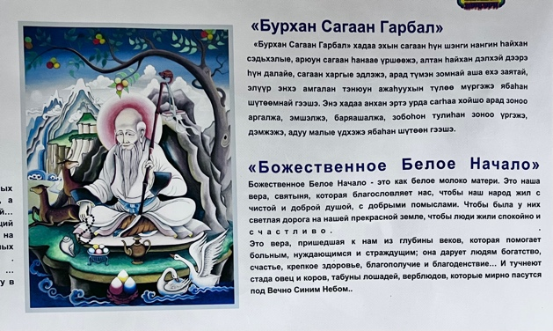
Figure 12. A poster displaying the White Elder’s responsibilities in both the Russian and Buryat languages is prominently displayed on one of the walls of the Tengri Organization (Assembly of Shamans) in Ulan-Ude. Photograph by the author.

2) The thirteen northern ‘Noyons’ or ‘Khatufs’ play an important role in the Baikal region’s system of gods and are considered to be the descendants of 99 Tengri, under the leadership of the eternal blue sky. Here, according to the doctrine and plan of Esege Malan Tengeri, God the Creator and the 99 Tengris, the earth was intricately woven. Thirteen Noyons (sons of God), righteous heroes and khans, were summoned by the Fathers (Tengris) to undertake a paramount mission: to descend from heaven to earth along with their wives, to procreate the Buryat-Mongol people, to safeguard them and to ensure their eternal survival. Thirteen celestial khans carried out the mandate of the Tengris. They selected the revered Lake Baikal as their terrestrial residence, establishing themselves along its banks and founded the Buryat people. They support every inhabitant of Siberia and the Far East, irrespective of nationality and religion, as well as being the protectors of the homeland and the sacred Lake Baikal.
Furthermore, they are thought to guide individuals in tracing their genealogies and histories, establishing a connection with the spirits of their ancestors and forebearers. The fundamental aspect of these thirteen Noyons is that their presence around Baikal safeguards people from disease, difficulties and misfortunes, while bestowing upon them physical, mental and spiritual fortitude, as well as endurance. They also protect Mother Earth and the animal kingdom. The prevailing belief among the residents near the lake is that these Noyons facilitate a connection to superior deities who alleviate all forms of ‘sickness and suffering’ (Figure 13).

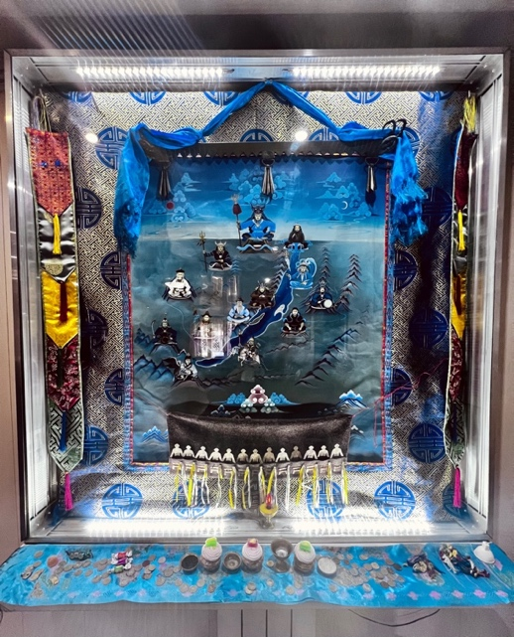
Figure 13. Thirteen Noyons have gathered around Lake Baikal with the purpose of safeguarding the local population against diseases and problems. Tengri Organization in Ulan-Ude. Photograph by the author.

Additionally, the symbolic use of these Noyons and gods is prevalent in water-related shamanic rituals around Lake Baikal, particularly the Predbaikal Buryat, who reside nearby. In this regard, a ritual called Ukhan Budlya (cleansing water) entails invoking the protection of mythical entities such as ‘youths resembling reeds’ and ‘maidens like mushrooms’ to safeguard the health of infants. An additional ritual, Ukhan Tarim (water incantation), is conducted to cure the ill, invoking help from celestial blacksmiths referred to as the ‘White Western Ones’. These rituals frequently employ consecrated Baikal water infused with Siberian juniper and thyme leaves. This water is dispersed or administered with a herb or reed broom for the purposes of blessings and healing. The essential point here is how this idea of healing works among the people.
The crucial aspect to consider is that shamans serve as the main agents between this idea and individuals, relying on their own philosophy and methods. According to one of the interviewees, who was a Buryat energy healer (Figures 14 and 15), the term ‘shaman’ in Buryati originates from a word that signifies the act of removing evil forces from an individual in order to safeguard and restore his or her health, similar to the process of vomiting. This means that, when an individual vomits, all evil and pathogenic substances will be expelled from his or her body.
However, when addressing this pollution and evil, it is necessary to realize that, within the shamanic healing framework, healing encompasses more than just the current moment. In this context, an individual’s existence is viewed as a written book that the shaman reads by dipping into the energy pole of ‘another reality’, where the past, present and future gather together; that is, the cure of a person’s disease takes into account their own life and the lives of their ancestors, based on the divine system and the significance of genealogy. Furthermore, due to the coexistence of Buddhist ideas and shamanism in this region, the entirety of one’s existence encompasses all his or her reincarnations as well. As she emphasized, ‘They (shamans) read thoughts, they can see into the future, and they see a person’s life completely; it depends on his or her age and the number of rebirths.’
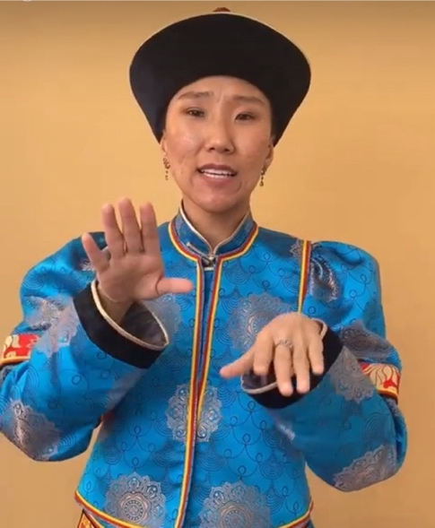
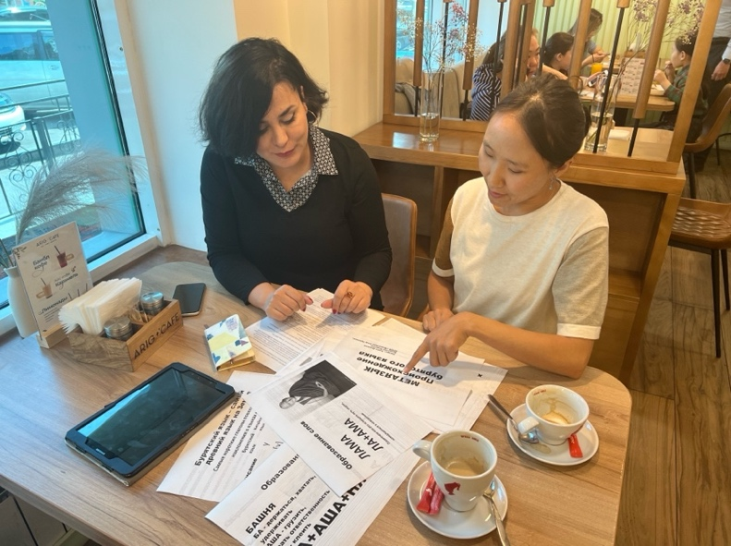
Figures 14 and 15. An energy healer from the Buryat community is elucidating certain terms in the Buryat language to me.

This concept of healing in Buryat shamanism, as also demonstrated by Manduhai Buyandelgeryan’s research (2007), includes a broader and more nuanced perspective so that it extends to addressing the past traumas experienced by individuals. She shows that Buryat shamanic therapeutic practices encompass not only individual healing, but also the restoration of society and historical reconstruction. This can be seen as a form of reconstructing the past following the suppression of religion and political violence during the socialist era, which signifies the communal enhancement and revitalization of cultural heritage.
Additionally, the Buddhist culture in the area reinforces this concept of healing and its associated connotations by incorporating these themes into its teachings, though it does so using a more intricate and dynamic philosophical approach that emphasizes the significance of family bonds and methods for reducing suffering. Cure in this context embraces a holistic approach that extends beyond the personal and physical dimensions to encompass the spiritual and cultural aspects. It not only includes an individual’s mental and physical health, but also addresses the broader social and spiritual balance, emphasizing the interplay between an individual’s health and their connection to society and the spiritual realm (Zhanaev 2022).
Thus, it is evident that all four themes in the stories pertaining to Baikal and their objectives are a direct reflection of the characteristics associated with the role of gods and religious beliefs in addressing the concept of healing. This image of Baikal, which has been deeply ingrained in the Buryat religious ideology for many generations, provided the indigenous community with a framework in which to view and regard the sacred lake as a fundamental aspect of health. The crucial matter here is that this perception established a standard of behaviour upon which specific sets of values and anti-values were delineated. Put simply, health was regarded as a value, while anything that the sacred lake inherently opposed in the narratives, such as death, illness and infertility, was deemed an anti-value, representing the negative outcomes of a lack of health.

New image: the pathogenicity of sacred water

The topic of pollution in Lake Baikal has garnered significant attention from journalists, literary writers and activists throughout the years. They have emphasized that ecological issues will have a direct impact on people’s daily lives and threaten the meaning of the lake-bioregion as a home (Chivilikhin 1963, Rasputin et al. 1989). Their idea was deeply interconnected with an uncertain future and unfamiliar relationships, and it highlighted the potential for the lake to undergo undesirable changes in the future (e.g., as discussed in Rasputin et al. 1989).
However, since 2006, this situation has become less pronounced, as Russia’s relations with international environmental organizations have deteriorated and nearly ceased due to the Russian authorities’ perception of international interference in a domain that is considered a matter of national security. From the government's viewpoint, the outcry from these foreign environmental organizations has engendered scepticism regarding the government’s dedication to safeguarding the environment, which is intrinsically linked to national identity, potentially fostering a basis for social unrest. Consequently, throughout this period, the majority of the news focused on the lake’s aesthetic appeal and opportunities for exploration, presenting any issues as resolvable. Even after 2010, the media heavily promoted the lake for commercial and touristic reasons while also suppressing the release of negative news about it.
Surprisingly, from 2015 to 2017, there was an unusual focus on the lake’s challenges, accompanied by a critical stance towards the government. This raised the question of the purpose of Lake Baikal: is it to serve as the world’s largest reservoir of pure water or as a tourist attraction? The prevailing narrative emphasizes the necessity of safeguarding Baikal from over-exploitation, highlighting that this sacred bioregion and the real scientific understanding of it have fallen victim to administrative and financial misconceptions. Newspapers adopt two approaches in this context: 1) utilize the lake extensively for maximum benefit; and 2) acquire comprehensive knowledge regarding the life-cycle of Lake Baikal to safeguard it from over-exploitation or potential destruction. The crucial aspect here is that the perception of ‘Baikal as an inexhaustible resource’ is nearly diminishing during this time. Indeed, the ‘insolent civilization’ is believed to have placed Baikal in a state of ecological emergency. On this subject, the media’s focus on the issue of rescue culminated in an emphasis on three intertwined factors: 1) a decrease in the lake’s water level; 2) the tourism boom; and 3) fish and seal mortality.
In this regard, the lake’s water level is declining due to Mongolia’s construction of dams on the rivers that feed into Baikal, along with power plants and dams in Irkutsk province. These years have seen a proliferation of expert discussions and managerial disputes in the media about this issue, particularly regarding the conflict between the Republic of Buryatia and the Irkutsk Oblast. The media have persistently investigated who profits from the scarcity of water and whether a truly critical threshold exists. In fact, initial alarming reports regarding the reduced depth of Lake Baikal emerged in the adjacent region of Buryatia and in residents’ fears of the extensive desiccation of wells because of the reduction in the lake’s water level.
During a public meeting held on 12 January 2015, President Vyacheslav Nagovitsyn instructed the Minister of Natural Resources to examine media allegations about the depletion of water in coastal wells, the occurrence of fires in peat bogs and the decline of fish populations in the Selenga, among other issues. The leader of Buryatia attributed this specifically to the declining water level of Lake Baikal, holding the hydroelectric power plants in the Angara region responsible for allegedly draining the lake’s water. The Buryat authorities dispatched a communication to Yuri Chaika, the Prosecutor General of the Russian Federation, regarding the ‘catastrophic consequences for the lake’s ecosystem’. In this context, Alexander Lebov, Deputy Minister of Natural Resources of Buryatia, informed the media: ‘If Baikal’s water level falls below the critical threshold, approximately 27,000 residents lacking access to a centralized water supply may face water scarcity.’
Nevertheless, scientists in Irkutsk contended that the problem of shortages of water was intentionally overstated by certain individuals. Valery Sinyukovich, a prominent expert at the Institute of Limnology SB RAS, provided a commentary on the situation: ‘The establishment of a hydroelectric power station will enable people to manage the water flow in the lake, taking their interests into account while conserving nature.’
The prevailing narrative pertains to the response of the Russian government, which instituted a high alert in the Irkutsk region and Buryatia owing to the critically low water levels in the lake. The media consistently asserts that the issues affecting the lake are caused by humans, noting that Lake Baikal’s water level has decreased by 40 cm, representing 68 percent of its normal capacity, and it predicts a further decline in fish populations compared to previous years. The groundwater level is declining significantly as well, potentially severing the water supply to populated regions. This is attributed to the Angara River, the sole outlet of Lake Baikal, which has also been reduced in depth, jeopardizing urban operations.
However, water scarcity is not the sole issue facing Lake Baikal, and it may not even be the most severe one. Experts from the Russian Academy of Sciences indicate that water scarcity results in alterations in pollutant concentrations and a reduction in mineral flows, potentially impacting production processes and the stability of the lake’s water column (Sorokovikova et al. 2010). This has serious consequences for the ecological condition and evolutionary dynamics of the organisms residing in Lake Baikal, disturbing the millennia-old equilibrium of its system. The result of this situation is the proliferation of harmful and potentially lethal Spirogyra algae in the lake, which now occupies nearly 60% of the Baikal’s shoreline. This stems from the release of untreated sewage from villages, augmented by phosphate-rich detergents, introducing phosphorus levels two to five times greater than those from human faeces, combined with laundry detergent, into the lake. The phosphorus influx into aquatic environments accelerates algal growth, thereby disturbing the natural ecosystem.
This is the point at which the discourse surrounding detergents and algae is amplified in the media and where the production of algae has placed the lake on the brink of an environmental catastrophe. This sensitivity extends to the degree that interpretations, resolutions and even prohibitions on the importation of detergents into Baikal are reported in newspapers. In a report, the Ministry of Natural Resources and the Government of the Irkutsk Region stressed that they are conducting extensive scientific research to evaluate the effects of phosphate-containing detergents on the lake’s ecosystem.
The crucial aspect is that, in contrast to earlier times, it is claimed that a cleaning system for Baikal cannot be established within one or two years, and as Mikhail Alexandrovich Grachev states in an interview with Rossiyaskaya Gazeta (2017.05.12), the evil spirits generated by worsening sanitary conditions at the shoreline will persist in the lake. These images have constructed a broader narrative, accompanied by dramatic headlines and exaggerated forecasts in media portrayals, consistently suggesting that the lake is either vanishing or being transformed into a vast swamp, an uninhabitable lake devoid of non-human species. Alexandrovich further characterizes this situation as follows: ‘Baikal has never faced such a perilous assault in its history. Scientific discoveries have indicated the emergence of toxic specimens, particularly among blue-green algae (...).’ One significant outcome of these conditions in the scientific literature is the disruption of the food chain in Lake Baikal, impacting fish and seals.
Conversely, some contend that these losses occur intermittently in the lake as part of a repetitive and cyclical pattern (Fagel et al. 2006). In this context, according to the remarks of the head of the Institute of Siberian Studies in the media:

Scientists, while investigating the causes of the mass mortality of Baikal seals (nerpa) during 1987-1988, established the potential for these animals to be infected with morbilliviruses (canine distemper), despite the initial ambiguity regarding the cause. In fact, in 1987-1988, approximately 6,000 animals perished. Initially, they attributed the blame to the Baikal Paper Mill, followed by general pollution. Ultimately, through molecular biology over a span of six months, they successfully demonstrated that these seals were afflicted with canine distemper. Pinnipeds were not previously impacted by this morbillivirus. The epidemic has ceased, and a layer of immunity has emerged. So far, divine mercy has prevented a recurrence. This marked the inaugural extensive alteration in Lake Baikal documented in the scientific literature. The task was arduous yet fruitful for the entire team.

However, the account of widespread fish and seal fatalities, coupled with the devastation of underwater coral reefs, was frequently depicted as a consequence of pollution, supported by images of seal carcasses on the shore and dead fish floating on the water’s surface.
Another concern regarding the pollution of the lake, alongside chemicals and environmental changes, is the influx of tourists (two million annually), which has led to significant criticism of all tourist-related activities due to the exponential rise in garbage and domestic sewage, factors that contribute to the proliferation of cyanobacteria and spirogyra. In this regard, the most incisive criticisms are directed at the Chinese, who are frequently associated with headlines like ‘the Chinese are taking Baikal,’ highlighting that the tourism sector has introduced unforeseen challenges for the Russian economy.
Journalistic reports on the matter emphasize the appeal of sectors of Lake Baikal’s shores that are allocated to foreigners, particularly the Chinese, leading to dissatisfaction among the locals. This discontent has culminated in a petition from Angarsk residents opposing ‘Chinese-style interference,’ which has garnered over 57,000 signatures on the Change.org platform. Yulia Ivants, the petition’s author, cautions that, if this trend persists, the coastal villages of Baikal will inevitably become a province of China within five to ten years.
Furthermore, the issue of tourists at Baikal, characterized as wild creatures lacking comprehension of ‘what Baikal is’, is evident during this period. For instance, at the Herd of Winds festival, covered by the media in Buguldeika, Director Sergei Provoznikov asserted that this area of the Baikal region remains pristine and unpolluted, unlike Baikalsk or Olkhon. He states, ‘the last thing we desire is for uncivilized tourists to arrive and impose their preferences for recreation, as has occurred on the Small Sea and Olkhon, where ecological issues are now pervasive along the entire coastline.’
On this subject, Alexander Anisimov, the head of the local administration, acknowledges that tourism could alleviate the economic difficulties faced by the villagers of the Baikal region, as they are unable to sustain themselves through fishing due to a lack of fishing quotas. However, he stresses his desire to prevent the village from becoming a mere exploitative hub for Russian tourism.
A prominent theme in the newspaper narratives from 1987-1988 is the insoluble nature of the issues, or the difficulties in resolving them. Consequently, readers frequently encounter reports that, while accepting efforts made for the health of Baikal, these initiatives merely serve to spotlight the persistent problem of Baikal pollution, which cannot be swiftly rectified. For example, on World Cleanup Day, divers from the Irkutsk Centre, the Ministry of Emergency Situations and volunteers collected garbage from the depths of Baikal near the village of Listvyanka. One diver stated that the accumulated garbage in this area cannot be eradicated in a single day of cleaning. The participants in this effort stated that the primary objective was to highlight the issue of Baikal pollution and promote mindful tourism.
Alternatively, the largest volunteer event, 360 Minutes for Baikal, involved 1,500 volunteers simultaneously cleaning up litter from 28 locations along the shoreline. They also believed that the participation of hundreds of volunteers in the clean-up constitutes merely half of the challenge. Conducting clean-up efforts without adequate communication with local authorities and business representatives is frequently problematic. This means that collaboration with the authorities is essential, as garbage collection constitutes an intermediate phase rather than a conclusive one.
Additionally, the themes of ‘rescue’ or ‘being saved’ are continually being reinforced through news regarding the allocation of state funds for the preservation of Baikal, with terms such as ‘Pearl of Siberia,’ ‘Sacred Lake’ and ‘the glorious sea’ frequently juxtaposed with the contrasting phrase ‘dangerous and toxic waters’, particularly in light of the state of emergency declared by the Ministry of Natural Resources in 2015. In this regard, according to the ministerial website, the Government of the Russian Federation allocated 576 million roubles in subsidies to the three Baikal regions for the protection of Lake Baikal under the Environmental Protection Program. This funding aimed to ensure the lake’s necessary protection and to mitigate the adverse effects of pollution sources on the ecological system of the Baikal natural territory, including the reconstruction of treatment plants and wastewater disposal systems.
In 2017, the pollution of Lake Baikal reached a critical level, prompting a response from the Russian government. After years of opposing reports on the lake’s condition, Vladimir Putin expressed regret over its considerable pollution and declared the lake a priority for the government he led. On this point, the media coverage also began to highlight the importance of numerous government initiatives aimed at rescue operations in the region by repeatedly mentioning the distribution of government funds. For instance, there was a focus on implementing a ‘Commission for Baikal’ to demonstrate an ongoing commitment to managing the environmental issues confronting the region and to act on government suggestions for water conservation zoning as a strategy to safeguard Lake Baikal. The significance of monitoring the health of the environment and engaging with the local population was underscored. However, in the present scenario, a recurring enquiry, both explicitly and implicitly, was posed: Why, despite the expenditure of billions of dollars on the preservation of Lake Baikal, has the lake’s environmental condition remained unresolved, and why have the recommendations from the commissions on Baikal merely shifted from one protocol to another?
Furthermore, the Chamber of Commerce of the Russian Federation determined that the allocation of 8.4 billion roubles from the budget for 2015-2018 for the Federal Target Program (FTP), ‘Protection of Lake Baikal and Social and Economic Development of the Baikal Natural Territory’, had been ineffective. Even inspectors reported that the environmental condition of Lake Baikal has not improved in the past three years; rather, it has further declined, and this decline and sense of futility had become increasingly apparent in the accounts of loss and catastrophe. Examples include the image of the transformation of Baikal into an aquarium and the extinction of the August Baikal yellow goby population, a primary food source for Omul. Here, the newspapers, emphasizing the economic transformations resulting from the collapse of factories and the fishing industry in the region, along with the ensuing transition to tourism, popularized two terms in media discourse regarding Baikal: garbage and sewage.
(1) Garbage. The discussion surrounding garbage in Baikal and on its shores has become more focused on unprocessed garbage and landfills in the media. In this context, four landfills in the Baikal region are receiving media attention due to their incomplete status or lack of functionality post-commissioning, despite 232.2 million roubles being allocated to these projects. Currently, there is no centralized facility for the processing of urban solid waste in the Irkutsk region or the Republic of Buryatia. Consequently, this government initiative, which started in 2013 and was projected for completion by 2020, has yet to commence, resulting in the imprudent expenditure of four billion roubles in federal funds.
(2) Sewage. The prevailing discourse regarding Baikal recently suggests that the main factor contributing to its pollution is not climate change or the local population residing along its shores in three regions, but rather the release of inadequately treated sewage. This sewage either enters Baikal directly or infiltrates it via contaminated sludge, which, exacerbated by recurrent flooding in southern Irkutsk, permeates the Baikal ecosystem, which has more potable water than any other reservoir and was a symbol of the gods’ mercy, who had decided never to dry it up.
Although Order No. 63 of the Ministry of Natural Resources of the Russian Federation, enacted in 2010, had established stringent standards for wastewater treatment prior to discharge into Lake Baikal, local authorities contend that these regulations are so rigorous that adherence is nearly unattainable. Indeed, modern technologies that enable compliance with these standards are costly in both construction and operation, potentially resulting in a significant increase in tariffs for the local population. Therefore, the Ministry of Natural Resources of the Russian Federation started to contemplate the possibility of easing the standards. Nevertheless, the proposed changes, released on the website regul.gov.ru, have elicited a negative response from the scientific community. They asserted that for various types of pollutant, the standards will escalate from 3.5 to 38 times, potentially resulting in catastrophic effects.
The salient aspect of these narratives and protests, both nationally and globally, is the emergence of bacterial contamination and diseases, indicating a deterioration in the lake’s epidemiological health. In this context, although the news centred on exploration expeditions, the emphasis shifted from the lake’s wonders or discoveries of oil to the presence of human faeces, which were discovered even in the centre of the lake during explorations. This situation has resulted from the proliferation of leisure boats discharging human waste into the water, as well as ships traversing the entire 600-kilometer length of the lake to release their sewage, in addition to tourist accommodation lacking adequate sewage systems or facilities.
The issue of fuel transfer across various sections of the lake further exacerbated this pathogenic situation, involving a method whereby ships replenish the tanks of smaller vessels by opening fuel tankers, which is highly uneconomic. In fact, two issues prominently reported in the media significantly damaged Baikal’s reputation: the non-potability of its coastal waters, and the emergence of two hazardous bacteria, enterococcus and E. coli, which can impact lung health and lead to blood infections. Hence, media discourse extended beyond the preservation of the lake, illustrating a narrative of death and disease.

Emerging story: the evil lake

It is obvious that every scientific fact or government initiative that is presented as a narrative or commentary in the media about the Buryats’ bioregion is translated in their minds through the lens of their worldview. In other words, the assessment of the pollution-induced developments in Baikal relies on a worldview that is rooted in nature and the shamanic-Buddhist divine system. Hence, the primary concern here is to shift from examining the objective characteristics of environmental issues and their impacts on the sacred lake to focusing on the psychological aspects, specifically the cultural considerations that are tied to spirituality or religion as the foundation of this society’s social order.
The main issue that should be noted here is the fact that the pathogenic nature of Baikal is derived from the presence of chemicals or toxic elements in its water. The term ‘poison’, which possesses the capacity to induce poisoning, can be interpreted as a focal danger. The depiction of poison as a symbol of death or a major departure from harmony and balance is frequently juxtaposed with water or milk, which are symbolic of vitality, fertility and abundance in the natural realm (Ferreira et al. 2013: 286-289).
This theme and contrast are distinctly evident in Buryatia and Olkhon. The Buryats frequently discuss the healing qualities of natural mineral springs, referred to as arshans, and Baikal, for various treatments such as baths, rinses and drinking. This tradition is documented as early as the eighteenth century, highlighting the sanctification of water-related sites. For instance, the waters of the lake were believed to have healing properties and were employed to treat rabies by immersing the afflicted individuals in the lake. Similarly, repeated bathing in cold mountain streams was employed for the treatment of animals, including horses suffering from tick bites.
Moreover, these waters are utilized in fertility rituals. On two occasions, I experienced this attitude due to my childlessness, which was atypical for the interviewers. In this regard, Marina, a shaman from Buryatia, accompanied me to a spring fountain in the city centre (Figure 16) following a personal conversation, asserting:

If you place a coin next to the statue in this spring, which we believe is connected to Baikal by underground waters, you will have conceived by next year’s spring. According to folklore, your voice will travel to Baikal and promote pregnancy if you offer something to this spring.
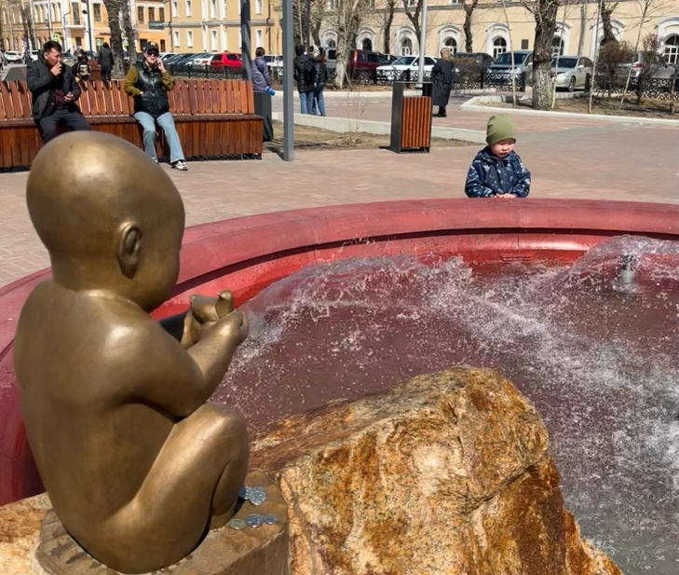
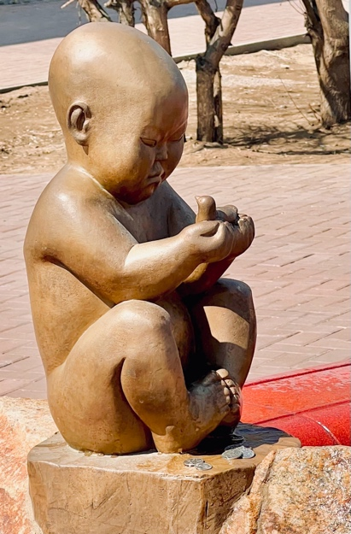
Figure 16. Fertility Spring. Photograph by the author.

I encountered a comparable situation during my visit to the women’s Datsan for a formal interview. Initially, my interviewee exhibited reluctance and a pronounced conservatism due to the war and my affiliation with a Western university; however, upon discovering my Iranian familial background, a nation historically allied with Russia, the High Lama entirely altered his perspective. He became much more amicable, referring to me as a ‘friend’ and even inviting me to remain for the afternoon’s fertility ceremony following the interview, as I was 36 years old and without children (Figure 17). At the conclusion of the ceremony, one of the female lamas provided me with a remedy: ‘We call this Baikal milk, which comes from animals that drink water from Lake Baikal and the area around it. This is usually given during private ceremonies to women who can’t have children.’
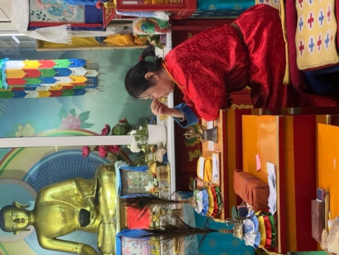
Figure 17. In an interview with the Grand Lama of Zungon Darzhaling Datsan, only female Buddhist datsan in Russia. Photograph captured by the author.

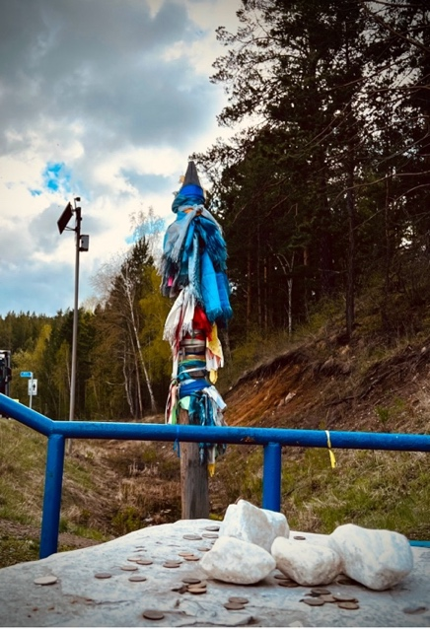
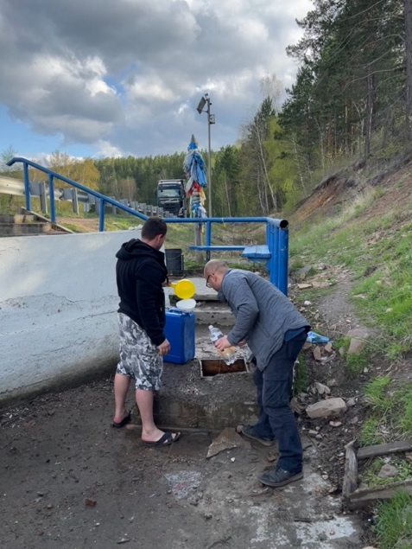
Figures 18 and 19: The subsequent poem was inscribed on a sign to describe the spring:
Hymn: ‘Arig Us (Ариг Ус)’/ We were born and raised on this land, which we call home/ As we begin the day, we remind ourselves that our native land will provide us with strength/ It provided us with the sacred water and brought us joy, peace, and happiness/ Arig Us will assist you in shaking off the burden of doubts from your soul/ Begin your day with positive feeling, breaking through the clouds of greyness/ We remember the day and moment when the living spring provided us with sacred water to drink/ It gave us happiness and a smile. Photographs by the author.

Additionally, during another excursion, I conversed with drivers near one of the arshans adjacent to Baikal. One of them parked by the road, replenished water containers and left a coin in the water source. The driver said that many individuals seek water from this sacred spring in their quest for healing and that the holy spirits will punish anyone who defiles these waters or steals the coins (Figures 18 and 19).
Nonetheless, the narrative propagated by the media involves the amalgamation of toxins with these healing waters, which are held to be both fertile and restorative. The crucial aspect here is that the integration of these two disparate categories in human cognition creates a compelling image and emerging story that indicates the erosion of the purity boundaries of the Buryats’ nature-based worldview. Indeed, this association of poisons and toxins is grounded in the historical connection between hazardous substances and taboos, despite their historical ties to medicine and mysticism (Cole 1998: 119).
In this context, the consensus from the interviews with lamas and shamans is that the idea of taboo in this region is linked to anything that disturbs the natural balance. This ‘anything’ may encompass food, particular activities, atypical behaviour or feelings, or even abstract notions such as colour. By observing taboos, Buryats demonstrate reverence for the spiritual realm and preserve their connection to it, which is crucial for their capacity to conduct healing, divination and other practices.
What is noteworthy is that the narratives presented in the media, which can be categorized into different levels, precisely illustrate this disruption of harmony caused by toxic substances: 1) industrial materials that have caused the deaths of animals and plants, emphasizing the idea of corpse and death; 2) garbage related to the process of rendering water undrinkable, emphasizing decay in its own nature; and 3) faeces, which are associated with the transmission of dangerous viruses and the growth of diseases in humans, emphasizing the idea of contagion. Clearly, these themes contrast starkly with the internalized narrative motifs in Buryat society regarding Baikal, which are founded on the three principles of revival, healing and fertility.
In addition, these themes correspond exactly to the original indigenous meaning of a taboo that can be associated with three fundamental aspects of emotional significance: a) the existence of danger; b) the potential for contagion; and c) the notion of untouchability (Malinowski 1931: 39). Indeed, the media debate, by promoting these three emotions both directly and indirectly, has created a revised perception of the Sacred Lake that fundamentally embodies chronic anxiety. This anxiety, which is caused by the violation of the established boundaries reflected in the first internalized image of the Baikal, inadvertently prompted the question among the Buryat as to where the boundary is between us and this ‘entity’, which is no longer the one we know. Therefore, the Buryat encounter an unbridgeable gap, a hiatus in knowledge, in their lack of ability to effectively control the environment.
This situation is clearly reflected in remarks and expressions of concern from several residents near Baikal. As one stated: ‘You can’t sense chemicals or radiation when you walk by the lake. But put swimming there out of your head. Only God knows what will happen to you with unknown diseases.’ As is obvious, there is anxiety about the lake’s pathogenicity. This issue sometimes becomes so strong that the source of common genetic diseases in the region, such as having extra limbs, is attributed to Baikal pollution: ‘It sounds impossible to forget the sacred lake’s breathtaking landscape, but you can't overlook flesh monsters in this region! It seems like a nightmare to have a baby with twenty limbs.’
There is a serious matter at issue here. Regarding the notion of taboo, there is always a ritual linked to it that seeks to restore the state of purity and certainty regarding boundaries that have been violated as a result of taboo (Douglas 2002), as well as reinstating the main narrative and metaphor to their initial position while simultaneously preventing the formation of new narratives surrounding their circumstances. Therefore, taboo-purifying rituals function to uphold the prevailing and predominantly fundamental narratives in religious societies. These rituals serve as guardians of nomos, or social order, 1) by providing a framework and mitigating potential risks and crises, and 2) by acting as a unifying force that aids in arranging a number of practical endeavours for dealing with existential anxiety about changes and losses (Leach 1964: 158). As a result, purification rituals act as a means of rescue.
It is essential to note that we are confronting an issue that society is unable to manage. As a result, people continuously rely on government officials and their rescue actions, as demonstrated by the growing rescue narrative in the newspapers. In this context, Marina Shaman, during a conversation on the Siberian separatists, highlighted a noteworthy issue that is pertinent to the topic of purification and rescue:

It is impossible to separate from Russia. At least for us, it is a significant loss because we cannot cope with our nature on our own. Many of our care systems are funded by the central government, and many of our environmental problems are solved by the central government, even if the results are often poor, but it is still preferable to local officials who are constantly at odds with one another.

The main issue concerning Baikal and the Buryat lies in their status as an indigenous, nature-centric society, where the infiltration of toxins and poisons (taboo substances) is progressively eroding the ecological integrity of their bioregion. This region has historically served as a cornerstone for healing practices and as a repository of shared beliefs and values. It is faced with irreversible destruction, despite government attempts at remediation, which remain confined to mere warnings or symbolic gestures. However, it is crucial to note that the media has transformed Baikal from a proactive, healing entity into a passive, ailing object awaiting help, thereby diverting the Buryats' attention from the lake’s usefulness linked to their religious identity to a dependent entity lacking the power of mana. This signifies an assault on Baikal’s previous image as a healer. In essence, Baikal has acted as a site for the physical and spiritual healing of the Buryat and their territory, establishing a paradigm wherein the sacred lake is expected to provide rescue, rather than one in which we are tasked with its preservation. Consequently, the Buryat are undergoing a condition of formlessness that diverges from the normal structure of their traditional knowledge, resulting in narratives that starkly contradict the original portrayal, in which disease and suffering were perceived as anti-values.
Nevertheless, the story does not conclude at this point. The media significantly harmed prior narratives as a source of knowledge by emphasizing the pathogenicity associated with toxic substances in the water. This is attached to the mythological and metaphorical quality of benevolence, which is central to healing, revival and fertility associated with Baikal in the Buryat collective memory. In other words, the image of Baikal transcends the mere loss or diminishment of its inherent characteristics; rather, it emphasizes a rebellion by Baikal as a dangerous force, shifting from a bastion of good to a source of evil. The consequence of this image has been a shift from the moral imperative of preserving Baikal to the imperative of protecting humans from its harmful effects. As a result, the media narratives have directly altered the Buryats' cognitive framework by influencing their perception of their position in relation to Baikal and by questioning the past and the entity responsible for their healing.

Conclusion

There is a prevalent view that the portrayal of pollution in the media might influence individuals’ perceptions of the hazards linked to it and their inclination to adopt safety precautions. In other words, those who perceive themselves as being directly impacted by contamination are more likely to comprehend the dangers that accompany it, leading them to respond promptly to early warnings and take preventive measures (Wang et al. 2021). Contrary to expectations, despite the growing attention from the media and their narratives about the polluted Baikal, the indigenous Buryat society, which relies on the lake for its traditional healing practices and therapeutic system, has not shown an increase in its efforts to address pollution. In fact, the Buryat have actively chosen to remain silent, particularly regarding the issue of pathogenic contamination.
This awkward situation, which is characterized by contradictory elements, can be traced back to the existence of what is a broken narrative. On this subject, the belief in the three attributes of healing, revival and fertility, which are aligned with the shamanic-Buddhist belief system of the Baikal region and regulate the norms of interaction with their bioregion, is inadvertently targeted by Russian newspapers, pushing academic findings on ‘contaminated matter’ to a subjective and interpretive level. It is vital to highlight that this phenomenon extends beyond the media’s dramatic interpretation. It also undergoes a secondary transformation when it enters the Buryat collective memory, based on their traditional knowledge. In this context, the water environment, which has long played a role in alleviating various forms of suffering (economic, spiritual, social) and restoring damaged units (familial and historical) through its powers of healing, is now revealed as an entity inside which decay occurs, and the risk of death and disease contagion has become inherent, particularly when it is touched. This is precisely the crux of the argument. The Baikal storyline can be encapsulated in this image: transitioning from a state of touchability for healing purposes to becoming untouchable due to its harmful nature and contagiousness, thereby portraying a silent taboo. Hence, the broken narrative can be attributed to the condition of anomie, leading to the disintegration of the view of Baikal as the symbol of a therapeutic gathering of deities or a system dedicated to seeking healing. Furthermore, the lack of a mechanism to regulate or manage this change has exacerbated the predicament for the Buryat, a society faced with the absence of the purifying ritual that traditionally eradicates taboos and upholds or restores social equilibrium by mitigating the dangers. Consequently, although the Buryats are located geographically in a region undergoing substantial transformation, they feel spiritually disconnected from the ecosystem they are part of and have a sense of alienation from the formerly healing Lake Baikal.

Bibliography

Bahr, Ann Marie 2004. Indigenous religions, New York: Chelsea House.

Barrett, Ron and George J. Armelagos 2013. An unnatural history of emerging infections, Oxford: Oxford University Press.

Berger, Peter 1967. The sacred canopy: elements of a sociology of religion, New York: Anchor.

Breyfogle, Nicholas B. 2013. The fate of fishing in tsarist Russia: the human-fish nexus in Lake Baikal, Sibirica: Interdisciplinary Journal of Siberian Studies 12/2, 1-29. doi:10.3167/sib.2013.120201.

Brown, Kate 2018. Saving the sacred sea: the power of civil society in an age of authoritarianism and globalization, Oxford: Oxford University Press.

Butina, Tatyana V., Bukin, Yurij S., Krasnopeev, Andrey S., Belykh, Olga I., Tupikin, Aleksey E., Kabilov, Marsel R., Sakirko, Maria V. and Sergey I. Belikov 2019. Estimate of the diversity of viral and bacterial assemblage in the coastal water of Lake Baikal, FEMS Microbiol Lett 366/9, fnz094. doi:10.1093/femsle/fnz094.

Buber, Martin 1970. I and thou, New York: Charles Scribner’s Sons.

Buyandelgeriyn, Manduhai 2007. Dealing with uncertainty: shamans, marginal capitalism, and the remaking of history in postsocialist Mongolia, American Ethnologist 34/1, 127-147. doi:10.1525/ae.2007.34.1.127.

Chivilikhin, Vladimir 1963. Светлое Око Сибир [The bright eye of Siberia], October Magazine H 4, 151–172.

Cole, Leonard A. 1998. The poison weapons taboo: biology, culture, and policy, Politics and the Life Sciences 17/2, 119-132. doi:10.1017/s0730938400012119.

Cover, Robert 1982. Nomos and narrative, Harvard Law Review 97/4, 4–64.

Dancygier, Barbara 2008. The text and the story: levels of blending in fictional narratives, mental spaces in discourse and interaction, in Todd Oakley and Anders Hougaard (eds.), Mental Spaces in Discourse and Interaction, 51–78. Amsterdam: John Benjamins.

--- 2012. The language of stories: a cognitive approach, Cambridge: Cambridge University Press.

Douglas, Mary 2002. Purity and danger: an analysis of concepts of pollution and taboo, Abingdon: Routledge.

Dugarova, Esuna 2023. Buddhism, power, identity: the transnational Buryat Buddhist living tradition, Europe Asia Studies 75/10, 1744–1774. doi: 10.1080/09668136.2023.2242605.

Fagel, Devon M., Ganat, Yosif, Silbereis, John, Ebbitt, Timothy, Stewart, William, Zhang, Heping, Ment, Laura R. and Flora M. Vaccarino 2006. Cortical neurogenesis enhanced by chronic perinatal hypoxia, Exp Neurol 199/1, 77-91. doi: 10.1016/j.expneurol.2005.04.006.

Felodernik, Monika 1996. Toward a natural narratology, London: Routledge.

Ferreira, Celio, Boholm, Åsa and Ragnar Löfstedt 2013. From vision to catastrophe: a risk event in search of images, in Paul Slovic (ed.), Risk, media and stigma: understanding public challenges to modern science and technology, 283-300. Abingdon: Routledge.

Haenisch, Erich 1948. Die Geheime Geschichte der Mongolen, Leipzig: Otto Harrassowitz.

Herman, David 2013. Storytelling and the sciences of mind, Cambridge, MA: MIT Press.

Humphrey, Caroline 1999. The end of nomadism, Durham: Duke University Press.

Innes, Robert Alexander 2010. Introduction: Native Studies and Native cultural preservation, revitalization, and persistence, American Indian Culture and Research Journal 34/2, 1-9. doi: 10.17953/aicr.34.2.y13028v6060344w9.

Iwata, Hisato, Tanabe, Shinsuke, Ueda, Kazuhiko and Ryo Tatsukawa 1995. Persistent organochlorine residues in air, water, sediments, and soils from the Lake Baikal region, Russia, Environmental Science & Technology 29/3, 792–801. doi.org/10.1021/es00003a030.

Korsgard, Ingrid 2013. Keeping the eye of Siberia luminous: environmentalism on Lake Baikal in a transitioning society, Macalester German and Russian Studies Honors Projects.

Krieger, Nancy 2021. Ecosocial theory, embodied truths, and the people’s health, Oxford: Oxford University Press.

Leach, Edmund R. 1964. Anthropological aspects of language: animal categories and verbal abuse in William A. Lessa and Evon Z. Vogt (eds.), Reader in comparative religion: an anthropological approach, New York: Harper and Row Publishers.

Losey, Robert J., Nomokonova, Tatiana and Olga I. Goriunova 2008. Fishing ancient Lake Baikal, Siberia: inferences from the reconstruction of harvested perch (Perca fluviatilis) size, Journal of Archaeological Science 35/3, 577–90. doi:10.1016/j.jas.2007.05.005.

Malinowski, Bronislaw 1931. The role of magic and religion in William A. Lessa and Evon Z. Vogt (eds.), Reader in comparative religion: an anthropological approach, New York: Harper and Row Publishers.

Maksimov, V. V., Astaf'ev, V. A., Dukhanina, A. V., Kraĭkivskaia, O. V., Mamontova, L. M., Shchetinina, E. V. and E. D. Savilov 2003. Indikatsiia patogennykh virusov v vode ozera Baĭkal i ego pritokakh [Indications of pathogenic viruses in water of Lake Baikal and its tributaries], Gig Sanit MarApr/2, 15-8. Russian. PMID: 12861681.

Nakata, H., Tanabe, S., Tatsukawa, R., Amano, M., Miyazaki, N. and E. A. Petrov 1995. Persistent organochlorine residues and their accumulation kinetics in Baikal seal (Phoca sibirica) from Lake Baikal, Russia, Environmental Science & Technology 29/11, 2877-2885. doi: 10.1021/es00011a026.

Nelson, Melissa K. 2017. North America: Native ecologies and cosmovisions renew treaties with the Earth and fuel Indigenous movements, in Willis Jenkins, Mary Evelyn Tucker and John Grim (eds.), Routledge handbook of religion and ecology, 138-147. Abingdon: Routledge.

Pio, Edwina and Sandra Waddock 2020. Invoking indigenous wisdom for management learning, Management Learning 52/3, 328-346. doi:10.1177/1350507620963956.

Pirdehghan, Maryam 2023. Disarticulated nomos, Anthropological Journal of European Cultures 32/2, 108-133. doi: 10.3167/ajec.2023.d.

--- 2024. Transforming home, Nature and Culture 19/2, 135-160. doi: 10.3167/nc.2024.190202.

Pliska, A. A., Batomunkuev, A. S. and D. A. Ponomarev 2021. Microorganisms of Lake Baikal and their pathogenic properties, IOP Conference Series: Earth and Environmental Science 677, 052034. doi: 10.1088/1755-1315/677/5/052034.

Rasputin, Valentin 1989. Siberia on fire: stories and essays, translated by Gerald Mikkelson and Margaret Winchell. DeKalb, IL: Northern Illinois University Press.

Sabirov, Rustam 2012. Buddhism in the Russian Republic of Buryatia: History and Contemporary Developments, in Bruce M. Knauft and Richard Taupier (eds.) Mongolians after Socialism: Politics, Economy, Religion, 235-248. Ulaanbaatar: Admon Press.

Sorokovikova, L. M., Sinyukovich, V.N. and I. V. Tomberg 2010. Chemical runoff of the Selenga River under conditions of low water content, Russian Meteorology and Hydrology 35/10, 700–705. doi:10.3103/S1068373910100080.

Singer, Merrill 2014. Anthropology of infectious disease, Abingdon: Routledge.

Sukhodolov, Alexander P., Fedotov, Andrei P., Makarov, Mikhail M., Kolesnikova, Alina V., Sukhodolov, Yakov A. and Polina G. Sorokina 2021. Eco-legal and economic aspects of developing Malomorsky fishing area of Lake Baikal, Aquaculture and Fisheries 6/5: 530–34. doi:10.1016/j.aaf.2021.02.007.

Thompson, Sharon L., Chenhall, Richard D. and Julie K. Brimblecombe 2013. Indigenous perspectives on active living in remote Australia: a qualitative exploration of the socio-cultural link between health, the environment and economics. BMC Public Health 13/1, 473. doi:10.1186/1471-2458-13-473.

Tsyrempilov, Nikolay 2021. Under the shadow of white Tara: Buriat Buddhists in imperial Russia, Leiden: Verlag Ferdinand Schöningh.

Tucker, Mary Evelyn and John Grim 2017. The movement of religion and ecology, in Willis Jenkins, Mary Evelyn Tucker and John Grim (eds.), Routledge handbook of religion and ecology, 1-13. Abingdon: Routledge.

Vunibola, Suliasi and Matthew Scobie 2022. Islands of Indigenous innovation: reclaiming and reconceptualising innovation within, against and beyond colonial-capitalism, Journal of the Royal Society of New Zealand 52/1, 4-17. doi:10.1080/03036758.2022.2056618.

Wang, Qiang, Su, Min, Zhang, Min and Rongrong Li 2021. Integrating digital technologies and public health to fight COVID-19 pandemic: key technologies, applications, challenges and outlook of digital healthcare, International Journal of Environmental Research and Public Health 18/11, 6053. doi:10.3390/ijerph18116053.

Weiner, Douglas R. 1999. A little corner of freedom: Russian nature protection from Stalin to Gorbachev, Berkeley, CA: University of California Press.

WHO Commission on Social Determinants of Health, World Health Organization 2008. Closing the gap in a generation: health equity through action on the Social Determinants of Health. Geneva: World Health Organization, Commission on Social Determinants of Health.

Zemskaya Tamara I., Pedro J. Cabello-Yeves, Olga N. Pavlova and Francisco Rodriguez-Valera 2020. Microorganisms of Lake Baikal: the deepest and most ancient lake on Earth, Applied Microbiology and Biotechnology 104/14, 6079-6090. doi: 10.1007/s00253-020-10660-6.

Zhanaev, Ayur 2022. A heap of leaves or fellow travellers: kinship and family life in the Buddhist texts for the Buryat laity (nineteenth to early twentieth centuries), Inner Asia 24. doi:10.1163/22105018-02302029.

Zhukovskaya, Natalia 2018. Шаманы и шаманки Бурятии: их мистический опыт и мои экспедиционные исследования. Часть 1. Oriental Studies 39/5, 97–109. doi:10.22162/2619-0990-2018-39-5-97-109

N/A. Байкала-озера сказки 1988. Ирку́тск: Восточно-Сибирское книжное издательство.

N/A. Сказания бурят, записанные разными собирателями 1890. Ирку́тск: Типография К.И. Витковской.

Баранниковой, Е.В. 1973. Бурятские народные сказки: волшебно-фантастические. Москва: Академия Наук СССР.

Гудкова, Екатерина 2019. Мифы и легенды о Байкале, Retrieved March 6, 2023, from https://www.culture.ru/materials/198868/mify-i-legendy-o-baikale

Мантатов, В. В. (ed.) 1983. ЛАМАИЗМ в БУРЯТИИ XVIII – НАЧАЛА XX ВЕКА: Структура и социальная роль культовой системы. Издательство “Наука”. Сибирское отделение.

Осиповн, Шаракшинова 1980. Мифы бурят, Ирку́тск: Восто́чно-Сиби́рское кни́жное изда́тельство.

Санги, Владимир 2017. Девочка-лебедь и другие северные сказки. Saint Petersburg: Rech.

Стародумов, Василий 2016. Хозяин Ольхона. Байкальские сказки, Санкт-Петербург: БХВ.

Фролова, Г. 2002. Бурятские народные песни: песни хонгодоров, Улан-Удэ: бурятский научный центр со ран.

This work is copyright of the author.

It has been published by JASO under a Creative Commons Attribution-NonCommercial-NonDerivatives ShareAlike License (CC BY NC ND 4.0) that allows others to share the work with an acknowledgement of the work's authorship and initial publication in this journal as long as it is non-commercial and that those using the work must agree to distribute it under the same license as the original. https://creativecommons.org/licenses/by-nc-nd/4.0/)

GENERATING SOCIALITY THROUGH THE SENSES IN MOVEMENT AND MUSIC THERAPY AMONG PEOPLE WITH RECURRENT PSYCHOSIS

JASMINE WU

Psychosis analyzed from a phenomenological orientation is a disembodied experience that involves a constant negotiation of self and reality. For people experiencing recurrent psychoses, its medicalisation and stigmatisation further complicate the relationship of self, medication, and society, as shown by the political economy of psychosis. In these cases where full recovery from the illness may not be possible, I reconceptualise psychosis as a pastime: a strategy to coexist with rather than be defined by the illness experience. Accordingly, I turn towards non-pharmacological interventions; arts-based therapies, such as dance and music, have been shown to benefit people with psychosis by reestablishing their experience of reality within the body and empowering them to regain control over their lives and interpersonal relationships. In my ethnography of the Psychosis Therapy Project (PTP) based in Islington, London, UK, which serves people with recurrent psychoses, I explore how its movement and music therapies work towards re-embodiment using bodily techniques of heat, synchronicity, synesthesia, and the transportive role of music. Thus, I take a sensory anthropological approach to sociality that also decenters vision as the main sense in healing—to be well is to feel well rather than just to look well. Finally, my fieldwork presents a case where a service user, who regularly participates in the movement group, manages psychosis as a pastime through practical and social enskilment. Ultimately, my work strives to demedicalise and destigmatise the lived experience of psychosis and honour the legacy of the PTP.

Keywords: psychosis, phenomenology, sensory anthropology, movement therapy

The rhythm of house music chugs in the background as we sit on couches facing each other, chatting. People move through this common area, joining and leaving conversations between refilling tea, attending their therapy appointment, and participating in the various sessions offered by the Psychosis Therapy Project (PTP). Every Wednesday for eight weeks, I started my fieldwork on these couches, building rapport with service users who were self-referred or referred by a medical practitioner to the PTP for experiencing recurrent psychosis. As service users shared about their day, I learned more about their experiences with psychosis, medication(s), and relationship to broader society, thus contextualising my phenomenological analysis of psychosis and its various therapies which follows.
To begin with theoretical underpinnings, phenomenology posits that human reality exists from within the body and is perceived by the senses including kinesthesia and proprioception (Fridland 2011); for instance, Merleau-Ponty elaborates that ‘the lived body is the “thereness of human reality”, and the body as it is lived in everyday dealings with the world is the centre of the field of perception and action’ (Morris 2012: 49). Thus, the body’s direct presence in and engagement with the environment, through posture and movement for example, allows people to constantly create identity, paving the way for embodiment orientations. How the body feels and lives becomes a form of knowing.
Accordingly, my research interest lies in cases where people experience disembodiment, such as during psychosis: a condition that medically manifests as delusions, hallucinations, disorganised thoughts and behaviours, catatonia, and reduced facial expressions (Calabrese and Khalili 2019). Phenomenologically, these symptoms can be explained as the loss of intuition over one’s body, making their body and environment feel confusing and at times frightening. For example, doubts of what is real may lead to the positive symptoms of delusions and hallucinations, whereas the negative symptoms of withdrawal and reduced facial expressions may stem from an unclarity of how to relate to others. Koch et al. (2017: 864-866) suggest that this disembodiment in psychosis includes ‘lost body boundaries, lost agency, and determination by external forces… [People] experience their body or parts of it as alien, their outer world as alien, and themselves as separate from it’. Therefore, these symptoms may be caused by and reinforce a lost connection with the bodily self— ‘a stable, continuous sense of the body across time’—which is ‘a core component of selfhood’ (Benson et al. 2019: 111).
Moreover, in people with more recurrent psychoses and thus a prolonged use of medication, their relationship with pharmacotherapy further complicates their bodily function and identity formation. For instance, while anti-psychotics may help manage the symptoms of psychosis, they may also over-suppress one’s ability to feel, diminishing their experience. In conversing with Mark, a mid-career artist and service user, I learned that his medication ‘messes with his feelings [by making him] feel unmotivated’. Along with the medication’s range of side effects, these resulting changes in motivation levels may also result in medical noncompliance, which can be anthropologically explained as existential problems in subjectivity ‘within the domains of self, agency, identity, social relations, and cultural and community response’ (Jenkins 2010: 38). In a separate essay, Jenkins and Carpenter-Song (2006: 392) provide an ethnography of people with recurrent psychoses, revealing how the sensory experience of self can be characterised as a palpable struggle to situate themselves relative to their illness and medications. For participants, negotiating a sense of self involves teasing out the effects of their medication, symptoms of their illness, and aspects of their personality... Rendering the self entails both explicit and tacit negotiation of a sense of ‘me’ versus ‘not me.’
Therefore, psychosis is not only a disorienting experience on its own, but also its medicalisation may leave the person particularly vulnerable, prompting them to act in culturally unconventional ways to manage their disorientation. For instance, Akira, an older service user with a strong voice, mentioned, ‘[some transfer patients to people] want to put you on edge… and the medication does it anyway, you know?’
In the broader healthcare system, the political economy of psychosis suggests that ‘antipsychotics have been used not as an adjunct to psychosocial treatment… but often an alternative to such care… Too often the psychiatrist is called upon to wedge the person [with psychosis] into an ill-fitting slot because an appropriately therapeutic setting is not available, affordable or even considered feasible…’ (Warner 2003: 250). This narrative of people experiencing psychosis as a burden and thus rushing ‘to the community—to cut institutional costs regardless of social costs’ (ibid) is also prevalent within the NHS, according to Walter, a service user with beard stubble and a pensive demeanor. As he fidgeted with his lighter, he mentioned that ‘it’s all about recovery and rehab and trying to get people back to work, out of the system. This works for some people, but not for most. [The current mental health system tries] to do “quick fixes”’. As such, people with psychosis may experience isolation on the levels of individual experience—from the medication—and collective social identity— due to stigmatisation—as they ‘contend daily with embarrassment and discrimination in their struggle to get better in the wake of serious mental illness’ (Jenkins 2006: 406). Ultimately, this phenomenological landscape of psychosis reveals the interplay of symptoms, medication usage, and stigmatisation that shape one’s ‘being-in-the-world’.
As the rates of psychosis continue to increase despite the development of various pharmacological treatments, I endeavoured to investigate cases of recurrent psychosis where recovery does not occur. During my fieldwork, these service users often redefined ‘recovery’ or ‘healing’ as the ‘management of life’ or ‘being able to live a normal life… that’s bearable and sensible’. Similarly, after conducting anthropologically developed subjective experience of medication interviews (SEMIs) for patients experiencing psychosis, Jenkins and Carpenter-Song revealed that ‘while medication is given a primary narrative placement in processes of recovery… [it] could not be expected to do all of the complex and subtle “work” involved in the process of recovery”’ (2006: 390). Control of the illness was cited as a strategy, manifesting as ‘efforts to “keep busy” to relax, and to distract oneself from otherwise disturbing symptoms’ (ibid). Finally, Jenkins and Carpenter-Song demonstrate that humanising social connection is paramount to managing psychosis as they allow ‘the individual to be treated as “just another person” rather than being marked as ill and excluded as such’ (2006: 394). Thus, to further destigmatise and demedicalise psychosis, I reconceptualise psychosis as a pastime, a way of being that, despite its management evidently containing hardships, can also be filled with ‘“small” and “everyday pleasures”’ of the joie de vivre (Jenkins and Carpenter-Song 2006: 397).
While my role as a medical anthropology student familiarised me with the political economy of psychosis and its pharmacological treatments, my background as a dancer prompted me to creatively turn towards non-pharmacological arts-based therapies, shown to help people with psychosis regain balance and trust with their bodies and world. For instance, music and movement therapies are forms of healing based on intuition and non-verbal communication. Movement therapy has been medically shown to improve patients’ physical wellbeing at the biochemical, neuronal, and psychological levels (Jola and Calmeiro 2017), while also building on the social connection healing of intersubjectivity as patients move and create meaning with their therapist and/or other patients. Ultimately, it is a ‘relational process in which clients and therapist use body movement and dance as an instrument of communication during the therapy process’ (ADMP 2023, my own emphasis). While body techniques vary, a common strategy is mirroring, which develops kinesthetic empathy: ‘a re-living or an epistemological placing of ourselves “inside” another’s kinesthetic experience’ (Parviainen 2003: 152). Current neuroscience research explains mirroring as when we move with others in a shared manner, our mirror neurons fire in

[…] our own sensory and motor brain areas when we observe the actions of others […] in order to build implicit relational skills and predict the actions of others. This skill is what we know as ‘intuition’—to be able to predict approximately what is going to happen in the course of an action or interaction. (Koch et al. 2017: 868-869)

This intuition helps to build kinesthetic empathy, which ‘fundamentally involves the observance of physical bodily action… [and] actively embodying the experience of the Other’ (Douse 2017: 288). Therefore, the active movement between people during mirroring helps to develops kinesthetic empathy, which is therapeutic for those experiencing disembodiment. Finally, what separates movement therapy from therapeutic exercise classes is often the free movement to music, which one of my early interlocutors described as ‘the movement of the soul’. Hinton and Kirmayer (2017) show that music can act as ‘flexibilisers’ that metaphorically push patients to embody flexibility and change in their own lives. For instance, ‘alterations of the musical line both represent and evoke bodily and cognitive impressions of movement, change, and flexibility. Music with these forms encourage the listener to experience their own capacity for shifting, and by analogy, flexibility and change. This effect may be heightened when the person actively participates in making music or dancing to it’ (Hinton and Kirmayer 2017: 20, my own emphasis). Through these metaphors of movement, both movement and music therapies can be beneficial to people with psychosis where they may feel disoriented and lose intuition towards outward experience. What follows will be an analysis of the PTP’s movement and music sessions through participant observation and interviews with service users and therapists.
To begin, I situate myself in my fieldwork by painting a vignette of the PTP’s movement and music therapy groups. During my initial meeting with the PTP Director in January 2024, I was introduced as a medical anthropology researcher to the therapists and the service users present in the common area that day, many of whom as regulars would remember me on my first day of fieldwork. During my initial attendances of both sessions, I introduced myself as a ‘researcher’ or ‘master’s student’ and briefly shared about my research question and role. My positionality as an Oxford student garnered interest from most service users, acting as a conversation starter to build rapport with them. For example, I learned that Walter’s daughter had also studied at Oxford. To my surprise, that and my status as an international student were not as intimidating as I anticipated, despite hearing the occasional paranoid statement about institutions and foreigners.
After spending the first hour of my time at the PTP mingling with or interviewing the service users and therapists, I climbed the stairs to the second floor of the Islington MIND building for the movement therapy group. During the next hour, I conducted participant observation while also actively partaking in the session. In the movement group, the activities varied per week but, from the third week onwards, it revolved around a theme set by the therapist. With this change, the therapist would also ask for our reflections on the theme using paper and crayons—adding a visual arts element to the session. Examples of themes included: ‘relating to others’, ‘coping with stress’ and ‘building self-confidence’. During this check-in activity, we sat on chairs formed in a circle, which we would either continue to do during our warm-up or which we would push aside to warm-up standing. Our seated warm-ups occasionally included mindfulness body scans. After the warm-up, the therapist played music from a speaker and we moved freely, mirroring each other, and answering the therapists’ questions about how our bodies felt. Then, the therapist would often bring an object prop for us to use: a percussion-based musical instrument, fabrics, beanbags, balls, etc. We would tactilely explore these objects, on some weeks name them, and then we would move with them. Finally, at the top of the hour, we would debrief about the session, revisiting our written or drawn reflections, and provide feedback about our bodily sensations and each other’s movements.
By contrast, the music group had a fixed structure and the only variation per week was the time dedicated to each activity based on the number and talkativeness of that week’s participants. The session began with an improvisation session where we all played the musical instruments laid on the table—a lamellophone, ukelele, lyre, guitar, bongos, maracas, keyboard, tambourine, etc. Next, each service user requested a song to be played from a speaker for the group to listen together. The service users would often start with why they chose that song for the week, and a discussion would usually follow once the song ended. The therapist facilitated the conversation’s flow. Finally, the session would close with another improvisation session—where service users may choose different instruments—and a quick debrief of the session. In the music therapy group, I held more of a passive observation role contrary to my active participation in the movement group; for instance, I partook in the music improvisation but not the song sharing part of the session although I occasionally shared my thoughts on a song that was played. I also did not participate in the debrief but listened carefully to the service users instead.
In narrowing the scope of my article I will focus on how these two sessions work rather than why they work. Therefore, my aim is to describe the body techniques used in these sessions by applying a sensory medical anthropology approach and specific ethnographic examples from my fieldwork. The following sections are structured as the flow of my fieldwork day, starting with the movement therapy group where I have identified the warm-up, mirroring, and the use of props as consistent components of the session’s structure. Then I present the music therapy group, structured into improvisation (first and last 5-10 minutes) and song sharing components (remaining time).
In the final section, I provide a case study of psychosis as a pastime by applying Ingold’s concept of ‘enskilment’ (2000) to demonstrate how a service user, Thor, manages their day-to-day living with recurrent psychosis.

Heat in the movement therapy

Each week, the movement therapist started the session with light stretching. During my first week of fieldwork, she also invited us to warm up our hands by rubbing them together. This motion caused heat through friction which we then touched to different parts of our bodies, warming them up and connecting with them. Taking turns, we each demonstrated touching a body part, such as the head, legs, arms, back, shoulder, belly, and neck. The movement therapist commented that ‘we often forget about our back or the backside of the body’ during this ‘transfer of energy’ from the hands to the respective body parts. She checked in with each of us to see if our bodies were feeling warmer.
Potter defines heat as ‘a crucial sense of energy that is discussed and experienced informally among dancers’ (2008: 454). Drawing on her ethnography of contemporary dancers in London, she reveals that ‘“warming-up”, or increasing the body’s internal temperature, is considered a necessity […] for bodily learning during training […] Muscles begin to feel more mobile’ (ibid). Although my fieldwork’s bodily learning did not pertain to training choreographed routines or styles of dance, the warm-up attuned us to our bodies and facilitated the movements that followed. For instance, it prompted us to locate the areas in our bodies that felt stiff or in pain, such as my neck and lower back, leading to a deeper level of awareness of my body in that present moment. By working through those tensions with gentle movement, warming-up also allowed us to create bigger movements during the subsequent freestyling exercises with less risk of injury; thus, it provided a safe way for us to explore the limits of our bodies with our surrounding environment. Furthermore, in the particular exercise of rubbing our hands together and then touching different parts of body, heat was generated and transferred through touch, a ‘boundary sensory mode (in contrast to the trans-boundary modes of heat and smell) […] bringing explicit attention to the body’s boundaries’ (Potter 2008: 456). As my hands patted my thighs, I became aware of how my hands felt on my legs and how my legs felt for my hands, echoing the sensation that ‘whatever you touch, touches you too’ (Hsu 2008: 440).
Finally, as the ‘social shaping [of boundary sensory modes such as touch and taste] defines what external objects may be contacted or consumed by individual bodies within a cultural group’ (Potter 2008: 456), I found that the movement therapist’s comment about how the backside of the body is often forgotten fascinating. With Western society’s emphasis on vision as the main sense for creating our ‘reality’ (Ingold 2000), and that we mostly only see what is in front of us, this socially constructed hierarchy may thus shape how our other senses operate, focusing our tactile experience to what is in front of us including our bodies. This does not imply that we question whether our backsides exist—we know proprioceptively we have heels, calves, buttocks, back, shoulder blades, etc.—but that these float in and out of awareness compared to our hands, bellies, thighs, and knees which we can always visually access. Therefore, vision shapes what we conventionally touch (actively, such as with our hands), such that the group was surprised by this reminder that we could also place our warm hands on our backs.
‘During the warm-up, the temperature of the skin increases and sweat begins to coat the body as internal heat is released into the surrounding air… its perception leads to the recognition of other bodies and external heat sources in space’ (Potter 2008: 454-456). Prior to starting the session each week, the movement therapist first asked how we felt about the room’s temperature. She would often offer to turn a portable radiator on if we found it too cold, and, as the weather transitioned into summer, she would in turn run a fan if it was too hot. One of the service users, a quiet gentleman named Giuseppe, consistently commented that, although he felt cold at the start of the session, he did not need the radiator because he knew the room would feel warmer as we carried on with the session. Indeed, by the end of each session, the room felt warmer as evidenced by some service users removing a jumper or unzipping their jackets.
Yet, what stood out at the end of the session was the liveliness that had been created during the session. We recognised this different type of heat by contrasting it to cooling-down, where we debriefed the session, packed up our bags, exchanged a ‘thank you, see you next week’ and moved towards the door. Drawing on Chau’s explanation of ‘red-hot sociality’ or social heat (2008: 488), Potter argues that

perhaps most importantly, heat in the studio [is] a means of sensing the life force of others […] generated by the gathering of living bodies and heightened through an explosion of sensory activity […] A sense of heat thus begins within the individual body but quickly transfers into the social realm. (2008: 455- 456)

Therefore, not only did we physically cool down, by slowing our movements and heartbeats once the session ended, but also the metaphorical cool-down of being dismissed and dispersing back into our own daily routine shows the different types of heat created in the movement group. The act of coming together and moving in a unified manner and rhythm amplified the production of the heats, revealing the importance of synchronicities, which will be explored next.

Mirroring movements and synchronicity in the movement therapy

Once our bodies are warmed up, the movement therapist played music from her tablet and speaker. It was usually slow, instrumental, and contained sounds of nature. We first moved around freely to the music for a few minutes, sometimes making use of the physical space around the room. Then, the movement therapist invited us to go around in a circle and demonstrate a movement on the spot for the others to copy. We would each perform for a short period and the remaining group members would take a few beats to appraise the movement before attempting it in their own bodies. Then we would pass the turn onto the person next to us through pausing our own movement, turning towards them, and either nodding or making eye contact with them. There were shoulder rotations, fingers stretching and closing, swaying, arm waves, popping and locking, knee bends, marching… Some weeks, the movement therapist challenged us to make our upcoming round of movements more complex than the first. This often required more focus from the participants copying the movement; one interviewee mentioned, ‘and then it takes so much coordination mentally [to mirror the other participants’ movements] doesn’t it? Yeah, to be able to consider a group… Yeah, I could manage, but a bigger group like that I would have found very difficult because I wouldn’t be able to contain all the information that was coming out…’
In his essay about collective effervescence among Australian Indigenous peoples, Durkheim writes, ‘the very act of congregating is an exceptionally powerful stimulant. Once the individuals are gathered together, a sort of electricity is generated from their closeness and quickly launches them to an extraordinary height of exaltation […]’ (Durkheim 1995: 217, my own emphasis). This electricity, felt by a group focusing in on their shared experience of the present, is an example of synchronicity, ‘a situation in which all participants involved are acutely aware of only one single event and turn their full attention to it’ (Hsu 2005: 85). In the movement group, as we all intently discovered how each other’s movements felt in our own bodies, we moved in a synchronised manner that pushed us to exist as a collective beyond our individual bodies. On such transformation, Hsu writes that ‘these intense moments of synchronicity between people […] are important not only because of the sensory experiences, emotions and memories that they create in the individual. More importantly, they make the social group physically real, engendering vitality in the group as whole’ (2008: 439). A manifestation of synchronicity was particularly prominent when we were asked at the end of a session what our energy level was; each response revealed that our energy levels coalesced at around 5-6 on a self-reported scale of 10: energised but still calm, with those who initially had higher energy slightly dropping and those who had started the session more tired now feeling more energised. Thus, the collective moving—of the same moves, at the same place and same time—emphasised sensory relatedness and generated synchronicity.
What was unique about this exercise, compared to simply following a choreography or sequence of moves led by the movement therapist, was that we tried each other’s movements. Thus, not only were we intentional about the move we wanted to share with group, but we were also intentional with how we received the performer’s move in our own bodies, at times modifying it to our own abilities. For instance, Akira mentioned in her interview,

I quite like the idea of taking a movement, you know, and each expressing a movement. And I think, you know, there’s something about expressing each other’s which works quite well, as well… Because when I did [a different movement therapy group in London], we copied it exactly. But I think that idea that you have an interpretation yourself is quite nice.

Trying each other’s moves in our own bodies prompted us to create intersubjective milieus by enhancing our somatic modes of attention towards bodily reciprocity. To begin, Csordas reveals that ‘a somatic mode of attention means not only attention to and with one’s own body, but includes attention to the bodies of others’ (1993: 4). Therefore, as we mirrored each other’s movements, our embodied presence in the exercise created an intersubjective milieu between our body-selves and the performer’s body-self, an act of seeing and being seen. Such presence is crucial; in my interview with the movement therapist, she explains,

when we share movement, it creates a space where people feel like they’ve been witnessed; even if I’m not talking, my presence, my movement and what I bring is quite important… By witnessing others, we form a connection for them in the context of feeling safe… Mirroring and sharing that movement of witnessing and attuning to that person.

I argue that attuning to a person involves turning our somatic modes of attention towards the relationship between each other’s bodies. For Merleau-Ponty,

the internal relation between my body and that of the other is bodily reciprocity. It is not simply that the infant perceives the other’s intentions immediately in perceiving his gestures […] but that it perceives its intentions in its body, and my body with its own, and thereby my intentions in its own body […] It is as if the other person’s intention inhabited my body and mine his. (Morris 2012: 115)

Therefore, in the mirroring exercise, we heighten our bodily reciprocity by practicing each other’s intentions in our own bodies through somatic modes of attention. This created intersubjective milieus that ultimately built kinesthetic empathy as we witnessed and attuned our body-selves to each service user. This social connectedness can be further enhanced by creatively introducing props into the moving group thereby adding multisensory and synesthetic dimensions.

Object use in the movement therapy

In Week 4 of my fieldwork where the session’s theme was ‘relating to others’, the movement therapist handed us a play parachute. We each took a corner and made waves at times so large that the parachute’s centre rose above our heads, and we could see each other from under it. We then took turns creating different wave-like patterns with the parachute, such as by varying the timing of our hands. One by one, we took turns demonstrating the movement which was then mirrored by the rest of the group. We rotated the parachute counterclockwise such that the colours facing us continuously moved to the right. Then, the movement therapist placed a beanbag on the centre of the parachute, and we tossed it around. Cynthia, a petite but energetic service user, mustered a powerful push, propelling the beanbag off the parachute onto the side shared by Giuseppe and the movement therapist. After the session, we drew our present thoughts onto sheets of paper using coloured crayons and shared them with the group (Figure 1).
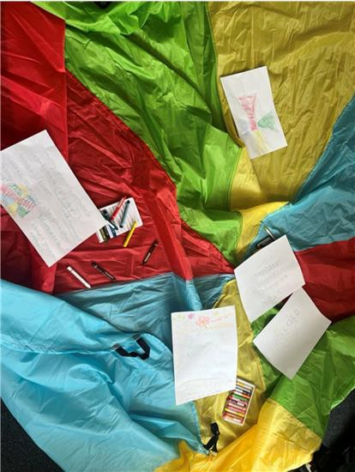
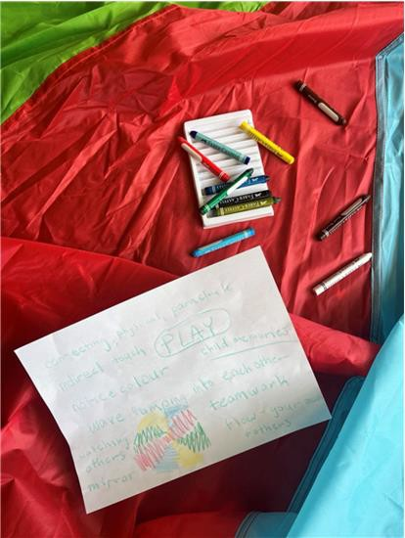
Figure 1. Left: Our drawings and words using crayons for the debrief of the play parachute activity. Right: my sheet of paper outlining my thoughts and feelings from the session

Although the warm-up and mirroring components of the movement group engage one’s senses such as hearing music, touching and feeling heat and proprioception, adding props heightened multisensory engagement through further visual, auditory and textural affordances. For example, the parachute’s bright colours, loud flapping, and nylon texture created different sensations than watching each other, listening to calm music, or touching our own skin as was the case in mirroring and warm-up. This incorporation of objects beyond the body was conducive to building social relations. For instance, as I received the parachute handle from the person on my left and passed my own parachute handle to the person on my right, I engaged in an ‘exchange of material objects’ which creates and reinforces social relations (Hsu 2008: 438). These objects also act as a vehicle for intersubjective sociality or what Hsu calls the ‘joint experience of real stuff, such as the sweat from dancing or from gardening’ (ibid). In the beanbags exercise, as we created waves in the parachute to keep the beanbag afloat, I felt Cynthia’s playful and mischievous energy in my own body through each parachute ripple, as she created large waves to jostle the beanbag off the parachute. Thus, we entered a social relation through the parachute, as I tried to counter her waves with similar energy to stabilise the beanbag. In this exercise, we had engaged closely with the parachute, spending the bulk of the session moving it, accomplishing different exercises with it, and to the point where both Giuseppe and I drew its colours on our sheet of reflection paper (Figure 1).
In contrast, the following week’s session took a more distant albeit still meaningful approach to incorporating objects. The session, whose theme was about ‘stress relief’, began with drawing or writing our interpretation of stress. After we shared our work with each other, we placed these sheets around the room to be revisited later. At the end of the session prior to debriefing, the movement therapist laid a set of props around the room and invited us to decorate the space in front of us with our sheets of paper (Figure 2).

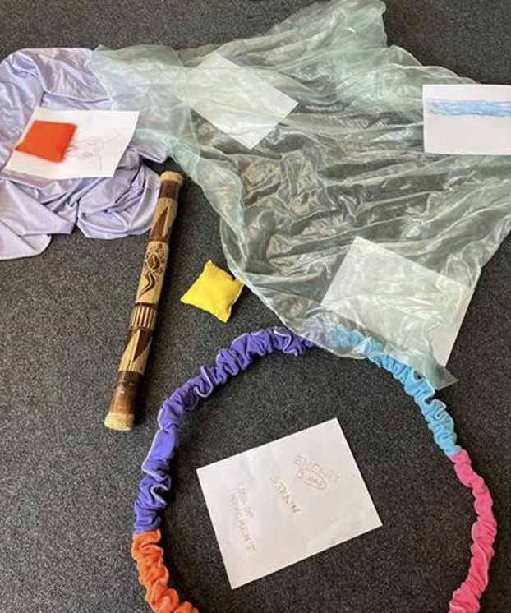
Figure 2. Our debrief included intentionally placing our sheets of paper among the objects in meaningful configurations.

When asked to justify why we put our paper in that particular location, Akira mentioned putting their paper in the circle as if to constrain the topics of stress that have been on her mind; upon closer inspection of the figure, these topics read ‘ENERGY’ and ‘SUGAR’ (both in red crayon, the latter word circled), ‘STRAIN’ and ‘LOSS OF MOVEMENT’ (in light brown crayon). We reflected on each other’s decision and gave each other feedback before closing the session.
In this exercise, we did not interact closely with the objects; at most, we briefly lifted the object to slip our paper underneath before returning to our seats. As such, instead of affording us with multisensory stimulation, the props played more of a metaphorical role. I propose the role of metaphor as, in accordance with Michael Jackson’s Thinking through the body: an essay on understanding metaphor, ‘[mediating] a transference from the area of greatest stress to a neutral area which is held to correspond with it’ (Jackson 1983b: 138). This occurs when ‘a movement is facilitated from the domain where the double-bind is manifest and where, before anxiety is most intense, to another domain which is relatively free from anxiety and accordingly still open to control and manipulation’ (ibid). In our movement therapy exercise, Akira had moved with her own body the sheet of paper listing her stressors, placing it inside the closed ring. Accordingly, she desired to contain the stresses of strain and loss of movement, to be relieved from them. Her intentional action was a ‘disruption in the habitus […] [which] lays people open to possibilities of behaviour which they embody but ordinarily are not inclined to express […] it is on the strength of these extraordinary possibilities that people control and recreate their world, their habitus’ (Jackson 1983a: 334-335, my own emphasis). By actively altering the environment of objects laid on the carpet floor—representing the habitus in this case—Akira reoriented herself to the stressors in her life. Therefore, through metaphorising the ring-shaped object, she was able to counter the stressors of strain and loss of movement.
On the other hand, I have yet to address the full contents of Akira’s sheet of paper, and I now turn my attention towards the word ‘ENERGY’ written in red crayon. Along with justifying why that word contributed to her interpretation of stress, she briefly mentioned she had deliberately chosen to write it in red crayon by association—providing an example of synesthesia, ‘a correspondence between two or more senses usually considered as separate described in western aesthetic and scientific terms’ (Young 2005: 61) However, it would be an oversight to simply assume that Akira is ‘innately’ or psychologically synesthetic, meaning one perceived input provides two sensory outputs in the brain. Although this may be the case, Young (2005: 64) reveals in her ethnography of the Pitjantjatjara peoples’ appraisal of the colour green that ‘synesthesia must be socially based or at least socially influenced’ as well. In Akira’s case it is possible that energy as a release of heat and vitality is culturally associated with the colour red as tends to be the case in Western society. She also explained that ‘energy’ in the context of stress is mostly positive or a productive form of energy, but it could also be negative as is the case with sugar highs and crashes; thus, the association with the colour red may be multifaceted, denoting not only heat, but also a warning to maintain proper sugar levels. Nevertheless, using objects in the movement therapy promotes multisensory engagement that may lead to synesthetic experiences among service users. These affordances of metaphor and multisensory engagement were also prominent in the techniques used in the music group, into which I delve in the upcoming section, thereby closing my analysis of the body techniques used in the movement group.

Instrumental improvisation in the music therapy

After moving downstairs to a room next to the common area, I sat with another group of service users around large tables holding musical instruments. Every week, we would start and end the session with improvising on these various instruments of which I most often found myself playing the mbira, ukelele, or maracas (Figure 3).

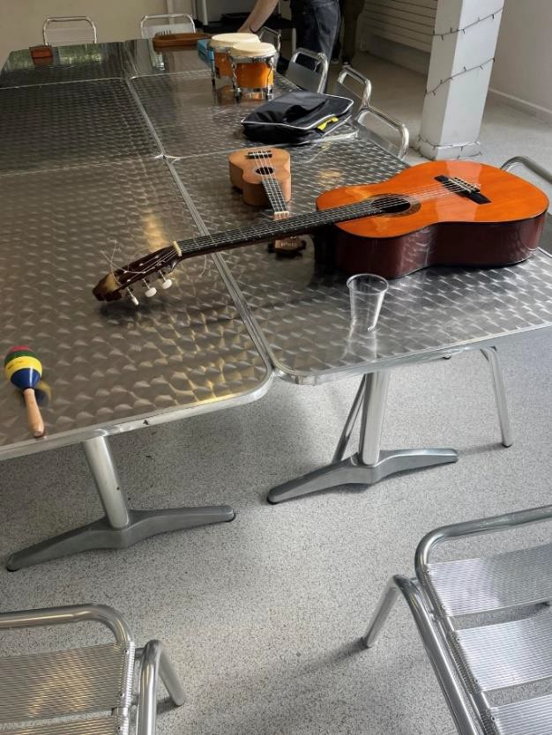
Figure 3. The instruments we played at the beginning and end of each session.

The service users also naturally gravitated towards certain instruments, with Terry, a talkative man with dyed hair and a captivating personality, opting for the acoustic guitar each week and Eric, another service user with a warm smile that reached his eyes, playing various tunes on the electric keyboard. The music therapist also joined, playing the piano, flute, and once even singing. Despite having some knowledge of music and rhythm through childhood piano lessons, I did not know how to play these instruments, but many of them were self-explanatory and percussive in nature. While some of the service users had musical knowledge, many others also fiddled with their instruments—creating an uncoordinated cacophony where somehow a melody and harmony often arose.
Interestingly, these improvisations adopted textures that expressed the intentionalities of the service users through their instruments. For example, in the third week of my fieldwork, the starting improvisation felt more vibrant, whereas the ending one felt more ‘delicate’ (direct quote from Walter). To describe the sounds as ‘vibrant’ or ‘delicate’, adjectives respectively associated with visual or tactile senses, points to Young’s argument about synesthesia as ‘a different way of thinking’ (2005: 73). For example, these two adjectives are related by the different energy levels they convey, meaning their association with the improvised music communicated the resulting intentionalities of the service users. Compared to the ‘vibrant’ improvisation, the lack of rhythmic cohesion and instead an emphasis on exploratory riffs of the ‘delicate’ improvisation suggested a more personal touch, as if people were playing the music for themselves rather than as a group. Through synesthetic metaphors, these improvisation sessions provided service users with a means of moving in and out of sociality by their own means.
Accordingly, these sessions, enabled us to enter conversations with each other without relying on speech; for instance, Eric mentioned, ‘you use your hands, you know, you use your hands. It’s something quite important about using your hands. Like in pottery, that’s the real satisfaction. But if you bang on the piano, you know, it’s like somehow you communicate with your hands…’ This multisensory communication—as in, not only through hearing but hearing-touch—engendered a feeling of presence, a deliberate attentiveness to one’s being-in-the-world because it is less cerebral and more bodily. Similar to Desjarlais’s fieldwork with the Yolmo peoples and their spirit-calling rituals (1996), these improvisation sessions required less intellectualising and instead more feeling. For instance, Desjarlais wrote about an embodied definition of healing, suggesting that ‘healing transformations take place not within some cognitive domain of brain or heartmind, but within the visceral reaches of the eyes, the ears, the skin, and the tongue. Indeed, the feeling of rejuvenation (rather than just its ideas or symbolic expression) is essential’ (1996: 159, emphasis in the original). This resonated with some of the service users who shared,

I find healing to me is, feeling and being well. To come together and not just looking well. I think looking well is kind of off and putting up a bit of a front when people are looking at visual things which are in terms of often superficial things, even if in your face or your eyes, you look well. (my own emphasis)

Of note is the importance of stimulating the senses in these healing rituals to create such feeling. In the improvisations, actively playing music prompted us to feel our skin on the instrument in producing sound and to feel our bodies resonate, tingle, shiver in receiving such sounds.
Additionally, Desjarlais (1996) suggests that presence in the Yolmo healing ritual was experienced, not only by the person whose spirit was lost, but by everyone, thus generating synchronicity. In other words, the ritual is a communal experience wherein the audience is key to its efficaciousness. In the context of my fieldwork, I noticed a similar phenomenon during the first improvisation of Week 8: Eric, on the piano, and I, on the xylophone, engaged in a call-and-response that organically rose to the melody among the other instruments. As I played a sequence of random notes on the xylophone, I heard a similar melody repeated back on the piano. At first, as I was turned away from the pianist, I did not pay much attention; however, when the piano repeatedly echoed my xylophone notes, I latched on. We continued this call-and-response a few times, reversing the roles such that I copied his sequence of notes. I felt a tingle in my body, perhaps from the heightened anxiety of wanting to correctly mimic his melody in front of the others, but also from anticipating his response on the piano keyboard. After the improvisation ended, leaving us both with broad smiles, we were greeted with buzzing from the rest of the group who exclaimed their excitement of listening to our back-and-forth riffs. Ultimately, even though the rest of the group did not directly participate in it, the redirection of their attention to our call-and-response demonstrated synchronicity. Their senses were stimulated, creating a feeling of ‘presence’ grounded in their body-selves.
My analysis of the improvisations and Yolmo healing rituals, both of which rely on a collective experience of feeling rather than thinking, prompt me to revisit the Western epistemological prioritisation of vision as a more rational, intellectual, analytical sense compared to hearing. Here, I aim to leverage hearing and touch in that hierarchy by arguing that hearing, especially music, enables e-motion and thus reaches a deeper level of understanding into one’s social experience through accessing the body.
To begin, ‘when it comes to affairs of the soul, of emotion and feelings, or of the “inwardness” of life, hearing passes seeing as understanding goes beyond knowledge, and as faith transcends reason’ (Ingold 2000: 246). Music, compared to sounds of speech, adds an additional layer of emotionality; Ingold suggests ‘what essentially distinguishes verbal sound is that its significance can be extracted from the sound itself. Musical sound, by contrast, delineates its own meaning: it is meaningful not because of what it represents, but simply because of its affective presence in the listener’s environment’ (2000: 408, my own emphasis). Therefore, hearing music is emotional, ‘yielding a kind of knowledge that is intuitive, engaged, synthetic and holistic’ (Ingold 2000: 245). For Eric, hearing music even unlocked feelings of which he may not have even been aware, pointing towards its intuition: ‘sometimes, I’m surprised how moving [the music group is]… you know, you don’t think that you’re feeling vulnerable or emotional, but then something about music can like, just touch that emotional part you know’ (my own emphasis). Through his use of synesthetic metaphors associating music with felt movement and touch, I suggest that emotions or e-motions are grounded in bodily experiences, drawing on Fuchs and Koch’s concept of embodied affectivity (2014). Particularly, they argue ‘bodily feelings should not be conceived as a mere by-product or add-on, distinct from the emotion as such, but as the very medium of affective intentionality […] Emotions can thus be experienced as the directionality of one’s potential movement, although this movement need not necessarily be realised in the physical space’ (Fuchs and Koch 2014: 3-4). Indeed, music generates a bodily experience, as suggested by an interviewee: ‘[some sorts of music] … more metaphorically sort of go… through my body, maybe my heart also, maybe… my arms? Yes, heart, well heart as well…’ (my own emphasis). Hearing and sound thus may better align with embodied definitions of healing than does vision, echoing the criteria for a successful Yolmo spirit-calling and the service users who prioritise feeling well rather than merely looking well.
In terms of hearing contributing deeply to one’s social experience due to its emotionality, Ingold establishes that ‘voice and hearing establish the possibility of genuine intersubjectivity, of a participatory communion of self and other through shared immersion in the stream of sound… hearing defines the self socially in relation to others’ (2000: 246-247, emphasis in the original). Thus, sounds and music, which we can hear all around us rather than merely in front of us, pushes us to regain a more ‘harmonious, benevolent, and empathetic awareness of our surroundings. Then, perhaps, we may rediscover what it means to belong’ (Ingold 2000: 246, emphasis in the original). In the following ethnographic example, I aim to show how hearing promotes sociality, where a moment of synchronicity within the improvisation session fostered the emotional experience of Walter’s pain to be collectively felt through music.
During the second improvisation of the same session, we did not try to recreate the call-and-response, instead letting our hands take charge of the instrument. At one point, Walter began banging the bongos with great force, explaining after that it was because of his ingrown toenail. In my interview with Eric, which was scheduled immediately after this music therapy session, he shared, ‘yeah, I was kind of a bit anxious in case he was angry, but he seemed alright…’ Thus, Eric had turned his attention towards Walter’s pain, as a response to the bongo noise. In her essay about inflicting acute pain through acupuncture, Hsu argues that ‘the presence caused by acute pain infliction can be understood as an alertness that opens up the patient to a potentially positive input from the social environment, and possibly, it is this directly felt social connectedness that is therapeutic’ (2005: 84-85). When a patient is poked with the acupuncture needle, their reaction of shouting and shivering or catching a breath of air is felt through somatic modes of attention by the therapist and anyone else present. Accordingly, ‘the acute pain event can be viewed as a trigger for an embodied experience of sociality’ as people turn their attention towards the patient (Hsu 2005: 85). In this case, Walter’s acute pain was not externally inflicted, instead arising from his ingrown toenail, and his response was to aggressively bang on the bongos instead of shouting. Synchronicity was generated as we collectively noticed the loud sounds he made, and our noticing allowed Walter’s pain to be heard literally and metaphorically. This synesthetic metaphor abounds; it is also present in the song discussion component, to be explored next.

The collective listening to and discussion of songs in the music therapy

When the first improvisation organically tapers off—when people feel that they have had enough and someone disengages from their instrument, which is noticed and followed by others—we begin our songs discussion. As an enthusiastic participant to this exercise, Walter shared,

I find I’ve got sort of an ingrown toenail, and I’ve got nerve damage, and I’ve got sort of problems with my hips with wear and tear, arthritis about, and I find when I get into the conversations [about the song choices], listen to music, it distracts me from physical pain that I feel that when I’m sometimes sitting alone. (my own emphasis)

How does hearing music distract one from the physical sensation of pain? In the previous section, while delineating the affective presence of music, I shared that music moves one through e-motion, a bodily experience integrating hearing with felt movement. How do these various sensory modalities overlap? In keeping with Young’s definition of synesthesia (2005), Ingold shares that

the senses exist not as distinct registers whose separate impressions are combined only at higher levels of cognitive processing, but as aspects of functioning of the whole body in movement, brought together in the very action of its involvement in an environment. Any one sense, in ‘honing in’ on a particular topic of attention, brings with it the concordant operations of all the others. (2000: 262)

Thus, if we shift our somatic mode of attention from pain to musical sound that evokes its own feelings, our whole being moves rather than senses if they were siloed. As phenomenology posits, there is less of a distinction among the senses than Western pop-psychology perpetuates, and this ‘different way of thinking’ (Young 2005) is all grounded in bodily motion.
While motion can encompass the heart beating faster, the jaw tightening, the eyes tearing, etc., I will demonstrate that the listener may also experience metaphorical motion of music across time: nostalgia. This may be another mechanism for pain distraction, actually taking a person out of their embodied presence and instead bringing them to their imagined past self. Such techniques of invoking nostalgia were consistently referenced in the music therapy group’s choice of songs and subsequent discussion. Over the weeks, service users chose songs from the same genre (20th-century rock, blues, and jazz were quite common), talking about various artists from their youth. One week, Walter continuously mentioned ‘how music is a mode of transportation to different eras in one’s life’ and multiple service users played music they remembered being ‘obsessed with’ during their childhoods or teen years. As we listened to these songs, I often noticed a pensive expression on the song requester’s face, as if they were elsewhere. Could it be that they found themselves back in a bodily experience they once had decades ago?
Finally, as the concept of interaffectivity emphasises, ‘emotions are not inner states that we experience only individually or that we have to decode in others, but primarily shared states that we experience through interbodily affection’ (Fuchs and Koch 2014: 7). Therefore, this technique of sharing music in real time with the group through collective listening distinguishes itself from simply giving each other music recommendations for their own time because it generates synchronicity. During my interview with the music therapist, she shared that

choice of song is very significant in how someone shares about themselves… I think there is always something interesting and positive about any song choice; there will always be something to say. It helps to validate. And that vulnerability or ‘being quite exposed’ is something that people sometimes speak about in group… (my own emphasis)

Unique to the group is the heightened feeling of being witnessed as the group listens to the song choices together. One interviewee explained

the social connection from being witnessed as fostering friendship and sort of listening to other people's experiences… of music and the ages that they were influenced, ‘cause you know the music group has got people of all different ages and all different nationalities and background. And it's really interesting and I think there is a shared sort of emotion that music can maybe evoke, and I think in the music therapy that we have here… it seems like a very safe environment to be able to express that.

Finally, in reference to the various ages and nationalities of the music group participants, I argue that this technique of collectively listening to songs promotes sociality regardless of whether the song lyrics are even cognitively understood. To begin, Langer writes ‘when words and music come together, music swallows words’ (1953:152); Ingold clarifies that ‘sounds of speech, to the extent that they are incorporated into a total musical phenomenon, cease to draw the listener’s attention to meanings beyond themselves – meanings that, in speech, the sounds had served only to convey or deliver up to the listener rather than actually to embody’ (2000: 408, my own emphasis). Thus, even when the song choice is unfamiliar and thus does not necessarily evoke nostalgia, it still has the capacity to move the listener. For example, Bela, a younger service user whom I met in my second week of fieldwork, chose an Icelandic song, which began with a rumbling noise before transitioning to violin and a choir of layered voices. Although no one in the group could understand the words sung, people felt their own emotions and the weight of the song, remembering and alluding to these sensations in that session’s debrief and even weeks later. The words no longer carried the same meaning as would have occurred had they been spoken; instead, the service users related this unfamiliar music based on their own backgrounds, sparking conversation to foster social connection. Ultimately, as the music therapist highlights, ‘the space is very open and can go many different directions. That’s where there is the aliveness…’
Halfway through my fieldwork, I learned that after eleven years of servicing the Islington community, the PTP was closing in the upcoming autumn of 2024. In pondering the PTP’s legacy such as destigmatising and demedicalising psychosis as a pastime, I present a final case study of how a service user, Thor, becomes more enskilled to manage his psychosis in a manner meaningful to him.
Ingold starts his argument by defining enskilment as ‘“understanding in practice” […] in which learning is inseparable from doing, and in which both are embedded in the context of a practical engagement in the world' (2000: 386). In delineating its process, he explains that it involves, ‘the fine-tuning of perception and action’ wherein ‘to observe is to actively attend to the movements of others; to imitate is to align that attention to the movement of one’s own practical orientation towards the environment’ (Ingold 2000: 37). Therefore, we learn by doing; we learn through embodiment. Ingold’s examples, however, revolve around hunter-gatherer societies and the use of tools in craftmanship, for instance with the Koyukon having

perceptual systems [that are] attuned to picking up information, critical to the practical conduct of his hunting, to which the unskilled observer simply fails to attend. That information is not in the mind but in the world, and its significance lies in the relational context of the hunter’s engagement with the constituents of that world. (2000: 55, my own emphasis)

Thus, we become enskilled not due to a drastic change in ourselves or our environment, but by refining our somatic modes of attention, modulating our relationship to our current environment. In reimagining enskilment for my fieldwork, Thor is a regular member of the movement therapy group who has a strong interest in breakdancing, which he first learned in boarding school. Many of his movements in the sessions are deliberately robotic, hitting the music’s occasional sharper beats. For Thor, the PTP is a ‘place to come to’ on Tuesdays to Thursdays and specifically the movement therapy session is ‘something to look forward to on Wednesdays’; in elaborating, he mentions that it is a ‘good space to explore movement’.
When I meet him in the common area before the movement group, he is usually sitting there among the others silently, wearing headphones. In our interview, he shares that he is ‘not super close to the other users’ as ‘he is just often there for the group’. Nevertheless, he prefers to have larger groups because there is more ‘scope for copying other moves’. He shares that he enjoys copying peoples' movements because ‘everyone has different ways’ of moving; for example, a new person joining the movement group often does ‘moves he has never seen before’ and that ‘it feels good because there are new and extra movements’. Although he mentioned he can feel a bit apprehensive with new participants, the movement group’s atmosphere is relaxed compared to other therapy groups where the presence of new participants can feel ‘intense’ or ‘intimidating’.
During these sessions, Thor is not directly taught how to move as there are no instructions on how to move one’s limbs. However, he learns new ways to engage his body through ‘routinely carrying out specific tasks involving characteristic postures and gestures…’ (Ingold 2000: 162). These routine tasks are the loose set of instructions to explore our own and each others’ movements provided with the movement group’s safety and open-mindedness. As such, when he tries one of my movements or I one of his, the postures we copy allow us to feel the sensations that the other feels but in our own body.
As sessions have progressed, the movement therapist has noticed how Thor engages and what he obtains from the sessions. These potential benefits extend beyond the acquisition of new dance movements; for example, the movement therapist shares that during the drop-in,

[Thor]’s usually quiet and verbal communication may not be the most comfortable way for him… since coming to the group he’s showing himself a bit more and appears to trust this space a bit more and has found something new that is quite exciting to him based on his feedback. And he has been taking a more proactive role to show himself and feeling more accepted, based off what I seen. His movements have also become more dynamic. (my own emphasis)

Therefore, Thor becomes more skilled at the movements themselves and at directing somatic modes of attention towards the intersubjective milieus he shares with others in the session. Moreover, the resulting new-found confidence of relating to others in his desired mode of communication becomes embodied as more dynamic movements rather than the initial rigidity. Thus, by treating psychosis as a pastime, rather than an all-consuming illness at which medication is merely thrown, Thor learns new skills that are meaningful to him and experiences the resulting sociality and joies de vivre.
Ultimately, these forms of enskilment become the ‘psychocultural strategies for struggle and control not through overcoming the illness or “fixing” the illness but, rather, through accommodating the illness. An accommodation or learning orientation to recovery stands in contrast to a problem-oriented approach that situates the illness as an enemy in relation to the self’ (Jenkins and Carpenter-Song 2006: 392, my own emphasis). Therefore, enskilling service users to manage their psychosis as a pastime demedicalises and destigmatises the illness by enabling them to exist alongside the illness rather than being wholly defined by it. It recenters their personhood in their experience of psychosis by providing new hobbies and creative outlets. In keeping with this desire-based framework, the PTP creates a therapeutic environment that is ‘warm, protective and enlivening without being smothering, over-stimulating or intrusive… [its service users are] allowed to maintain a valued social role, together with their status, dignity and a sense of belonging to the community at large’ (Warner 2003: 242). It accomplishes this culture of care through the body techniques discussed within the movement and music therapy groups such as heat, synchronicities, synesthesia, and the transportive role of music. Although the PTP may soon no longer exist, its legacy of fostering such a community shall live on, serving as a standard for future psychosis interventions.

Bibliography

ADMP 2023. What is dance movement psychotherapy? Association for dance movement psychotherapy, perma.cc/LQ7Q-UGYF (accessed 17 Aug 2024).

Benson, Taylor, Brugger, Peter and Sohee Park 2019. Bodily self‐disturbance in schizophrenia‐spectrum populations: introducing the Benson et al. Body Disturbances Inventory (B‐BODI), PsyCh Journal 8/1, 110–121. doi: 10.1002/pchj.280.

Calabrese, Jordan and Yassir Al Khalili 2019. Psychosis, Nih.gov. perma.cc/BU62-HDYF (accessed 17 Aug 2024).

Chau, Adam Y. 2008. The sensorial production of the social, Ethnos 73/4, 485–504. doi: 10.1080/00141840802563931.

Csordas, Thomas 1993. Somatic modes of attention, Cultural Anthropology 8/2, 135–156. doi: 10.1525/can.1993.8.2.02a00010.

Desjarlais, Robert 1996. Presence, in Carol Laderman and Marina Roseman (eds.), The performance of healing, London: Routledge.

Douse, Louise 2017. Flow in the dancing body: an intersubjective experience, in Vicky Karkou, Sue Oliver and Sophia Lycouris (eds.), The Oxford handbook of dance and wellbeing, 273-292. Oxford: Oxford University Press.

Durkheim, Émile 1995. The elementary forms of the religious life, translated by K. Fields, London: The Free Press.

Fridland, Ellen 2011. The case for proprioception, Phenomenology and the Cognitive Sciences 10/4, 521–540. doi: 10.1007/s11097-011-9217-z.

Fuchs, Thomas and Sabine Koch 2014. Embodied affectivity: on moving and being moved, Frontiers in psychology 5. doi: 10.3389/fpsyg.2014.00508.

Gibson, James 1977. The theory of affordances, in Perceiving, acting, and knowing: toward an ecological psychology, Hillsdale, NJ: Lawrence Erlbaum Associates, Publishers.

Hinton, Devon and Lawrence Kirmayer 2017. The flexibility hypothesis of healing, Culture, Medicine, and Psychiatry 41/1, 3–34. doi: 10.1007/s11013-016-9493-8.

Hsu, Elisabeth 2005. Acute pain infliction as therapy, Etnofoor 18/1, 78–96.

--- 2008. The senses and the social: an introduction, Ethnos 73/4, 433–443. doi:10.1080/00141840802563907.

Ingold, Tim 2000. The perception of environment: essays in livelihood, dwelling and skill, New York: Routledge.

Jackson, Michael 1983a. Knowledge of the body, Man 18/2, 327-345. doi: 10.2307/2801438.

--- 1983b. Thinking through the body: an essay on understanding metaphor, Social analysis: the international journal of anthropology 14, 127–149. doi: jstor.org/stable/23170418.

Jenkins, Janis 2010. Pharmaceuticalized self and imaginary in the social field of psychiatric treatment, in Pharmaceutical self: the global shaping of experience in an age of psychopharmacology. Santa Fe, NM: School for Advanced Research Press, 17–40. doi: 10.1177/1363461512437148.

Jenkins, Janis and Elizabeth Carpenter-Song 2006. The new paradigm of recovery from schizophrenia: cultural conundrums of improvement without cure, Culture, Medicine and Psychiatry 29/4, 379–413. doi: 10.1007/s11013-006-9000-8.

Jola, Corinne and Luis Calmeiro 2017. The dancing queen: explanatory mechanisms for the ‘feel-good effect’ in dance, in Vicky Karkou, Sue Oliver and Sophia Lycouris (eds.), The Oxford handbook of dance and wellbeing, 12–40. doi: 10.1093/oxfordhb/9780199949298.013.1.

Koch, Sabine, Kolter, Astrid, Fuchs, Thomas, Sattel, Heribert and Janna Kelbel 2017. (Dis-)embodiment in schizophrenia: effects of mirroring on self-experience, empathy, and wellbeing, in Vicky Karkou, Sue Oliver and Sophia Lycouris (eds.), The Oxford handbook of dance and wellbeing, 862–882. Oxford: Oxford University Press. doi: 10.1093/oxfordhb/9780199949298.013.44.

Langer, Susanne 1953. Feeling and form, New York: Charles Scribner’s Sons.

Morris, Katherin 2012. Starting with Merleau-Ponty, London and New York: Continuum.

Parviainen, Jaana 2003. Kinaesthetic empathy, Dialogue and universalism 13/11-12, 151–162. perma.cc/5W8N-4SXE (accessed 17 Aug 2024).

Potter, Caroline 2008. Sense of motion, senses of self: becoming a dancer, Ethnos 73/4, 444–465. doi: 10.1080/00141840802563915.

Searle, John R. 1980. The intentionality of intention and action, Cognitive Science 4/1, 47–70. doi: 10.1207/s15516709cog0401_3.

Tuck, Eve 2009. Suspending damage: a letter to communities, Harvard educational review 79/3, 409–428. doi: 10.17763/haer.79.3. n0016675661t3n15.

Warner, Richard 2003. Recovery from schizophrenia: psychiatry and political economy, London: Brunner Routledge.

Young, Diane 2005. The smell of greenness: cultural synaesthesia in the western desert, Etnofoor 18/1, 61-77. doi: jstor.org/stable/25758087.

This work is copyright of the author.

It has been published by JASO under a Creative Commons Attribution-NonCommercial-NonDerivatives ShareAlike License (CC BY NC ND 4.0) that allows others to share the work with an acknowledgement of the work's authorship and initial publication in this journal as long as it is non-commercial and that those using the work must agree to distribute it under the same license as the original. https://creativecommons.org/licenses/by-nc-nd/4.0/)

RACIAL GASLIGHTING OR SELF-FULFILLING BELIEFS? RETHINKING POSTCOLONIAL EXPLANATIONS IN THE PARISIAN BANLIEUES

LUISA SCHONEWEG

Since Edward Said’s Orientalism (2019 [1978]), postcolonial anthropology has increasingly explored how dominant groups employ stigma against ethnic minorities to uphold and reinforce existing power structures. Robert K. Merton’s well-established concept of self-fulfilling beliefs posits how such subordination is perpetuated through a direct justification using derogatory stigma (1968: 475ff.). More recently, postcolonial philosophers Angelique M. Davis and Rose Ernst (2019) have proposed an alternative framework: ‘racial gaslighting’ analyses how stigma operates to conceal subordination and thereby sustain it. This paper is the first to critically compare the two models and demonstrates how social anthropology can analyse the persistence of subordination through stigmatisation beyond self-fulfilling beliefs, as racial gaslighting. It examines the ethnographic case of police violence and stigmatisation against Parisian banlieue residents in contemporary France. The analysis shows that, although French police officers may justify oppressive actions against banlieue residents through beliefs that render their violence self-fulfilling, actions are heavily informed by power interests, which racial gaslighting identifies as the underlying force sustaining them. The paper further discusses the implications of this for understanding banlieue residents’ experiences of resistance, hegemonic power structures in France, and the potential for systematic change.

Keywords: self-fulfilling beliefs, racial gaslighting, postcolonial France, banlieues

Introduction

On 30 June 2023, the UN Human Rights Office raised concerns with the French government about systematic racism and discrimination in the French police system (Shamdasani 2023). The Foreign Ministry of France replied shortly after:

Any accusation of systematic racism or discrimination by the police in France is totally unfounded […] The forces of law and order deal with situations and acts of extreme violence with great professionalism (Ministère de l’Europe et des Affaires Étrangères 2023, my translation).

On the same day, two of the biggest police unions in France posted a press release on X, responding to riots against police violence: they were ‘fighting a war’ (‘nous sommes en guerre’) against ‘the dictates of these violent minorities’ (‘le dictat de ces minorités violentes’), ‘savage hordes’ (‘hordes sauvages’) and ‘pests’ (‘nuisibles’) (Alliance Police Nationale and UNSA Police 2023). The riots were initiated following the death of Nahel Merzouk on 27 June 2023, a 17-year-old boy from the Parisian suburb of Nanterre (Richardot 2024). He was shot by a police officer during a traffic stop, during which he was hit with rifle butts several times and threatened with a bullet to his head if he did not cut the engine (Boutros 2024: 15). His death was the third in 2023, and part of a larger history of police killings in traffic stops, with victims being to a large extent People of Colour and/or of Arab origin (Jabkhiro and Foroudi 2023). And yet, the Foreign ministry insisted: ‘Any accusation of systematic racism or discrimination by the police in France is totally unfounded’ (Ministère de l’Europe et des Affaires Étrangères 2023).
As early as 1948, sociologist Robert K. Merton studied the enduring nature of racist domination in contemporary Western societies (Merton 1968: 477ff.). His examination spans merely 15 pages, using one concise framework of explanation:

The self-fulfilling prophecy is in the beginning a false definition of the situation evoking a new behavior which makes the originally false conception come true (Merton 1968: 477)

Actors internalise the stigma as true, enact it as such so that initial expectations ‘come true’ (Merton 1968: 477) or are ‘real in their consequences’ (Thomas and Thomas 1928: 572). ‘For the prophet will cite the actual course of events as proof that he was right from the very beginning’ (Merton 1968: 477), domination over ethnic minorities is justified and hence perpetuated; systematic racism in the French police is publicly declared as ‘totally unfounded’ because the officers’ oppression is seen as necessary in the face of ‘extreme violence’ that they provoked themselves.
The impact of Merton’s framework cannot be underestimated. Formulating this in 1948, he shed light on the structural causes behind naturalised racist beliefs where other anthropologists still contributed to ‘the birth of an anthropathology of “the American Negro”’ (Tapper 1997: 269). Until today, his concise model has been cited in thousands of academic pieces (Wineburg 1987: 28), spanning sociology (e.g. Killian 1959), social psychology (e.g. Rosenthal and Jacobson 1968), economics (e.g. Ferraro, Pfeffer and Sutton 2005) political science (e.g. Harvey 2022), and, the discipline thoroughly invested with domination contexts in its ongoing ‘dark turn’ (Ortner 2016: 47), social anthropology (e.g. Dozier 1951; Bourdieu 1991: 220ff.; Said 2019).
Over 70 years after Merton, however, postcolonial philosophers Angelique M. Davis and Rose Ernst asked again, ‘How does white supremacy […] remain inextricably woven into the ideological fabric of the United States?’ (Davis and Ernst 2019: 761). ‘Racial gaslighting’ is what they call their explanation, a term stemming from the 1944 feature film Gaslight, in which a husband secretly dims the lights in the house, making his wife Paula feel ‘crazy’ for seeing variations in lighting (Cukor 1944). Joining the new philosophical field of epistemic gaslighting research (e.g. McKinnon 2017, Berenstain 2020, Ruíz 2020), Davis and Ernst use the term to show how stigmatisation of minority groups does not justify but ‘obfuscate the existence of a white supremacist […] power structure‘ (Davis and Ernst 2019: 761, emphasis added); systematic racism is sold as ‘totally unfounded’ by the French government with reference to ‘extreme violence’, not to necessitate but to conceal the power-informed abusive violence enacted by the police.
Despite their different assumptions, self-fulfilling beliefs and racial gaslighting have yet to be brought into conversation. Considering the abundance of social anthropological analyses on contexts of cultural power, domination, and their reproduction (Ortner 2016: 49ff.), the need for reliable and postcolonial-sensitive frameworks in these fields is apparent. I argue that racial gaslighting offers a lens for understanding the complexities of stigma-informed subordination that lie beyond the explanatory scope of Merton’s self-fulfilling beliefs model. To develop this point, I place the two frameworks in dialogue, by applying them to the government-led and police-executed stigmatisation of Parisian banlieue residents in France, exemplifying how each interprets dimensions of the same phenomenon from a different perspective. Anthropologists have extensively analysed the ‘territorial stigma’ (Wacquant 1993: 375) attached to Parisian suburbs, les banlieues, spanning racism, xenophobia and socio-economic discrimination (Mbembe 2009: 48ff.; Tshimanga, Gondola and Bloom 2009: 5ff.; Slooter 2019: 10ff.; 47). More than being a textbook example of subordination through stigmatisation, the Nahel Merzouk case from 2023 exemplifies the actuality and decades-spanning endurance of these dynamics, making the French case particularly instructive for examining the mechanisms each model seeks to explain.

La crise des banlieues

Racial gaslighting and self-fulfilling beliefs are both explanatory concepts that were developed in contexts where stigmas – ‘false definitions’ or ‘spectacles’ – are constructed by dominant groups to perpetuate their superior positions in society (Merton 1968: 475ff.; Davis and Ernst 2019: 761ff.). Since the 1980s, anthropologists have examined how ethnic stereotypes particularly in colonial power contexts serve to justify their own dominant ruling status (e.g. Todorov 1987; Mason 1990; Overing 1996) with Western systems ‘constru[ing] the colonized as a population of degenerate types’ (Bhabha 2004: 101). Edward Said provided the famous example of how the West constructed ‘the Orient’ to be ‘aberrant, undeveloped, inferior’ (Said 2019: 300), ‘as a Western style for dominating, restructuring, and having authority over [it]’ (Said 2019: 3). In a similar manner, for Merton, false realities target the inferiority of out-groups, ‘all those who are believed to differ significantly from “ourselves” in terms of nationality, race, or religion’ (Merton 1968: 479). In racial gaslighting, it is ‘spectacles’ that are built on racist stereotypes and aim at pathologising ethnic minorities in light of upholding white supremacist power structures (Davis and Ernst 2019: 763f.).
These perspectives assume a definition of the dominant group drawing upon its capability to construct cultural ideology as objectified truth (Asad 1973: 14ff.; Sharma and Gupta 2006: 357ff.; Said 2019: 205ff.) Said builds on Gramsci’s conception of ‘hegemony’ (Gramsci 2005: 5ff.), defining dominant groups in their capacity to construct leading cultural ideologies that uphold their ruling status (Said 2019: 7). Pierre Bourdieu emphasises the ‘orthodoxic mode’ of these cultural contents, as being the only ‘acceptable way … of thinking and speaking the natural and social world’ (Bourdieu 2013: 169). The stigma’s universalised shape is understood – or ‘misrecognised’ (Bourdieu 2013: 172) – in the realm of the stigma’s unbroken universality. Knowledge about ‘the Orient’ had ‘the epistemological status equal to that of historical chronology or geographical location’ (Said 2019: 205), so that assigned inferiority was established as a naturalised truth (Said 2019: 7).
Merton’s work on self-fulfilling beliefs builds on a similar analysis (notably made 30 years before Said’s conceptualisation), also using assumptions about truth and power as the foundation for his framework to explain the persistence of subordination through stigmatisation. Where dominant group members ‘produc[e] the very facts which [they] observe’ (Merton 1968: 478), they enact the stigma’s truth and hence perpetuate the subordinate position of ‘the other’. It is the upholding of this stigma-as-truth that fuels its continued enactment and corresponding reproduction of domination through stigmatisation (Merton 1968: 483f.).
In contrast to this convention for understanding, racial gaslighting offers a different perspective. The framework assumes that the objectified stigma is first and foremost not the mental basis for finding ‘natural’ confirmations for the existing power order but that it obscures power. Through objectifying dominated group members’ ‘actions or mental states [as] problematic’ (Davis and Ernst 2019: 764), oppressive actions are not justified in light of the stigma but detached from being an outcome of power structures in the first place. And it is this obscuring of power that is analysed as the fuel behind the enacted reproduction and eventual persistence of domination through stigmatisation (Davis and Ernst 2019: 771). Gaslighting is hence ‘put[ting] out of circulation a particular way of understanding the world’, notably by contrast with the term’s psychoanalytical application, in which the stigmatised are driven into psychological, rather than ‘epistemic breakdown’ (Pohlhaus 2020: 677).
Assessing both frameworks for the purposes of social anthropological analysis, an ethnographic example is inevitable. With his concept of ‘territorial stigma’, Loïc Wacquant (1993: 375) opened the academic discussion on the subordination of Parisian suburbs, les banlieues (according to Müller 2024: 213).
These residential areas came into being as a response to housing scarcity after the Second World War. The French government invested heavily in social housing units around Paris, building completely new neighbourhoods of large apartment blocks, les cités. Beginning with the 1980s, new immigration regulations encouraged migrants who already lived in France to move to these projects. Simultaneously, the so-called ‘Barre Law’ promised economic incentives for many former inhabitants from better-off financial backgrounds to aspire to home ownership outside the banlieues. Over time, the banlieues developed into central residential areas for vulnerable societal groups, especially immigrant and ethnic minorities. Such segregated living arrangements further worsened their already precarious situation, subjecting them to racial discrimination, low education levels, poverty, and unemployment (Slooter 2019: 33ff.).
Dismissing these factors as ‘sociological excuses’ (former Prime Minister Lionel Jospin, cited in Fassin 2013: Fn. 32, 242), political leaders in the 1990s did not acknowledge the socioeconomic hardships of banlieue residents as part of the welfare state’s responsibility. Driven by the political competition for votes, the ‘real’ issue identified especially by the political right were the security concerns stemming from these ‘Zones Urbaine Sensibles’ – one of three spatial categories to identify degrees of security concerns institutionalised by the government in the mid-1990s (Slooter 2019: 46) – in which particularly young men of Colour and/or of Arab origin were represented as ‘thugs/gangsters (voyous), scum (racaille) or drug traffickers (trafiquants de drogues)’ (Slooter 2019: 53). The result was a shift in the political agenda that, continuing in 2025, prioritises addressing ‘the security issue’ over tackling systematic socioeconomic hardships (Fassin 2013: 44ff.; Slooter 2019: 59f.).
The content and racial connotation of ‘the violent other’, particularly in its targeting of youngsters of Arab origin, fits neatly into the dogmata Said identified in Western ‘Orientalism’. With police officers having ‘been inculcated with the idea that venturing into the banlieues means entering dangerous territory akin to a “jungle,” whose residents are “savages”’ (Fassin 2013: 168), they not only understand residents as ‘aberrant, undeveloped, inferior’ but the banlieue as ‘at bottom something to be feared (...) or to be controlled’ (Said 2019: 300f.). In June 2005, for instance, Nicolas Sarkozy famously announced his ‘zero-tolerance’ strategy against urban violence with the words of cleaning these areas with a Kärcher, a type of pressure washer: ‘“nettoyer les cités au Kärcher”, meaning that he would “clean out” the housing projects, removing their “racaille” (“scum”)’ (Sarkozy 2005, cited in Garbin and Millington 2012: 2068).
Although abundant socio-historical examinations have confirmed this situation of subordination through stigma, detailed ethnographic accounts of how territorial stigmatisation plays out in reality are rare (Slooter 2019: 14). One of the most elaborate ethnographies that does exist comes from Didier Fassin. In his book Enforcing order: an ethnography of urban policing (2013), the social anthropologist provides a detailed ethnographic analysis of how discriminatory domination manifests in practice. Fassin spent 15 months, between May 2005 and June 2007 with officers of the Brigade Anti-Criminalité (BAC) (Fassin 2013: 29), a police unit established in 1994 in response to the ‘supposedly worrying increase in crime’ in the banlieues (Fassin 2013: 219). Apart from the numerous examples he gives of interactions between ‘les jeunes des banlieues’ and anticrime squad officers, Fassin also analyses his observations as instances of self-fulfilling beliefs (explicitly Fassin 2013: 57). This provides a valuable source for how Merton’s model is understood and applied in social anthropology.

Domination and ‘honest mistakes’

During the 15 months Fassin spent with police officers of the anticrime squad he observed abundantly how officers treated residents with a ‘spectacular deployment of public force’ (Fassin 2013: 42), while the crimes were generally relatively minor. Disproportionally inflated police presence and physical violence were the norm in most operations Fassin took part in (Fassin 2013: 41f.; 63ff.). For example, in May 2005 he observed how residents had to endure an excess of physical police violence as a response to a noise complaint due to vehicle driving in a nearby park:

Seeing their friend [the driver] in difficulty, a dozen teenagers who were in the vicinity rushed to his rescue and formed a threatening circle around the officers, who, outnumbered by their opponents, had to retreat and call for reinforcements. Once alerted, all the uniformed and anticrime squad patrols active that night swiftly arrived, overrunning the project as they searched for suspects. The police deployment was striking and brutal. On that spring evening, many children were at the playground, the youngest under the watchful gaze of their parents. In the ensuing disorder, a number were pushed. One officer, aiming to intimidate a nine-year-old he had judged insolent, put the barrel of his Flash-Ball [a non-lethal gauge weapon] to the boy’s head. A mother who tried to shield her children was questioned aggressively. Horrified residents looked out of their windows as the police stormed the neighbourhood paths and the stairway of the buildings. The door to the apartment where the family of one of the suspects lived was broken down, the furniture overturned and several persons hurt, including the teenage sister of the young man being sought. She was doing her homework, and, as she came out of her room at the wrong moment, she was roughed up, ending the night in the hospital with a broken arm and a neck injury. Her brother – a well-known drug dealer – was finally arrested but released a few hours later, when the police realized he was blind and could not therefore have been involved in the initial altercation. (Fassin 2013: 39)

The exceptional reaction of the anticrime squad is apparent. From the framework of self-fulfilling beliefs, officers behaved in this manner due to their belief that ‘the violent other’ is real. This conviction becomes obvious in many examples. As Fassin overheard a conversation between a sergeant major and his colleague in the anticrime squad patrolling car one evening in May 2005:

We were passing by a middle-class apartment complex. The sergeant major observed: ‘See, I’ve never been in that complex in all the time I’ve worked here. I don’t even know what it’s called’. His colleague asked: ‘Is it public housing?’ Answer: ‘Not necessarily, but there are hardly any blacks or Arabs.’ Silence followed, then he pulled himself together: ‘Not that there aren’t any whites who wreck everything, well, little French kids who don’t want to get left behind and copy their black and Arab buddies!’ His colleagues laughed. His reasoning seemed irrefutable. (Fassin 2013: 146)

The trouble caused by ‘blacks or Arabs’ is classified in sharp distinction to what ‘little French kids’ do. His logic appears as a textbook self-fulfilling belief, that because People of Colour and/or of Arab origin are ‘the violent other’, anticrime squads focus most operations on them, leading him to ‘cite (...) [this] course of events as proof that he was right from the very beginning’ (Merton 1968: 477). Similarly, in the noise complaint operation, the model of self-fulfilling beliefs interprets publicly displayed violence as empirical proof for the officers that ‘the violent other’ is indeed reality. It is a performance for the ‘mainstream population […] that only a quasi-military expedition was capable of reestablishing the authority of the state in territories that threatened to escape it’ (Fassin 2013: 42).
The belief in the necessity of countering (assumed) violence by young male residents of Colour and/or of Arab origin does not exclusively result in disproportionate exercises of physical violence. Anticrime squad officers also withhold them from filing complaints. Fassin elaborates on how a young man of North African origin was hit by a police bullet by accident when he returned from a soccer game and the crime squad agents had a dispute with a group of teenagers on the other side of the road (Fassin 2013: 138f.). When Fassin was surprised why the man never filed a complaint,

the anticrime squad officers told […] [him] they had explained to the young man that, since he had ‘little brothers who had already been in trouble’, it was better for him to hold back. (Fassin 2013: 139)

Likewise, creating a ‘habitus of humility’ (Fassin 2013: 92) is a further means in the eyes of officers to keep ‘the violent other’ in line:

One evening in the spring of 2005, uniformed officers patrolling on foot in a neighborhood of modest detached houses saw three boys of North African origin, about 15 years old, playing soccer peacefully in a small square. For no reason, they decided to conduct a stop and frisk. ‘I live just over there, don’t search me here’, begged one of the teenagers; ‘I don’t want my mother to see.’ But the three had to submit to the humiliating ordeal of the body inspection in full view of their neighbors and the boy’s mother, who came to find out what he was being accused of. (Fassin 2013: 91)

By carrying out public frisks such as this that serve no real necessity, the presumed violence of ‘the other’ is enacted by the police, and thereby confirmed as reality. As a police captain who responded to Fassin asking her about why they use ‘painful armlocks, throat compressions, suffocation and beatings’ (Fassin 2013: 127) with suspects, summarised this mindset:

‘[I]n fact, it’s just taking precautions’, because ‘if someone refuses to cooperate, we don’t know to begin with if we’re dealing with a dangerous criminal or just a driver without license.’ (Fassin 2013: 127)

‘Taking precautions’ becomes both the result of, and the justification for, the belief in ‘the violent other’. It is this internalised, circular self-affirmation that Fassin identifies as the underlying fuel for the anticrime squads to reproduce banlieue residents’ subordination through oppressive actions. And it is the firm belief in the danger posed by banlieue residents that comprises the root of this vicious circle.
However, many of the ethnographic accounts Fassin provides do not fit this model of necessity. In the example of the three school kids, it is a questionable assumption that a peaceful, football-playing boy, fearful of what his mother might think and even willing to be searched in a discrete location, poses a threat on the ground, thereby justifying a full-body inspection in sight of everyone around.
On the other hand, one could argue that officers see themselves threatened by potential violence in any encounter with youngsters from the banlieues in light of the generalising stigma, rendering not only refusals of cooperation but all interactions a matter of ‘just taking precautions’ (Fassin 2013: 127). However, Fassin gives further accounts where the evoking of humiliation appears to exceed the level of intimidation enacted. The following scene occurred in November 2008, when youth workers called the police after a youngster started vandalising a Youth Judicial Protection hostel:

Without greeting the adults or attempting to determine what had been happening, around 20 officers rushed up to the second floor where the teenagers had taken refuge and were pretending to be asleep. […] A female officer, claiming that a boy had insulted her from the hostel window, rushed up to one of the black youngsters and slapped him in the face. Her companions burst out laughing. One officer pointed out that this was not the youth in question and she had struck the wrong one, which set the law enforcement agents’ laughter off even more.
On the bedside table of one of the African boys was a box in which he kept small objects and souvenirs that were significant to him. His family name – Koné – was inscribed on the box. One of the officers picked up a marker and wrote the letters ‘a’ and ‘n’ over the ‘é.’ ‘It’s Conan the Barbarian!’ he chuckled. The others found the joke hilarious. (Fassin 2013: 160f.)

In line with self-fulfilling beliefs, one would have to argue that the officer acted to intimidate, slapping the teenager she thought insulted her. However, the reaction of missing her actual offender resulted in a moment of laughter rather than a continued search for ‘the dangerous culprit’. Classifying this as an act out of justified necessity in the face of danger seems inaccurate.
What this example lets shine through is that police officers do not necessarily enact a belief in the stigma but their position as dominant group members. As one police officer implicitly admits his own actions of illegal frisks:

‘It’s like a game. I’m the cop, I’m going to check you. You’re the alleged culprit, you submit to a check. Of course, it doesn’t serve any purpose, except to perpetuate the unhealthy atmosphere between the police and the youth.’ (Fassin 2013: 92f.)

On the one hand, this officer mirrors the ‘precaution-taking’ captain from above, in the manner that they both assume the criminalisation of banlieue residents. Here, however, the officer admits that body searches are not driven by an assumption of violence, but by an understanding of sustaining existing ‘unhealthy’ dynamics and power games. Self-fulfilling beliefs fail to capture that although individuals state they act out of necessity in light of perceived danger, they do not always do so; some of them enact their dominant group status, reflecting a performance of unequal power rather than a necessity arising from the stigma.

Obscuring violence and ‘the violent other’

Racial gaslighting assumes that reactions by dominant group members to ‘the violent other’ ‘obfuscate the existence of a white supremacist […] power structure’ (Davis and Ernst 2019: 761). Whereas Merton’s concept of self-fulfilling beliefs explains the reproduction of subordination through assumptions that justify oppressive actions as necessary, this framework treats such explanations at most as spurious correlations and proposes a deeper, underlying mechanism: subordination may be justified by actors along their held beliefs but persists primarily because oppressive actions are obscured as practices of domination in the first place.
The examples from above can be embedded in this analytical perspective. After police officers arrested the blind young man while breaking his sister’s arm in the example from above, one of the biggest police unions released a public statement the next day, writing about ‘“attacks of indescribable savagery” against the police, making reference to officers “set on [by residents] and seriously injured.”’ (Fassin 2013: 39) Hence, far from talking about any form of oppressive action by officers that would be in need of justification, officers are even framed as the victims of the situation. Fassin observed this self-staging of victimhood in different contexts. As a police union official told him:

‘In the difficult outer cities, our colleagues’ routine work has become impossible: they get metal pétanque boules thrown at them from the top of the apartment blocks, they’re sprayed with gasoline. In those no-go zones, it’s good to get in the habit of debriefings with a shrink so you don’t lose it completely.’ (Fassin 2013: 192)

The pathologisation of ‘the violent other’, living in ‘no-go zones’ and insidiously attacking officers, obscures that any application of power by the police happened in the first place. However, the framework agrees with Merton that there are cases where officers indeed justify their oppressive actions with the stigma. Racial gaslighting understands justification and obscuring not as mutually exclusive but in an interplay with each other. As the following situation during a traffic check in May 2005 illuminates:

The driver and his passenger, both Turkish, were subjected to an identity check and body search. The former’s papers were in order, but the latter had none. The driver, a young man, quietly pleaded with the officer: ‘Look, he’s just come to look for work, he hasn’t done anything, he hasn’t stolen anything.’ The sergeant major, immovable, replied firmly: ‘I’m not here to discuss the law, I’m here to uphold it.’ […] On arrival at the precinct, we met the senior officer in charge of the control room, who commented mockingly: ‘So, anticrime squad, you’re going after illegal aliens now?’ In a transparent allusion to the alleged invasion by immigrants to which he often referred in my presence, the sergeant major replied: ‘I’m defending my country!’ (Fassin 2013: 147f., emphasis added)

The lens used by the officer in front of the suspect is that he must arrest him to ‘uphold the law’. In line with Merton, domination is justified through the idea of him being a criminal. In conversation with his colleague, however, his reasoning for arresting the man is suddenly not a rationalised enactment of the law anymore, but a defence of ‘his’ country against ‘the immigrant other’. For racial gaslighting, the criminalisation of the suspect first and foremost masks power enactment as a justification. It accordingly does not matter whether dominant group members obscure oppression intentionally or without awareness. What counts is that any justification of action through the pathologisation of ‘the violent other’ – in front of suspects like this man or in public statements – obscures its dominant power-informed nature.
Returning to the police officer who admitted the ‘game’ of illegal searches to actually not serve any purpose except perpetuating ‘the unhealthy atmosphere between police and the Youth’ (Fassin 2013: 93), Fassin adds the following observations:

He continued for a moment, expanding on this idea of the uselessness and even harmfulness of identity checks, but suddenly stopped, probably judging that he had gone a little too far in confiding to a stranger and, moreover, a researcher. ‘Identity checks can be useful sometimes,’ he said; ‘If a crime is committed and we realize afterwards that the individual we’ve checked was present, that makes him a suspect.’ (Fassin 2013: 93)

He shows his two lines of arguing in the same manner as the officer above; the official story of necessity and danger, just like his colleague, obscures the underlying maintenance of the anticrime squad’s power superiority.
Accordingly, violence against banlieue residents, such as putting a Flash-Ball to a 9-year-old’s head or defacing a teenager’s personal items, cannot be assumed to happen as ‘honest mistakes’ under the false assumption that violent self-defence or intimidation are necessary. Whereas the idea of self-fulfilling beliefs would classify officers’ reactions to potential danger as the justifying fuel for the persistence of oppression, racial gaslighting embeds them as a means to obscure oppression, opening the possibility for officers to not primarily enact a stigma, but superiority belief.

‘Damned-if-you-do, damned-if-you-don’t’

The question arises how both models deal with the other side of the story: the experiences of dominated group members when subject to oppressive actions. Against how his model is usually applied (e.g. Rist 1970; Zulaika 2009; Glover, Pallais and Pariente 2017), in Merton’s initial definition, dominated groups do not necessarily have to enact the assigned stigma for the belief to be self-fulfilling. Rather, subordinates are caught in a ‘damned-if-you-do and damned-if-you-don’t process’ (Merton 1968: 480), in which whatever they do, the dominant group’s virtues are always regarded as the out-group’s vices (Merton 1968: 483f.). What dominated group members eventually internalise is not ‘what they are’ but ‘what they are damned for’ in the eyes of society.
Fassin picks up on this and fixes banlieue residents’ understanding of their virtues as vices with ‘know[ing] they only have the right to remain silent’ (Fassin 2013: 92). He gives examples for this internalisation: on one of his visits at the Youth Judicial Protection hostel, Alassane, a 16-year-old boy of Malian origin, had become subject to police violence earlier that day. He was approached by two officers who asked to see his identity card, and, not having it on him, he ran back to his hostel room to retrieve it. The officers interpreted this as a flight attempt, although he came back with his ID (Fassin 2013: 142). One of the youth workers described the scene that followed:

‘They were so violent I got involved. They were shouting at him. Stuff like: “I’m going to kneecap you,” several times. And then “You’re a failure in your family, you’re a failure at school, little faggot.” It was so violent, what they were shouting, it was incredible.’ (Fassin 2013: 142)

When Fassin joined, the youth workers were trying to encourage the boy to file a complaint:

But the boy was clearly reluctant to do so, and although he seemed distressed by the blows, the curses and especially the insulting comments, he was minimizing them: ‘No it’s nothing, it doesn’t matter. – I don’t agree, you mustn’t leave it at that, you have to make a complaint.’ (The adolescent, getting angry): ‘Yeah, if I had been by myself, I would have hit him. I was had. – No, you were right to behave that way, otherwise they’d have taken you into custody. But that means we have to do something as well […]’ (The boy, stubbornly): ‘No, it doesn’t matter, it’s in the past, it’s done. […] There’s no point!’ […] He swallowed his frustration and rage. (Fassin 2013: 143)

In the interpretation of the concept of self-fulfilling beliefs, Alassane internalised that the only action available to him was to remain silent, and so he did. Dominated group members are assumed to regard their scope of action as limited to this ‘damned-if-they-do-and-don’t’ arena.
It is this internalisation that allows Merton and Fassin to focus on institutional mechanisms as the drivers of change, effectively excluding the actions of dominated group members from the possibility of disrupting their ongoing subordination (Merton 1968: 488ff.; Fassin 2013: 228f.); ‘[t]he systematic condemnation of the out-grouper continues largely irrespective of what he does’ (Merton 1968: 482; emphasis in the original), concludes Merton. ‘[I]t is […] a policy rather than individuals that needs to be analysed’, is how Fassin ends his analysis (2013: 228).
Merton’s assumption that residents are limited in their ability to remain silent already appears doubtful when looking at Alassane’s reaction: ‘if I had been by myself, I would have hit him’ (2013: 143). Likewise, even the encouragement by youth workers to file a complaint counters this assumption of passive acceptance.
Anthropologists have widely agreed with what James C. Scott phrases as subordinate groups’ reactions ‘to be found neither in overt collective defiance of powerholders nor in complete hegemonic compliance, but in the vast territory between these two polar opposites’ (Scott 1990: 136). In contrast to Fassin, conflict researcher Luuk Slooter captures this ‘vast territory’ in his monograph The making of the banlieue (2019). Having spent nine months between May 2010 and August 2011 in 4000sud, one of the four neighbourhoods of the North Parisian banlieue La Courneuve (Slooter 2019: 84f.), he provides numerous ethnographic examples of residents’ vast variety of reactions to the police, the government, and social structures in France more broadly.
He picks up on what Fassin and Merton see as the only possible form of reaction and shows how remaining silent is just one of several ways in which individuals navigate the assigned stigma. In an interview with Hassan, a 27-year-old resident of 4000sud in July 2010, this understanding becomes apparent:

‘Okay I am gonna tell you something that probably carries too far […] Have you heard of the Shoah? […] The Germans that put the Jews in the ghetto? This is exactly the same. Only the barbed wire is missing. We live here together. We will die here together. That’s how it is. Guys in the neighbourhood don’t feel French. They know that they are different, even though almost all of these boys have the French nationality.’ (Slooter 2019: 181)

At first glance, Hassan, like Alassane in Fassin’s example, has internalised his lack of right to speak up. He knows he is ‘the other’, or ‘different’ despite his passport, and assumes ‘we will die here together’, thus feels he has to remain silent. This reaction however stems not from the internalisation of what is a vice but from an understanding that it is an assigned racist stigma, in his drastic comparison to the antisemitic genocide by the Nazi German regime. 25-year-old resident and youth worker Moussa, in discussion with Slooter and his friend Hamza, exemplifies this level of reflection even more drastically:

‘Maybe we look like gangsters...’ Moussa points to Hamza and himself ‘[…] with my jacket, he with his hoody, but we are not. What about you?’ Moussa looks at me. ‘Didn’t you think it was very dangerous before you came here? And what do you think now? Maybe you have seen something. Minor crimes. It’s not all the time the case. And it happens everywhere. Even in politics. Sarkozy also steals, but he does it in such a way that nobody sees it.’ (Slooter 2019: 174)

More than that, Slooter observed that it was common knowledge among residents that the police and the government were primarily responsible for keeping ‘the violent other’ alive. As Hassan continues his elaborations:

‘I distrust a guy with a tie more than a guy with a hoody. You know what I mean? The man with the tie uses difficult words, an incomprehensible language, but in the meantime he knows exactly where he goes. Humans are bad. Humans are bad. We are here to clean up the shit of the Whites. That’s how I see it...’ (Slooter 2019: 182)

Although he is like Alassane in accepting this fate, he does not do so out of internalisation of what is ‘damned by the in-group’ but because he believes he cannot escape the assignment of the stigma by the men ‘with the tie’. In other words, both Moussa and Hassan understand their lowly position with respect to power, far from having unreflectively internalised that ‘they are not allowed to speak up’.
Against Merton, Slooter accordingly demonstrates how residents not only connect the dominant group’s power superiority to stigma ascription but indeed let action follow. Especially by showing themselves overtly present in the neighbourhood, with visibility being ‘emphasized by big Dolce and Gabbana sunglasses, an expensive Adidas shirt, new [trainers] and the correct up-to-date haircut’, some ‘young people identify themselves as tough and cool and their neighbourhood as (potentially) dangerous and threatening’ (Slooter 2019: 184). Slooter elaborates on their common ‘routines of surveillance’, in which youngsters ‘allow and prohibit the presence of particular people’ and thereby ‘police and discipline “their neighbourhood”’ (2019: 143; emphasis added). As he describes one of the many encounters of surveillance in June 2010, when he walked down a street past a group of five boys around 16 or 17:

They fall silent when I pass by. Somewhat uneasy with the situation, I nod a greeting. Move along. After ten seconds, one of them shouts: ‘Eh!’ And then louder ‘EH!!!’ I turn around. One of the guys is coming to me, still holding a plastic tray with French fries in his hands. He has a downy moustache, sleep in his eyes and asks aggressively:
‘Are you a keuf [slang for a cop]?’
‘No, I am not’.
‘So, you are not a keuf?’
‘No’
‘What are you doing here?’
‘I live here’
‘Where?’
‘There’ (I point to the Leader Price).
‘Where is there?’
‘Next to the Leader Price’.

In an attempt to calm him down, I say that I come from the Netherlands. To no avail.

‘Are you fucking with me?’
‘What do you mean?’
‘Shut the fuck up!! Fuck off!!’

The guy spit on the ground, his saliva lands just before my feet. He walks back to his friends. (Slooter 2019: 91f.)

Against assuming a passive submission to the police’s wants, these youngsters could not care less about the vices assigned to them. Beyond Hassan’s and Alassane’s recognition of the stigma’s origin in the power position of the ‘man with the tie’, they are resisting the dominant power position of ‘keufs’, in light of their knowledge that the stigma of ‘the violent other’ is ascribed by them in the first place.
This is not the only form of resistance to the subordination through stigmatisation Slooter observed. The municipality of La Courneuve launched an extensive campaign against banlieue inequality, in which Slooter’s interview partners contributed through a variety of actions, e.g. releasing rap songs about daily life experiences on social media, organising demonstrations or founding associations to improve the neighbourhood (Slooter 2019: 179). He describes how residents came together for an event called Ma Courneuve organised by citizens and the municipality in June 2010:

There are belly dancers with oriental music; an old man reads his favorite poems; rappers give an ode to La Courneuve; and a boy reads out the love letter that he wrote for the girl he is secretly in love with. At the end of the evening, they all come together on the stage and sing: […]

My Courneuve,
I am proud of it,
And too tired
To always justify myself for living here. (Slooter 2019: 176)

Such actions seem to question Merton’s claim that bottom-up change is close to impossible – because dominated group members remain silent knowing that their ‘systematic condemnation […] continues largely irrespective of what he does’ (Merton 1968: 482; emphasis in the original). Nevertheless, given the continued persistence of the belief in ‘the violent other’ despite residents’ reflections and actions, there must be an additional reason why bottom-up change remains so difficult.

‘Good echoing’

Racial gaslighting does not assume that resistance to stigmatisation necessarily collapses under the circular reasoning of in-group actors. Rather, what is crucial is that, ‘for those who are aware of racial gaslighting, it can be almost impossible to combat their pathologisation by the dominant narrative, due to the ubiquitous nature of white supremacy’ (Davis and Ernst 2019: 764).
Firstly, the model acknowledges that members of dominated groups can indeed be aware of the stigma being assigned and the power-informed gaslighting process itself. ‘Sarkozy also steals, but he does it in such a way that nobody sees it’, says Moussa (Slooter 2019: 174). ‘The man with the tie uses difficult words […] but in the meantime he knows exactly where he goes’, observes Hassan (Slooter 2019: 182). Or, as 23-year-old rap artist Michel reflects even more clearly on the stigma assignment: ‘There is a will to show it like that. Whose will? Politicians. The media. But the biggest gangsters don’t live in La Courneuve.’ (Slooter 2019: 173, emphasis in the original).
However, the approach does not assume this level of reflection to be generalisable for all dominated group members, confirming Scott’s assumption of a ‘vast territory’ of actors’ reactions (1990: 136). Building on Davis and Ernst, Cynthia Stark exemplifies how, in Western patriarchal societies, women at times struggle to reflect on their own pathologised subordination. She embeds contexts into the framework of discriminatory gaslighting in which women express that victims of sexual assault are

[…] perhaps making a big deal out of nothing or that the boys should be allowed to make one mistake. They are tempted to laugh or express outrage along with others when women make allegations of mistreatment, yet they also feel a nagging discomfort in doing so. (Stark 2019: 231)

In light of this acknowledgement, instead of assuming inaccurately a generalised non-reflective internalisation, racial gaslighting is concerned with showing why some dominated group members are ‘knowers’ (as Hassan, Moussa or Michel) and others are not (as in Stark’s case). Gaile Pohlhaus elaborates on how although dominated groups lack the hegemonic power to establish societal definitions of reality, they can still engage in the same practices of ‘echoing’ within ‘plausibility structures’ (Berger and Luckmann 1991: 174), as police officers do when spending their workdays with like-minded colleagues. ‘[S]urvival echoing counters epistemic gaslighting by providing support for beliefs to those under conditions of systematic and structural epistemic gaslighting’; it is the ‘[f]inding and maintaining [of these] sources of good echoing’ that are critical for remaining knowers under domination through stigmatisation (Pohlhaus 2020: 682).
Coming back to Slooter, examples such as youngsters collectively claiming the banlieues as ‘their’ neighbourhoods or residents gathering to sing songs about ‘Ma Courneuve’, reveal sources of echoing that fit the framework. Racial gaslighting opens up the scope for analysing the degree of reflection of banlieue residents as an outcome of ‘survival echoing’, conducted in its own ‘plausibility structures’ within communities, i.e. institutions, event formats, and social networks.
Secondly, racial gaslighting acknowledges that bottom-up change is still ‘almost impossible’ (Davis and Ernst 2019: 764). This is, however, not because dominated groups do not resist, but, in light of gaslighting’s mechanisms, ‘due to the ubiquitous nature of white supremacy’ (Davis and Ernst 2019: 764). Beyond the scope of self-fulfilling beliefs, Alassane might as well have followed his youth workers’ advice and filed a complaint. This act of resistance would likely have failed regardless, because even had he explained that he was called ‘a failure in your family, […] little faggot’ (Fassin 2013: 142), the judicial system would probably have interpreted this not as a form of power informed oppression but as an act of necessity attributable to his categorisation as ‘the violent other’.
Whereas Alassane’s case remained hypothetical, in one court proceeding Fassin examined, a banlieue resident of Turkish origin refused to remain silent. He had been beaten to the point of hospitalisation by police officers who believed he had insulted them. The sergeant major responsible was questioned in court about a statement he had made to his squad minutes before they left the car to commence their operation: ‘We lost the Algerian War. 40 years ago we chickened out. We’re not going to do it again today. Take no prisoners: it’s no holds barred!’ (Fassin 2013: 121). Defending himself in court, he argued:

‘But it wasn’t meant at all in a racist way. Anyway I’ve lived in an Arab environment for 30 years. My first wife was an Arab, and my second one is too. I really said that to relax the younger officers, because some of them were quite wound up.’ (Fassin 2013: 121)

A classic case of racial gaslighting, his enactment of structural police racism is detached from being oppressive in any way and instead reframed as a necessary response to the violence stemming from banlieue residents – the pathological explanation for why his young protégés were afraid. Even the public prosecutor confirmed in the end, ‘We’re all aware how difficult this job is, the incredible conditions in which police interventions take place’ (Fassin 2013: 123). Eventually, the officers got convicted with minor penalties that were never enforced (Fassin 2013: 124). As the gaslighting approach explains, resistance against stigma subordination is undermined because it is not acknowledged as such in the first place.
Crucially, gaslighting does however not equate the status of knowers with resistance. Alassane’s cry of ‘There’s no point!’ (Fassin 2013: 143) and Hassan’s resignation – ‘We will die here together’ (Slooter 2019: 181) – both reveal moments of reflection, yet neither translates such reflections into action. Gaslighting researchers thereby stress that those being pushed into ‘epistemic breakdown’ (Pohlhaus 2020: 677), through denial and discrediting of their experiences of oppression, for which they are instead blamed, is a form of ‘white supremacist violence’ and has to be acknowledged as such (Davis and Ernst 2019: 771). The framework embeds Alassane’s and Hassan’s reactions as forms of suffering, stemming from obscuration and pathologisation. In addition to resistance being hindered from success through being obscured, it is this despair and frustration stemming from gaslighting acts of concealment that prevent resistance in many cases from happening in the first place.
Whereas Merton sees change as possible only through transformed institutions – while ignoring the very good reasons why these institutions are not being changed by the group in hegemonic power – gaslighting examines the concrete hindrances bottom-up resistance is confronted with. The outlined processes sustaining oppression function precisely because they remain obscured. Deconstructing these mechanisms as racial gaslighting hence undermines the very conditions that give them their force, enabling a clearer understanding of how they may be countered – through institutional change and bottom-up resistance.

Conclusion

In Orientalism, Edward Said wrote, ‘After all, any system of ideas that can remain unchanged as teachable wisdom […] must be something more formidable than a mere collection of lies.’ (Said 2019: 6) How social anthropologists can capture this more formidable something, is what I attempted to exemplify in this paper. I showed how French anticrime officers operate in a structural world that ‘their kind’ created in the first place, informed by the hegemonic power that is reproduced through it. It is this reality that postulates, two days after a 17-year-old boy from the banlieues is shot in a traffic control: ‘Any accusation of systematic racism or discrimination by the police in France is totally unfounded’ (Ministère de l’Europe et des Affaires Étrangères 2023).
I argue that the persistence of subordination through stigmatisation should be analysed not just as self-fulfilling beliefs, but more within the framework of racial gaslighting. The ethnographic examples demonstrated that (a) Merton’s conceptualisation of actors who justify oppressive actions through their belief in the truth of stigma does not adequately explain the persistence of structures of subordination, whereas racial gaslighting accounts for the power-laden nature of these contexts, arguing that such structures endure primarily because oppressive actions are obscured as practices of domination. The vicious circle fuelling this continuous obscuring is (b) rooted in the fact that the hegemonic power to establish stigma also entails the power to structurally maintain it. This watertight concealment of subordination through stigma is (c) the reason why bottom-up change is as difficult, and power structures as persistent. Accordingly, racial gaslighting embeds mere collections of lies into dominant groups’ formidable capacity to obscure oppressive actions by using stigma as a rationale.
Merton’s theory is of course not wrong. That initial hegemonic definitions of reality are sustained by their capacity to shape individuals’ perception of confirming evidence, is a fundamental assumption across the social sciences. It is this profound nature that makes the model simultaneously insufficient for analysing the purposes he developed it for. This highlights the need to critically reflect on the contexts in which social anthropologists apply Merton’s theory and to always keep our eyes open for new perspectives – even if they stem from a fictitious film character in the 1940s messing with gaslights.
Bibliography

Alliance Police Nationale and UNSA Police 2023. [#Communiqué] : Maintenant ça suffit ! #violences #nanterre, Platform X https://perma.cc/UF8G-6PJP (accessed 17 Nov 2025).

Asad, Talal 1973. Introduction, in Talal Asad (ed.), Anthropology and the colonial encounter, 9–19. New York: Humanity Books.

Berenstain, Nora 2020. White feminist gaslighting, Hypatia 35, 733–758. doi: https://doi.org/10.1017/hyp.2020.31.

Berger, Peter and Thomas Luckmann 1991 [1966]. The social construction of reality: a treatise in the sociology of knowledge, Middlesex: Penguin Books.

Bhabha, Homi K. 2004. The location of culture, Oxon: Routledge.

Bourdieu, Pierre 1991. Language and symbolic power, translated by Gino Raymond and Matthew Adamson, Cambridge: Polity Press.

--- 2013 [1977]. Outline of a theory of practice, translated by Richard Nice, Cambridge: Cambridge University Press.

Boutros, Magda 2024. The epistemic power of the police, Theoretical Criminology 28/4, 1–21. doi: https://doi.org/10.1177/1362480624126391.

Cukor, George (Director). Gaslight (1944) [Film]. United States: Metro-Goldwyn-Mayer.

Davis, Angelique M. and Rose Ernst 2019. Racial gaslighting, Politics, Groups and Identities 7/4, 761–774. doi: https://doi.org/10.1080/21565503.2017.1403934.

Dozier, Edward P. 1951. Resistance to acculturation and assimilation in an Indian pueblo, American Anthropologist 53/1, 56–66.

Falen, Douglas J. 2020. Introduction: facing the Other, Anthropological Forum 30/4, 321–340. doi: https://doi.org/10.1080/00664677.2020.1850420.

Fassin, Didier 2013. Enforcing order: an ethnography of urban policing, Cambridge and Malden: Polity Press.

Ferraro, Fabrizio, Pfeffer, Jeffrey and Robert I. Sutton 2005. Economics language and assumptions: how theories can become self-fulfilling, Academy of Management Review 30/1, 8–24. doi: https://doi.org/10.5465/amr.2005.15281412.

Garbin, David and Gareth Millington 2012. Territorial stigma and the politics of resistance in a Parisian banlieue: La Courneuve and Beyond, Urban Studies 49/10, 2067–2083. doi: https://doi.org/10.1177/0042098011422572.

Glover, Dylan, Pallais, Amanda and William Pariente 2017. Discrimination as a self-fulfilling prophecy: evidence from French grocery stores, The Quarterly Journal of Economics, 1219–1260. doi: https://doi.org/10.1093/qje/qjx006.

Gramsci, Antonio 2005 [1929-1935]. The Intellectuals, translated by the editors, in Quintin Hoare and Geoffrey Nowell-Smith (eds.), Selections from the prison notebooks, 3–23. London: Lawrence and Wishart.

Harvey, Katherine 2022. A self-fulfilling prophecy: the Saudi struggle for Iraq, London: C. Hurst and Co.

Jabkhiro, Juliette and Layli Foroudi 2023. France riots: what are rules on police shooting at traffic stops? Reuters https://www.reuters.com/world/europe/french-police-use-of-force-powers-road-traffic-stops-2023-06-28/ (accessed 17 Nov 2025).

Killian, Lewis M. 1959. The purge of an agitator, Social Problems 7/2, 152–156. doi: https://doi.org/10.2307/799167.

Mason, Peter 1990. Deconstructing America: representations of the Other, London: Routledge.

Mbembe, Achille 2009. The Republic and its beast: on the riots in the French banlieues, translated by J. M. Todd, in Charles Tshimanga, Didier Gondola and Peter J. Bloom (eds.), Frenchness and the African diaspora: identity and uprising in contemporary France, 47–54. Bloomington and Indianapolis, IN: Indiana University Press.

McKinnon, Rachel 2017. Allies behaving badly: gaslighting as epistemic injustice, in Ian James Kidd, José Medina and Gaile Pohlhaus (eds.), The Routledge handbook of epistemic injustice, 167–174. Oxon: Routledge.

Merton, Robert K. 1968. Social theory and social structure, New York: The Free Press.

Ministère de l’Europe et des Affaires Étrangères 2023. Déclaration de la porte-parole du Haut-commissariat des Nations unies aux droits de l’Homme (30 juin 2023), France Diplomatie https://perma.cc/ZH74-HV4P (accessed 17 Nov 2025).

Müller, Thaddeus 2024. Doing/undoing stigma: the moral enterprise of territorial stigma, Journal of Contemporary Ethnography 53/2, 212–247. doi: https://doi.org/10.1177/08912416241229690.

Ortner, Sherry 2016. Dark anthropology and its others: theory since the eighties, HAU: Journal of Ethnographic Theory 6/1, 47–73. doi: https://doi.org/10.14318/hau6.1.004.

Overing, Joanna 1996. Who is the mightiest of them all? Jaguar and conquistador in Piaroa images of alterity, in James A. Arnold (ed.), Monsters, tricksters and sacred cows, 50–79. Charlottesville, VA, and London: University Press of Virginia.

Pohlhaus, Gaile 2020. Gaslighting and echoing, or why collective epistemic resistance is not a ‘witch hunt’, Hypatia 35, 674–686. doi: https://doi.org/10.1017/hyp.2020.29.

Richardot, Robin 2024. One year after Nahel Merzouk’s death, the feeling of injustice remains in Nanterre, Le Monde https://perma.cc/YCV7-V4ZC (accessed 17 Nov 2025).

Rist, Ray C. 1970. Student social class and teacher expectations: the self-fulfilling prophecy in ghetto education, Harvard Educational Review 40, 411–451. doi: https://doi.org/10.17763/haer.40.3.h0m026p670k618q3.

Rosenthal, Robert and Lenore Jacobson 1968. Pygmalion in the classroom, Urban Review 3, 16–20. doi: https://doi.org/10.1007/BF02322211.

Ruíz, Elena 2020. Cultural gaslighting, Hypatia 35, 687–713. doi: https://doi.org/10.1017/hyp.2020.33.

Said, Edward W. 2019 [1978]. Orientalism, London: Penguin Books.

Scott, James C. 1990. Domination and the arts of resistance: hidden transcripts, New Haven, CT, and London: Yale University Press.

Shamdasani, Ravina 2023. Press briefing: France, Press Briefing Notes https://www.ohchr.org/en/press-briefing-notes/2023/06/press-briefing-france (accessed 17 Nov 2025).

Sharma, Aradhana and Akhil Gupta 2006. Popular culture, in Aradhana Sharma and Akhil Gupta (eds.), The anthropology of the state: a reader, 357–359. Oxford: Blackwell Publishing.

Slooter, Luuk 2019. The making of the banlieue: an ethnography of space, identity and violence, Cham: Palgrave Macmillan.

Stark, Cynthia 2019. Gaslighting, misogyny, and psychological oppression, The Monist 102, 221–235. doi: https://doi.org/10.1093/monist/onz007.

Tapper, Melbourne 1997. An ‘anthropathology’ of the ‘American Negro’: anthropology, genetics, and the new racial science, 1940-1952, The Society for the Social History of Medicine 10/2, 263–289. doi: https://doi.org/10.1093/shm/10.2.263.

Thomas, William Isaac and Dorothy Swaine Thomas 1928. The child in America, New York: Alfred A. Knopf.

Todorov, Tzvetan 1987. The conquest of America: the question of the Other, translated by Richard Howard, New York: Harper and Row.

Tshimanga, Charles, Gondola, Didier and Peter J. Bloom 2009. Examining Frenchness and the African diaspora, in Charles Tshimanga, Didier Gondola and Peter J. Bloom (eds.), Frenchness and the African diaspora: identity and uprising in contemporary France, 3–18. Bloomington and Indianapolis, IN: Indiana University Press.

Wacquant, Loïc 1993. Urban outcasts: stigma and division in the Black American ghetto and the French urban periphery, International Journal of Urban and Regional Research 17/3, 366–383. doi: https://doi.org/10.1111/j.1468-2427.1993.tb00227.x.

Wineburg, Samuel S. 1987. The self-fulfillment of the self-fulfilling prophecy, Educational Researcher 16/9, 28–37. doi: https://doi.org/10.3102/0013189X01600902.

Zulaika, Josebo 2009. Terrorism: the self-fulfilling prophecy, Chicago, IL: University of Chicago Press.

This work is copyright of the author.

It has been published by JASO under a Creative Commons Attribution-NonCommercial-NonDerivatives ShareAlike License (CC BY NC ND 4.0) that allows others to share the work with an acknowledgement of the work's authorship and initial publication in this journal as long as it is non-commercial and that those using the work must agree to distribute it under the same license as the original. https://creativecommons.org/licenses/by-nc-nd/4.0/)

LIN ZHANG. THE LABOR OF REINVENTION: ENTREPRENEURSHIP IN THE NEW CHINESE DIGITAL ECONOMY. NEW YORK: COLUMBIA UNIVERSITY PRESS 2023, 312 P. ISBN: 9780231195317

Hongshan Wang

Lin Zhang’s book examines the proliferation of digital entrepreneurship in post-2008 China, revealing both its promises and frustrations. This research challenges the uncritical celebration of entrepreneurialism and problematises the entrepreneurialisation of labour through multi-sited interviews and observations. By juxtaposing the lived experiences of differently positioned subjects—including urban elites and grassroots entrepreneurs engaged in IT start-ups, rural peasants involved in family-based e-commerce, and transnational middle-class female resellers—the book uncovers the inherent structural inequalities and tensions within digital entrepreneurship.
This book consists of six chapters. Chapter 1 provides a historical overview of China’s socioeconomic restructuring and the rise of entrepreneurialism. As China reintegrated into global capitalism in the late 1970s and confronted challenges such as the crisis of its export-oriented and investment-driven economic model, the 2008 global financial crisis, and the US-China trade war, it embraced entrepreneurialism, promoting ‘mass entrepreneurship and innovation’ as a strategic alternative development path. The author, however, argues that while entrepreneurialism offers empowerment, freedom, autonomy, and choice, it also exacerbates precarity, inequality, and risk. As a new regime of autonomous and flexible labour, the discourse of digital entrepreneurship encourages individuals to reinvent themselves as self-reliant labourers and risk-takers.
Chapters 2 and 3 focus on the entrepreneurial reinvention in Beijing’s Zhongguancun (ZGC), also known as China’s Silicon Valley. Chapter 2 traces the evolution of state-entrepreneur relations in ZGC. During the Mao era, Beijing mobilised scientists and engineers from leading universities and state-owned research institutes to enhance ZGC’s scientific and technological capabilities. Following the reform and opening up in 1978, many of these individuals turned to nongovernmental IT businesses and pursued entrepreneurial ventures. However, the state’s power did not retreat; instead, its socialist redistributive goals continued to shape the lived experiences of various generations of ZGC’s IT entrepreneurs. Elite IT entrepreneurs, equipped with strong educational credentials, technological expertise, and political networks, found it easier to secure funding, resources, facilities, and patronage. In contrast, grassroots IT entrepreneurs often felt marginalised in this competitive landscape. Consequently, this state-led entrepreneurial reinvention has predominantly benefited a few well-positioned and connected entrepreneurs.
Chapter 3 discusses the controversies surrounding China’s Mass Entrepreneurship and Innovation Space (MEIS). Before the 1990s, China’s entrepreneurial space, including incubators, accelerators, and coworking offices, was primarily supported by government institutions and state-owned enterprises (SOEs). However, due to market-oriented reforms, this state-led entrepreneurial environment evolved into a hybrid model characterised by enterprises affiliated with universities or SOEs. Simultaneously, state-led financial liberalisation attracted a surge in global venture capital, causing the MEIS to increasingly prioritise profit-driven motives. This convergence of political and commercial interests incentivised government officials at all levels to maximise the value of ZGC’s real estate, leading to a profit-driven, financialised approach that squeezed out small to medium-sized high-tech start-ups and ultimately compromised the state’s techno-nationalist development goals.
Chapters 4 and 5 explore the lived experiences of rural entrepreneurs in the villages of Shandong Province, China, known for their e-commerce handicraft production. The 2008 global financial crisis intensified the rural crisis in China, giving rise to e-commerce entrepreneurship as an alternative path for rural development that seeks to reconcile the tensions between sustainable development and social equity. The rise of entrepreneurialism and platformisation attracted many migrant returnees and marginalised urbanites to engage in entrepreneurial activities in the countryside. Together with their families and relatives, they set up online stores on e-commerce platforms to sell various commodities. This new form of rural ‘platformised family production’ (104) integrated existing family-based labour arrangements with platform-mediated business models and revitalised the rural economy.
However, the inherent contradictions of rural digital entrepreneurship have become increasingly prominent in recent years. The labour that underpins rural digital entrepreneurship—particularly that of women at the lowest end of the e-commerce supply chain—is often obscured by the rhetoric of entrepreneurship. Despite claims of digital empowerment, platformised family production remains deeply entrenched in traditional gender roles and patriarchy. Furthermore, the exclusion of older generations from digital technologies has intensified both gender and intergenerational inequalities. Another significant challenge is the growing saturation of the rural e-commerce market, which has led to price wars, vicious competition, and the proliferation of counterfeit goods. This tension undermines community solidarity and hinders efforts towards technological independence and domestic innovation. Moreover, successful peasant e-commerce entrepreneurs are adept at branding and self-branding, effectively linking their rural entrepreneur identities to society, the market, and the state. This connection enables them to gain greater media exposure and policy support, which subsequently translates into economic, cultural, and political capital. However, this transfer of capital primarily benefits local elites, thereby exacerbating class inequalities in rural China.
Chapter 6 shifts the research focus from urban and rural contexts to the transnational mobilities of female daigo entrepreneurs. Daigo typically refers to young, urban, middle-class, and well-educated women living or studying abroad, who exploit loopholes in Chinese tax and customs laws to resell luxury goods purchased overseas to clients in China. This entrepreneurial practice requires female resellers to perform affective labour, cultivate ‘enterprising femininities’ (209) on social media, and establish rapport with their customers. Through this feminised entrepreneurial labour, these resellers achieve both freedom and economic independence. However, they also encounter challenges, such as the need to respond to constant customer demands, navigate government scrutiny, and fulfil domestic responsibilities while managing their entrepreneurial lives.
Overall, this book offers an ambitious exploration of digital entrepreneurship in China, making it ideal for readers interested in digital entrepreneurship and structural inequalities. The research highlights critical tensions between urban and rural areas, elites and grassroots classes, central and local authorities, individualism and collectivism, innovation and copying, modernity and tradition, as well as gender disparities. Two key aspects of the author’s innovative approach stand out in particular. First, the author introduces an analytical framework that examines digital entrepreneurship as labour, thereby making the labourers behind these practices more visible. Another significant contribution is the emphasis on the crucial role of the family in entrepreneurial reinvention. By serving as both a unit of social reproduction and economic production, the family strengthens the resilience of grassroots entrepreneurs.

This work is copyright of the author.

It has been published by JASO under a Creative Commons Attribution-NonCommercial-NonDerivatives ShareAlike License (CC BY NC ND 4.0) that allows others to share the work with an acknowledgement of the work's authorship and initial publication in this journal as long as it is non-commercial and that those using the work must agree to distribute it under the same license as the original. https://creativecommons.org/licenses/by-nc-nd/4.0/)



ZEYNEP K. KORKMAN. GENDERED FORTUNES: DIVINATION, PRECARITY, AND AFFECT IN POSTSECULAR TURKEY. DURHAM: DUKE UNIVERSITY PRESS 2023. 276 P. ISBN: 978147809355-8

WESAM HASSAN

In December 2021, I stumbled upon a café with a sign announcing a Tarot and fortune reading, as shown in the image below, while I was walking with a Turkish friend in Istanbul. My friend was a sceptic of the practice and said with a smile, ‘Don't believe in fortune telling but don't stay without it either’ (Fala inanma, falsiz da kalma). Both of us were intrigued by the sign and we decided to enter the café, order Turkish coffee, and ask for a reading of our ‘fal’- the Turkish word for fortune. After drinking the coffee, I carefully followed my friend’s instructions: inverted the cup upside down on the saucer, swirled it twice in a closed motion, placed my ring on its base, and waited for it to cool. When the fortune-teller arrived, he held the coffee cup and began to interpret the patterns left by the coffee grounds. Each symbol made of coffee residue seemed to convey information about events and people in my present and in the future. I listened eagerly and noticed that the fal narratives were both personal and cautionary, advising me to pay close attention to certain events in my life. The coffee’s price was more expensive than usual because it included the cost of the fortune-telling.
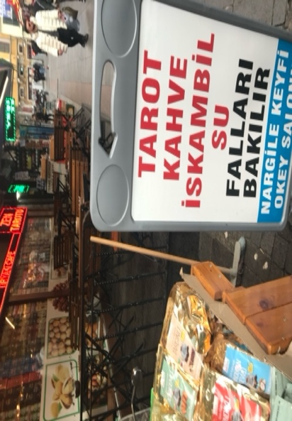
Figure 1. The coffee shop sign that we visited in December 2021in Kadıköy neighbourhood. The sign reads ‘Tarot, Coffee, Cards, and Water, fortune reading’
This memory was evoked while reading Zeynep Korkman’s book, which provides a deeper understanding of the entangled labour, precarity, and affective relations experienced by both fortune tellers and their clients in the intimate publics of the divination economy in postsecular Turkey. I learned that the fortune-telling fee was covertly included in the price of coffee, as it has been illegal to charge for fortune-telling services since the early 1920s when fortune-telling was criminalised as part of Atatürk's modernisation efforts to build a secular Turkey. This criminalisation aimed to eliminate traditional, religious, and superstitious practices from the public sphere and promote more secular activities. Korkman conducted extensive ethnographic research on fortune-telling practices with ‘divination publics’, which consisted of secular Muslim women and LGBTQI+ people enmeshed and subjugated within the multitude of patriarchal and authoritarian power dynamics in Turkey. Korkman utilises the prism of fortune-telling and its dynamics to unpack the gendered, affective, and precarious realities that both the fortune-teller and their clients feel. Her analysis thoughtfully positions her interlocutors' interactions with the divination economy within the context of Turkey’s evolving affective and precarious atmosphere. Most importantly, Korkman adopts a feminist approach to theorise how her interlocutors navigate forms of subjugation, uncertainty, and precarity through the type of labour employed within this practice.
Korkman argues that divination provides an authentic space in which feminised subjects interact freely to share their vulnerabilities and dreams over fortune-telling narratives and intersubjective experiences. In such spaces, divination practices and narratives thrive on ‘(hissetmek – feeling) that bridges deeply felt desires, fears, and anxieties’ (10). Korkman describes this labour as a ‘feeling labour’, a notion that encompasses emotion and affect within the notion of ‘feeling’ that fortune-tellers deploy while describing their source of knowledge and interaction in the telling of ‘fal’ narratives and deal with the anxiety of everyday living with its gendered vulnerabilities and ambiguity. Korkman explains that fortune-tellers refer to the practice of divination as an iterative process of feeling that encompasses attunement with the client as well as diligent expression of emotions and intersubjective empathetic understanding in ways that the client feels understood and recognised (222- 223). Bayhan, the fortune-teller, and Korkman’s interlocutor, describes it as ‘I look into their eyes. I hold their hands. I feel their energy. It is not really about the shapes [of coffee residues]. But if I said things out of the blue, they would be scared. Coffee, tarot cards—these are just instruments’ (161). Bayhan continues ‘“I get a feeling” [içime doğuyor]. Something happens when I see someone. It grows stronger when I touch them. Sometimes without any instruments’ (162). By coining the term ‘feeling labour’, Korkman emphasises the nature of the affective labour through illustrating the intimate interactions between fortune tellers and their clients, revealing the intricate connection between affective and emotional aspects of the divination practice. Korkman argues that this emotional attunement, which Beyhan describes, between the fortune teller and client blurs the boundaries between self and others, as well as between genuine and manufactured feelings (165). Korkman distinguishes between the concepts of emotional, affective, and feeling labour. She explains that feminist scholarship has utilised the concept of emotional labour to reveal gendered workers’ inner emotional states and how they are integrated into draining labour processes to produce the desired emotional outcomes, while the term affective labour emphasises the commodification of affects (164-165).
Korkman unpacks the analytic of the ‘postsecular’ to describe the current socio-political and authoritarian environment in Turkey. Rather than focusing on the dichotomy between the religious and the secular, Korkman tends to multitudinous factors that define contemporary Turkey beyond religion, such as class dynamics, ethnic and racialised politics, the secular elite and Islamist populists, and gendered realities and inequalities. She argues that the distinction between religious and secular is not a fixed or stable concept, but rather a dynamic and contested one. She posits that people who participate in the pastime of fortune-telling, both as customers and practitioners, identify themselves as both secular and Muslim, despite holding seemingly contradictory beliefs. Korkman argues that fortune-telling represents an occult practice in which belief and scepticism coexist and that Turkish people can readily embrace these dual positions in their daily lives. Rather than proclaiming the failure or demise of the secular era, Korkman argued that Turkey in its current postsecular era is both shaped and challenged, and that the proliferation of fortune-telling and occult-based fortune practices has influenced the process of secularisation in Turkey. Korkman traces the political changes under the rule of the AKP (Adalet ve Kalkınma Partisi [Justice and Development Party]) and Turkey’s increasingly Islamic authoritarian reality that affects freedom of speech with increased violations against women and LGBTQI+ movements. She draws on the international politics of the AKP and the end of efforts to gain EU membership, moving away from democratisation and EU membership aspirations and targeting feminist and queer movements while eroding gender-sensitive legal frameworks.
The book is divided into three main parts. The first part is titled ‘The Religious, the Superstitious, and the Postsecular.’ Korkman examines the historical background of the criminalisation of divination practices in Turkey and how they have been influenced by the emergence of the modern Turkish state and Atatürk’s pursuit of rationality and secularism as the fundamental tenets of modernising Turkey. She elucidates the alterations in the public domain and social patterns in contemporary Turkey that have transformed traditionally gender-segregated spaces during the Ottoman Empire into mixed-gender spaces. Korkman’s focus is on secular Muslim fortune-tellers and their relationship with the gender dynamics of Turkish secularism. She unpacks how fortune-tellers negotiate the ambiguity of their livelihoods and embody a form of labour that transcends the paradoxical categories of the religious and secular, masculine and feminine, rational and superstitious, and modern and traditional in postsecular Turkey. The second part is titled ‘Femininity, Intimacy, and Publics’, where she explains that divination publics are intimate communities where feminised subjects engage in emotional and affective labour, forming bonds rooted in feminine, relational intimacy. Korkman argues that public divination can alleviate some of the risks associated with being intimate for gender and sexual minorities, thereby providing relief from the coercive powers of the political public sphere and mainstream public culture. She distinguishes postsecular divination publics from gender-segregated Islamic and gender-mixed secular sociabilities manifested in the formation of public intimacies between women and LGBTQI+ subjects. She situates divination publics in relation to the proliferation of discourses on sexuality and intimacy under AKP rule, particularly in the post-2010 period when marital, reproductive, and sexual intimacies are regulated through heteronormative norms, premarital and pronatalist policies, and coercive powers targeting feminist and LGBTQI+ bodies. The third part of the book is titled ‘Feeling Labour, Precarity and Entrepreneurialism’, where Korkman explains how fortune tellers employ feelings of labour to connect with clients and perform their work in an atmosphere that is precarious and ambiguous. Precarity acted as a driving force to engage in entrepreneurial pursuits by managing their own clients, especially in the current transformative and digitised economies of divinatory practices such as online fortune-telling applications. Furthermore, Korkman defines precarity as a form of sensation and a constant state of feeling anxiety and uncertainty (187), which are not distributed equally between people, as they are subject to gendered and classed dynamics among others.
Korkman explains that divination publics are typically not deemed significant in feminist politics (154). Although fortune-telling cafés are not usually political spaces, they possess potential as proto-political spaces akin to gay clubs or bathhouses, which became sites of resistance in response to oppression. While not considered counterpublics, these juxtapolitical spaces can intersect with political movements, as seen during the 2014 Gezi Uprising, where fortune-telling cafés functioned as havens from police violence and locations for political expression (155). However, their value lies in their distance from formal politics, providing a space apart from the increasingly moralising and disciplinary political sphere in Turkey, which can be hazardous for those marginalised by heteropatriarchal norms (155). Finally, Korkman’s book illustrates the significance of divinatory spaces that offer marginalised and subjugated precariat an intersubjective space that allows them to connect, converse, and experiment with alternative approaches to belonging and to the public to alleviate gendered vulnerabilities in the context of modern Turkey.

This work is copyright of the author.

It has been published by JASO under a Creative Commons Attribution-NonCommercial-NonDerivatives ShareAlike License (CC BY NC ND 4.0) that allows others to share the work with an acknowledgement of the work's authorship and initial publication in this journal as long as it is non-commercial and that those using the work must agree to distribute it under the same license as the original. https://creativecommons.org/licenses/by-nc-nd/4.0/)

JEAN-PAUL BALDACCHINO AND CHRISTOPHER HOUSTON (EDS.) SELF-ALTERATION: HOW PEOPLE CHANGE THEMSELVES ACROSS CULTURES. NEW BRUNSWICK: RUTGERS UNIVERSITY PRESS 2024. 208 P. ISBN: 9781978837225

Summer Qassim

As a comparative collection on how people change themselves across varying ethnographic contexts – China, Italy, Pakistan, Norway, New Zealand, Turkey, Malta, Britain, and the Solomon Islands – this edited volume is quick to distinguish itself from fusing the ubiquity of this self-centeredness with neoliberalism, however far the latter’s global reaches. Eschewing the assumption that, because self-alteration projects are everywhere they must be a result of macro socio-political forces, the volume from the outset takes the position that the omnipresence of self-alteration projects across ethnographic sites and times ‘relativize[s] neoliberal trends and programs, rejecting the argument that contemporary projects and motivations of self-alteration are generated solely by global capitalism’ (2). While a well-established position in anthropology by now, the tendency to inscribe self-alteration’s methodological individualism within global capitalism remains an attractive premise outside the discipline and, as a result, this volume’s careful framing is helpful. That said, the volume’s Part II engages with the socio-political contexts that serve as motivators or provocations for self-alteration, having already examined self-change rather than ‘the ontology of the self’ in Part I. The volume also neatly sidesteps the intellectual minefield of which self is discussed by simply asserting that while the ontological premises of each case-studied-self might differ, the point is that in each case a different self is sought. This sidestepping is convenient in its avoidance. Rather than address the longstanding anthropological question of whether there is a universal notion of the self (contributor Rapport’s methodological individualism notwithstanding), or the cultural relativity of the concept of the self, the editors argue that ‘self-alteration is a cross-cultural universal’ (3), and methodological attentiveness to self-alteration will offer insight into the a priori self-assumed.
Whether or not these projects confirm or deny a knowable, universal awareness of a self is not thoroughly examined, nor is the distinction between these differing, traceable, a priori selves and culturally-relative selves entirely clarified. Nonetheless, this is a comprehensive volume that, in four parts, largely takes a phenomenological approach to understanding the fluidity of a self. There are several strengths to the volume. Orsini’s contribution on Italian anorexia serves as a valuable reminder and reframing that, for those who engaged in disordered eating practices, this mode of self-alteration offers an agency that biomedical models of disease would rather describe as a received mode of suffering. Similarly, Senay’s distinction between the Islamic nafs or lower self/ego offers important context to what might look like simple apprenticeship amongst the reed musicians they observe. Another key insight the volume offers is Rountree’s observation that, amongst Maltese ‘New Age’ shamans, any self-alteration is conceived as connected to a collective Self. What is not made entirely clear in any of the case studies, however, is whether this linkage of lowercase self to any notion of a collective uppercase Self is instrumental, outside of the explicit desire for revolution – does any awareness of waning public support in governance mean overreliance on the interconnectedness of self to Self to effect material change?
Finally, while some of the contributors note that their respective selves changed as a result of participating in self-alteration practices alongside their interlocuters, the volume admits to largely relying on descriptions of self-alteration as ‘unseen’ changes or on narrative presentations to validate their existence (18). The volume would have done well to include ethnographic instances in which the altering self is continuously archived – with one of the best personal archival recordings one’s online presence. Methodological and ethnographic attention to projects that use digital mediums that include analyzing interlocuters’ ‘digital footprints’ would have strengthened the volume’s assertion that methodological attention to the changed self tells us something about the nature of the prior self. There are new anthropological studies that take this explicit focus that are not included in the volume, which is a shame for an otherwise comprehensive comparative collection.

This work is copyright of the author.

It has been published by JASO under a Creative Commons Attribution-NonCommercial-NonDerivatives ShareAlike License (CC BY NC ND 4.0) that allows others to share the work with an acknowledgement of the work's authorship and initial publication in this journal as long as it is non-commercial and that those using the work must agree to distribute it under the same license as the original. https://creativecommons.org/licenses/by-nc-nd/4.0/

JIM CHERRINGTON AND JACK BLACK (EDS.) SPORT AND PHYSICAL ACTIVITY IN CATASTROPHIC ENVIRONMENTS. ABINGDON: ROUTLEDGE 2023. 320 P. ISBN: 9781032125411

GABRIELE PAONE

Sport does not traditionally fall within the classic research themes of the social sciences, having only received academic attention in relatively recent years. However, sport holds significant research potential as it can be considered a ritual and, consequently, a cultural construction in which the values, practices, and identities produced by the individuals who participate emerge (Archetti 1998). But sport is not only a reflection of the society that practices it: it is also a dynamic arena where identities, values, and power structures are shaped and contested, as well demonstrated in Sport and physical activity in catastrophic environments, edited by Jim Cherrington and Jack Black.
This book contains 13 chapters that integrate insights from politics, philosophy, anthropology, sociology, geography, and psychology, to explore the complex relationship between sport, physical activity, and catastrophes — conceptualised here as ‘the end of the world’. The authors argue that this ‘end’ is not a single distant possibility, but rather a multifaceted reality already unfolding globally. They explore this phenomenon through four distinct ‘end’ categories, each corresponding to a different part of the book.
The end of capitalism opens the book, and the focus is on how sport and physical activity can both challenge and reinforce capitalist structures, particularly within post-colonial contexts. For instance, Chapter 1 by Critchley presents a skateboarding project in Kingston, Jamaica, as a space for resisting and reimagining capitalist structures, offering insights into the limitations and obstacles of sport community-commoning as a form of post-capitalist practice. Similarly, Chapter 3 by Giles et al. examines the complex and often contradictory relationships between Indigenous communities in Canada and the extractive industries that operate in the area. This chapter discusses how these industries fund sports and recreational programmes to craft the image of being ‘good neighbours’, while calling for a deeper understanding of these dynamics to prevent the perpetuation of colonial practices.
The second part of the book, the end of the social, focuses on how major crises, particularly the recent COVID-19 pandemic, have affected social norms and structures in relation to sport and physical activity. This part has a dual nature. On one hand, it highlights how sport has served as a fertile ground for fostering resilience and political engagement. A notable example is the Wubble, a controlled environment created during the pandemic for the 2020 women NBA season, where players leveraged their visibility to pursue activist goals, particularly in relation to the Black Lives Matter movement (Chapter 6, Munro-Cook). On the other hand, Begović (Chapter 7) illustrates how sports (and athletes) in Montenegro have been heavily utilised to promote political agendas, being reduced to mere tools for political gain.
The third section of the book delves into the theme of the end of nature caused by the Anthropocene, and how sport can both mirror and influence its impact. In Chapter 8, Cherrington challenges the stereotype of mountain bikers as environmental vandals, arguing instead that mountain biking and trail building can foster a deeper connection with nature, and that this engagement may help individuals better understand and confront environmental destruction. A positive impact on the environment can also be achieved more indirectly, as Amann and Doidge discuss in Chapter 10. They explore how football fans, often viewed as passive consumers of the sport, can become active agents by leveraging their collective power to advocate for environmental sustainability, both within the sport and beyond.
The final part of the book addresses what the authors define as the end of morality. Here, the attention turns to the moral and ethical challenges that emerge in the context of sport and physical activity, particularly in situations where conventional moral frameworks are eroded or questioned by catastrophic events. Sport itself can be a breeding ground for these challenges, as demonstrated by Gibson in Chapter 11. Practices and institutions within sports — whether through sports science research used for military purposes (e.g., enhancing snipers’ efficiency) or in competitive environments where performance is the sole focus — can lead to significant harm, including the dehumanisation of athletes. In the concluding chapter, Ravizza examines how sport can serve as a means of rehabilitation and social inclusion for former child soldiers in Africa. Often marginalised due to actions committed during conflicts, these children can find in sport a valuable tool to reconnect with society. Additionally, sport provides a constructive platform for them to develop essential skills, such as non-violent conflict resolution.
Overall, this book moves beyond the conventional views of sport and physical activity as a panacea, and offers instead a balanced critique that acknowledges both their benefits and drawbacks. It highlights ways in which sport and physical activity can foster positive outcomes such as social inclusion, resilience, and environmental awareness — whether through skatepark spaces used for community activities, former child soldiers in Africa engaging in sport as a means of rehabilitation, or football fans’ potential in mobilising for climate action. At the same time, the book critically examines how sport and physical activity can reinforce colonial power dynamics, as seen in sport-for-development programmes in Cameroon, or be co-opted for political purposes, such as promoting government agendas in Montenegro. Future editions could include other sports and physical activities not considered here that have the potential to play a significant role in challenging environments (e.g., martial arts). While the volume presents unique perspectives and valuable insights, it does face some challenges typical of edited collections, such as varying chapter quality. Nevertheless, it is a valuable read for those interested in how sport and physical activity not only reflect but also shape the complex and often catastrophic environments in which they occur, giving us hope and helping us navigate ‘the end of the world’.

Bibliography

Archetti, Eduardo P. 1998. The meaning of sport in anthropology: a view from Latin America, European Review of Latin American and Caribbean studies 65, 91–103.

This work is copyright of the author.

It has been published by JASO under a Creative Commons Attribution-NonCommercial-NonDerivatives ShareAlike License (CC BY NC ND 4.0) that allows others to share the work with an acknowledgement of the work's authorship and initial publication in this journal as long as it is non-commercial and that those using the work must agree to distribute it under the same license as the original. https://creativecommons.org/licenses/by-nc-nd/4.0/

HUGH TURPIN. UNHOLY CATHOLIC IRELAND: HYPOCRISY, SECULAR MORALITY, AND IRISH IRRELIGION. STANFORD: STANFORD UNIVERSITY PRESS 2022, 325 P. ISBN: 9781503633131

JACOB EVANS

With the dust still settling from the tremendous fall from grace that the Catholic Church is experiencing from scandals ranging from abuse of power by ordained clergy to the discovery of mass graves on Church property, Hugh Turpin brings us on an incredible ethnographic journey through the ‘last Catholic country’ (Pope Paul VI, p. 22) as it struggles to reconcile with an increasing disparity between the Church’s structures of morality and those of the public. In conducting this ethnography, Turpin examines the moral and conceptual dilemmas of identity that the people who make up ‘Holy Catholic Ireland’ (5) are facing as the decline of Catholicism threatens to unravel the social and cultural identities that the country has professed since 1921.
Turpin weaves an amazing narrative of what ordinary people are feeling as he questions how they continue to justify their stance toward Catholicism in a society that no longer considers it as the ‘Alter Christus’ (1). I credit Turpin’s compelling narrative to his wonderful use of ethnography which is made possible by his diligence and familiarity with the culture and language of Ireland. From casual conversations at parades and protests to structured interviews, Turpin captures the raw emotions and feelings of his interlocutors and brings you into these conversations with quotes from participants like ‘the Church are a bunch of pricks but the current lad seems alright’ (93).
The rawness of his ethnographic work makes the interlocutor case studies in Chapter 3 and his participant observation outlined in Chapter 5 all that more impactful as the words jump out of the page and bring you into the traumatic and confusing process of religious decoupling. Specifically, the case study of his interlocutor Peter, as he struggles with the rejection of Catholicism in his own life but the decision to include it in his child’s, paints a vivid picture of the internal moral and ethical turmoil that Ireland is facing as ‘what was once unimpeachable […] has now become impure, desacralized, and openly questionable’ (94), but that remains socially essential.
While Turpin’s ethnographic work alone is compelling, it is further complemented by his integration of quantitative methods. The resulting mixed-methods approach avoids the usual pitfalls of this compromise and instead bolsters both types of data. The charts and figures in Chapter 2 quantitatively describing the decline of Catholicism in Ireland give context to the ‘complex scene of secularization and fragmenting consensus’ (12) outlined in Chapter 1. As the book transitions to ethnographic data, the conclusions drawn in the first two chapters become thick in their description, as the numbers represented in Chapter 2 materialize as the individuals, families, and communities that find themselves in the chaotic and confusing fray caused by Ireland’s divorce from the Catholic Church.
Concluding the book, Turpin expertly points out that Catholicism is more than just a religion in Ireland. Pointing out the complex relationship that religion and religious institutions have in our conception of self, social and cultural structures, and the imagination of the nation-state. As Ireland and other highly religious countries continue on a path of secularization, Turpin’s book will remain an excellent examination of the thoughts, feelings, and emotions of the people caught in the middle. Turpin’s book highlights that the separation of church and state is not as linear as some would have us believe and that in this messy separation, a vacuum is created that people will fill by shifting and molding their existing cultural and social structures to fit the new space. Overall, this book is a fantastic read and an interesting look at the contemporary questions and queries that religion still presents to anthropologists as we continue transitioning to an ever more secular world.

This work is copyright of the author.

It has been published by JASO under a Creative Commons Attribution-NonCommercial-NonDerivatives ShareAlike License (CC BY NC ND 4.0) that allows others to share the work with an acknowledgement of the work's authorship and initial publication in this journal as long as it is non-commercial and that those using the work must agree to distribute it under the same license as the original. https://creativecommons.org/licenses/by-nc-nd/4.0/)

ROOSBELINDA CÁRDENAS. RAISING TWO FISTS: STRUGGLES FOR BLACK CITIZENSHIP IN MULTICULTURAL COLOMBIA. STANFORD: STANFORD UNIVERSITY PRESS 2023. 274 P. ISBN: 978-1503635807

DANIELA VIECILI COSTA MASINI

Raising two fists is the result of over 15 years of immersive ethnographic research with anti-racism activists in Colombia. Through her work, Roosbelinda Cárdenas offers a nuanced and comprehensive analysis of how some of the country’s leading Afro-Colombian organizations have advocated for what she terms as ‘Black Citizenship’, highlighting their strategies, challenges, and successes in combating systemic racism and demanding rights to national inclusion.
The book is not only about activism but is in itself part of the author’s political engagement within Colombian social movements. Cárdenas’ work is both a tool for documenting Afro-Colombian activists’ voices, and a means of amplifying and contributing to them. Through her critical engagement, she showcases an interesting example of engaged and collaborative anthropology, challenging colonial legacies embedded in academic practices, where research often serves only external audiences without contributing to the communities being studied.
Cárdenas delves into the limits and possibilities of the various political strategies that these activists have used in their struggles for justice, specifically, in demanding rights from the state through the language of multiculturalism. The book inserts itself into a broader Latin American scholarship that has delved into the issue of multiculturalism (Rivera Cusicanqui 2010), bringing meaningful ethnographic contributions to how it unfolds on the ground, and how it shapes people’s identities and socialities.
The book’s title, Raising two fists, refers to the dual strategy these activists adopt: both claiming full citizenship rights as members of a multicultural state, and seeking to strengthen diasporic solidarities amongst Black peoples. The author argues that such diasporic movements represent a way through which Afro-Colombians navigate and transcend the constraints of the state.
By bringing attention to ‘beyond-the-state’ political strategies, her own research serves as fuel to dream ‘bigger dreams than state-sanctioned rights to difference’ (60). Her exploration of what it means for Afro-Colombians to vivir sabroso (to live well) and to defend peace offers a transformative perspective on justice and well-being. For these activists, peace is not merely the cessation of declared war, but also the dismantling of structural inequalities that perpetuate black people’s suffering and death. This broadened understanding of peace refers to what, in this book, is discussed as fostering politics of life, instead of politics of death.
Whilst Cárdenas’ focus on diasporic connections is compelling, her emphasis on its northward trends, giving special attention to Colombian ties with Black North American social movements, misses an opportunity to engage more directly with anti-racism struggles within the broader context of Latin America. Nevertheless, Raising two fists offers valuable insights into the potentials and limitations of fighting for Black citizenship beyond Colombia, contributing to a more solid understanding of multiculturalism across other Latin American contexts.
As Cárdenas discusses, the language of multiculturalism is intertwined with the politics of victimization of black people. She lays out a critical view, without falling into presumptuous academic cynicism that tends to dismiss how research collaborators evaluate their own struggles. Instead, the author engages with their perspectives thoughtfully, recognizing the agency and wisdom embedded in their actions, while critically analysing the broader structural and historical forces that shape their experiences.
For example, when analysing the inclusion of an ‘ethnic chapter’ in the peace accords between FARC and the Colombian state (which was meant to safeguard differential reparations towards Afro-Colombians and Indigenous populations affected by the conflict), Cárdenas calls attention to how this was a victory for Black movements in the country. However, it also consisted of an attempt to integrate Afro-Colombians into a national project, rather than actually changing it. Fundamentally, the book helps understanding what it means for black activists to play a political game ultimately defined by a state whose institutional apparatus is the same that commits genocide against them.
Furthermore, Cárdenas skilfully addresses the complexities of the Colombian context of long-term armed conflict, narco-traffic, enduring colonial legacies, and pervasive economic extractivism, showing how these intersect in producing dispossession and displacement of Afro-Colombians. And despite these themes’ complexity, her writing remains accessible for those who wish to familiarize themselves with Colombia’s more recent political history.
Although the author explicitly states that her objective is not to directly contribute to the extensive literature on war and violence in Colombia, her ethnographic findings bring interesting insights about this matter. For instance, how, amongst campesinos, participation in the illegal coca market could be understood as a strategy of survival in the face of the state’s neglect, which resonates with other scholars (Ramírez de Jara 2001, Zapata, Herrera and Tapias 2023).
Campesinos’ participation in networks of narco-traffic complicates the boundaries set between politics of life and politics of death and challenges the clear-cut distinction between ‘us/afro-victimas’ and ‘them/guerrilla’ often adopted by activists in their interactions with the state. The book could have further explored this matter, since it points to yet another risk of the politics of multiculturalism and victimization in Colombia, that consists of deepening the stigma of those involved in illegal activities and turning invisible the contexts of inequality in which violence and narco-traffic unfold. In this context, Black citizenship risks being only for those who manage to fit into the dominant language of victimization.
Finally, Cárdenas’ engagement with Colombian scholarship deserves special mention. Unlike the prevalent tendency in Global North academia to overlook the contributions of local academics — treating field sites primarily as sources of data extraction rather than spaces of meaningful intellectual dialogue — Cárdenas recognizes and engages with reflections and discussions emerging from within Colombia. In doing so, the book not only enriches its own analysis but also contributes to dismantling academic hierarchies rooted in colonialism.

Bibliography

Ramírez de Jara, María Clemencia 2001. Between the guerrillas and the state: the cocalero movement, citizenship and identity in the Colombian Amazon, Harvard: PhD Thesis.

Rivera Cusicanqui, Silvia 2010. Ch’ixinakax utxiwa: una reflexión sobre prácticas y discursos descolonizadores, Buenos Aires: Tinta Limón.

Zapata, Edwin Alexander Hernández, Herrera, Milton Danilo Morales and Nayib Esther Carrasco Tapias 2023. Discurso e ideología en la afiliación a grupos guerrilleros en Colombia: más allá de la simpatía ideológica, Dados 66/3, e20200375.
doi: https://doi.org/10.1590/dados.2023.66.3.299

This work is copyright of the author.

It has been published by JASO under a Creative Commons Attribution-NonCommercial-NonDerivatives ShareAlike License (CC BY NC ND 4.0) that allows others to share the work with an acknowledgement of the work's authorship and initial publication in this journal as long as it is non-commercial and that those using the work must agree to distribute it under the same license as the original. https://creativecommons.org/licenses/by-nc-nd/4.0/)

ANNEMARIE GOLDSTEIN JUTEL. PUTTING A NAME TO IT: DIAGNOSIS IN CONTEMPORARY SOCIETY. SECOND EDITION. BALTIMORE: JOHN HOPKINS UNIVERSITY PRESS 2024. 216 P. ISBN: 9781421448923

LEIGHTON SCHREYER

The verbal act of presenting a patient with a diagnosis is never a simple act of conveying value-neutral biomedical information. It is an act fraught with symbolism.
– Suzanne Fleischman (1999: 10)

Annemarie Goldstein Jutel’s Putting a name to it is a far-reaching exploration of the sociology of diagnosis that deconstructs the view of diagnoses as prior ontological entities, revealing them to be ‘social categories that organize, direct, explain, and sometimes control our experience of health and illness’ (166-67). Jutel’s main argument revolves around the idea that diagnoses are not just neutral labels for health conditions but emerge from and are influenced by broader societal contexts, including political, economic, and cultural pressures, technological advancements, medical practices, and shifting social norms.
More than a category, Jutel argues that diagnosis is a process, which she seeks to lay bare, beginning with an interrogation of classification practices. As one of medicine’s most powerful classification tools, diagnoses help decide ‘how the vast expanse of nature can be partitioned into meaningful chunks, stabilizing and structuring what is otherwise disordered’ (17). By identifying a certain expression of symptoms or behaviours as disordered, diagnosis serves as ‘a cultural expression of what a given society is prepared to accept as normal and what it believes should be treated’ (4), which is to say that diagnosis ‘must be viewed as a social product of consensus rather than a natural one’ (41, emphasis mine). To illustrate how diagnoses are socially framed and negotiated, Jutel considers the shifting boundaries of two conditions—overweight and stillbirth—across time and space, considering how societal values and norms concerning appearance and bodily autonomy, for instance, are inscribed into and through medical practice.
At the personal level, Jutel describes how ‘[t]he pursuit of diagnosis brings patient and doctor together’ (66). For the patient, receiving a diagnosis may offer clarity, confer legitimacy to one’s illness experience, and help the individual find community among people who share a diagnostic label, yet it can also lead to discrimination, stigmatization, and the devaluing of lived experience. Issuing a diagnosis, on the other hand, ‘confers power to the doctor as allocator of resources’ (69). Importantly, as the roles of patient and doctor change with the diffusion of informational knowledge through e-scaped medicine and the rise of self-diagnosis, so too do the power dynamics that diagnosis engenders and the medical authority it holds. Where diagnosis takes on a particularly interesting place, is in the case of contested, or medically unexplained, diseases such as fibromyalgia, chronic fatigue, and long COVID, which Jutel elaborates on. For many such conditions, lay activism has played an important role in disease recognition.
Jutel further considers the phenomenon of medicalization by presenting diagnosis as an ‘engine’ that is driven by commercial interests, including but not limited to those of the pharmaceutical industry. She delves into this through a study of the creation and promotion of Female Hypoactive Sexual Desire Disorder (FHSDD), which was ‘influenced by a convergence of three factors: pharmaceutical companies, urologists closely associated with this industry, and media-savvy sex therapists operating in the for-profit sector’ (108). Jutel reveals similar economic interests to also govern technologies such as medical imaging and genetic testing, which make diseases visible and diagnosis possible, and which present individuals as always-already sick and in need of treatment. However, she is careful not to view technology ‘simply as a tool of social control’ (141) and creates space for the hope that technological advancement brings.
New to the second edition of this book is a chapter on ‘COVID-19 as a sociological phenomenon’ (145-56), in which Jutel provides a timely examination of how COVID-19 is ‘shaped by the same social forces as any other diagnosis’ (145). Her analysis of the emergence of and response to the diagnosis of COVID-19 seeks to show ‘us how the seemingly neutral disease label is a rich social phenomenon, dependent on consensus and power, linked to resources and therapeutics, stigmatizing and valorous, and a trigger for myriad social actions’ (155-56).
Annemarie Goldstein Jutel’s Putting a name to it, now in its second edition, is influential in exploring the cultural, social, and medical aspects of diagnosis, but it is not without its criticisms and points of contention. Jutel’s book primarily focuses on the Western medical system and may not fully (or even begin to) account for the diversity of diagnostic practices in different cultural or international contexts. A deeper sociological analysis would have considered diagnostic practices across more diverse contexts, including different approaches to health offered by traditional or alternative medicine that do not rely on the Western diagnostic paradigm. Moreover, although Jutel offers an insightful critique of how diagnoses function within society, she doesn’t always provide clear or actionable solutions for how to address the issues she raises. That said, she acknowledges that this is not her intention. Rather, Jutel describes her efforts as painting, ‘with a broad brush, […] the place of naming in medicine and the tensions naming can engender’ (16). Jutel acknowledges that her model for the social understanding of diagnosis is not absolute or complete; that she has herself ‘created categories into which [she is] forcing reality’ (164) in order to present her ideas in a cohesive and seemingly sound manner.
Notwithstanding these limitations, the book stands as an important contribution to the sociology of diagnosis in Western biomedicine and positions the dynamic social nature of diagnosis and diagnostic practices as an important point of academic reflection and study.

Bibliography

Fleischman, Suzanne 1999. I am…, I have…, I suffer from…: a linguist reflects on the language of illness and disease, Journal of Medical Humanities 20/1, 1-31. doi: https://doi.org/10.1023/A:1022918132461

This work is copyright of the author.

It has been published by JASO under a Creative Commons Attribution-NonCommercial-NonDerivatives ShareAlike License (CC BY NC ND 4.0) that allows others to share the work with an acknowledgement of the work's authorship and initial publication in this journal as long as it is non-commercial and that those using the work must agree to distribute it under the same license as the original. https://creativecommons.org/licenses/by-nc-nd/4.0/)

ALEX K. GEARIN. GLOBAL AYAHUASCA: WONDROUS VISIONS AND MODERN WORLDS. STANFORD: STANFORD UNIVERSITY PRESS 2024. P. 296. ISBN: 9781503636576

MEGAN JENKINS

Attempting to overcome simplistic, singular renderings of ayahuasca ceremonies, Alex Gearin – as suggested in the title Global ayahuasca – attends to the consumption of the psychoactive brew across three international contexts. These are Perú, where largely North American and European tourists interact with indigenous Amazonian practitioners; Australia, where ayahuasca is a relatively new phenomenon consumed in ‘neo-shamanistic’ ceremonies; and China, where ayahuasca is sought after for its ability to enhance one’s performance in the workplace.
First outlining the history of both ayahuasca itself and the existing scholarship in the introduction, Chapter 1 dives into the colonial and postcolonial histories of its use and export in and from South America in the 17th and 18th centuries. Chapters 2 and 3 then describe ethnographic fieldwork undertaken in Perú, and the nature of ayahuasca tourism at retreats commercially run by Shipibo indigenous healers. Chapter 4 then examines the more (though not entirely) secularised practice of ayahuasca ceremonies in Australia, where ayahuasca is a relatively new phenomenon popularised at the turn of the millennium, and where its religious significance has been transformed into a quasi-secular ‘spiritualism’ and praised as an escape from the city into nature. The final case study, Chapter 5 investigates the Chinese phenomenon – the most difficult to gain access to due to strict drug laws – of ayahuasca ceremonies performed for their ability to make one better at one’s job, as well as navigating the broader challenges of life in 21st-century capitalist China. Chapter 6 explores ‘integration’ – tracing the ways in which participants from all three contexts made the wondrous visions they had experienced actionable in their everyday lives.
The book is ethnographically rich, often describing at length the personal stories of interlocutors through the insights they reached through taking ayahuasca, which allows the reader to understand both the deeply moving, transformational potential of the brew and the rich variance in biographical backgrounds of its consumers. In so doing, Gearin strikes an effective balance between looking at broad power structures within which these ceremonies are performed and sought after while also maintaining an empathetic appreciation for these journeys.
Global economic inequality runs through Gearin’s ethnography, but he only pulls it out explicitly in his conclusion; capitalism is, as he puts it, the ‘common meta-axis’ around which his interlocutors’ psychedelic experiences ultimately revolved. This was partly due to the commercial nature of his research sites, but further, ayahuasca experiences were often defined by capitalism in the negative, insofar as ayahuasca retreats in Perú and Australia were motivated by a desire for escape from the incessant demands of capitalist labour. In China, by contrast, ayahuasca was sought for its enhancement of the drinker’s capacity to labour. In the concluding chapter, Gearin offers a question for future ethnographies on the topic: how is inequality made manifest even in the experience of its transcendence through psychedelic substances?
A further tension drawn out is the desire to balance anthropological respect for cultural context with respect for the transcendental qualities of psychedelics which in many ways induce universal psychological states. Running through both the ethnographic vignettes and their analysis, this tension is made most explicit in the chapter on ‘Integration and society’ — this section is thus most unique and insightful. Drawing together insights from all three of the contexts, Gearin traces the diverse ways in which participants ‘integrate’ the lessons learned from their experience with ayahuasca into their everyday lives, and the challenges this raises for them as they attempt to both return to and transform those lives considering their psychedelic visions. It is in these processes that the cultural context most clearly announces itself. The visions, Gearin suggests, are inevitably shaped by the world in which they are experienced; this is true from the moment of seeking them out, colours the content of the visions themselves, and becomes especially salient as participants attempt to integrate.
Time is a thread that again is only pulled on explicitly at the end. However, it is present from the first chapter’s analysis of the colonial history of ayahuasca, where Gearin outlines how ayahuasca brewing and consumption was in fact not a particularly widespread practice among indigenous Amazonians until the past couple of centuries – despite the widespread vision of it among white Euro-American tourists as an ‘ancient’ indigenous practice. It is also an undercurrent in his analysis of ‘primitivist tourists’ attending Peruvian ceremonies, searching for a primordial escape from the trappings of modernity. Ironically, for the leaders of such ceremonies, the commercialisation of their services is an entry point into the modern capitalist economy. The account of the Chinese experience contrasts this with the notion of an enchanted modernity, rather than an escape from it. Time does not only feature in this abstract analytical sense, however; it also figures centrally in the visions themselves. For most non-Indigenous users of ayahuasca, Gearin describes, visions are often intimately tied to the past – memories take on a magical quality, able to be recalled with stunning clarity; traumas and difficult moments are revisited – and in the integration phase, able to be overcome so that everyday life can resume with a new psychic freedom. For indigenous practitioners, however, the visionary quality of ayahuasca has been long praised for its facilitation to see the future. It is through this analysis in the conclusion that the value of this international, comparative ethnographic approach shines most clearly and Gearin’s expert mediation between the micro and the macro of temporality.
Rather than tipping into nihilistic relativism (Rabinow 2011) Gearin manages to effectively communicate a sense of shared desire for betterment in a way that ultimately highlights ‘the person in the social and visionary experiences they inhabit, navigate, and help to animate’ (193). He deftly navigates the perennial anthropological struggle between the particular and the universal, structure and agency, with his international approach and openness to ‘true’ visionary experience a fruitful perspective from which to consider these questions. It not only provides an interesting and clear ethnographic account of the world of ayahuasca for unfamiliar readers, but also provokes discussion of broader themes which can be taken up not only in similar ethnographic contexts but by anthropologists of capitalism and extraordinary experiences alike.

Bibliography

Rabinow, Paul 2011. Humanism as nihilism, in The accompaniment: assembling the contemporary, Chicago, IL: University of Chicago Press.
doi: https://doi.org/10.7208/chicago/9780226701714.001.0001

This work is copyright of the author.

It has been published by JASO under a Creative Commons Attribution-NonCommercial-NonDerivatives ShareAlike License (CC BY NC ND 4.0) that allows others to share the work with an acknowledgement of the work's authorship and initial publication in this journal as long as it is non-commercial and that those using the work must agree to distribute it under the same license as the original. https://creativecommons.org/licenses/by-nc-nd/4.0/

MICHEL VERDON. TOWARDS AN OPERATIONAL SOCIAL ANTHROPOLOGY VOLUME 1: AN EPISTEMOLOGICAL HISTORY OF SOCIAL ANTHROPOLOGY. ENGLAND: GROSVENOR HOUSE PUBLISHING 2024. P. 210. ISBN: 9781803819525

V. EMMANUEL LEON

Verdon states that kinship is the core of anthropology. Researchers’ assumptions and projections of their conceptions of what it means to be human (ontology) and their assumptions about their ‘ways of knowing’ (epistemology) have been issues that haunt the discipline (12-13). Verdon skilfully argues that, by reassessing the foundations of anthropology, we can find a solution to produce an operational anthropology by parting from a singular conception of ontology. In this first volume, we delve into the theoretical foundations of kinship studies – descent, corporations, alliances, exchange, Marxist, and transactionalist theories – to understand anthropological praxis up to the beginning of the 1980s. This volume serves as a prelude to a second volume that will directly discuss how to produce an operational social anthropology.
Within the preface, we learn that this book series is, in essence, a translated and republished version of Verdon’s original book, Contre la culture, in two volumes. Additionally, he mentions that Contre la culture is a rework of a series of articles he wrote in the 1980s and 1990s (1). Volume 1 showcases Verdon’s mastery over foundational texts and their impact in the discipline up to the 1980s. However, the use of language such as ‘contemporary’ for works written in the 1980s suggests that some further revision and referencing of more recent debates could strengthen the connections between the critical and much-needed historical insight Verdon provides, and current anthropological discussions.
As a standalone volume focused purely on providing a critical account of the epistemological history of anthropology up to the 1980s, it does a fantastic job. While he does not situate his findings in conversation with contemporary works, his solution of parting ways from a singular ontology/cosmology deeply resonates with the concept of epistemological pluralism, as coined by Boghossian (2006). This concept is contemporarily discussed by interdisciplinary academics surrounding, within and outside anthropology (Arantes 2023, Gatt, 2023, Basu 2024, Escobar 2020). It would be interesting to see how Verdon could use his mastery of dissecting and tracing the transformation of ideas over time to understand the epistemological history behind 21st-century ways of knowing in anthropology.
Focusing on the contents of this first volume, first, he moves from Maine to McLennan with his work, Primitive marriages (20). Verdon highlights McLennan’s misunderstandings and refusal of Maine’s arguments regarding descent (22). Then he examines the impact of McLennan on academics, such as Morgan, in The League of Iroquois. According to Verdon, the epistemological assumptions that taint the discipline originate from this period, marked by the spread of evolutionist ideas that create incompatible binaries between groups, including interpersonal relations, domestic and political spheres, and structures of descent with territoriality. As Verdon discusses, these theoretical binaries would be reconciled in Rivers’ work, Social organisation (31), where Rivers mediates Morgan’s and Maine’s ideas into descent theory (27) through the distinction between domestic and political levels (30). Afterwards, Malinowski, according to Verdon, in The Argonauts and Crime and customs in savage society (29), gave space for academics to reconcile this so-called incompatibility by using participatory observation.
After this, Verdon introduces mid-20th-century ideas, beginning with Lévi-Strauss’ structuralist ideas, as presented in his work Structures élémentaires. Verdon describes the influence of Mauss’ Gift exchange (69) on Lévi-Strauss’ work, noting that his arguments regarding incest and alliance theory, specifically the exchange of women, are deeply rooted in Mauss’ functionalist ideas of exchange (76). While Verdon presents an overall well-structured argument, his versatility with Lévi-Strauss' work is not as clear as it is with Maine, McLennan, Rivers, and Morgan. While his analysis of Lévi-Strauss’ theories is deeply rich, this could have been streamlined more effectively to focus on aspects that directly advance the epistemological history of anthropology, as he can be at times too descriptive. Nonetheless, he compensates for this by contrasting and tracing how evolutionist thoughts and positivist agendas continued to impact the epistemologies of anthropologists around this time, particularly among French academics.
Regarding Marxism in the mid-late 20th century, Verdon dissects ethnographic examples of how Marxism is used in kinship studies (70) - for example, the work of Bloch and Meillassoux. Regarding Meillassoux, Verdon tracks the impact of the evolutionist paradigm (85) in Femmes, greniers et capitaux. In this work, Meillassoux, as analysed by Verdon, projects his evolutionary assumptions about the need to replace maternal filiation with paternal filiation under the pretext of a higher production-based argument. Verdon explains that Marxism falls ill with the same Western patterns and definitions of kinship (93), only that it repeats, albeit in a different rhetoric’ (94). While Anglo-Saxons would argue based on morality, Marxists would argue in terms of production; however, the root of their epistemic failures stems from the same place – the assumption of a singular ontology that limits openness to other ways of learning.
In terms of transactionalism, Verdon presents a somewhat love-hate relationship. He traces the ancestry of transactionalism as far back as Malinowski’s work (99), where a practical break from the lack of recognition of the individual in what was previously poorly termed ‘primitive people’ is evident. Transactionalism would present itself as an alternative to descent theory (128). Nonetheless, Verdon explains this would also have been taken to the extreme, where collective-based arguments were discarded, and individuals’ de-personalising arguments would be singled out as correct.
In conclusion, this work demonstrates Verdon’s strengths in his deep knowledge of the historical roots of anthropology, as evidenced by his critical, concise, and structured writing style. However, streamlining arguments by revising contemporary discussions could strengthen his arguments and support his aim of building a living operational social anthropology. In this first volume, he constructed and traced different ways of knowing from the impact of 19th-century thinkers such as Maine and McLennan up to Schneider’s transactionalism (99). Then, he uses all these findings to start building his argument against a singular ontology and epistemology, which will be followed up in the second volume of his series ‘Towards an operational social anthropology’. Overall, this volume lays a critical foundation for a second volume. The impact of this upcoming volume could be further enriched by explicitly weaving the historical epistemological roots of anthropology with current anthropological and ethnographic debates.

Bibliography
Arantes, Lydia Maria 2023. Stitching together (in) anthropology class: on the use of craft practices in Higher Education Humanities, FORMakademisk. Research Journal of Design and Design Education 16/4, 1-9. doi: https://doi.org/10.7577/formakademisk.5386.

Basu, Paul 2024. Towards the pluriversal museum: from epistemic violence to ecologies of knowledges. Museums & Social Issues 18/1-2, 1–16.
doi: https://doi.org/10.1080/15596893.2024.2333658

Boghossian, Paul 2006. Fear of knowledge: against relativism and constructivism, Oxford: Oxford University Press.

Escobar, Arturo 2020. Pluriversal politics: the real and the possible, translated by David Frye. Durham, NC: Duke University Press.

Gatt, Caroline 2023. Decolonizing scholarship? Plural onto/epistemologies and the right to science, Frontiers in Sociology 8. doi: https://doi.org/10.3389/fsoc.2023.1297747

This work is copyright of the author.

It has been published by JASO under a Creative Commons Attribution-NonCommercial-NonDerivatives ShareAlike License (CC BY NC ND 4.0) that allows others to share the work with an acknowledgement of the work's authorship and initial publication in this journal as long as it is non-commercial and that those using the work must agree to distribute it under the same license as the original. https://creativecommons.org/licenses/by-nc-nd/4.0/)

BRADY G’SELL. REWORKING CITIZENSHIP: RACE, GENDER AND KINSHIP IN SOUTH AFRICA. STANFORD: STANFORD UNIVERSITY PRESS 2024. 312 P. ISBN: 9781503639171
MAXIME BOURDIER

Decades of disillusionment with the post-apartheid promise of democracy, which ignited in South Africa during mass protests in 2021, underpin Reworking citizenship: race, gender and kinship in South Africa. Based on two decades of engagement with the country and one spent in the Point neighbourhood of Durban (57), Brady G’sell deftly ties literature on race, gender, and labour into a well-considered discussion of ‘relational citizenship’ (204-205). Reworking citizenship is anchored around the notion of kinshipping, or ‘the formation and solidification of relationships expressed in a kinship idiom’ (5). For her informants, social and political belonging was ‘constituted through […] relationships that were insecure’ (186). Forging these webs of relationships with family, neighbours, lovers, and the state becomes ‘the very structure by which economic resources are distributed and social reproduction is enabled’ (16). Kinshipping becomes a way of creating and maintaining those relationships, of making them feel more secure through reciprocal economic, affective, and political obligations. Methodologically eclectic, G’sell provides a textured account of the increasingly politicised category of motherhood through oral histories, participant observation, archival research, and interviews.
The first three chapters provide historical and contemporary context, while the last three explore different livelihood strategies. Chapter 1 lays out the Point neighbourhood as ‘segregated yet heterogenous, interdependent yet discordant, and poor yet rich in resources’ (58). The resulting ‘kinshipping in a kinless place’ (42) makes livelihood strategies and their justifications starkly visible. Chapter 2 historicises the category of motherhood through an analysis of welfare policies. Apartheid was sustained through the welfare state, testifying to the anxieties of white national purity and maintaining race and class hierarchies. In Chapter 3, G’sell explores the crafting – and policing – of good motherhood through Children’s Court cases from 1949 to 1998. The archival ethnographies of Grace, Magdalena, and Rosemary demonstrate how the shifting categories of race, gender, and class are also instrumentalised by women in the Point. With detailed ethnographic vignettes of the quotidian negotiations of Point mothers, Chapter 4 centres on the lives of 15 women and examines the ‘repertoires of verbal and nonverbal expression’ (137) characteristic of the fluid perception of motherhood. Chapter 5 takes us courtside, exploring Maintenance Courts as ‘a performative sphere of democracy’ (167) through which not only are claims for resources made, but the intimate economies of modern South Africa are renegotiated. The decision to take a former boyfriend to court was torn between longing for reconnection or retribution (171), providing another strategy for rhetorical empowerment, material redistribution, and ultimately reworking belonging in the nation. Chapter 6 describes another such livelihood strategy, investigating the often poorly perceived marriages between South African women and foreign African men. Her continued references to multiple interviews with social workers (Chapter 3) are particularly insightful. Their experience reminds us to investigate institutional oppression not solely through an ideological lens but also through the personal affective relationships that actors of the state build in their daily work. The overall emphasis on the social relations that signify political and economic belonging in South Africa provides compelling support for Nyamnjoh’s advocacy of ‘relational citizenship’ premised on the interdependence of persons.
The transformation of citizenship captured by G’sell is acknowledged as being the result of global neoliberalisation and its restructuring of the nation-state as premised on economic participation (Brown 2015). This situates Reworking citizenship firmly within the now well-discussed turn to ‘Dark Anthropology’. There is undeniable value in both those ‘cultural critiques’ that dissect the dark realities of the world we live in and the body of work which explores new social movements while critically unpacking monolithic assumptions about neoliberalism and capitalism (Ortner 2016). G’sell’s work sits in the former category, and the potential Point mothers’ claim-making offers for imagining alternative futures is not done justice. Despite being mentioned at the end of the conclusion (211-214), the activist outlook remains understated throughout the body of the monograph. Reworking citizenship could more effectively distance itself from being an ethnography of suffering that fringes on what could be read as ‘voyeuristic quasi-pornography’ (Kelly 2013).
Emphatically embracing the incompleteness of citizenship (Nyamnjoh 2022) forces us to reconsider hegemonic assumptions about the perfect citizen and their genealogies. Especially flagrant in a post-apartheid South Africa where the feeling of empty democracy is prevalent (1), ‘no institution, however carefully thought through from the outset, is perfect’ (Nyamnjoh 2022: 597). The axiomatic completeness of juro-legal citizenship obscures the potential affordances that characterise Point mothers’ kinshipping. G’sell’s discussion of the Muslim Sisterhood (Chapter 6) stands out here. Instead of being framed on what these relationships lack, she focuses on how important Zulu and Xhosa social values such as ilobolo (bridewealth payment) are renegotiated in light of cultural differences and the changing nature of labour. Paying ilobolo not only reinstated the social value of future wives (194) but also secured social reproduction and in doing so ‘strengthened feelings of belonging within South Africa’ (186). Instead of trying to simulate the social status of marriage and thus alleviating the burden of not conforming to modern citizenship standards, marrying foreigners becomes mobilised in transforming the very parameters of that citizenship. Moving beyond the bleakness felt throughout the chapters, ‘hustling’ and ‘getting by’ can thus be reframed as more than everyday weapons of resistance: they become methodological and theoretical tools in their own right. The various livelihood strategies described are no longer forms of strategic survival or simple examples of relational citizenship for Point women but become the way through which we should rethink the category of citizenship itself.
Overall, the historical depth of its highly textured ethnographic material makes Reworking citizenship a well-considered template for studies of South Africa and offers rich comparative perspectives for scholars deconstructing the rigid categories of citizenship more generally. Understanding social reproduction through the mobilisation of race, class, and the increasingly politicised category of motherhood is essential to seeing inequities only visible when considering ‘citizenship as lived’ (204). Relational citizenship, wherein Point mothers ‘demanded collective recognition that they were not just autonomous subjects but relational persons’ (32), provides a framework for subverting a Foucauldian governmentality that seeks to isolate political subjects. Yet, the richness of Reworking citizenship often dampens its theoretical potential, leaving the reader contemplating the emptiness of a promised citizenship instead of embracing the productivity inherent in its incompleteness.

Bibliography

Brown, Wendy 2015. Undoing the demos: neoliberalism’s stealth revolution. Brooklyn, New York: Zone Books
Kelly, Tobias 2013. A life less miserable? HAU: Journal of Ethnographic Theory 3/1, 213–16. doi: 10.14318/hau3.1.020.
Nyamnjoh, Francis B. 2022. Citizenship, incompleteness and mobility, Citizenship Studies 26/4-5, 592-598. doi: 10.1080/13621025.2022.2091243.
Ortner, Sherry B. 2016. Dark anthropology and its others: theory since the eighties, HAU: Journal of Ethnographic Theory 6/1, 47-73. doi: 10.14318/hau6.1.004.

This work is copyright of the author.

It has been published by JASO under a Creative Commons Attribution-NonCommercial-NonDerivatives ShareAlike License (CC BY NC ND 4.0) that allows others to share the work with an acknowledgement of the work's authorship and initial publication in this journal as long as it is non-commercial and that those using the work must agree to distribute it under the same license as the original. https://creativecommons.org/licenses/by-nc-nd/4.0/)

HELEN HOLMES. THE MATERIALITY OF NOTHING: EXPLORING OUR EVERYDAY RELATIONSHIPS WITH OBJECTS ABSENT AND PRESENT. NEW YORK: ROUTLEDGE 2024. 163 P. ISBN: 9780367655570.

LAURA BERGIN

Helen Holmes’ The materiality of nothing offers a provocative intervention in material culture studies by foregrounding absence as an active and generative force in everyday life. Drawing on interdisciplinary frameworks from anthropology, sociology, and science and technology studies, Holmes challenges conventional understandings of materiality, arguing that absent objects, whether lost, discarded, forgotten, or unmade, continue to shape social relations, emotions, and practices. Through a series of case studies, the book demonstrates how absence operates within domestic spaces, digital environments, and sustainability initiatives, positioning ‘nothingness’ as a critical site of inquiry.
Throughout the book, Holmes argues that material absence is an ongoing process with social, political, and affective consequences. This assertion builds on and extends established anthropological work on materiality (Miller 2005, Ingold 2012) by emphasising the relational dynamics between presence and absence. The book deftly illustrates how objects that are no longer physically present continue to exert influence, or ‘haunt’, in the form of waste, digital possessions, or anticipated but unrealised materialities.
Holmes’ analysis is enriched by a range of case studies from her decade-long career highlighting the multifaceted and complex impact of absence. For example, she examines how people experience and interact with discarded objects, revealing how material (dis)use is embedded in broader socio-economic and environmental frameworks. Her discussion of digital possessions, such as lost data or deleted social media accounts, incorporates discourse on virtual materiality (Drazin 2012, Pink et al. 2016), complicating traditional boundaries between tangible and intangible forms of ownership.
One of the book’s most compelling contributions is its interrogation of sustainability through the lens of absence. Holmes critically engages with circular economy theories, demonstrating how material disappearance produces and reflects social tensions through recycling, waste management, or the phasing out of single-use plastics. By focusing on what is removed, rather than what remains, Holmes shifts the conversation on sustainability from visible interventions to an analysis of the unseen processes that structure contemporary consumption and disposal practices.
This approach to (in)visibility in sustainability research resonates with anthropological critiques of waste (Douglas 1966, Reno 2015) and contributes to emerging debates on the ‘politics of disappearance’ in environmental governance (Gabrys 2019). Holmes argues that the rhetoric of sustainability often obscures the afterlives of materials, raising important methodological and ethical considerations for researchers studying this field.
Methodologically, The materiality of nothing pushes the boundaries of ethnographic inquiry by demonstrating how absence can be studied as an empirical phenomenon. Holmes employs an eclectic mix of qualitative methods, including participant observation, interviews, and visual methods (including photography, filming, and drawing), to capture how absence is enacted and experienced. This approach is particularly relevant for anthropologists working on themes of ephemerality, loss, and the intangible dimensions of material culture.
The book also engages with affect theory, showing how absence is structurally produced and deeply felt. Holmes’ discussion of how people emotionally navigate missing objects through nostalgia, grief, or frustration, as well as how they are ‘haunted’ by lost or absent objects, aligns with broader anthropological engagements with affect, loss, and materiality (Navaro-Yashin 2012, Ahmed 2014).
While Holmes’ argument is compelling, some readers may find that the book raises more questions than it definitively answers. The concept of material absence is expansive, and at times the analysis feels diffuse, moving between different forms of absence without fully resolving the complexities of their interconnections or relationships. Additionally, while the book successfully challenges traditional materialist frameworks, further engagement with non-Western perspectives on materiality and absence could have deepened the discussion.
Regardless, The materiality of nothing provides a vital contribution to contemporary debates in material culture studies, anthropology, and sustainability research. It encourages new avenues for thinking about the presence of materiality, as well as the significance of what is missing, erased, or made to disappear.
Holmes’ The materiality of nothing is a valuable and thought-provoking addition to material culture scholarship. It challenges anthropologists to rethink absence as an active and consequential force, offering theoretical insights and methodological innovations that will be of interest to scholars across multiple disciplines. The book will appeal to researchers working in material anthropology, waste studies, digital anthropology, and environmental humanities, as well as to those interested in the broader implications of sustainability, (dis)use, and disappearance in contemporary society.

Bibliography
Ahmed, Sara 2014. The cultural politics of emotion, Edinburgh: Edinburgh University Press.

Douglas, Mary 1966. Purity and danger: an analysis of concepts of pollution and taboo, London:
Routledge.

Drazin, Adam 2012. Ethnographies of materiality, Journal of Material Culture 17/1, 101-107.

Gabrys, Jennifer 2019. How to do things with sensors, Durham, NC: Duke University Press.

Ingold, Tim 2012. Being alive: essays on movement, knowledge and description, London: Routledge.

Miller, Daniel 2005. Materiality, Durham, NC: Duke University Press.

Navaro-Yashin, Yael 2012. The make-believe space: affective geography in a postwar polity,
Durham, NC: Duke University Press.

Pink, Sarah, Horst, Heather, Postill, John, Hjorth, Larissa, Lewis, Tania and Jo Tacchi 2016.
Digital ethnography: principles and practice, London: SAGE.

Reno, Joshua 2015. Waste away: working and living with a North American landfill, Oakland, CA:
University of California Press.

This work is copyright of the author.

It has been published by JASO under a Creative Commons Attribution-NonCommercial-NonDerivatives ShareAlike License (CC BY NC ND 4.0) that allows others to share the work with an acknowledgement of the work’s authorship and initial publication in this journal as long as it is non-commercial and that those using the work must agree to distribute it under the same license as the original. https://creativecommons.org/licenses/by-nc-nd/4.0/)

ASLI ZENGIN. VIOLENT INTIMACIES: THE TRANS EVERYDAY AND THE MAKING OF AN URBAN WORLD. DURHAM: DUKE UNIVERSITY PRESS 2024, 271 P. ISBN: 9781478025627

PEYTON CHERRY

Composed of a series of vivid personal stories by transgender individuals in Turkey and descriptions of Turkish legal and political histories, Aslı Zengin’s monograph is a valuable from-the-field account of violence, intimacy, space, and state. Regardless of one’s regional speciality or theoretical focus, Zengin’s writing compels and educates about the everyday lives of people marginalised by a complex interplay of systems. Violent intimacies: the trans everyday and the making of an urban world is a monograph published in 2024 by Duke University Press. In six chapters bookended with an introduction and coda, Aslı Zengin covers the different mechanisms by which the Turkish state enacts violence on transgender citizens while also focusing on the strategies these individuals use to make spaces for community and family.
This book is situated across multiple disciplines, including anthropology, transgender studies, queer and feminist studies, and Middle Eastern studies. Zengin’s book covers over a decade of research on trans everyday lives in Turkey. In the introduction, Zengin defines the concept of ‘violent intimacies’ as one used to ‘expose the connective tissue of a cisheteronormative social order that is intertwined with neoliberal governmentality, biopolitical and necropolitical order, and authoritarian management of social difference’ (6).
Zengin distinguishes ‘violent intimacies’ from ‘intimate violence’, arguing that ‘violent intimacies centres on the formation, organisation, and circulation of intimacy through violence and hence encourages readers to rethink the very notion of intimacy itself’ (8). The author supports this distinction through both her theoretical engagements with intimacy, affective and physical proximity, and embodiment; and through the evocative accounts of transgender individuals. The rest of the book is organised by concepts as follows: (1) displacement as emplacement, (2) extralegality, surveillance, and police violence, (3) psychiatric demarcations of sex/gender, (4) touch, gaze, and the heteropenetrative state, (5) justice, criminal law, and trans femicides, and (6) funerals and experiments with trans kin.
The description of the geographical spaces used every day by transgender individuals, or lubunya, is the focus of the first chapter and crucially lays out the neighbourhoods and streets where lubunyalar were able to find work, homes and a sense of community. Although Zengin’s addition of the historical changes different Istanbul neighbourhoods have undergone is significant to mark when and where the lubunyalar she speaks with have been displaced or emplaced, it is sometimes difficult to imagine or follow. This would likely be of no issue for a reader familiar with Istanbul, but for other audiences, the chapter would benefit from more maps, photos, or illustrations to communicate place.
Following the movement of trans women through these neighbourhoods, especially Beyoğlu, establishes the methods by which networks and ‘safe’ spaces are cultivated. Importantly, Zengin argues that ‘the presence of this place [Beyoğlu] has been essential to the reproduction of a sense of trans communality’ and that even with multiple displacements ‘trans people succeeded in establishing a form of emplacement by founding Istanbul LGBTT [a trans majority LGBTI+ organisation] and creating an intimate space of proximity with and for one another’ (65).
Violence faced by police and government interventions is the focus of chapters two and three, including how discriminatory attitudes towards transgressive genders and sexualities are medicalised. Chapter two’s emphasis on surveillance uses examples of the fines trans people were subject to through the hidden ‘bonus system’ where different categories of crimes would offer different points to police officers. Through the categories of travesti (transvestite) and bilinen bayan (the known lady) trans women became specific targets as police attempted to decrease sex work on the streets. This forced trans women to engage in even more sex work to pay the fines. Zengin sets this system of punishment within ‘the logic of hypervisibility’ wherein trans women are ‘intensely visible as objects of police force and public gaze, while rendering them intensely invisible as ordinary subjects in everyday life’ (93).
For Zengin, ‘hypervisibility’ is a concept interwoven with the violence and intimacy of transgender lives. It extends into the efforts of lubunya who wish to be legally recognised as their gender identity, which requires psychiatric sessions and medical surgeries. The third chapter creatively introduces anecdotes from medical professionals who presided over the state-mandated group psychiatric sessions and from lubunya who experienced them. By showing parallel perspectives of the psychiatric sessions and examinations required by lubunya to prove their ‘true’ sex/gender, Zengin more accurately illustrates the situation for readers, even those who have no prior knowledge of these topics.
Chapters four and five continue the themes of surveillance, hypervisibility, and legitimacy by describing the requirements for genitals trans people must have and the lack of punishment for the murder of trans people, especially trans women. Zengin describes the experiences of trans women who underwent surgeries requiring a penetrable vagina to meet the requirements of the state, analysing how ‘touch and tactility operate as political tools’ (131). The construction of biological sex via touch and gaze are vital elements to Zengin’s argument and the brief chapter is a perfect companion to the previous one about psychiatric evaluations of transness. The hate crimes against trans people analysed in chapter five introduce how the acceptance of violence towards minority groups based on categorisation as ‘honour crimes’ or ‘crimes of tradition’ upholds the cultural norms of a cisheteronormative state and permits defences such as ‘unjust provocations’ to limit the sentences of those who harm LGBTI+ individuals (157).
The final chapter brings the readers full circle with the funeral of a trans woman named Sibel which was described in the introduction. Through more personal anecdotes and several photographs from the field, Zengin discusses how lubunya communities often struggle to organise a funeral which permits trans kin to be laid to rest recognised as the gender they chose to live as. The concept of ‘trans kin’ is vital for this chapter and understanding themes of belonging, communality, and place-making throughout the monograph. Many lubunyalar are concerned about how they will be remembered after death, including whether they will be remembered at all. Some lubunya whose bodies are claimed by their blood relatives are buried in cemeteries for the unknown (kimsesiz). Due to both their transness and their occupation as sex workers, blood family may literally and figuratively bury their trans kin. Zengin engages with the notion of these acts as ‘killing a person even beyond their physical death’ and suggests that ‘the blood family can be one of the most violent sovereign models of intimacy, a deadly one, in fact’ (189).
However, Aslı Zengin does not depict any group in her monograph as simply evil or ignorant, arguing that it is institutional models and morals of gender, sexuality, and sex which largely determine the reactions of natrans (non-trans) Turkish citizens to the lubunyalar. She ends on a bittersweet note about the dissolution of Istanbul LGBTT and a description of what has happened to her interlocutors in the years since her fieldwork, including the reality that she has lost contact with many.
With a tremendous amount of care and sensitivity, Zengin writes about the recent histories of lubunyalar, and, although the first third of the book is sometimes too dense for non-specialists, the majority reads clearly and expertly. I expect this monograph will become a suitable touchstone for many scholars researching transgender issues, various types of violence and intimacy, and the complexities of visibility.

This work is copyright of the author.

It has been published by JASO under a Creative Commons Attribution-NonCommercial-NonDerivatives ShareAlike License (CC BY NC ND 4.0) that allows others to share the work with an acknowledgement of the work's authorship and initial publication in this journal as long as it is non-commercial and that those using the work must agree to distribute it under the same license as the original. https://creativecommons.org/licenses/by-nc-nd/4.0/)

MARGOT WEISS (ed.) UNSETTLING QUEER ANTHROPOLOGY: FOUNDATIONS, REORIENTATIONS, AND DEPARTURES. Durham: Duke University Press 2024. 344 P. ISBN: 978-1-4780-3038-6

Maria Murad
The volume Unsettling queer anthropology: foundations, reorientations, and departures edited by Margot Weiss combines innovative, diverse, and new critiques on queer anthropology. The preface, which features a link to a queer anthropology mixtape ‘for errant ethnographers’ (iv) and vignettes of lyrics from the songs, sets the creative and innovative tone for the book.
The book is organized into three sections. The first section, ‘Foundations: queer anthropology’s contested genealogies’, features three chapters that explore the contested and neglected origins of queer anthropology and touch on the colonial entanglements of the discipline. The first chapter covers alternative methodologies that queer anthropology can learn from Black feminist and lesbian knowledge, art, and activism. The second, written by the editor, aims to decenter the white, American-centric nature of queer anthropology and show how queer theory can be used and has been shaped by disciplines outside of the humanities. In fact, queer theory must use an interdisciplinary approach that relies on empirical data to help diversify the voices conducting said research. The final chapter of this section argues that ‘Scientific and other social investigations of sexuality became part of the racial formation of sexualized bodies under racial capitalism and colonial and imperial rule’ (78). It illuminates how the early study of sexuality is linked to social science. For example, Bronisław Malinowski’s diary entries discuss sexuality and other anthropologists at the time would claim that colonized peoples had a ‘wrong’ or ‘bad’ form of sexuality compared to the colonizing Europeans.
The second section of the book, ‘Reorientations: queering the anthropological canon’, features five chapters exploring queer critiques of canonical topics in anthropology. The first chapter calls for a queering of kinship studies. Lucinda Ramberg argues that kinship creates configurations of sexuality, identity, and relatedness. They note how historically, anthropology has been ‘un-queer’ by focusing on white, colonial, and heteronormative kinship and how it is considered a ‘social death’ in most cultures if someone remains unmarried. Ramberg argues for a reorientation of kinship to include queer relations as well. Chapter 5 takes a linguistic approach and argues for the inclusion of gender-neutral pronouns in English while showcasing other languages where gender neutral pronouns are the norm. Chapter 6 shows how performance in both physicality and ephemera among queer interlocutors should not be seen as transgressive but as ‘part of a repertoire of embodied critique’ (147). Chapter 7 discusses transnational queer anthropology and the multiplicity of queer and trans life along local and global scales, beyond Western and non-Western hegemonies. The final chapter in the section discusses the geopolitical use of queer rights to bolster liberal, Eurocentric states as safe and accepting of queer identities and vilify the non-Western world as ‘sexually perverse’ (173). Sima Shakhsari also highlights how Western interventionism in these ‘non-liberal’ states creates inhospitable environments for the queer folk that the West claims to support and protect.
The last section is titled ‘Departures: reworlding queer anthropology’ and features six chapters all focused on reimagining queer anthropology beyond the current boundaries of the discipline. Chapter 9 is a Black queer anthropology roundtable and is one of the standout chapters of this volume. It features a discussion on inclusion, the academy, Black study, and abolitionist practice. It offers a raw, honest, and personal view into the difficulties of being Black and queer in the academy and offers a launching point for cross-institutional collaboration outside the University. Chapter 10 introduces the concept of ‘trans vitalities’ which ‘calls for a rethinking of how researchers and policymakers approach the quality of trans lives’ (215). Elijah Edelman notes how the metrics used to measure quality of life are the same used to measure suffering, which often center economic success. Edelman departs from this norm and shares the mapmaking activity they conducted with trans interlocutors in Washington, D.C. to show other ways of how trans people measure and describe their quality of life that are more useful and productive than economic metrics.
The next chapter highlights ableism within queer anthropology. Erin Durban reminds us that anyone could become disabled at any moment. They call for anthropology to be more accepting and accessible for those with disabilities, citing that the historical image of a hypermobile anthropologist exploring their fieldsite alone must change to include more possibilities and collaborations so queer disabled anthropologists can have equal opportunities when conducting fieldwork. Chapter 12 is another exceptional section of this volume, arguing that queerness appears everywhere within nature and biology, whether it be asexual tulips or the trans embodiments of starfish. Juno Parreñas shows readers how ecological phenomena all around us offer alternatives to heteronormativity. Chapter 13 is written by Anne Spice, a queer Indigenous anthropologist, who discusses the effects of ‘apocalypse time’ and impending climate change disasters on indigenous land defense camps which are often very queer spaces. Spice juxtaposes capitalist, apocalyptic time to indigenous forms of temporality. Spice uses the Tlingit’s concept of ‘haa shagóon’ to show how both Indigenous and queer people consider the past, present, and future generations when discussing time and their environment (272). Such alternatives reject an apocalyptic future of extinctions and climate disasters and aim to fight for the possibility of future generations and the future of the planet. The final chapter of the section and the book features vignettes of infra-ordinary moments during and before the COVID-19 pandemic that deserve attention and have the potential to re-world queer anthropology. A focus on the quotidian of queer lives offers new insights for queer anthropological research.
Not only is this volume disruptive and innovative but it is creative, inspiring, and a genuinely great read. From a playlist, to roundtable discussions, to sketch elicitations from interlocutors, to endotic field note vignettes – this volume features an array of ethnographic methods all concerned with critiquing and pushing forward queer anthropology into new and undiscovered directions.

This work is copyright of the author. It has been published by JASO under a Creative Commons Attribution-NonCommercial-NonDerivatives ShareAlike License (CC BY NC ND 4.0) that allows others to share the work with an acknowledgement of the work's authorship and initial publication in this journal as long as it is non-commercial and that those using the work must agree to distribute it under the same license as the original. https://creativecommons.org/licenses/by-nc-nd/4.0/)

RACHEL MARIE NIEHUUS. AN ARCHIVE OF POSSIBILITIES: HEALING AND REPAIR IN THE DEMOCRATIC REPUBLIC OF CONGO. DURHAM: DUKE UNIVERSITY PRESS 2024. 216 P. ISBN: 9781478025757

MERCEDES BAPTISTE HALLIDAY

Audience Member: Who were you talking about when you wrote “we were never meant to survive?”
Audre Lorde: I was talking about you.
- Audre Lord (2020: 233)

An archive of possibilities: healing and repair in the Democratic Republic of Congo by Rachel Marie Niehuus is a formula for a salve, to anoint the festering wounds of colonialism, racial capitalism, mineral extraction, and the exploitation of labour in the Democratic Republic of Congo (DRC).
With Niehuus drawing on her expertise as a trauma surgeon, eloquent parallels are illustrated between physical injury and social injury. There is a seamless transition between discussing the repair of the physical body, and of the social body of the nation; ‘in all my years studying the human body, I have never seen a wound heal without a trace’ (12). This statement additionally speaks to the constant threat of war and civil unrest, that creates a hostile, but not sterile environment for healing and repair. The fieldwork for this experimental ethnography began in 2010, and took place in and around Goma, a city in Eastern Congo, bordering Rwanda. Niehuus centres the experience of her Congolese interlocutors in the research, critically assessing the complexities of her positionality as a white American woman. The book heavily relies on the Black radical tradition, such as works by Achille Mbembe, Christina Sharpe and Sylvia Wynter, to name a few, which enables the research to be critically positioned in a broader context of the ‘Black Atlantic’ (Gilroy 1993).
From the outset, Niehuus states her intention to find universal utility from Congolese people’s ongoing suffering. She writes ‘I believe that Congo has much to teach us all about the possibilities of healing amid political and economic collapse’ (13). This sentiment evokes black speculative and Afro-surrealist thinkers, such as Octavia Butler and D. Scott Miller, who determine that Black and colonised people have already experienced a world-changing apocalypse, in the form of colonialism. The prospect of climate collapse threatens the broader world with a similarly catastrophic fate. As one interlocutor remarks in relation to the Ebola disease in the conclusion of the book, ‘you’re scared of it coming to you, of dying like we are dying’ (150). Black people have historically and continue to be excluded from the category of ‘the human’; denied individual plasticity, and seen as fungible, collectively malleable (Schuller and Gill-Peterson 2020: 3), and subject to necropolitics (Mbembe 2019). As another interlocutor puts it ‘these days, I am so poor. Some days, I ask myself whether I am even human’ (32). Under racial capital, Black people’s lives and bodies are valued as sites of extraction, for their realised and potential productivity. As such, from a Black feminist, posthumanist perspective, I think it is problematic for utility to be so explicitly sought in the pain, suffering and death of Congolese people (13). Rather, I see this research as offering further opportunities for gestures of care and solidarity towards Congolese people, through the act of recognising and listening to ‘that brokenness – speech of suffering’ (hooks 2015: 16). Giving space to those voices to exist in their fullness in the archive of possibilities, in ‘disruptive’ resistance against anti-Black hegemony (hooks 2015: 17).
Following this, Chapter 1 examines Congolese people’s entanglements with the land. The writer recalls the maxim ‘to be Congolese is to have soil in your hands’ (36), which speaks to the land as ‘both the site of the original wound in Congo and the possibility for a different future’ (39).
Chapter 2 presents the mutability of dynamics between soldiers and civilians, interrogates binary notions of what it means to be a victim and perpetrator in war, and the complex obligations of care ‘amid the fear’ (58).
Similarly, Chapter 3 challenges assumptions of care, positing the hospital as a site for both healing and harm. Citing the increased risk Congolese women face of dying in childbirth, the uncounted rates of still births, and the often heavy-handed treatment expecting mothers receive from hospital staff (81).
Chapters 4 and 5 are concerned with the future. Niehuus illustrates how embracing death and violence can be understood as practices of resistance and healing in the DRC (101). So too can dreaming, imagining, and mobilising to create a better world that does not exist in the present (127).
Throughout the text, the reader is given the gift of rest. Each chapter is bookended with interludes, and begins with art, photography, poetry and vignettes. This offers the reader the chance to rest and reflect in the pages between the sometimes graphic and harrowing scenes. For those with lived experience of anti-Blackness, such as myself, these interludes are particularly welcomed.
Overall, An archive of possibilities: healing and repair in the Democratic Republic of Congo is a timely ethnography that unbandages the wounds of the DRC, giving readers an understanding of the country’s historical and present-day strengths and vulnerabilities. In the spirit of the Black radical tradition, the book holds space for hope and possibility. A materialised testament of Black aliveness, and colonialised people’s ability not only to survive, but to resist, heal and repair on the path to liberation and freedom.

Bibliography

Gilroy, Paul 1993. The Black Atlantic: modernity and double consciousness, London: Verso.

hooks, bell 1989. Choosing the margin as a space of radical openness, Framework: The Journal of Cinema and Media 36, 16-17. doi: https://www.jstor.org/stable/44111660

Lorde, Audre 2020. Büchergarten, Berlin, Germany, in Audre Lorde: dream of Europe; selected seminars and interviews 1984-1992, edited by Mayra A. Rodríguez Castro, Chicago, IL: Kenning Editions.

Mbembe, Achille 2019. Necropolitics, Durham, NC: Duke University Press.

Schuller, Kyla and Jules Gill-Peterson 2020. Introduction: race, the state, and the malleable body, Social text 38/2, 1-17.

This work is copyright of the author.

It has been published by JASO under a Creative Commons Attribution-NonCommercial-NonDerivatives ShareAlike License (CC BY NC ND 4.0) that allows others to share the work with an acknowledgement of the work's authorship and initial publication in this journal as long as it is non-commercial and that those using the work must agree to distribute it under the same license as the original. https://creativecommons.org/licenses/by-nc-nd/4.0/)

LOUISE STEEL AND LUCI ATTALA (eds.) EARTHY MATTERS: EXPLORING HUMAN INTERACTIONS WITH EARTH, SOIL AND CLAY. DURHAM: UNIVERSITY OF WALES PRESS 2024. 242 P. ISBN: 9781837721351

ANNA L. MALPAS

In a new edited volume, Louise Steel and Luci Attala explore the earthy potentials of soil, dirt, earth and clay. Following their previous texts, Plants matter and Body matters, Earthy matters dives down into the world underneath our feet and explores the materials that come to be enmeshed with the social lives of human and more-than-human entities. The evocative nature of the ‘earthy matter’ discussed in this volume is rich with possibilities, and each chapter presents a thoughtful way in which those possibilities may be activated.
The result of this assemblage of chapters is explicitly political. Claiming that their series ‘dethrones the human by drawing in materials’ (xv), Steel, Attala, and their contributing authors turn away from objects and instead highlight the materials themselves. Earthy matters leans into the New Materialism turn in anthropology, with most of the highlighted accounts drawing heavily from scholars such as Tim Ingold (2011, 2012, 2013) and Jane Bennet (2009). However, the political urgency of this volume is not just rooted in theoretical concerns. Steel and Attala want readers to reimagine the Earth itself in a more sustainable fashion, whether that be through listening to Indigenous voices, or by imagining humans as fully enmeshed with, and influenced by, the vibrant matter beneath our feet. This is a point made most explicitly in Simone Sambento’s chapter on caves, in which she suggests that human actors must take responsibility for the relationships we cultivate with the world we are entangled with. This political call to action resonates throughout the volume.
Louise Steel begins by exploring ‘the vibrant capacities of ochre’ and highlighting the ways in which the earthy substance helped to co-create the material world of ancient peoples (31). Rather than focusing on the symbolic qualities or character attributed to ochre, Steel instead considers the material properties of ochre, and how its thing-power (through its vibrancy and staining abilities) created new material entanglements with the humans interacting with it.
Simone Sambento’s third chapter investigates the relationships between humans and caves – a relationality that some caving communities describe as ‘love affairs’ (57). She explores how caves and the speleologists that investigate them are involved in an affective relationship of co-creation as bodies and stone come into contact. Sambento notes that caves have a significant life both before and beyond human existence. However, she also suggests that human explorers leave an indelible imprint in those long-term stories. By describing the intimate processes of crawling and bodily manipulation though which speleologists come to know the cave, Sambento suggests that the cave and the explorer could be understood as ‘forming each other’ (65). The relationality of earthy material and humans is also explored in Joanne Clarke and Alexander Wasse’s fourth chapter on people and plaster. Clarke and Wasse attend to the material properties of plaster, and question how those qualities inform the development of both symbolic meaning and the relationships between the people working with those materials.
Chapter five applies assemblage theory to a Kissonerga Mosphilia ceremonial hoard. In this chapter, Natalie Boyd discusses how the hoard has transformed over time from a tactile relationship to a visual one to be appreciated from behind the glass of a vitrine. Boyd draws attention to the flows of matter and networks that became a moment in time during the hoard’s journey to becoming ‘the “underneath” for the building’ that was subsequently built atop it (116). Following the thread of buildings, the sixth chapter looks at the agencies of concrete and brick, and how they are constituent parts of the relational convergence of people and matter. Alexander Scott considers the ‘physical, socio-economic and ideological landscapes’ that are created through material actants such as concrete and brick (125). He points to how the choices of brick or concrete as material have shaped the development of the built environment in at times unexpected ways.
In Chapter seven, artist Eloise Govier presents a powerful investigation of somatic correspondences between humans and plastics. By showing how one may come to know the ‘layer of litter forming and coming to know the floodplain beneath us through sound and feel-under-foot’, Govier demonstrates the ways in which plastics can become composite parts of the earth (155). Connections between somatic correspondences and earthy substances are also evident in Chapter eight. Benjamin Alberti investigates Candelaria anthropomorphic ceramics – presenting these pots as forms that are touched and formed in a process that should be understood as a kind of growing.
In the final chapter, Luci Attala returns to the political thesis of the volume with a compelling depiction of how soil is both teeming with its own vibrant life, but also materially intertwined with generations of people. Attala’s confident examples of the processes of deliberately creating (growing) compost, utilising night-soils as material resource, and turning human bodily remains into soil suggest ways in which new vibrant earthy lives can be created through the cultivation of death and waste.
The studies presented by these chapters span vast temporalities, geographies, and forms of material entanglement and extraction. Earthy matters attempts to draw these extremely disparate case studies into conversation, suggesting the many ways in which the ‘quivering potential’ of earthy materials could be offered analytical primacy (31). However, while in many ways this breadth is a strength, at times it feels that the subject matter is too disparate, and results in a diffusion of some of the earthy qualities that need further attention. At times the thematic thrust of the volume feels less engaging than it could be, as chapters bounce from Argentinian ceramics, to caves, and concrete buildings in Liverpool. Nonetheless, Earthy matters opens a tantalising discussion and leaves readers hungry to spend more time delving deeply into the shimmering potentials that might be hidden beneath their feet. This text will be of particular interest to anthropologists working within a framework of New Materialism or those interested in multispecies and human-environmental entanglements in the Anthropocene.

Bibliography
Bennett, Jane. 2010. Vibrant matter: a political ecology of things, Durham, NC: Duke University Press.

Ingold, Tim 2011. Earth, sky, wind and weather, in Being alive: essays on movement, knowledge and description, 115-25. London and New York: Routledge.
--- 2012. Towards an ecology of materials, Annual Review of Anthropology 41, 427-42. doi: https://doi.org/10.1146/annurev-anthro-081309-145920
--- 2013. Making: anthropology, archaeology, art and architecture, Abingdon and New York: Routledge.

This work is copyright of the author.

It has been published by JASO under a Creative Commons Attribution-NonCommercial-NonDerivatives ShareAlike License (CC BY NC ND 4.0) that allows others to share the work with an acknowledgement of the work's authorship and initial publication in this journal as long as it is non-commercial and that those using the work must agree to distribute it under the same license as the original. https://creativecommons.org/licenses/by-nc-nd/4.0/)

NATHANAEL J. HOMEWOOD. SEDUCTIVE SPIRITS: DELIVERANCE, DEMONS, AND SEXUAL WORLDMAKING IN GHANAIAN PENTECOSTALISM. STANFORD: STANFORD UNIVERSITY PRESS 2024. 292 P. ISBN: 9781503638068

YOMI CHIBUIKEM FOLARANMI

Seductive spirits is the result of fieldwork Nathanael J. Homewood carried out between 2015 and 2016 in Ghanaian Pentecostal congregations in the greater Accra area. His work aims to investigate the imaginaries these congregations construct around sex with demons. It is a detailed exploration of what Homewood terms the pneumoerotic, ‘sexual relationships between bodies and spirits’ (69), and its radically transgressive implications for how, even outside the immediate research context, we may begin to think through the binaries and boundaries and modernity and coloniality, and past the limitations of our five senses as we normally understand them.
After giving context for Ghanaian Pentecostalism—its historical development, influence from local cosmologies, and entanglements with Western evangelical influence—Homewood situates contemporary attitudes towards spirits and sexuality within a broader cultural matrix. He illustrates how beliefs about sex with demons are not simply theological abstractions but are shaped by and reflected in popular Ghanaian films and published testimonies. These media forms, saturated with dramatised scenes of demonic seduction and possession, reinforce and circulate spiritual anxieties, especially around sexuality, gender, and bodily boundaries. Demonology, in this context, is not confined to the pulpit; it is a popular vernacular of moral and metaphysical crises.
With this densely layered background established, Seductive spirits unfolds across six thematically organised chapters that trace the permutations of sex with demons as a spiritual and phenomenological experience. Focussing on various kinds of deliverance ‘scenes’, Homewood explores among other things how spirits seduce or violate humans through masturbation, how spiritual marriages blur the line between dream and waking life, and how demonic agents infiltrate the body’s orifices—sometimes transmitted through intimate contact, sonically, and through unwitting contracts made with the demonic. Chapter six, ‘Serpentine scenes’, dwells on the idea of metamorphosis into animals, on the parts of the demons, the possessed, as well as some of the prophets, a recurring motif in Pentecostal deliverance that indexes anxieties about animality, desire, and human sovereignty.
The response to demons in Pentecostal churches is to exorcise them. The process of exorcism in these circumstances centres on the pastor calling attention to the demon, naming them and describing their characteristics, as well as enumerating in lurid detail, or inducing the possessed to enumerate the kind of sex acts that they engender. In the explicit descriptions of sex with demons, and in the deliverance of people from these kinds of demons, there is a blurring of the boundaries between the private and the public, the earthly and the spiritual, the material and the imaginary. But Homewood argues that the docility that follows exorcism is not really the point; the docile body is usually swiftly moved on from and attention given to another site of activity or resistance. The point would seem rather to be the voyeuristic detailing and acting out of demonic sex, the often violent intervention of the pastor which comes about from ‘tarrying’ on the subject (91).
Homewood cannot always perceive what his research subjects seem to be experiencing. As a self-reflexive outsider, he does not possess what he calls ‘demonologeyes’—an evocative if somewhat clunky coinage he leans upon to try to imagine what the prophets and congregants may be perceiving when they encounter demons in their various manifestations. Demonologeyes describes the unique ‘haptic visionary sense at the very core of deliverance’ (181). The point is that while Pentecostal practices may appear to be ocular-centric, they in fact persuade us to rethink sight itself—participating fully in the communal drama that deliverance services entail seeing the unseen. More broadly, Homewood argues that sex with demons encourages us to rethink and reimagine our relationship to the senses.
Homewood argues that to build a hermeneutics out of this reimagining: ‘an intense interdisciplinarity was required […] queer theory, sense studies, animal studies, philosophy, theology, and Black studies are just some of the fields utilized to better understand the theoretical richness of Pentecostalism’ (12). The ethnography, which takes the sensual extremely seriously, unfolds with thick description bolstered by interpretation informed by these various fields.
For one example out of several, Homewood appears to lean on a conception of queerness as being inherently subversive. He recounts one case, which is so startling in its violence that Homewood expresses anxiety over his ‘embodied complicity’ (145) as a passive participant-observer, of a woman outed as a lesbian against her will during a deliverance service (she is said to be possessed by the ‘spirit of lesbianism’). She is physically assaulted in a bid to make her submit. She however never stops struggling and resists deliverance to the very end. Finally, out of exhaustion (the attempt at deliverance takes two hours, out of a service which had already gone on for half a day), the exorcism is abandoned without fanfare, and proceedings move on—with her body still moving, ignored. The subject has not in fact been made docile. She tells Homewood afterwards that she does not feel that she needs to be delivered of lesbianism; she had believed she was to be delivered of some other spirit, and affirms that the exorcism did not work. She remains transgressive, even while maintaining a level of belief in deliverance. And indeed, prior to her verbal dissent, her body is one example among others of ‘bodies that refuse docility, bodies not seduced by Pentecostal noisemaking but instead by a choreosonic sense that constructs a clamoring resistance toward exclusionary Pentecostal sexual mores’ (152). By ‘noisemaking’, Homewood literally means the ritualised deliberate making of noise that is the norm in Pentecostal services.
Seductive spirits does not rely on queer theory alone or even majorly; but in the inherent queerness of sex with demons, it could be said to be generally focussed on subversion. For Pentecostal practices and ideas which may seem to uphold racist, demonising stereotypes about African sexuality and spirituality, Homewood finds them, despite themselves, valuable for how tarrying with them, to borrow his word, may prove ironically decolonial. ‘Cavorting with demons is decolonial in that it unveils the religio-sexual foundations of modernity/coloniality, delinks sexuality from binaries, good and evil, hetero- and homo, and constructs new sexual worlds’ (209).
Homewood’s book will naturally be of use to anyone interested in the unique permutations of postcolonial spirituality and religion; it is also of great benefit to anyone concerned with the various fields from which it draws. It is particularly relevant, I believe, to the anthropology of experience, for how it stretches beyond the profane realm of the senses. Regrettably we do not get much insight into the socio-economic origins of the research subjects, and the congregations often seem homogeneously blurred into a kind of Greek chorus. It could also be argued that in Homewood’s pluriversal attempt to see through Pentecostal eyes, as it were, he does not engage with what really may be happening in these psychologically intense and coercive environments, in case neither exorcisms nor sex with demons are not actually happening, and how believers may indeed be acting out trauma or desperation or indoctrination.
But perhaps I am imposing my own ideas about what might be psychologically real. All the same, with Homewood’s self-awareness as an ethnographer, and his openness to new experience without imposing judgement, Seductive spirits stands as a groundbreaking, dramatically and captivatingly written, intelligent account, which has the good humour to consider seriously and in detail the absurdities and injustices recounted without becoming unduly voyeuristic.

This work is copyright of the author.

It has been published by JASO under a Creative Commons Attribution-NonCommercial-NonDerivatives ShareAlike License (CC BY NC ND 4.0) that allows others to share the work with an acknowledgement of the work's authorship and initial publication in this journal as long as it is non-commercial and that those using the work must agree to distribute it under the same license as the original. https://creativecommons.org/licenses/by-nc-nd/4.0/

ANNIKA SCHMEDING. Sufi Civilities: Religious Authority and Political Change in Afghanistan. STANFORD: STANFORD UNIVERSITY PRESS 2023. 348 P. ISBN: 9781503637535

ANIKA KABANI

In Sufi civilities, Annika Schmeding presents an intimate ethnography of contemporary Sufi communities in Afghanistan, weaving together questions of civil sociality, religious authority, gender, transformation and hope through political turmoil. It offers a careful portrait of Afghanistan’s various mystical communities as a ‘civil society’, a sociosphere that she argues is distinct and far more rooted than the foreign NGO landscape that conceptually dominates academic and policy discussions of Afghanistan.
One of Schmeding’s central concerns is exploring the diversity of Sufi communities in Afghanistan, demonstrating through attentive and richly textured historical and anthropological detail that Sufis in Afghanistan have wide-ranging spiritual, organisational, and political practices. As such, she argues that ‘Sufism’ is not a united category. This necessarily raises the question of exactly what it is that binds the category together, such that it is analytically useful. Schmeding is careful not to seek to define Sufism, but rather suggests its main ethos — the ‘search for an experiential encounter with the Divine’ (7) — and lists some of the characteristics and practices that anchor it: participation in zikr (vocalised chanting or silent, collective or individual, musically accompanied or not), and engagement with poetry and dreams, with contention between different Sufi communities over some practices including ziyarat (shrine visitation associated with saint veneration), and musical accompaniments to zikr. Schmeding’s depiction of Sufism is thus somewhat practice-centric, though she also does, more implicitly, rely on a more organisational understanding of Sufism — the orders that she mainly engages with are those that are associated with or comprise the Sufi Council (Shura-e Tasawwuf) in Afghanistan, who strategically organise on behalf of the main tariqas to legitimise their religious authority and challenge the communities that are antagonistic towards practices like ziyarat and musical accompaniments to – or loud, rhythmic – zikr (zikr jahr).
However, for all its ethnographic nuance and even cautions to the contrary, Sufi civilities falls into a familiar trap: a subtle moral typology that casts Sufis as ‘good Muslims’ — refined and ‘civil’ — against an implied foil of ‘bad Muslims’ epitomized by groups like the Taliban. This dichotomy not only simplifies the complexity of Muslim lifeworlds but also forecloses a more radical anthropological question: what if the Taliban, too, can be read through the lens of an ‘irfani devotion-inspired spiritual discipline?
Schmeding’s Sufis are, at times, overly idealised as members of ‘civil society’ that are — quite correctly — not captured by mainstream NGO-influenced conceptions of civil society in Afghanistan. Schmeding lists their varying positionalities — they appear in civil society as ‘resistance fighters and aid workers in refugee camps, as politicians and businessmen, as actors and musicians, as university professors and students, mullahs and mobile phone sellers’ (5), as ‘public intellectuals, educators, and artists’ in the public sphere (201). Schmeding explores how these diverse Sufis in Afghanistan take varying political positions — against, with, and selectively aligning with the state. She reaches a limit, however, when it comes to the overlap between the Taliban and Sufism — expressing some shock when faced with the realities of Taliban members attending communal zikr or being involved with various tariqas. The confluences are more than just shared membership, and to Schmeding’s credit, she explores (though with palpable discomfort) the overlaps between the origins of the Taliban and Sufism through their Deobandi-style education.
The dominant tone of the book is one of admiration towards Afghanistan’s Sufi communities — a sentiment that, for perhaps obvious reasons, she does not extend to the Taliban. Afghanistan’s Sufi orders become, in effect, the moral counterpoint to the Taliban. In this way, the book risks reproducing a liberal-secular framing of religion in which the ‘good Muslim’ is poetic, mystical, driven by the imperatives of adab (ethical self-conduct), and invested in bettering the public sphere, compatible with pluralism and civility — while the ‘bad Muslim’ is the dogmatic antithesis, the anti-Sufi Taliban.
This binary is not unique to Schmeding’s work. It echoes a broader trend in post-9/11 anthropology, where Sufism is often valorised as an antidote to Islamic ‘extremism’. While this may serve liberal political desires, it is anthropologically limiting. Although this stance is understandable given Schmeding’s deep relationships in the field, it occasionally compromises her exploration of alternative ways of thinking about the Taliban in relation to ‘civil society’, and how movements like the Taliban might share organisational and spiritual logics with Sufism.
Indeed, if one steps back from the normative frame, striking similarities emerge. The Taliban’s internal structure is deeply hierarchical, centred on absolute allegiance to an emir who functions, in many ways, like a Sufi shaykh. Disciples (or fighters) display extreme deference to their leader, seeing him as a spiritual and political guide. The Taliban also emphasise ritual discipline, long-term spiritual training (through madrasas), and the cultivation of humility and obedience. As Schmeding points out, the fact that many Taliban leaders have backgrounds in Sufi or Deobandi traditions — which themselves grew out of reformist Sufism — complicates any clean separation between ‘mystical’ and ‘militant’ Islam. To extend her argument, however, these continuities are not only historical but remain active in shaping how authority and piety are lived.
By framing Sufism and the Taliban as counterposed movements beyond common genealogies and some shared membership, Schmeding misses an opportunity to explore the implications of these shared genealogies. What if, instead, we read the Taliban as one of Sufism’s potential iterations? What if the very tools of spiritual discipline — submission to authority, bodily comportment, ethical self-cultivation — can be mobilised toward radically different ends? This is not to equate Sufi ethics with Taliban ideology, but to acknowledge that the grammar of devotion and hierarchy is not confined to forms of liberal religiosity. Such a perspective would open richer, and more unsettling, anthropological questions.
Sufi civilities is an important and beautifully written book. Its contribution to the anthropology of Islam is significant, particularly in its contestation of Western NGO-defined civil society and instead turning attention to more rooted forms of everyday piety. But it also exemplifies a common pitfall: the subtle reification of a moral binary between Sufis and their more difficult Muslim counterparts. A more radical reading would push us to see how even groups like the Taliban might be understood not outside the logic of Sufism, but as its disquieting mirror. Only by holding open this possibility can we begin to unravel the full complexity of Muslim lifeworlds.

This work is copyright of the author.

It has been published by JASO under a Creative Commons Attribution-NonCommercial-NonDerivatives ShareAlike License (CC BY NC ND 4.0) that allows others to share the work with an acknowledgement of the work's authorship and initial publication in this journal as long as it is non-commercial and that those using the work must agree to distribute it under the same license as the original. https://creativecommons.org/licenses/by-nc-nd/4.0/)

LISA BHUNGALIA. ELASTIC EMPIRE: REFASHIONING WAR THOUGH AID IN PALESTINE. STANFORD: STANFORD UNIVERSITY PRESS 2024. 277 P. ISBN: 9781503637511

VIVIAN HONG

Weaponization of humanitarian aid has featured as a growing arena of mainstream focus in the 18 months since Israel’s latest war on and genocide in Gaza began in October 2023. Attention has largely centered on Israel’s ‘total blockade’ (extending the existing blockade since 2007) of Gaza, limiting of aid entry far below ceasefire terms during temporary truces, and direct targeting of aid convoys, UN staffers, and emergency healthcare workers. Some critics also consider disproportionate focus on stymied humanitarian aid (as opposed to killing and occupation) as a form of weaponization which normalizes war.
Military and humanitarian enmeshments, including the 2024 Gaza floating pier, also caught headlines. Operational for only 20 days before it was permanently closed, the $230 million floating ‘humanitarian aid’ dock (which incurred hundreds of millions more in damage), rapidly built by the US military between March and May 2024, was constructed to support humanitarian aid shipments. The effort was reported as first initiated by Israeli Prime Minister Benjamin Netanyahu, with President Biden in late October 2023 to open a maritime humanitarian assistance route. Enabling only a small number of trucks to come through, the floating pier was ultimately largely ineffective in supporting aid efforts. The project further failed to interfere with the Israeli blockades or to enable safer operating conditions of humanitarian organizations. In its short lifespan, it was leveraged in assisting an Israeli operation which killed nearly 300 Palestinian civilians and rescued four hostages.
In her timely ethnographic work, Elastic empire: refashioning war through aid in Palestine, political geographer Dr Lisa Bhungalia provides an important interrogation into the normalization of securitized aid in Palestine. Securitized aid manifested again in the Gaza floating pier, months after her work was originally published in November 2023 using research conducted from 2009-2021. While more ‘spectacular’ forms of violence have drawn recent global attention, Bhungalia’s work reminds us of the protracted (US shadow) war of ‘asphyxiation’, which has long accompanied more blatant and visceral forms of violence. This ‘quieter’ war enacted through the ‘interlacing of aid and law’ contributed conditions and blueprints for current formations of Israeli violence against Palestinians, building upon even longer histories of imperial formations and their haunted sites.
Applying a topological approach to space and power, Bhungalia examines contemporary forms of sovereignty through the concept of elasticity. She explores the making and unmaking of Palestinian life by foreign aid amidst overlapping regimes. Bringing together varied ethnographic and primary sources from across Palestine, Amman, and Washington D.C., she reveals intimate interlinkages that collapse presumed temporal and spatial distinctions. She ultimately chronicles a US war over two decades which normalized securitized aid in Palestine (and beyond), transfigured Palestinian daily life, and blurred the lines between the global war on terror and humanitarianism.
Bhungalia begins by tracing the centrality of Palestine to contemporary consolidation of US terrorism financing law infrastructures in Chapter 1. She argues that these legal, material measures codified a ‘preemptive model of punitive governance’, legitimizing state violence against ‘threats-in-waiting’ and expanded the US security state’s reach. Chapter 2 explicates the ‘elastic empire’, wherein Palestine figures as an archetype of the American empire’s workings and Palestinians figure as objects of empire. Bhungalia then focuses in on the terrorism list as a technology of power. Chapter 3 traces how these lists work on and through Palestinians to achieve counterinsurgency measures via fragmentation, pacification, and long-term dispossession, ‘softening’ a population to become more governable. She remains ever attentive to individual/collective participations in the politics of refusal. Chapter 4 considers what remains post-USAID, tracing the afterlives and reverberations of Western-aligned donor intervention in Palestine. Finally, she concludes by examining Israel’s enactment of ‘asphyxiatory violence’, which she argues emerges as an increasingly preferred method of warfare, especially by liberal imperial and settler-colonial powers seeking to manage the visibility of their violence. In what she deems a culminating moment in the war of humanitarian aid and law, Bhungalia chronicles Israel’s termination of six Palestinian organizations after designating them as terrorist. She ultimately argues that this form of slow, debilitating violence evades certain visual and temporal registers, contributing to a redistribution in contemporary warfare and late modern empire, where ‘“unknowability” is precisely the point’ (26).
Though the scale of rapid and spectacular violence has since reached unprecedented scales, Bhungalia’s attentiveness to preceding and ongoing ‘quieter’ wars are more essential than ever. In considering the asphyxiatory violence (Chapter 5) of the US security state’s legally codified ‘prosecutorial web’ (Chapter 1), we might see how Israel’s current war on Gaza became politically and materially possible to enact at its present scale, and better understand geopolitical formations of surveillance and pre-emptive persecution which reverberate forward from it. Revisiting the first Trump-Netanyahu term and the then end of USAID to Palestine (Chapter 4), present ambivalence towards illegal Israeli settler expansion into Palestine becomes contextualized as an extension of the same ongoing, already-endorsed violence. It further opens up questions about the fate of regions around the world which have seen USAID programs rapidly terminated with little warning since January 2025. Bhungalia demonstrated how this period of USAID retreat in Palestine saw an escalation to the counterterrorism paradigm across donor aid practices, despite the absence of aid avenues which originally introduced the US’s securitized practices, technologies, and norms. We might ask, as she does, ‘consider[ing] what remains living and breathing in its absence—what kind of violence is embedded in a world that cannot be returned’ (114)? Bhungalia’s observations regarding widespread implications of preemptive security (Chapter 1 and 2) might be particularly chilling in the current moment when revisiting the technology of the terrorism list (Chapter 3). Since March 2025, the US, and other countries such as Germany, have leveraged ‘the list’ in ever more extreme and expanding ways against its lawful, law-abiding residents, including those who are not Palestinian nor pro-Palestine activists.
Bhungalia centers ‘empire’, interrogating its presence and workings in Palestine, primarily engaging Ann Stoler’s orientation towards imperial formations (2006, 2013). Framings of the US in the terms of empire have become popular once more. Scholars from the early 2000s reconsidered the valence and possibilities of ‘empire’ as, at once, a problem in post-national times, generative analytical frame, and historical formation, resulting in interventions such as the search for new imperial histories (Gerasmiov et al. 2005) and proposals of new imperialism (Harvey 2003). Others since have theorized about the grounds for what, if anything, might lie beyond empire (Bonilla 2015, Burbank and Cooper 2023, Butler 2012, Coronil 2017). Departing from an analytical apparatus grounded in present and historical ethnographic evidence, she is able to account for contemporary forms of imperialism which diverge, contradict, and differentiate in degrees of sovereignty. We might ask what follows the visibility of ‘empire’ and its ‘elastic’ influences beyond borders? How do we conceptualize the US empire currently, as its preference for less visible asphyxiation takes a backseat to direct forms of military violence, accompanied more often by blatant celebration than liberal imperial justifications? What might it mean for Israel to figure as an imperial center alongside the US, when it’s ‘desires’ contextualize imperial subjects who are variably (and often temporarily) made imperial agents in the collapse between imperial peripheries and center(s)? How might we consider Bhungalia’s proposal of Palestinians as objects of US empire, when individuals increasingly inhabit blurred, non-citizen (or perhaps un-citizen), imperial subject/agent positions vis-à-vis US empire?
Bhungalia’s intervention elucidates the conditions of possibility for the current brutality being enacted by the US and Israel in Palestine, through tracing prior decades of convergence between humanitarian and military efforts. It demonstrates the mechanisms that proliferate and repeat, metastasizing and accelerating, no longer requiring the same temporal lag for normalization. In times of visceral violence, Bhungalia reminds us of the long-enduring forms of ‘softening’ violence that emerge without an ‘event’ which we can point to, but that occur and dispossess nonetheless.

Bibliography

Bonilla, Yarimar 2015. Non-sovereign futures: French Caribbean politics in the wake of disenchantment, Chicago, IL: University of Chicago Press.

Burbank, Jane and Frederick Cooper 2023. Post-imperial possibilities: Eurasia, Eurafrica, Afroasia, Princeton, NJ: Princeton University Press.

Butler, Judith 2012. Partings ways: Jewishness and the critique of Zionism, New York: Columbia University Press.

Coronil, Fernando 2019. The future in question: history and utopia in Latin America (1989- 2010), in The Fernando Coronil reader, edited by Julie Skurski, Gary Wilder, Laurent Dubois, Paul Eiss, Edward Murphy, Mariana Coronil and David Pedersen, 128-162. Durham, NC: Duke University Press.

Gerasmiov, I., Glebov, S., Kaplunovski, A., Mogilner, M. and A. Semyonov 2005. In search of a new imperial history, Ab Imperio 1, 33-56.

Harvey, David 2003. The new imperialism, Oxford: Oxford University Press.

Stoler, Ann L. 2006. Imperial formations and the opacities of rule, in Craig Calhoun, Frederick Cooper and Kevin W. Moore (eds.), Lessons of empire: imperial histories and American power, 48-60. New York: New Press.

Stoler, Ann L. 2016. On degrees of imperial sovereignty, in Duress: imperial durabilities in our times, 173-204. Durham, NC: Duke University Press.

This work is copyright of the author.

It has been published by JASO under a Creative Commons Attribution-NonCommercial-NonDerivatives ShareAlike License (CC BY NC ND 4.0) that allows others to share the work with an acknowledgement of the work's authorship and initial publication in this journal as long as it is non-commercial and that those using the work must agree to distribute it under the same license as the original. https://creativecommons.org/licenses/by-nc-nd/4.0/)

MARON E. GREENLEAF. FOREST LOST: PRODUCING GREEN CAPITALISM IN THE BRAZILIAN AMAZON. DURHAM: DUKE UNIVERSITY PRESS 2024. 304 P. PAPER ISBN: 978-1-4780-3108-6

OLIVIA BIANCHI

In speculative enterprises, profit must be imagined before it can be extracted.
– Anna Lowenhaupt Tsing (2005: 57)

The Brazilian state Acre, the location of Maron E. Greenleaf’s research, has continuously had to grapple with a complex positionality between periphery and frontier. To exist has long meant to have to deforest (15) – this counts for the whole of Brazil, as well as the small state located at the far-western border to Perú and Bolivia. In 2012, at the beginning of Greenleaf’s research, green capitalism had been praised as solution to the climate crisis and deforestation of the world’s lungs. Set out to do a supply chain analysis of forest carbon offset (13, 159) – green capitalism’s showcase commodity – the author instead wrote a well-thought-out account disentangling the relationships at play in a place which, at the time, was celebrated for being ‘a leader in forest-focused development’ (19).
For consumers in the Global North, some compensation of our carbon-offsetting lifestyle has naturalized into just agreeing to some extra travel fees (157). The complex yet obscured work that takes place in regions we thus task with keeping carbon in place is the focus of the book, work underpinned by multilayered socioenvironmental relations (14, 157). This work is needed to valorise the forest and keep the carbon it holds protected. Integral to green capitalism, as Greenleaf illustrates comprehensibly and in an accessibly written fashion, are the mutually dependent beneficiary relations that emerge: be that between state, forest, people and/or other entities, such as the formative BR-364 road, that runs both though the state and the book. Five ethnographic vignette-rich chapters are underpinned by four descriptive interludes. Together they fulfil the book’s aim in transmitting the complex and connected nature of the relations locally at play.
The first chapter creates a strong base for Greenleaf’s relational approach by elaborating both the context of the prior carbon boom, and the regionally crucial component called the ‘rubber narrative’. The narrative retells the story of the rubber tapper-led socio-environmental and political movement: after the commodity’s boom (late 19th century) and bust (1910/1920s) (37), the workers that stayed in the Acrean forest practiced the nonlethal rubber tree tapping technique despite its continuously falling price, along with other forest-based means of subsistence. With the moving in of the southern Brazilian cattle ranchers at the behest of the dictatorship and the local government (1970s/1980s), the workers collectively organized against the violent land claiming and clearing, resulting in an internationally known movement pioneering a new tenurial form for protected yet extractively used areas (34, 42). Building on this grassroots movement, the self-titled ‘Government of the Forest’ (1999-2010) redefined Acre’s extractivism as socially inclusive and environmentally sustainable, explaining and supplementing the quantitative data on deforestation rates that sought to make Acre worth investing in through admittance into programs such as California’s cap-and-trade program (35, 51).
The second chapter centres around the exploration of ‘inclusive productivism’ through elaborating the exemplary case of açaí berries, eloquently outlining the tensions and frustrations that arise in the economically and ecologically changing Amazonian landscapes. Chapter 3 and 4 subsequently examine the creation and distribution of forest benefits. Throughout the chapters Greenleaf reiterates just how green capitalism, characterised by explicit inclusion, can reinforce exactly the kinds of marginalization it seeks to combat (31-32). Furthermore, her positionality and background in both anthropology and law shape the discussion throughout the book. The latter proves important in Chapter 3, as Greenleaf discusses the locally specific political and legal complexity of land rights, and the resulting jurisdictional approach of attaching forest carbon’s new value to labour instead of private land titles (99). Acre did so through the concept of ‘ecosystem service providers’ wherein smallholders’ well-being and status are linked to activities that reduce emissions through protecting the forest, and sustainable use of its natural resources (100, 109). The redistribution of benefits created the means and narratives to constitute the state in rural areas (108), and with it a new type of citizenship. The conflicting understandings of these relationships are explored in Chapter 4. The smallholders receiving state support were – often for the first time – moved from being on the margins to being included in political processes, forming the basis of a relationship with a previously neglectful and at times violent state (126-127). This resulted in requests for a long-term and stable relationship fostered through continuous benefits, as well as guaranteed governmental crop purchases (124), which runs contrary to the state officials’ stance on benefits as limited impulses (122).
The last chapter illustrates the cultural dimension of Acre’s forest valorisation by turning from the rural to the urban forest. Through forest-themed public spaces and performances in Acre’s capital Rio Branco, feelings of pride and belonging are meant to be fostered for urban ‘forest citizens’. Their pejorative accounts of avoidance or fear (144) towards the forest speak of the gaps between the state’s imagined valorised landscape and persisting views of the ‘mata’ (147) as something to be cut back to make space for cattle or monocrop plantations. In these gaps many Acreans see ‘robberies and lies’ (142) – a context brought up in the Afterword as integral for the high percentage of Acrean votes (160) going to Bolsonaro’s administration (2019-2022).
The book succeeds in balancing between going into depth to understand how performance, productivity, politics and culture (131) interplay, making the forest valuable, while also explaining how this transformation failed, without falling into pitfalls of framing carbon as simply bad or a ‘standardized commodity that epitomizes green capitalism’ (155). While referencing feminist anthropological work regarding capitalism as (culturally) produced (9), Greenleaf unfortunately did not nuance the gendered components of the processes that make up Acre’s green capitalism as a fragile ‘incomplete experiment’ (10). Considering the overall balanced and holistic nature Greenleaf’s account presents, by integrating landscape and other more-than-human actors and underpinned by few carefully chosen and strong images, such shortcomings should rather be seen as curious questions, many of which have been discussed in the recently written Afterword.

Bibliography

Tsing, Anna Lowenhaupt 2005. Friction: an ethnography of global connection, Princeton, NJ: Princeton University Press.

This work is copyright of the author.

It has been published by JASO under a Creative Commons Attribution-NonCommercial-NonDerivatives ShareAlike License (CC BY NC ND 4.0) that allows others to share the work with an acknowledgement of the work's authorship and initial publication in this journal as long as it is non-commercial and that those using the work must agree to distribute it under the same license as the original. https://creativecommons.org/licenses/by-nc-nd/4.0/

ANDREA BEHRENDS. LIFEWORLDS IN CRISIS: MAKING REFUGEES IN THE CHAD–SUDAN BORDERLANDS. LONDON: HURST 2024. 307 P. ISBN: 978191172322-6
Josiane Matar

Lifeworlds in crisis, a book by Andrea Behrends, takes the reader on a journey through the Chad–Sudan borderlands over the past two decades, beginning in 2000. Drawing on Edmund Husserl’s concept of the lifeworld, Behrends offers a nuanced and comprehensive analysis of how people in Chad sustained their everyday lives amid the ruptures brought about by violence, war, and displacement.
Building on her experience conducting research in volatile and crisis-affected settings, the book is structured into three parts—defined both temporally, in relation to different phases of the conflict, and spatially, by tracing her interlocutors’ trajectories of displacement and their navigation of uncertainty. Across these chapters, Behrends employs rich ethnographic vignettes to convey the lived realities and suffering experienced by her interlocutors, offering both an intimate portrayal of daily life and a critical engagement with broader theoretical debates on crisis, migration, humanitarianism, and belonging. The book not only presents the adaptive strategies of displaced people but also reflects a deep commitment to understanding how lifeworlds persist and transform in the face of ongoing uncertainty.
The opening section of the book traces the lives of Sudanese migrants as they arrived in Chad between 2000 and 2003, prior to the escalation of conflict. Behrends highlights how they gained access to land and essential resources, establishing forms of social integration that were both practical and relational. Through field narratives and engagement with existing literature on belonging and social networks, she offers a longitudinal perspective on how these early efforts at settlement shaped later strategies for navigating crisis and displacement.
The second part of the book focuses on the war period (2003–2010), examining how individuals either avoided or strategically accessed humanitarian and development aid amidst escalating conflict. Behrends traces the diverse tactics her interlocutors employed, foregrounding their creativity in navigating aid systems. Importantly, this section also reflects on her own involvement in facilitating access to resources—blurring the lines between researcher, advocate, and participant. This positionality speaks to broader anthropological debates around ethics and researcher involvement in crisis contexts. Beyond documenting the experiences of displaced individuals, Behrends expands her analysis to include the internal dynamics of the humanitarian sector. She offers critical insights into competition between aid agencies, the constraints facing aid workers, and the ways beneficiaries actively engage with systems of categorization to negotiate security and belonging. Rather than framing humanitarianism solely through institutional policy, she brings attention to the agency and situated knowledge of those receiving aid. She highlights how they actively engaged with categorization systems, developing flexible and situational forms of belonging as tools for negotiating survival and protection.
In the third part of the book, Behrends shifts her focus to the post-war period, turning to the role of the Chadian state and its evolving presence in the borderland region. She examines how both local communities and aid agencies perceived and interacted with state authorities, revealing the shifting dynamics of governance in the aftermath of conflict. This final section introduces a tripartite analytical framework that brings together the perspectives of the state, aid agencies, and borderland residents. Through this lens, Behrends explores how competing visions of governance and development intersect, diverge, and mutually inform one another. She critically unpacks the different ways each group understood what it meant to govern and be governed, offering a layered analysis of statehood, authority, and negotiation on the margins.
A particularly compelling contribution of Behrends’ work lies in her sustained attention to both those who fled and those who remained. This dual focus presents an important dimension to displacement studies, which often treats refugees as a homogeneous group, overlooking the varied experiences and trajectories shaped by different forms of mobility and immobility. Furthermore, the recurring presence of her interlocutors across different chapters, and the evolving relationships she develops with them, invite readers to follow their lives over time. This ethnographic continuity is one of the book’s most significant methodological and analytical strengths.
This sustained engagement with her interlocutors is matched by a writing style that is both accessible and analytically rigorous. The book remains engaging even for readers unfamiliar with the Chad–Sudan conflict. Behrends’ thoughtful integration of ethnographic storytelling with theoretical reflection allows the text to function both as a scholarly resource and as a deeply human account of lives shaped by instability. Her comprehensive and reflexive approach makes this work especially valuable for anthropologists, migration scholars, and humanitarian practitioners.
Beyond its rich ethnographic and analytical contributions, Lifeworlds in crisis also offers a framework for thinking through crises that extend beyond war and violence. It prompts critical reflection on how lifeworlds are shaped by economic collapse, political instability, and the prolonged uncertainty experienced by refugees caught in long-term limbo in host countries where return is not possible. In raising these questions, Behrends opens important avenues for further inquiry into how survival is negotiated in contexts marked by structural immobility and fragmented governance. The book stands as a vital contribution to scholarship on refugee agency, resilience, and the everyday politics of belonging and survival in times of protracted crisis.

This work is copyright of the author.

It has been published by JASO under a Creative Commons Attribution-NonCommercial-NonDerivatives ShareAlike License (CC BY NC ND 4.0) that allows others to share the work with an acknowledgement of the work's authorship and initial publication in this journal as long as it is non-commercial and that those using the work must agree to distribute it under the same license as the original. https://creativecommons.org/licenses/by-nc-nd/4.0/

Gabriel Abend. Words and Distinctions for the Common Good: practical reason in the logic of social science. Princeton AND Oxford: Princeton University Press 2023. 464 P. ISBN: 978-0-691-24706-9
David Zeitlyn

An end to (implicit) ontology?
Gabriel Abend’s book is subversive in many ways. He pitches it as a reorientation of social science away from implicit ontological commitments that can only lead to trouble, towards a more explicitly moral undertaking. Who can oppose this? Who could be against morality? By purifying the area we are forced, he argues, to recognise an inescapable element of morality in all we (social scientists of whatever stripe) do.

My hope is to make things better for social science research. Help social scientists improve their word uses and distinctions, improve the quality of their arguments, and get away from confused and fruitless disputes [about whether a burrito is a sandwich, Pluto a planet, Begin a terrorist, ideology a form of power etc etc]. (310)

He introduces two contrasting (but deeply interconnected) activities that characterise sociology and other social sciences including anthropology. He calls these Activity WF (WF= word first) and Activity DF (DF= discrimination/classification first). The confused and fruitless disputes alluded to in the quote above are from the unacknowledged ontological commitments implicit in statements such as ‘terrorism is X’, ‘power is Y’. The problem lies in the copula: the thrust of ‘is’ is to link words with the world. Confusing, perhaps impossible, and untestable says Abend. We would do better, make a more modest sociology, if we refrain from such claims. We can still do a lot: discussing how terrorism should be understood or how terrorists can be distinguished from freedom fighters (if at all). Better to be modest and concentrate on what is doable: Activity WF and Activity DF which are hard enough, complex enough without being riven by arguments about ontology (what’s in the world). I note this is a return to older, more philosophical understandings of ontology rather than the way it has been used in anthropology in what was once called the ontological turn (but now seems so old hat). And to be clear these activities (WF and DF) are preliminaries – about the way actual research projects are framed rather than the research projects themselves. But Abend argues we need less criticism that invokes different ontological understandings of the world: ‘that is not what terrorism is’ which ultimately cannot be resolved by research. The maxim is: never ask ‘what-is-F?’ questions. He quotes one of my favourite ideas ‘essentially contested concepts’ (from William Gallie), although he is not a fan of the idea of concepts in general. And Activity WF and Activity DF ‘aren’t truth-apt. Unlike empirical research, their results aren’t truth claims’ (329). This is absolutely NOT an argument for relativism, for abdication from forms of realism. His point rather is that unexamined ontological commitments make for trouble. We can do more and better anthropology and sociology without needing them. The ontological questions should be decided by wider social groups than cliques of academics. This is one of the ways in which the book is subversive. Critical realists will say he has fallen for the ‘epistemic fallacy’, but I think that is wrong. For all its length this is a preliminary work about the practice of social science. As such Abend is not denying that ontological questions obtain but he is saying they are less pressing on research practice than is usually thought.
In the wonderfully titled appendix (Make Pluto Great Again) he points out that ‘A widespread assumption—shared by scientists, the public, and the media—was that “what is a planet?” and “how to define ‘planet’?” were interchangeable, getting at the same thing’ (341). He thinks assuming that interchangeability is a bad thing and that it has hugely detrimental consequences for social science. Much is made of inverted commas, quote marks: Discussing Pluto you have to distinguish ‘“Definition of ‘planet’.” Then: “Definition of Planet.” The former is about a word, in quotation marks, and the latter about a thing.’ (343-4). How many planets are there? Easy to ask, hard to answer: 8 (without Pluto), 9 (with Pluto), 110 (with Pluto-like objects). ‘It depends what you mean by “planet”’. Ah ha, says Abend, gotcha: this is no longer about the solar system but about words and their meanings. He continues to show how the disputes in astronomy resemble those elsewhere: in taxation law about what makes something a sandwich (do burritos count?) or a product such as bread (are tacos included?). In social science what constitutes gender, terrorism, nations etc. Better to leave such constitutional issues to wider groups than social scientists who have enough on their plate trying to design good research projects (353 ff.). Hence my title, although it should more accurately be put as an end (or an abstention perhaps?) to making (implicit) ontological commitments.
As part of Activity WF he insists that ‘you can’t discover how to use “w.” There’s no fact of the matter about it. In light of this fact, here’s a proscription for social science communities to consider: no turning down manuscripts or dismissing applications and candidates on semantic grounds, by making top-down semantic claims’ (320 my emphasis). Rather than semantics being fixed facts about the world, these are (disputable) facts about a community (here of social scientists), about the decisions on word usage they have made and may change.
The book is also subversive in its writing style which is refreshingly free of jargon. At the risk of parody, I will try and channel my inner Abend thus. His style is refreshingly different from the norm. I characterise it by giving three features. These are 1. absence of jargon, 2. a love of lists, 3 short sentences.
1. absence of jargon. The writing is a wonderful change from the norm. Abend manages to write about complex subjects without indulging or succumbing to the paralyzing infection often caught in graduate school suggesting that English sentences which ape French in translation have more theoretical heft. Eschewing jargon does not mean he avoids complex topics or long words: I had to look up a couple (propaedeutic: a preliminary summary or an introduction to something (201), lagniappe: a return gift or a gratuity. (268)). The scholarship is stupendous, and the bibliography encyclopaedic ranging from Plato to Haraway. I point to a couple of fellow travellers (a project and some fellow travelling words) that are omitted below but in a work of this scope, such is inevitable.
2. lists. He does like a list, and he likes numbering them all the more. In the main text there are many, many numbered lists including a fourteen-pointer (starting 154 ending on 160). There is also a table of the Desiderata of scientific projects which has 50 numbered entries (table 9.1 252ff) later grouped into 9 categories. Yes, lists and numbered entries can help. But in a long book like this, their use just seemed a bit too much to this reader.
3. short sentences. Enough said.

The text has a studied casualness that is occasionally overdone. It may have been ok to have some uses of ‘guys’ (is 47 an instance of ‘some’?) but that 25 of them were actually ‘you guys’ seems overdone. More work for the copy editor.

Parallels and connections not made
He writes well about how theory is not a thing (201). What is not mentioned but might have helped the argument, is the literature on misplacing concretism and reification. These bogeys of anthropology set recurring traps as Bateson warned us – following Whitehead’s use of misplaced concretism (Bateson 1980 [1958 2nd, 1936 1st]; second edition: 262-3). On the closely connected term reification, see Kavoulakos (2019) for clarifying the distinction between the more general sense from the Marxist sense (to which I am not alluding). Marilyn Strathern talks about objectification as well as reification in the Gender of the gift (1988: 176, 180).
The other parallel that leaped out at me is about multilingualism. On page 299 he briefly discusses the possibility that ‘social science work on “power” in American English and on “Macht” in Standard German couldn’t be said to be about the same thing.’ Here I think the Dictionary of untranslatables project would have been helpful (see, e.g., Cassin 2014 [2004], 2009 and Apter 2015). Not that it changes his argument but rather would strengthen it.
To conclude I will quote the start of the Acknowledgments section which I hope will give a good feel for the writing style and humour of this important book. Abend extends an invitation to us (social researchers) to join the discussion, to help work out how we can do things (organise social research) better.

Acknowledgments
The Public Performance of gratitude undermines genuine gratitude. Acknowledgment sections are front regions. In thanking a fancy scholar for their feedback, I’m making it known that I have a relationship with them and they’re interested in my work. In thanking a fancy organization, I’m making it known that I was awarded one of its coveted fellowships or grants. Acknowledging acknowledgment sections’ perverse qualities and effects doesn’t annul them. Saying that you’re genuinely grateful doesn’t make your gratitude genuine. If anything, the adverb ‘genuinely’ is a suspicious word choice. (369)

Bibliography
Apter, Emily 2015. Lexilalia: on translating a dictionary of untranslatable philosophical terms, Paragraph 38/2, 159-173. doi: https://doi.org/10.3366/para.2015.0155.

Bateson Gregory 1980 [1958 2nd, 1936 1st]. Naven: a survey of the problems suggested by a composite picture of the culture of a New Guinea tribe drawn from three points of view. Second Edition

Cassin, Barbara 2009. Untranslatables and their translations: a logbook, Transeuropéennes. URL: www.transeuropeennes.eu/en/articles/voir_pdf/83/Untranslatables_and_their_Translations.html (accessed 8 January 2025)
--- (ed.) 2014 [2004]. Dictionary of untranslatables: a philosophical lexicon. Princeton, NJ: Princeton University Press.

Kavoulakos, Konstantinos 2019. Reification, in Hugh LaFollette (ed.), The international encyclopedia of ethics, 1-8. Chichester: Wiley-Blackwell.

Strathern, Marilyn 1988. The gender of the gift: problems with women and problems with society in Melanesia. Berkeley, CA: University of California Press.

This work is copyright of the author.

It has been published by JASO under a Creative Commons Attribution-NonCommercial-NonDerivatives ShareAlike License (CC BY NC ND 4.0) that allows others to share the work with an acknowledgement of the work's authorship and initial publication in this journal as long as it is non-commercial and that those using the work must agree to distribute it under the same license as the original. https://creativecommons.org/licenses/by-nc-nd/4.0/)

PERIG PITROU. Ce que les humains font avec la vie. Paris: Presses Universitaires de France 2024. 536 P. ISBN: 2130863132

DAVID N. GELLNER

Perig Pitrou’s new book, Ce que les humains font avec la vie, is a big and ambitious work of theoretical synthesis that deserves to generate extensive discussion and debate. It is far more than just a work of synthesis, however, as I will discuss. The title could be rendered ‘What humans make out of life’, ‘What humans do with life’, or, more tendentiously, ‘How humans construct life’. The book self-consciously presents itself as not proposing yet another new ‘turn’ that would grant itself an epistemological free pass and that would erase the history of the discipline before some putatively foundational starting point, whenever and wherever that might be placed. On the contrary, Perig Pitrou starts from his conviction that one must build on what has gone before:

So many contemporary theories that claim to be original seem to make a tabula rasa of the past or just depict the history of the discipline as a catalogue of errors […] For us, the robustness of an anthropological theory is to be found precisely in its ability to establish links with earlier eras and to confront the discoveries of today with those made by our predecessors. (483)

The book is clearly embedded in its French context, but at the same time it exists in an intense dialogue with Anglophone anthropology. On many pages all the references are to British, US, South American, or Scandinavian authors writing in English. You will find many old favourites from Malinowski and Evans-Pritchard to Marilyn Strathern, from Tim Ingold to Anne-Marie Mol, from Descola and Viveiros de Castro to Laura Rival. Eben Kirksey’s works are discussed over several pages. Later in the book, Veena Das, Scheper-Hughes, Ortner, Robbins, Bellacasa, Fassin, João Biehl, and many others make an appearance. There is lots of Foucault and Agamben, as one might expect. Descola is a big influence. In different ways Ingold and Sahlins are also important, as discussed below.
In surveying and synthesizing all these diverse authors, Pitrou aims to produce ‘big theory’, a new approach that, taking his inspiration from Sahlins, he calls cosmobiopolitics. He is not content with the ‘everything is what it is and not another thing’ position of so much modern anthropology, i.e., the particularist refusal of all theory and generalization. Behind all the diversity and difference that anthropology has documented, there has to be the possibility of a general theory built on the comparison of particular cases (31–2). That theory should be capacious enough to encompass all the classic concerns that anthropologists have had, including the analysis of social structure and politics, as well as ritual, religion, kinship, vitality, and non-human others.
In pursuit of this ambitious comparative programme, Pitrou provides a robust defence of collaborative and dialogic working. He also defends methodological ecumenism (333ff). Anthropologists are – and should be – the ultimate bricoleurs in the social science academic marketplace. Given that this is such a big and ambitious book, covering so much ground, I feel obliged to mention that it does not have an index – a serious disservice to its readers.
Pitrou begins from the ethnographic context he knows best (from his doctoral research): the sacrifices that the Mixe people in Mexico make in order to tame life and ensure fertility. He then broadens out to study life in all its ramifications, right up to the genetics and new reproductive technologies of contemporary times.
In order to make sense of Pitrou’s position, I contrast him with three major anthropologists of our time, all of whom he draws on and defines himself against, to a greater or lesser degree: Sahlins, Bloch, and Ingold.

Pitrou and Sahlins

A big mistake that sociologists often make – a classic case would be Giddens – is to think that all premodern societies are pretty much alike. They tend to characterize such societies as the opposite of whatever their particular description of modernity emphasizes. They know about the anthropological record, but they aren’t that interested in it, and do not have a strong sense of its huge variability. This is where Pitrou, and authors that he follows, such as Sahlins, score strongly: they know a lot about the vast differences between different non-modern societies. They know that different non-modern societies really do ‘deal with life’ very differently.
Pitrou’s approach is an example of the new animism. Following Sahlins, he uses the term ‘metaperson’ to talk about gods and spirits, which he takes from Graeber and Sahlins’ On kings. Pitrou recognizes Sahlins as a major figure and influence:

More than a century after the birth of anthropology and several years after the ‘ontological turn’, [Sahlins’] Copernican revolution constitutes a major synthesis. It recapitulates the efforts of contemporary anthropology to rid itself of the anthropocentric presuppositions of Durkheimian sociology. Instead of seeing nature or religion as projections of society, this model envisages the social through its interactions with non-humans. […]

With Sahlins we come to the end of the first phase in the exploration of the anthropology of life. He achieved a double synthesis that integrates into the same model the history of anthropology and the sheer variety of the societies that the discipline has studied. He defines an object – the cosmobiopolitical order – and the method for studying it by means of a universal question: How do humans socialize the powers of life by building intellectual systems, techniques, and institutions all aiming to establish a shared society with metapersons? […]

But history doesn’t end there. This synthesis remains partial, since it restricts itself to ethnographic works on non-Western societies. Since the end of the last millennium, the history of the discipline has become more complicated. At the same time, the relation to the powers of life has been modified. Biotechnologies have extended our power over life while inequalities in the conditions of human life and degradation of the circumstances of life raise multiple questions about the ways we live on our planet. To be faithful to Sahlins’ method, we need to go forward by opening both his model and our reading of the ethnographic record of traditional societies to the riches of contemporary works in the anthropology of life. (191–3)

Sahlins’ theory is outlined in greater detail in his posthumous The new science of the enchanted universe: an anthropology of most of humanity, which appeared too late to feature in Pitrou’s book. Sahlins adopts the language of Jasper’s Axial Age and gives us specific dates for the first Axial Age (800–300 BCE) and the second Axial Age (15th–18th centuries) (Sahlins 2022: 72). But, in fact, Sahlins goes on to make it clear that nothing has really changed: ‘Long after the first Axial Age […] and despite the transcendentalism of the second […], the world is still pretty much full of Jove; as Bruno Latour would say, we have never been modern’ (Sahlins 2022: 72). In other words, the Axial Age breaks haven’t changed much. In practice all they have done is to furnish us with illusory convictions that prevent us from understanding ‘most of humanity’ and that mislead us into imposing on reality false distinctions between gods and humans, between nature and culture, religion and science, etc.
Sahlins was, one may say, a typical North Central American in that history is foreshortened: everything between the Neolithic Revolution and 1776 is one large and undifferentiated ‘pre-modern’ blancmange. Interestingly, Sahlins more or less acknowledges this in The new science. He does not really engage with what the difference between immanent and transcendent worldviews are, or what the consequences of transcendentalism are (except to accuse those who fail to understand immanentism of being in thrall to transcendentalism). Pitrou’s survey of ways of socializing life may be susceptible to a similar objection: that it does not distinguish radically different ways of relating to life and nature, consequent upon these Axial Age conceptual transformations.

Pitrou and Bloch

Pitrou’s project has something in common with Maurice Bloch’s short treatise, Prey into hunter (1992), with its theory of rebounding violence. There is the same inductive method, starting from a paradigmatic ritual – in Bloch’s case the terrifying Orokaiva initiation ritual after which the hunted boys return and are reincorporated as empowered, revitalized adults. In Pitrou’s case, it is his Mixe chicken sacrifices that bring life and ensure a good maize crop – a technique – which at the same time enlists a greater power, the power of ‘he who gives life’, so that religion, ritual, and techniques, are all coordinated and undifferentiated in producing and prolonging life.
Pitrou’s theory is much more ambitious, inclusive, and expansive than Bloch’s. Compared to Bloch’s rather ‘take-it-or-leave-it’ attitude to his own theory, Pitrou is open-ended and a builder. He issues an invitation to join him on an intellectual journey. Pitrou includes a lot more ethnographic examples than Bloch, and he casts his net much wider. He is much more generous in trying to reach out and incorporate the whole of contemporary anthropology and beyond into his mission, to show how it all points in the same direction. He wants not just to synthesize all past anthropology of traditional societies, but to apply the same approach to STS – science and technology studies – and to the burgeoning anthropology of life transformations: organ transplants, cloning, genetic modification, IVF, etc.
Pitrou’s discussion of Bloch, on pp. 185–9, makes it clear that he approves of Bloch’s refusal to reduce phenomena to naturalism, ‘which would make the social dependent on the vital’, or to constructivism, ‘which would assert humans’ capacity to construct social order without taking into account natural constraints’ (188). However, in Bloch’s account ‘the role of metapersons is relegated to the background’. This is where Pitrou is emphatically on the side of Sahlins.
Animal sacrifice and the human fear of being substituted for the animal both play a big role in Bloch’s thesis. Pitrou also discusses Evans-Pritchard’s Nuer religion and provides an interesting interpretation of the way in which Nuer religion complements and enriches the account of social organization in The Nuer. Pitrou comments: ‘animal sacrifice appears as the biopolitical institution par excellence, a practice that materializes a theory of life by combining several elements.’ (162) The same could be said of many other cultures, e.g. Nepal, where goat sacrifices at the domestic level and buffalo sacrifices at the state level are the climax of the biggest annual festival of the year (Gellner 1999).
But what are we to make of those cultures in which blood sacrifice is completely taboo? Bloch, wanting to apply his rigid and monistic theory more broadly, ties himself into knots trying to make ‘rebounding violence’ fit the Japanese case. The same problem may be identified here, in Pitrou’s theory. For all that Pitrou’s theory is much more ambitious in scope, it would seem to be susceptible to similar objections. Is there really only one kind of ritual? (Gellner 1999) Cannot ritual be used for multiple purposes? Did Jaspers’ Axial Revolution not introduce a new transcendentalist approach into the world, one that does not fit very well with his theories? (Strathern 2019) Like Bloch, Pitrou may be too monistic in his notion of ‘life’ and not sensitive enough to the various and highly distinct purposes for which ritual can be mobilized.

Pitrou and Ingold

There are several passages in Pitrou’s book (150-1, 255-6, 259), some quite trenchant, in which he is keen to distinguish his project from Ingold’s. Pitrou concludes:

[…] our procedure is diametrically opposed. If one looks at Ingold’s bibliography, it reveals the fragility of a method that has broken with an empirical approach and become philosophical speculation. Despite references to his ethnographic experience and to the investigations of others, Ingold tirelessly articulates a theory of life: his own. (259)

Pitrou is keen to ground his theory in actual cases taken from a broad range of ethnographies, including both classic works and contemporary phenomena. He wants to do justice to the complexity of social life, including politics, ‘a dimension that is wholly absent from Ingold’s writings for the last twenty years’ (151). In Pitrou’s reading, politics is also effectively absent from many putatively new approaches in anthropology. Looking back at the anthropological classics, Pitrou also seeks to apply the notion of biopolitics to simple societies, i.e. not to confine it to modern contexts. At the same time, he wants to include a proper consideration of the precarity of life, as exemplified by the kinds of desperate and violent contemporary situations that Veena Das and Didier Fassin have specialized in analyzing.
In sum, Pitrou’s book is both a survey and a manifesto for a research programme. Its complexity and its ambition may be off-putting to some, especially in the age of the soundbite and the TikTok video. But for those with a serious interest in anthropological theory, it has a lot to offer. Given the range of authors engaged with, an English translation is clearly needed at the earliest opportunity.

Bibliography

Bloch, Maurice 1992. Prey into hunter: the politics of religious experience, Cambridge: Cambridge University Press.

Evans-Pritchard, E. E. 1956. Nuer religion, Oxford: Oxford University Press.

Gellner, David N. 1999. Religion, politics, and ritual: remarks on Geertz and Bloch, Social Anthropology 7/2, 135-53. [Republished in David N. Gellner 2001. The anthropology of Buddhism and Hinduism: Weberian themes, Delhi: Oxford University Press].

Graeber, David and Marshall Sahlins 2017. On kings, Chicago, IL: HAU Books.

Sahlins, Marshall 2022. The new science of the enchanted universe: an anthropology of most of humanity, Princeton, NJ: Princeton University Press.

Strathern, Andrew 2019. Unearthly powers: religious and political change in world history, Cambridge: Cambridge University Press.

This work is copyright of the author.

It has been published by JASO under a Creative Commons Attribution-NonCommercial-NonDerivatives ShareAlike License (CC BY NC ND 4.0) that allows others to share the work with an acknowledgement of the work's authorship and initial publication in this journal as long as it is non-commercial and that those using the work must agree to distribute it under the same license as the original. https://creativecommons.org/licenses/by-nc-nd/4.0/)



Natalia Gutkowski. Struggling for Time: Environmental Governance and Agrarian Resistance in Israel/Palestine. Stanford: Stanford University Press 2024. 336 P. ISBN: 9781503636828

Sacha Mouzin

Natalia Gutkowski’s Struggling for time advances a compelling shift from the spatial focus of settler colonial studies to the temporal frameworks through which agrarian governance operates in Israel/Palestine. Israel is placed first in the book to refer to, in the words of the author, the ‘1948 borders of the Israeli state or historic mandatory Palestine excluding Gaza and the West Bank’ (2024: 1). Drawing upon interviews with state planners in different ministries (notably the Ministries of Agriculture and Interior), conservation ecologists and Palestinian agronomists in the 1948 state of Israel, the book argues that the Israeli state ‘settles time’ as much as it occupies land, calibrating durations from bureaucratic rhythms to the lifetime of olive trees. The concept of a ‘time grab’, justified in the name of past heritage or agrarian future, anchors the analysis.
Methodologically, the book is a state-system ethnography within Israel’s 1948 borders, built upon multi-sited fieldwork (2012-2015) that sits atop roughly fifteen years of engagement with local agrarian environments. The author’s positionality as an Ashkenazi Jewish Israeli is discussed albeit not sufficiently given its inherent complexities. The book was written before the beginning of the genocide in Gaza and daily Israeli attacks in the West Bank. As the author argues, most of the discussions on Palestinian agriculture had so far been based in the Occupied Territories, hence the need to give voice to Palestinians within the state of Israel. These voices are however mostly felt through few encounters with Palestinian farmers (mostly highly educated, relatively wealthy, men) and Palestinians working inside ‘the state’. The author’s positionality does however allow for unique granular access to the Israeli ministries and the workings of state bureaucracies. Gutkowski does explicitly state that this is not a study of Palestinian agriculture per se, but of how power and control operate in the settler-colonial encounter through agrarian governance. That clarity effectively frames some of the book’s strengths and limits from the start.
The first chapter, ‘Draining the swamp’, centres on Sahl al-Battuf (the Beit Netofa Plain), an endangered wetland whose fate exemplifies the notion of ‘green grabs’. In 2012, the Israeli Ministry of Agriculture announced a new ‘sustainable agriculture’ program that Palestinians in that area had to implement. The author powerfully shows the irony behind Israeli agricultural policies that historically drained these same wetlands, considered to be a relic of ‘non modern’ Palestinian agriculture that today state ecologists suddenly champion as heritage landscape that should be preserved. In both cases, the policies are at the expense of Palestinians, displaced under the rationale of either ‘modernisation’ or ‘conservation’. While in the former case displacement was executed using police or military confrontation, in the latter, time is the mechanism of power as Palestinians face procedural delays and stagnation, ultimately abandoning their farming livelihood. The chapter effectively shows how conservation and planning bureaucracies depoliticise resource allocation in their discourses while still dispossessing Palestinians of their land and allocating resources, such as water, to favour neighbouring Israeli Jewish farms.
The second chapter, ‘Returning to the seventh year’, tracks the institutionalisation of shmita, the biblically mandated sabbatical year for the land every seven years, into a modern regime of agricultural governance. Here, scripture becomes policy: shmita is mobilised to perform Jewish indigeneity through agricultural time, while the state must heavily spend to manage the resulting economic challenges of a legally imposed fallow year every seven years (temporary land sales, certification schemes, off-ground container cultivation). Gutkowski juxtaposes the state’s energetic accommodation of shmita with its neglect of Muslim inheritance law that fragments Palestinian holdings, underscoring selective temporal legality. The chapter also further complicates the familiar axiom that settler colonialism is ‘a struggle of land over labour’, by showing how labour opportunities for Palestinians are inherently dependent upon Jewish religious calendars. Palestinian producers often fare best in shmita years becoming practically entangled with such institutionalised time.
Chapter three, ‘Cultivating time in an olive tree’, powerfully reveals how time control reaches the olive groves. The development of the Barnea olive cultivar, adapted to irrigation and with juvenility reduced from decades to a few years, shapes the life of olives to fit industrial agriculture. In 2016, Palestinians still owned most olive groves inside Israel, yet Jewish industrial plantations now produce far more oil per hectare, overtaking Palestinian production in quantity and access to markets. Meanwhile, Palestinian terraced groves are reframed as ‘biblical’ scenery for tourism. Gutkowski adds nuance by refusing a simple modern/traditional binary by showing how some Palestinian agronomists also advocate for such techniques of olive ‘modernisation’. Industrial time and its focus on short-term efficiency takes over knowledge, skills and olive varieties that had been carefully crafted by Palestinians over centuries. The chapter deftly links short-term efficiency to long-term ecological loss while complexifying the notions of a single Palestinian versus Israeli agriculture.
The final chapter, ‘Freeing time like a Palestinian agronomist’, turns inward to Palestinian agronomists employed by the state. It highlights how professionalism and ‘neutrality’ in bureaucratic interactions, can be a survival strategy for Palestinians to protect careers and families. Resistance, Gutkowski suggests, often occurs in the ‘margins’: in the after-hours or the retirement projects where people reallocate their time. The chapter’s provocation is that free time is political time. This chapter is, in my opinion, the weakest in terms of structure and argument. Framing ‘neutrality’ and free time as ‘resistance’ remains unconvincing.
More generally, making ‘time’ the master analytical framework sometimes risks overreach. Most, if not all, of the workings of power and legality could be glossed within a ‘temporal structure’; the book is hence strongest where it shows the specific instruments through which temporal power holds: religious calendars, agrarian imaginaries, waiting time, agricultural production cycles, or the appeal to biblical or future time in policies. For a book on agriculture, that ends with the very vast question of how to democratise food production under climate change, the focus on time sometimes comes at the expense of the agrarian aspect of agrarian governance. Who lies behind terms used by the author such as ‘agriculturalists’ for instance? Potential comparisons with agricultural developments in neighbouring countries could for example have clarified what is settler-specific and what is agro-industrial more broadly.
None of these reservations blunt the book’s importance. In an era when ‘sustainable futures’ are invoked to justify decisions worldwide, the book effectively shows the many paradoxes behind Israel’s supposed commitment to ‘sustainable agriculture’ and ‘conservation’, a hypocrisy made even more intolerable since 2023. This book is hence an extremely well-documented, ethnographic and historical account of how the politics of time has long shaped agriculture and mediated the dispossession of Palestinians in Israel/Palestine.

This work is copyright of the author.

It has been published by JASO under a Creative Commons Attribution-NonCommercial-NonDerivatives ShareAlike License (CC BY NC ND 4.0) that allows others to share the work with an acknowledgement of the work's authorship and initial publication in this journal as long as it is non-commercial and that those using the work must agree to distribute it under the same license as the original. https://creativecommons.org/licenses/by-nc-nd/4.0/)

GUILHERME ORLANDINI HEURICH. CODERSPEAK: THE LANGUAGE OF COMPUTER PROGRAMMERS. LONDON: UCL PRESS 2024. 214 P. ISBN: 9781800085992

XINYUAN WANG

Guilherme Orlandini Heurich presents the world of Rubyist computer programmers in this vivid and refreshing ethnography. Ruby, which he calls a marginalized computing language and a hallmark of the Web 2.0 era (34), is his case for examining programming as a socio-technical collective practice. He defines ‘coderspeak’ as a language that pretends to be both human and machinic, building on perceived kinship between computing processes and human cognition. Emerging in the late 1970s as part of a rising computational culture, programming languages like Ruby, he argues, transcend the scale of technical tools and become cultural products.
Heurich’s central argument—that programming cannot be understood without the cultural and social context in which it occurs—is carried through an ethnography of Ruby programmers, drawing on interviews with figures including Ruby’s creator and the author’s own experience working at a tech company – Upstream. The anthropological framing is successful in shifting attention from abstract programming to the social processes behind it, revealing how coding practices are shaped by collaboration, identity, and politics. This approach contributes meaningfully to anthropology’s engagement with technology, and invites discussions between natural and artificial linguistics, though its impact on computer science is less certain.
Heurich blends technical explanation with ethnographic insight, even structuring parts of his prose in the style of Ruby code. Themes include open-source software as a ‘recursive public of a massive cultural shift’ (27), collaborative working nature, and the gender and racial dynamics of tech communities. Heurich seeks to show that programming is as much about people and culture as it is about code. Behind the phenomena of technical innovations, it is the hugely complex social and technical process which anthropologists should be looking at (28). His observations aim to change the way we think about knowledge and power in the establishment of global internet infrastructures. The argument appears successfully, particularly in emphasizing the social dimensions of programming, which are often overlooked and technically black-boxed. By using an anthropological lens, Heurich sheds light on the human factors that shape coding practices, contributing valuable insights to both anthropology and the history of computer science.
Heurich systematically documents the genealogical era when Ruby was used as main programming language and on what applications was the language distributed in comparison to other popular programming languages (34). He traces the 1960s and 1970s – the time when ‘computing would start to become masculinised’ (125). Then the early 2000s sees ‘the emergence of free software and a politics of community building’, while the 2010s saw the dominance of big tech in every aspect of society when ‘[c]ode was still play, but it had become money too’ (101). Touches on capitalism and neoliberalism enrich the anthropological perspectives of this book, yet limited criticism is applied. One can see a compassionate view among the honored history of free software communities, and a potential critical lens applied to the privatization enforced by big tech capitals, although it is not further discussed or engaged with. For instance, the brief but incisive case of GitHub’s centralized control over open-source projects hints at a stronger critique that is never fully developed. A potential case study of Github (169) is concise and forceful to the topic: ‘GitHub hosts the majority of open-source projects in the world, but GitHub itself is not open source. What if GitHub decides to shut its services down?’ While these themes are persuasively explored, the book engages less deeply with economic anthropology than it could.
Discussions of minority status are tied to Ruby’s own position in the programming world and to the background of its creator, Matz, a Japanese Mormon. Matz likens his lifelong experience as a religious and linguistic minority to Ruby’s trajectory, from obscurity to popularity and back to niche status, seeing this cyclical marginality as natural and even positive. The book uses this analogy to connect personal identity, linguistic hegemony, and software community culture, including contrasts between ‘people-focused’ and ‘technology-focused’ hacker conferences and the conflicts between English hegemony and Japanese creators and the core team of Ruby spaces. These reflections link sociolinguistics with computing practice, revealing how both natural and artificial languages shape community boundaries.
The Ruby community’s approach to language design—eschewing prescriptive tools in favor of diversity—exemplifies the book’s concern with resisting technical monocultures. Here Heurich’s anthropological lens is effective, showing how design philosophies mirror cultural values. Yet the book leaves open whether such pluralism can withstand broader market pressures and infrastructural dependencies. For anthropology, Coderspeak demonstrates how ethnographic methods can be applied to the study of technical fields. It bridges the gap between the technical and the social, offering a fresh perspective on the anthropology of technology. The book’s success ultimately depends on its interdisciplinary reach and its ability to engage both anthropologists and technologists in a meaningful dialogue. Although, it is worth questioning whether its contribution is as groundbreaking in computer science itself as for anthropology, where the technical aspects of programming are more often prioritized over social analysis.
The book closes with an open question: if Ruby fades from use, is ‘coderspeak’ still a language without speakers? This liminal framing reinforces the work’s central concern with the boundaries between natural and artificial language. By consistently interrogating how code operates as a communicative practice, Heurich offers a compelling, if sometimes under-critiqued, account of programming as cultural work.
Overall, Coderspeak succeeds as an anthropological study, offering fresh insights into the social dimensions of programming and valuable case material for teaching and research. Its main limitation is a reluctance to push its critiques of power and capital to the same depth as its ethnographic description—a choice that makes the book accessible and engaging but leaves some of its most provocative points only partially explored.

This work is copyright of the author. It has been published by JASO under a Creative Commons Attribution-NonCommercial-NonDerivatives ShareAlike License (CC BY NC ND 4.0) that allows others to share the work with an acknowledgement of the work's authorship and initial publication in this journal as long as it is non-commercial and that those using the work must agree to distribute it under the same license as the original. https://creativecommons.org/licenses/by-nc-nd/4.0/)

Dr Wesam Hassan is a Fellow in Anthropology at the London School of Economics and postdoctoral affiliate with the anthropology department at the University of Oxford. She was awarded her DPhil in Anthropology from the University of Oxford and was guest editor for a JASO special issue titled Uncertainty and Survivance: What Remains After the Crisis? Email: w.a.hassan@lse.ac.uk
Professor emeritus and former chair of social anthropology at the University of Gothenburg, Sweden.
I wish to thank Robert Parkin and JASO’s two anonymous reviewers for help and suggestions.
In the rest of this paper, references to Fei (1939) will be given only by page number.
Accounts of the contemporary scene in Kaixiangong exist, for example, by Geddes (1963), Fei (1983), Gonzales (1983) and Chang (1999). These accounts are somewhat irrelevant for present purposes.
This figure of thought seems to follow the cultivation of rice in the wider Southeast Asian region. See, for instance, Bloch (1989) and Estévez (2023: Ch. 17, 18, 19).
In large areas of Jiangnan in eastern China, earth burials were similarly shunned traditionally. Here cremation was an alternative to final abandonment. See further Aijmer (2023).
University of Southern Mississippi and University of St Andrews
College of Marin
For more on Akawaio geontologies and Alleluia, see Cooper (2015). For more on the history of missionisation and Alleluia among the Makushi in Guyana, see Whitaker (2016a). This article is partially based on these doctoral theses and contains updated data from Whitaker’s 2021 fieldwork with the Akawaio in Kamarang/Warawatta.
Whitaker’s fieldwork for this article was conducted during the COVID-19 pandemic in 2021 among the Akawaio in Kamarang Keng in Guyana. Kamarang Keng is composed of two main sections. The first is the Kamarang side, which is part of Akawaio territory but mostly consists of a government station containing a large coastlander population (mostly occupied in mining-related work) as well as Akawaio people. The second is the Warawatta side, which is located directly across the river from Kamarang. Warawatta is overwhelmingly composed of Akawaio people and is centred around traditional cassava farming. Whitaker’s fieldwork involved participant observation and 32 open-ended interviews that addressed the pandemic and climate change in addition to other topics. Social distancing, masking, and other public health measures were carefully practiced throughout this fieldwork. Cooper’s fieldwork was conducted in 2012-2013 in villages across the Akawaio territory in Guyana and was centred on participant observation and open-ended interviews focused on the Alleluia religion and cultural geography.
The word toshao is a traditional term for village leaders among many Indigenous groups in Guyana.
For more on these two ontologies, see Descola (2013). In general, naturalism refers here to the ontology of Western science, which posits the exterior world (often conceptualised as ‘natural’ or ‘material’) as shared among all beings and the interior world (whether conceptualised as ‘mental’, ‘spiritual’, or ‘cultural’) as divided. In contrast, animism refers here to a different ontology, which posits the exterior world as separated into different perspectives while the interior world is shared among all beings (see also Viveiros de Castro 1998; Whitaker 2021a). Animist ontologies often underpin the notions of sorcery (emphasising the efficacy of shared interiorities) discussed herein.
Whitaker explained that he had committed to wearing a mask for public health reasons during the process of applying for fieldwork permissions and so he could not remove the mask as requested.
Among the Akawaio and other Indigenous groups in Amazonia, some people chose to combine traditional and Western forms of treatment for COVID-19 (see De Souza et al. 2021: 76).
Whitaker also heard about the 13-year-old girl from other villagers, but he was unable to verify this information.
Curfews and closures of businesses were not in place while Whitaker was in the village. We are not sure if these measures were used previously or afterwards in Kamarang and Warawatta.
These concerns were likely related to conflicting statements by national political figures in Guyana. In particular, a political opposition leader reportedly made allegations in mid-June of 2021 against a batch of Sputnik V vaccines. This led to acrimony with the government and also contributed to rising vaccine scepticism among some in Guyana. See https://op.gov.gy/index.php/2021/06/17/opposition-leaders-statement-on-sputnik-v-vaccines-reckless-self-serving-president-ali/ and https://demerarawaves.com/2021/06/17/health-minister-there-is-nothing-fake-about-batch-of-sputnik-vaccines-in-response-to-harmons-call-for-suspension-until-verification/, both archived at https://web.archive.org/.
For more on these political events, see Whitaker (2025a).
Elizabeth Povinelli’s (2016) work on geontology provides a context for discussing different conceptualisations of human and non-human life. She contrasts animist ontology (emphasising geontology) with Western ontology. She examines this contrast by discussing deserts and relations between life and its other. She also situates COVID-19 within the context of capitalism’s colonisation of the broader world (Povinelli 2020). Her perceptions resonate with those of many Akawaio people who hold animist geontological views and maintain a general distrust of outsiders.
In this article, the ethnonym Pemon primarily refers to Arekuna, Kamarakoto, and Taurepan groups (see also Butt 1960: 100).
For example, although Whitaker did not focus on pantoni concerning the brothers during his fieldwork among the Akawaio, he encountered different accounts of the two brothers (generally under different names) during fieldwork with the Makushi in Guyana (Whitaker 2016a).
Similar stories have been documented throughout the region among Indigenous groups since at least the nineteenth century (see Hilhouse 1825: 53).
This relates to ‘soul loss’ as documented across Amazonia as a common form of illness treated by shamans.
Among the Pemon, the term ewan also can refer to a womb and to the dapón (or ‘stool’) of the heart, which is referred to as ewan nepö. In the context of Alleluia (also known as Areruya), the heart is strengthened by participating in religious rituals. The heart is the dapón of the escape-prone yekaton (soul) (see Lewy 2011: 70).
Potentially related references to surreptitious poisoning of enemies had actually been documented concerning the Akawaio as early as the 1760s (Bancroft 1766: 267-268).
Although not in relation to Youd’s missions, Hilhouse mentions the devastation wrought by small pox in the interior region (1825: 128).
The name I’siwon refers to a being that is an owner or master (Cooper 2015, 2020).
An Alleluia prophet is known as a pukena’ in Akawaio and as an ipukenak in Pemon (see Lewy 2011).
The circum-Mount Roraima region contains 26 known Alleluia churches (Cooper 2020).
School of Anthropology, Universidad Diego Portales. This research is based on an MSc dissertation in Visual, Material and Museum Anthropology, University of Oxford (2023).
Following Mignolo and Walsh, ‘coloniality is constructive, not derivative, of [Western] modernity’ (2018: 4)
The two exhibited pots not included in this study (object numbers 1884.67.3 and 1884.64.26) were not chosen due to their resemblance to Vessels D and E, which were better suited to the aims of this research.
It was difficult to determine which animal is portrayed in this vessel, as different camelid species were regarded as either domestic or wild within the Moche world.
With this concept, Weismantel emphasizes that these entities were made centuries before the European colonization; that they resist colonial interpretation and have the potential to change how we think.
Department of Religious Studies, University of Zurich, Zurich, Switzerland, Kantonsschulstrasse1, 8001 Zurich. Tel: +41 44 634 47 18. Email: maryam.pirdehghan@uzh.ch
The methodology encompasses a broad domain that investigates the relationship between narrative and mind, not only in written texts, but also in oral narratives and other storytelling mediums, including interpersonal communication, film, radio news broadcasts, digital communication and virtual spaces.
In the classification of lamas in Buryatia, three groups can be identified: philosophers, physicians, and astrologers.
Interestingly, even the prevalence of shamanic beliefs in Buryatia was evident during my interviews with lamas, as those outside Buryatia typically exhibited significant resistance to shamanic concepts. In contrast, Buryat lamas not only lacked such resistance, they often hailed from shamanic lineages and were amenable to moderate interpretations of shamanism.
Natalia L. Zhukovskaya’s two-part article, ‘Male and female shamans of Buryatia: their mystical experiences and the author's field research’ (2018), meticulously examines the approaches and healing practices of contemporary shamans.
Scientists and researchers, including Grigory Galazy, Valentin Rasputin, Eugene Simonov, Mikhail Krondlin, Irina Orlova, Oleg Timoshkin, Sergei Shapkaev, Mikhail Gorbachev, Arkady Ivanov and Irina Panteleeva have criticized the condition of Lake Baikal from 1950 to 2020.
My paper, ‘Disarticulated nomos,’ published in the Anthropological Journal of European Cultures (2023), analyzes media coverage of the sacred lake from 2006 onward, illustrating how the media constructs varying dominant narratives about Baikal during different periods, and how these narratives damage the original perception of Baikal among the Buryat people.
The Interdepartmental Commission directed the Ministry of Industry and Trade, in collaboration with the Ministry of Natural Resources, to disseminate information in newspapers regarding the preparation of amendments to the draft technical regulations of the Customs Union concerning the safety of synthetic detergents and household chemicals. Accordingly, they must implement a restriction on the import of detergents containing phosphates exceeding 0.5 to Lake Baikal and the Baikal region starting in 2018.
School of Anthropology and Museum Ethnography, Oxford University, UK; Michael G. DeGroote School of Medicine, McMaster University, Canada. Email: jasmine.wu@medportal.ca
Jenkins and Carpenter-Song (2006: 397) explain that these small pleasures are ‘typically thought to be a domain of experience that is largely absent in lives of persons with schizophrenia [or psychosis]’. As I intend to uncover the nuances of psychosis management using a desire-based approach (Tuck 2009), I aim to decentralise the damage-based narrative of mental illness in these peoples’ lives. Yet, I do not intend to invalidate the negative experiences one may have had; rather, I strive to show the fullness of the experience and that these people are more than their illness or than being broken by their illness.
Instead of striving to prove why movement and music therapies work for people experiencing psychosis, I assume that these sessions are in fact therapeutic to the service users, given the benefits of kinesthetic empathy and ‘flexibiliser’ properties to psychosis management.
I follow Fridland’s definition of proprioception as the ‘intracorporal tracking of somatic location and limb position’ (2011: 523).
Gibson (1977) defines affordances as properties of the environment that can be used by an animal (in this case the session’s participants) and that are unique to that animal.
As we did not directly touch the object, we did not experience its tactile affordances, nor its sounds, smells, etc., which would often require lifting the object close to the respective sensory organs to be perceived. Thus, we experienced these objects distantly, primarily through vision.
In this case, Akira’s real-life experience of stressors.
I lean more towards synesthesia as socially influenced, thus leaving space for the individual differences in senses and perception. Accordingly, I recognise a limitation of my ethnography, which follows a general criticism of phenomenological approaches, is the assumption that our senses, bodies, and perception are universal entities such that I, the ethnographer, am able to follow the service users’ experiences of the therapies.
I distinguish intentionality from intention, defining the former as the intention to act or experience of acting and the latter as a particular plan to be acted upon (Searle 1980). In this case, the service user may not know how or what they will play on their instrument, but only that they have deliberately chosen to play that particular instrument, hence demonstrating intentionality rather than intention.
Hearing inherently includes movement through biophysics (such as air pulses on the ear drum), which is why I use ‘felt movement’ to suggest conscious bodily movement.
I recognise that voice can also be related to words, which I have argued is an intellectual form of communication, suggesting a possible contradiction. In this case, I am interpreting voice as the sounds created by the vocal cords which may not necessarily have rational or linguistic meaning. Ingold distinguishes between rationality/speech and emotion/music dualisms in The perception of the environment: essays on livelihood, dwelling and skill (2000).
The phrase ‘I hear you’ means literally ‘I hear the sounds you are making’ but may also adopt a deeper meaning of ‘I understand where you are coming from’. Thus, similar to the movement therapist’s idea of witnessing, I argue that Walter’s bongo-banging allowed us to better understand his pain and sympathise with him.
Here, I suggest that to evoke nostalgia, the song must be familiar; either the song must have been directly heard in one’s past or contain references to which one can relate their past experiences. If the person does not understand the words because the song is in a different language, for example, I argue that it does not feel familiar and thus does not evoke nostalgia (although other feelings may arise).
When speaking with staff about the potential impact of the closure, he mentioned that ‘it’s easy for us to say is “it will be a loss for [the service users]” but the experience is different for everyone. It might just be “finding a different thing to do at that time each week”; sometimes it’s more of a practical versus emotional matter…’ Thus, for some, the PTP occupies diverse roles in service users’ lives, ranging from being psychologically therapeutic, to a quotidian distraction, to an opportunity to learn new skills.
As aforementioned, the movement therapist often opts for slower and flowing music, but at times the playlist included a song with sharper beats. In sessions where he is the only attendee, Thor has also requested his own music choice be played. Similarly, he hopes to have more input on music choices in upcoming sessions so that the service users can get to dance to each other’s music choices.
MSc in Social Anthropology, University of Oxford.
Merton did not use the term ‘beliefs’ himself, but he grouped both the persistence of racial prejudice in the United States and the collapse of a bank triggered by depositors’ expectations of failure under the heading of the self-fulfilling prophecy (Merton 1968: 477ff.). Yet only the latter example operates through the realisation of a temporal prediction, with depositors’ initial beliefs prompting them to withdraw their savings, thereby causing the very bankruptcy they feared. In applying his model to racial prejudice, Merton instead highlighted how pre-existing assumptions shape behaviour in ways that reproduce and reaffirm those assumptions (Merton 1968: 478ff.) – an instance that hinges far less on a prediction being realised than on the recursive effects of entrenched beliefs. For this reason, I refer to ‘self-fulfilling beliefs’ in analysing racial stigmatisation in France, emphasising its grounding in persistent assumptions rather than prophecy.
Although constructed in the context of racial oppression against People of Colour, their framework is applicable, and has been applied, to different discriminatory domination contexts, also beyond race (e.g. Berenstain (2020) or Stark (2019) for women’s gaslighting experiences in patriarchal societies). Since the stigma examined here entails a strong racist connotation, I will refer to the authors’ original term, while suggesting a more general label of ‘discriminatory gaslighting’ for other contexts.
Beyond the focus of this paper on ‘othering’ as part of the contemporary Western colonial gaze, ‘the other’ is constructed and applied in culturally diverse manners that do not have to be connected to subordination (e.g. Overing (1996) on Native Amazonian discourse). For an elaborate literature review on this, see Falen (2020).
Many scholars do not even cite Robert K. Merton as the father of the self-fulfilling prophecy (or belief), instead attributing it to Robert Rosenthal and Lenore Jacobsen (Wineburg 1987: 36, fn. 2). In their social psychological study on how teachers’ expectations form the test results of marginalised students, they framed the truth-becoming of beliefs in the one-to-one realisation of the in-group’s expectation in the out-group’s behaviour, leading many scholars nowadays to see this as a condition for the framework. (Wineburg 1987: 28ff.)
DPhil candidate, School of Anthropology and Museum Ethnography, Linacre College, University of Oxford. Email: hongshan.wang@linacre.ox.ac.uk
School of Anthropology and Museum Ethnography, University of Oxford. Email: wesam.hassan@anthro.ox.ac.uk
Affiliated Lecturer, Department of Social Anthropology, University of Cambridge. Email: sq241@cam.ac.uk
School of Anthropology and Museum Ethnography, University of Oxford. Email: gabriele.paone@anthro.ox.ac.uk
MPhil Candidate in Social Anthropology, School of Anthropology and Museum Ethnography, University of Oxford. Email: jacob.evans@anthro.ox.ac.uk
MPhil candidate, School of Anthropology and Museum Ethnography, Wolfson College, University of Oxford. Email: daniela.viecilicostamasini@wolfson.ox.ac.uk
MSc candidate in Medical Anthropology, School of Anthropology and Museum Ethnography, University of Oxford. Email: leighton.schreyer@keble.ox.ac.uk
MPhil student in Social Anthropology, Green Templeton College. Email: megan.jenkins@anthro.ox.ac.uk
MSc candidate, School of Anthropology and Museum Ethnography, St Antony’s College, University of Oxford. Email: emmanuel.leonbobadilla@sant.ox.ac.uk
DPhil candidate, School of Anthropology and Museum Ethnography, University of Oxford. Email: maxime.bourdier@stx.ox.ac.uk
Postdoctoral Research Associate, Sustainable Materials Innovation Hub, University of Manchester. Email: laura.bergin@manchester.ac.uk.
DPhil in Anthropology, School of Anthropology and Museum Ethnography, University of Oxford. Email: peyton.cherry@anthro.ox.ac.uk
DPhil candidate, School of Anthropology and Museum Ethnography, University of Oxford. Email: maria.murad@lincoln.ox.ac.uk
DPhil candidate in Anthropology, School of Anthropology and Museum Ethnography, University of Oxford. Email: mercedes.baptistehalliday@anthro.ox.ac.uk
DPhil candidate, School of Anthropology and Museum Ethnography, University of Oxford. Email: anna.malpas@anthro.ox.ac.uk
MSc candidate in Visual, Material and Museum Anthropology, School of Anthropology and Museum Ethnography, Reuben College, University of Oxford. Email: abayomi.folaranmi@reuben.ox.ac.uk
DPhil candidate, School of Anthropology and Museum Ethnography, Keble College, University of Oxford. Email: anika.kabani@anthro.ox.ac.uk
MPhil candidate, School of Anthropology and Museum Ethnography, Keble College, University of Oxford. Email: vivian.hong@keble.ox.ac.uk
MSc candidate in Visual, Material and Museum Anthropology, University of Oxford. Email: olivia.bianchi@stcatz.ox.ac.uk
DPhil candidate in Migration Studies, University of Oxford. Email: josiane.matar@worc.ox.ac.uk
Institute of Social and Cultural Anthropology, University of Oxford. ORCID: 0000-0001-5853-7351. Email: david.zeitlyn@anthro.ox.ac.uk
Professor Emeritus of Social Anthropology, School of Anthropology and Museum Ethnography, University of Oxford. Email: david.gellner@anthro.ox.ac.uk. This review essay is a reworking of remarks made at a book launch for Ce que les humains font avec la vie held at the Maison Française d’Oxford on 28 April 2025. I take responsibility for the translations from the original French.
DPhil candidate, School of Anthropology and Museum Ethnography, University of Oxford. Email: sacha.mouzin@anthro.ox.ac.uk
School of Anthropology and Museum Ethnography, University of Oxford. Email: connie4anthro@gmail.com

