REIMAGINING MOCHE VESSELS:
ENGAGING AND (RE)PRESENTING PRECOLONIAL CERAMICS AT THE PITT RIVERS MUSEUM

MACARENA PÉREZ SELMAN

Museums are increasingly challenged to address the legacies of colonialism in their collection and exhibition practices, particularly for archaeological objects crafted in worlds unfamiliar with post-colonial and post-Enlightenment realities. This paper examines the case of the precolonial Moche to explore how their perspectives can inform the interpretation and display of Moche vessels in European ethnographic museums, specifically, the Pitt Rivers Museum of the University of Oxford. By adopting a newly constructed ontologically informed embodied (OIE) approach – one that considers the socio-material interconnections between humans, objects, and Earth – this research reveals novel insights into the status of other-than-human entities, specifically Moche vessels, as not only mere artifacts but also subjects. It demonstrates how understanding Moche concepts of personhood and materiality, and the centrality of exchange and transformation within their ontology, can serve as a starting point to analyze museum exhibitions and inspire innovative display strategies that move beyond traditional, object-focused narratives. This approach contributes to broader discussions of museum decolonization and indigenization, offering pathways for creating intercultural spaces and representing the heritage of non-Western groups with greater relevance, awareness and sensitivity.

Keywords: Moche, museum decolonization, ethnographic museums, archaeological objects, interculturality

Introduction: meeting the vessels

Inside a Victorian glass case located on the ground floor of the Pitt Rivers Museum (PRM), are ceramic vessels crafted by the Moche, who inhabited the arid deserts of the North Coast of present-day Perú between 100-800 CE (Bone 2023) [see Figure 1]. Their iconography, carved figures, shapes, and colors drew me to visit them weekly when I was in Oxford. However, the vitrine that stood between us prevented a full appreciation of their three-dimensionality and interactive dimensions. Imagining them in motion, I began thinking about how they had participated in ceremonies at burial sites involving encounters with humans and non-humans, the living and the dead. I also knew from past visits to Perú that some of these ceramics even produced sound when in contact with water—qualities imperceptible within the confines of a display case.
Considering that museum exhibitions are not neutral and construct a specific narrative by highlighting certain qualities of objects and hindering others (Evans et al. 2020), and that the PRM’s original display was organized typologically, I started to wonder how the creators of these vessels would perceive their current exhibition. How would the Moche react to the glass case that renders them static and emphasizes only their visual qualities? In what ways could their perspectives contribute to the interpretation of these artifacts and inform their current display? Moreover, could these perspectives be accessed through the vessels themselves?

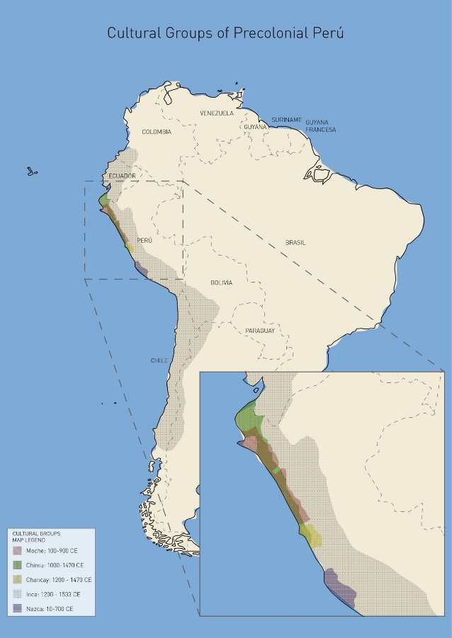
Figure 1. Geographical map illustrating the precolonial groups’ temporal and spatial locations in South America. The geopolitical nation-state borders provide a sense of orientation. Image created by José Hassi and author.
An ontologically informed embodied approach

The Moche have captivated scholars through the rich and complex material remnants they left behind (Alaica 2018). In the absence of a written language, researchers have relied on the forms and iconographic depictions of ceramic vessels to gain insights into the Moche world (Espinosa et al. 2023, Quilter 2020). While these studies have proven enlightening, interpretations of these precolonial objects frequently stem from perspectives that universalize modern Western dichotomies such as natural/supernatural, culture/nature and subject/object (for instance, Chapdelaine 2011, Woloszyn 2008). Interestingly, a substantial body of research has revealed that these divisions find no grounding in the Moche world (Alaica 2018, Benson 2012).
In stark contrast with studies examining Moche ceramics that normalize these dualisms, this article builds upon the framework of the ontological turn in anthropology. This theoretical and methodological position challenges fundamental assumptions about the subject of anthropological inquiry. Rather than assuming fixed categories of being, the ontological turn explores different constitutions of what reality is (Holbraad and Pedersen 2017). Applying this approach to the analysis of a museum context, I ask whether modern categories used to study and present ‘objects’ are congruent with a Moche perspective. This inquiry not only sheds new light on the transformative and dynamic world of the Moche and their vessels, but also offers a critical perspective for assessing the processes of collection, acquisition, interpretation, and exhibition of precolonial objects in European museum settings.
Previous works have highlighted the indivisibility of the natural and social and the absence of subject/object categories within certain contemporary Indigenous worlds across the Americas (Blaser and De la Cadena 2017, De la Cadena 2020). Within this framework, entities are not isolated but are constituted through their interconnections with other beings, including humans, flora, fauna, mountains and rivers. In this sense, all entities coexist and interact as part of a shared social world, emerging through praxis – understood as transformation through ongoing relations – as described by Viveiros de Castro (2019).
The author traces a distinction between poiesis and praxis, with the former belonging to a paradigm of production that aligns with a modernist view of culture shaping raw nature. In contrast, praxis emphasizes an exchange-oriented paradigm where forms arise from the dynamic interplay of forces and matter. As such, rather than being produced through an initial act, entities emerge and continually take shape through processes of exchange with others – human and non-human – in which every act is a response. This emphasis on exchange and interconnectedness directly challenges dominant anthropocentric paradigms by establishing a symmetry between human and non-human entities. Consequently, this perspective provided a fertile ground for an ontologically informed exploration of Moche vessels as socio-material entities engaged in transformative relations.
The Western dualisms previously mentioned, alongside the mind/matter divide, have also significantly influenced sensorial approaches to the vessels. Scholars have predominantly focused on discrete, visual aspects of the pots, concentrating on either their iconographies, form, or material composition (Weismantel 2021). These approaches often disregard how these vessels ‘were made to be seen, held and set in motion, filled and emptied’ (Weismantel 2021: 139). Additionally, they overlook their status as dynamic and interactive entities that have the capacity to generate, sustain and mediate social relationships (Gell 1998).
Recognizing the contributions and limitations of these approximations, this article builds upon Weismantel’s (2021) work, proposing an embodied approach that extends her treatment of Moche vessels as active and relational entities. This notion involves a deliberate emphasis on the relationship between flesh body and the clay bodies, which facilitates a comprehensive exploration of the pots beyond visual means, encompassing kinetic and tactile dimensions.
This research also seeks to explore how these vessels have been interpreted and exhibited within the ‘Pottery and Pottery Making’ case at the PRM from the 19th century to the present day. To do this, a decolonial/dewestern lens, working in complement with an ontologically informed embodied (OIE) approach, becomes crucial. Current theoretical positions have critically evaluated museums’ often Eurocentric interpretations and displays of Indigenous objects. Several attempts at decolonizing these institutions have been made, including considering the museum as a ‘contact zone’ (Clifford 1997), collaborating with source and descendant communities (Kreps 2020, Peers and Brown 2003), repatriating objects (Okubadejo 2022), and including Indigenous perspectives in the care for collections (Wali and Collins 2023). However, these approaches have not been without their critics. Some argue that museums maintain intellectual and material control over objects (Boast 2011), and it is important to question whether simply incorporating Indigenous ways of knowing into the museum’s pre-existing dominant framework establishes a truly symmetrical, intercultural system. Contrary to the notion of adding Indigenous voices into the museum, this study aims to propose alternative interpretation and exhibition strategies that create a space where the Moche ontology and the institutional perspectives can meet.
I argue that by adopting an OIE approach to analyze the vessels under study, new insights can be gained into their socio-material significance, and more broadly, into the Moche world that birthed them. Additionally, this framework offers a mechanism to critically evaluate the exhibition of the pots within museum contexts from a decolonial and intercultural perspective, opening pathways towards more innovative forms of display.
What follows is a discussion based on research conducted at the PRM between June and August 2023, where I sketched, photographed, filmed and ‘played’ with five Moche vessels displayed in the ‘Pottery and Pottery Making’ case [Figure 2], bringing forward their tactile and interactive aspects. According to the PRM’s collection database (2025), the museum currently holds 26 Moche objects, seven of which are exhibited. However, during my research, I found that many of the vessels on display lacked proper classification by cultural group. I employed the visual methods previously mentioned to identify the Moche pots and make selections for my study. By cross-referencing my observations with artifacts in other museum online collections, I was able to determine that certain pots of unknown origin were Chimu, and that others labelled as Chancay were actually Moche. After confirming my observations with Dr Hugo Ikehara, I notified the museum of these findings.
I also consulted archival materials to investigate the vessels’ historical interpretation within the PRM and examined their display case through the visual methods listed before. In this article, I will first delve into the collection itself by focusing on the vessels as representations and dynamic interactors. This will not only reveal insights into the Moche conceptions of personhood, materiality, exchange and continuity, but also the significance of the vessels as socio-material entities that both portray and engage in processes of transformation, rather than being inanimate objects. Building upon the findings of the first section, the second part of this paper will explore the treatment, classification and display of the vessels within the museum from the 19th century onwards, as well as propose new ideas for their exhibition. This way, we will be able to reach conclusions pertaining to the difficulties that emerge when considering precolonial Amerindian perspectives in the interpretation and display of pre-Hispanic objects within European ethnographic museums.

Some insights into the Moche and their pots: a world of mutability, exchange and interconnection

The Moche had a circulatory ontology, wherein liquid substances carry a vital force that moves across all bodies. Flowing unceasingly and open-endedly through the skies, rivers and oceans, fluids traverse human and non-human entities alike. These bodies act as channels through which liquids transform from one state into another (Cummins and Mannheim 2011, Weismantel 2021). In essence, all entities are integrated and integral parts of a wide and continuous circulation that is crucial for the regeneration and sustenance of life.
Seen in this way, the ocean serves as the origin of all beings—deities, animals, plants, and humans alike (Weismantel 2021). In their nascent state, bodies are considered wet and malleable – qualities that materialize in the very fabrication of ceramic vessels – transitioning over time to a dry and rigid state, a process referred to as ‘mineralization’ (Weismantel 2021: 121). As portrayed in Figure 3, to highlight these damp, formative qualities, the Moche depicted human and non-human infants with intentional softness, avoiding the elaborate carvings and details that typically define adult or supernatural figures (Woloszyn 2008).
In the process of mineralization, the body’s ability to be molded diminishes. Nonetheless, moving away from malleability does not entail moving away from the potential for transformation. The Moche perceived the life cycle of bodies as a continual state of metamorphosis within a context of interconnected relationships that extend beyond the body’s boundaries (Weismantel 2021).

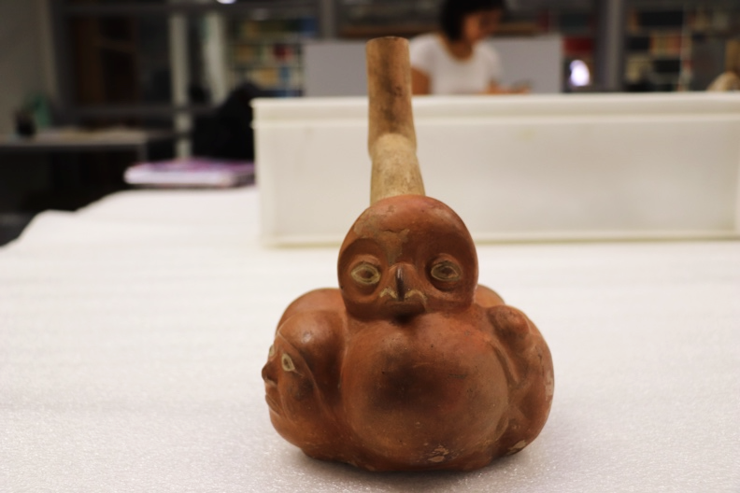A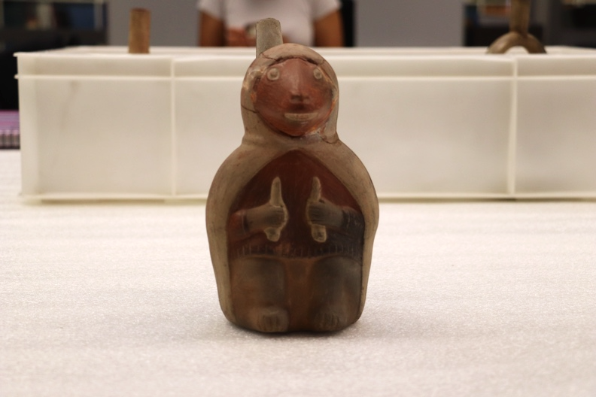B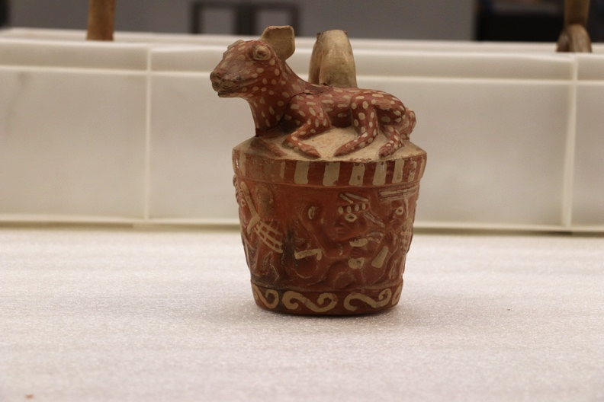C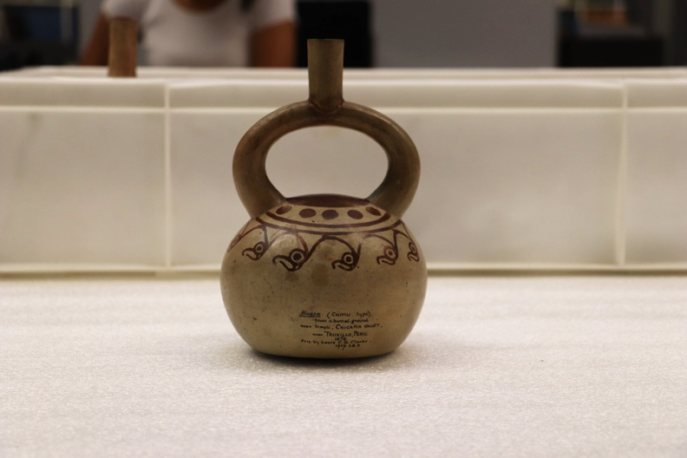D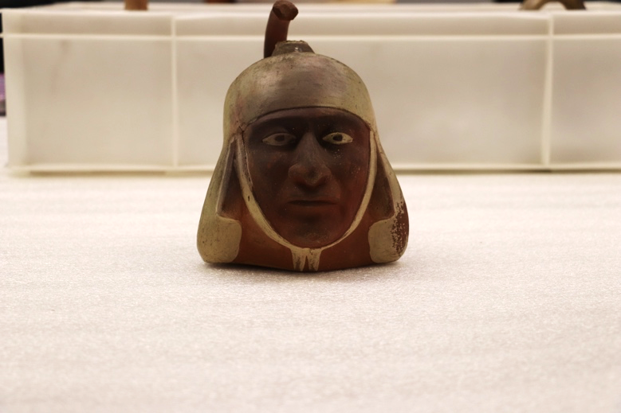E
Figure 2. Front view of the five Moche vessels (A-E, details in tables 1 and 2) chosen for the study. Images captured by the author.

To delve further into this, it is important to draw upon the ethnographic insights from present-day Indigenous worlds, particularly those where relationality operates as an ontological axis, not to claim direct continuity but to illuminate comparable logics of transformation. The Wari’, residing in the Amazonia region of Brazil, perceive that achieving personhood revolves around developing distinct physical attributes through the connections forged and upheld through sharing substances such as food and body fluids. These attributes materialize in ornamentations that make each body unique. Essentially, the Wari’ become persons within networks of interlinked bodies that develop similar points of view through sharing substances (Conklin and Morgan 1996, Vilaça 2005). These connections encompass not only humans, but also domestic plants and animals, who are considered kin as substances are exchanged with them (Viveiros de Castro 2019).

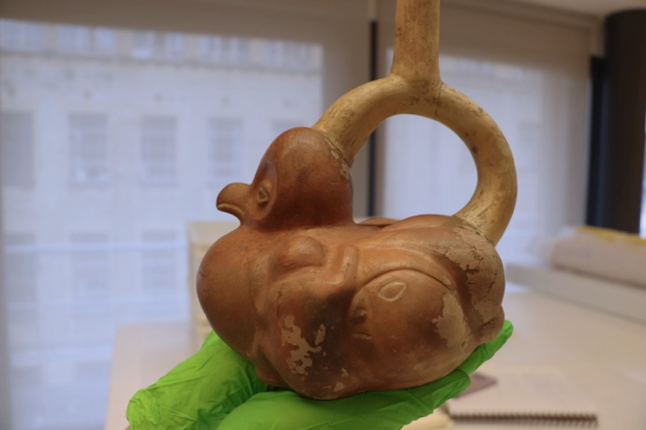A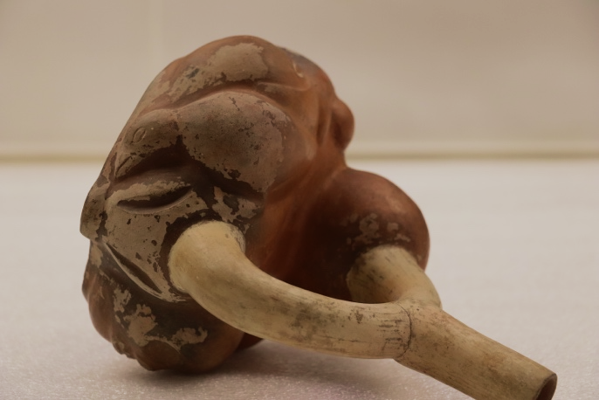A
Figure 3. Two sideview images of Vessel A, showcasing a human infant (left) and a young bird (right). Images captured by the author.

Rather than dividing the universe into humans and non-humans, a division is formed between persons and non-persons. In this paradigm, personhood is not an attribute exclusive to humans, but a status of similarity, or a shared perspective, acquired through physical proximity and consubstantiality. Yet, those designated as non-persons are still subjects – persons within other sets of relations – that apprehend reality from different points of view (Viveiros de Castro 2019). This perspective offers an interesting framework for interpreting the figure portrayed on Vessel B.
Within the Moche world, a distinction is drawn between domestic and wild animals. While domestic animals are usually depicted in a ‘naturalistic’ style, numerous wild animals are anthropomorphized, as exemplified by the wild camelid on Vessel B. Scholars propose that this difference in depictions arises from an association between wild animals and the supernatural realm, reflecting a Moche desire to personify their qualities of strength, agility and potency. In this sense, wild animals – or those who are not consubstantial – ‘were understood as animated beings that had important roles in their own ecosystems’ (Alaica 2018: 870).
However, this becomes more complex when examining other portrayals of wild animals, such as the figure on Vessel C. As the vessel turns, a scene of a deer hunt by Moche hunters comes to life. In contrast to the anthropomorphized wild camelid on Vessel B, this deer is depicted in a ‘naturalistic’ form. This difference can be understood through the notion of exchanging perspectives between hunter and prey.
The anthropomorphized camelid of Vessel B, which appears alone, could be a form of abstract subjectification of the ‘other’, understanding it as a person within its own systems of relations. However, when wild animals are portrayed alongside Moche hunters, they appear as ‘prey’. The deer on Vessel C assumes a ‘naturalistic’ form that responds to how it is seen from the embodied perspective of a Moche hunter – in effect, as a non-person liable to being killed. Following Viveiros de Castro’s notion of perspectivism (2019), the status of personhood depends on the observer’s standpoint rather than being a fixed quality.
Although the deer may appear as a non-person to a Moche hunter, it is still a subject which, in different contexts, could even assume the role of the hunter. Why, then, hunt deer? Because the animal is recognized as a subject within other sets of relations, ritual hunting becomes an opportunity to exchange perspectives, enabling mutual transformation through an intimate understanding of others and their attributes. Subjectivity thus becomes a necessary condition for participating in the reciprocal exchange of perspectives. As interactions with ‘non-persons’ facilitate the acquisition of attributes that contribute to the development of a unique physical composition, bodies remain in an ongoing transformation revealing their inherent instability.
The mutability of entities is not confined to the representations on the pots but extends to the interactions with them, as in the case of Vessel D, which is highly transformative in interaction [Figure 4]. As the vessel moves around, what appears to be birds from one perspective, gradually mutates into ocean waves and a burning sun. Moreover, when placed upon a flat surface, it wobbles, producing sounds akin to a rattle when filled with water. As the pot reveals ‘the capacity of clay to become lively flesh’ (Zuidema 1967, quoted in Weismantel 2021: 78), the Moche conception of body transformation proves to be multifaceted.

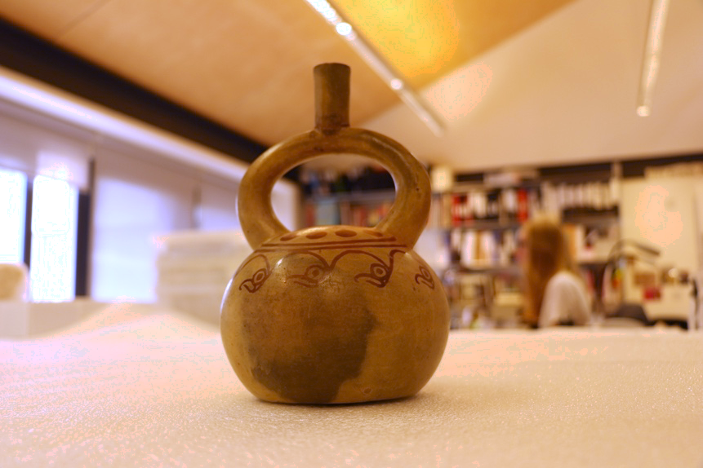D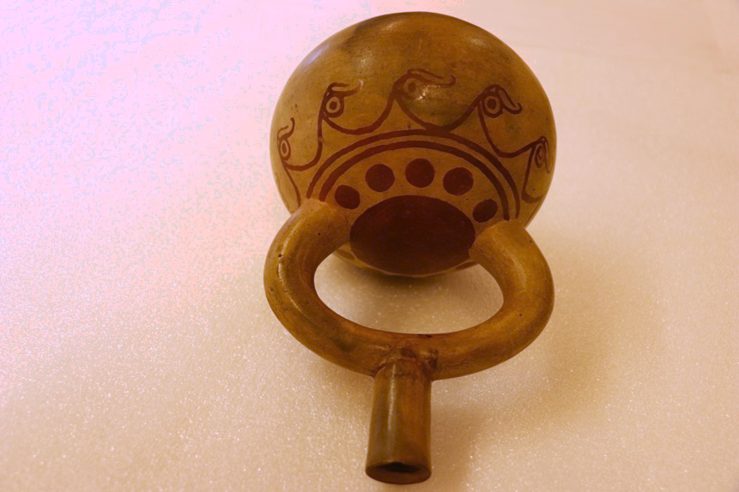D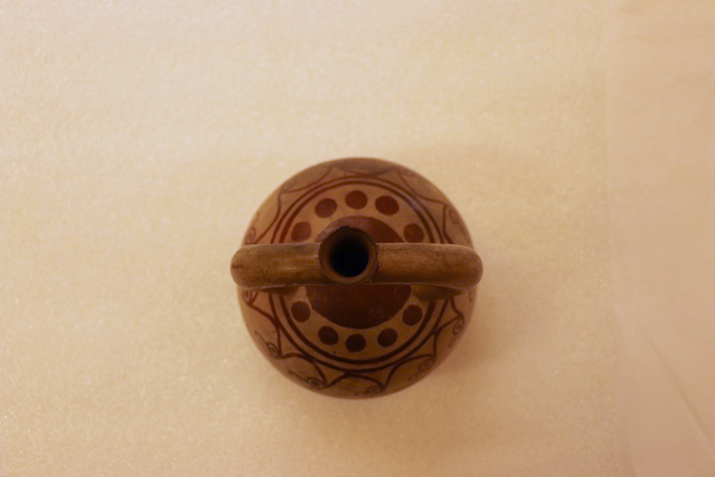D
Figure 4. Three images illustrating how the same painted imagery of Vessel D transforms in different positions. In the first picture, where Vessel D stands upright, the depictions appear as flying birds. In the second, with the vessel lying down, the same motifs resemble sea waves. In the third image, viewed from above, the iconography forms a sun. Images captured by the author.

Firstly, clay and flesh bodies transform diachronically, commencing as wet and malleable and advancing towards hardness. Secondly, solidified bodies continue to mutate through exchange with others, evidencing their incompleteness. In these exchanges, ‘personhood’ is built and maintained by acquiring certain traits from others. Notably, an entity’s position within the exchange is never stable, thus, solidification does not equate stability. As bodies engage in different sets of relations, they constantly re-emerge, being an open-ended process of transformation.
However, this process is not confined to self-transformation alone. Bodies actively participate in the transformation of other entities. This extends beyond beings engaged in exchanges, also encompassing the substances exchanged themselves. By holding and pouring liquids, vessels participated in the circulation and transformation of liquids and corporeal forms (Weismantel 2021).
This can be clearly seen in the participation of the pots in funerary rituals. The five vessels under study were originally crafted for these instances. Evidential remnants indicate that while certain vessels were never utilized for the consumption of liquids, instead serving as offerings for the dead, others bear traces of having been used for sharing chicha – a type of corn beer prevalent among precolonial societies of the Americas – with the deceased. Either as offerings or vessels, the pots assumed an active role in ritual practices, facilitating the exchange of substances between Moche people and their ancestors (Weismantel 2021).
As Muro (2022) underscores, ancestors and deities were active participants in the social world. They were perceived as powerful entities responsible for facilitating the circulation of vital substances and safeguarding the collective welfare of the living community. In exchange, the living would revere and feed them, orchestrating elaborated ceremonies. In this dynamic, the vessels played a significant role, steering transitions from one state to another and contributing to the establishment and perpetuation of connections with entities of the supernatural world (Weismantel 2021). Nevertheless, only certain persons had access to the tombs and participated in these substance-sharing rituals, as exchanges with powerful ancestors granted exceptional qualities that few could attain.
One such figure is Vessel E, a Moche portrait vessel of a priest with a ‘twin’ in the Ethnologisches Museum, Berlin (Ethnologisches Museum 2023). The employment of molds for crafting these portraits has puzzled researchers, given that standardized reproductions cannot capture the distinctive facial traits – eyes, mouth, or nose – typically associated with individual identity. Ethnographic work with the Wari’ offers a useful interpretative lens for analyzing these understandings of the body and personal identity. As Conklin and Morgan (1996) note, distinctiveness among the Wari’ is not necessarily articulated through facial features but through bodily marks that materialize the relationships a person maintains through exchanges. Seen in this way, the contrast between Vessel E and its twin – and the humans they presumably represent – becomes more significant.
Archaeological interpretations suggest that differences in ornamentation – in this case, the twin’s application of black pigment details post-firing (Donnan 1965) – indicate hierarchical ranks (Donnan 2004, Woloszyn 2008). Yet, much like the Wari’ society, these ornaments might also reflect the interconnections through which a person becomes constituted. For the Wari’, personhood is not fixed but exists in varying degrees, with social value related to the extent of one’s social ties (Conklin and Morgan 1996: 672). Following this logic, ornamentation is not merely a marker of rank but an expression of the distinct relational processes through which each body is constituted. Through ongoing exchanges with powerful ancestors, each priest – and perhaps each pot – could acquire distinct attributes, such as vitality or fertility, that were then materialized on the body. In this way, the differences between Vessel E and its twin do not only illustrate social hierarchy but also the transformative potency of ongoing interactions within the tomb.
These findings reveal the material articulation of identity and the body were materially articulated, as well as how burials were sites of activity and exchange (Muro 2023). Moreover, they show that within the Moche world, death was not merely an endpoint, but rather a threshold – a transformation in both matter and meaning that did not exclude the deceased from participating in social life. Nonetheless, the notion of the dead as the source of vitality may appear paradoxical. As is the case in many societies around the world, ancestors remain ‘alive’ within social relations, while their bodies undergo a transition from flesh to bones. Consequently, death assumes a dual role – a transformation in social relation and an ongoing mineralization of the body.
As dead bodies transition from flesh to bones, they integrate into the ‘geologic time spans’ of the planet (Weismantel 2021: 122). Essentially, ancestors become part of the Earth and its systems. As Earth serves as the very foundation of existence, these ancestors need to be honored and fed. Consequently, death entails a transformation in power, as ancestors, once humans, serve as the wellspring of the flow of vital forces.
In this context, we can perceive the ‘circulatory ontology’ of the Moche not solely as the flow of vital forces within liquids, but also as an encompassing concept that includes the minerals enriching the soils and providing materials for crafts. Therefore, there are two distinct cycles – water and mineral. The relation between these two cycles can be apprehended as a dynamic interplay of complementary opposites, where each defines and relies upon the other in a reciprocal manner. It is precisely the qhariwarmi (Dean 2007: 504), the fruitful intersection of these two cycles, that births all life on Earth as we know it.
In summary, according to this reconstruction of Moche ontology, akin to Viveiros de Castro’s (2019) concept of multinaturalism, the distinctive nature of each entity lies in its body. However, all bodies originate from the same source and ultimately become minerals that compose the Earth. Echoing the design of a stirrup spout [Figure 5], it might be possible to interpret that terrestrial beings follow a rhythm of 1-2-1, that commences in unity, unfolds in differentiation, and concludes in oneness. Thus, all beings are simultaneously the same and different. Entities are ontologically inseparable and exist in relation to others; therefore, all bodies are ‘inherently-with-others’ (De la Cadena 2019: 40). Figures like Vessel A [Figure 5] not only embody the circulating dynamics of life and death, but whilst in motion, also manifest principles of continuity and interconnectedness between mineral, human, animal, and vegetal forms. Conversely, as distinct physical manifestations, entities are differentiated beings actively participating in exchanges with their surroundings. The vessels, then, are not only active participants in ceremonies, but also incarnate the vitality that emerges from the (re)productive encounter between liquids and minerals.

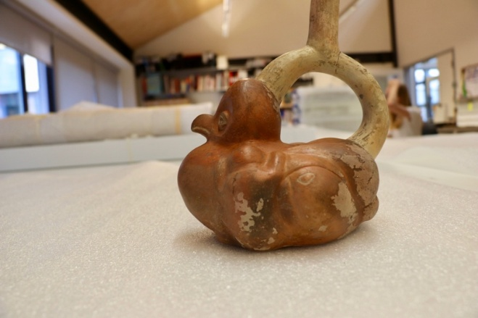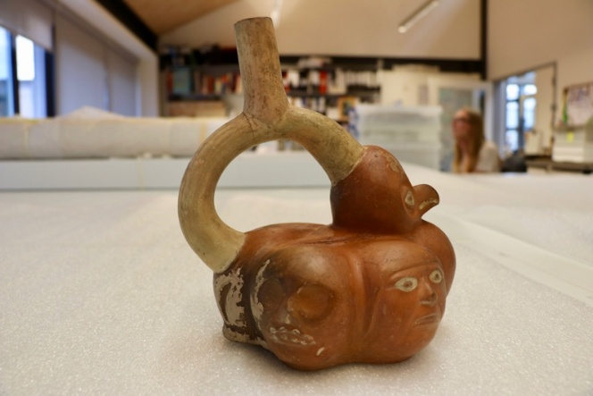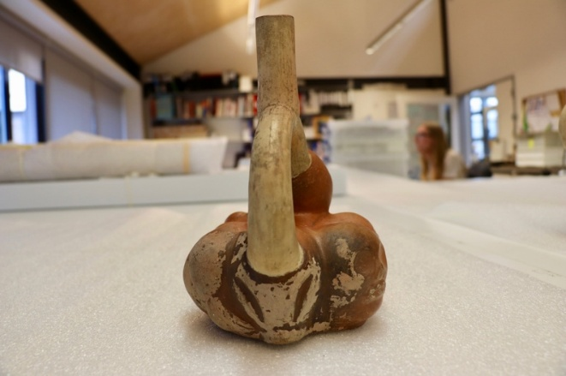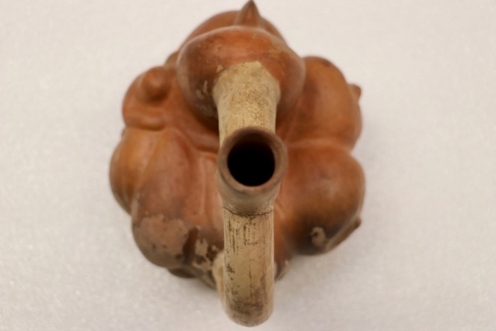
Figure 5. Four different perspectives on Vessel A, which capture its mutability and multiplicity. Images captured by author.

The pots and the Pitt Rivers Museum: processes of acquisition, interpretation and display

After approximately a millennium within the confines of tombs, many vessels – now housed in museums around the globe – resurfaced as a result of huaqueo (grave robbing) (Benson, 2012). After looting, a significant void was created as these objects were decontextualized from the burial sites and their spatial arrangements. The emergence of these pots through illicit means was certainly the beginning of an afterlife characterized by gaps of information. Furthermore, their presence in the contemporary world has triggered a range of issues concerning the interpretation and treatment of these ‘acolonial objects’ (Weismantel 2021).
Determining the precise moment when the five investigated vessels were looted remains a challenge, yet there is information regarding their acquisition processes. The PRM’s online collections database (2023) suggests that the vessels became entangled ‘in Western economic processes of the acquisition and exchange of wealth’ (Stocking 1985: 5) towards the end of the 19th century and the beginning of the 20th century. It remains uncertain whether these pots were directly purchased from looters or obtained through local markets, auction houses or even excavations.
As shown in Table 1, the identity of the field collector for vessels B, C, D and E remains unknown, and significant gaps persist regarding the vessels’ collection sites (PRM 2023). This deficiency has notably undermined the accurate recognition of the ‘cultural group’ responsible for their crafting. For instance, the PRM database designates the geographical provenance of vessels B and C as the Lima Region or Trujillo Province (PRM 2023). The presumption that these vessels were collected in Lima has led to their incorrect association with the Chancay world.

Table 1: Systematization of data from the PRM online catalogue regarding collection and acquisition. Table devised by the author using available online object label information.
Vessel (Object number) | Date Collected | Collector | Place collected | Date acquired | Mode of acquisition
A (1947.7.9) | 1884-1901 | William Maxwell Ogilvie of Dundee | Unknown – South America | 1947 | Donated by Frederick and Heneage Ogilvie (sons of collector)
B (1902.83.29) | Unknown | Unknown | Lima, Perú | 1902 | Purchased from George Fabian Lawrence
C (1902.83.28) | Unknown | Unknown | Lima, Perú | 1902 | Purchased from George Fabian Lawrence
D (1919.28.3) | 1878 | Unknown | Valley of Chicama, Trujillo, Perú | 1919 | Donated by Louis Colville Gray Clarke
E (1884.67.9) | 1874 | Unknown | Tumbes, Ecuador-Perú. | 1884 | Donated by Augustus Henry Lane Fox Pitt-Rivers

In their journey into the PRM, the clay bodies have continued to accumulate markings that attest to the varied social relations in which they have been involved. After their acquisition in 1902, Henry Balfour, the first curator of the PRM, inscribed ‘Trugella, Peru’ in black ink onto vessels B and C [Figure 6]. This becomes interesting given that the Moche inhabited what is today known as the Trujillo region and considering the numerous people intertwined in the afterlives of the pots. To the best of our understanding, collector and antiquarian George Fabian Lawrence acquired vessels B and C around 1902, from Stevens’ Auction Rooms in London (PRM 2023). These inscriptions likely represent instances of misheard oral transmission concerning the pots’ origins. As such, they are the evidence and testimony of the vessels’ ‘fragmented biographies’ (Basak 2011: 108).

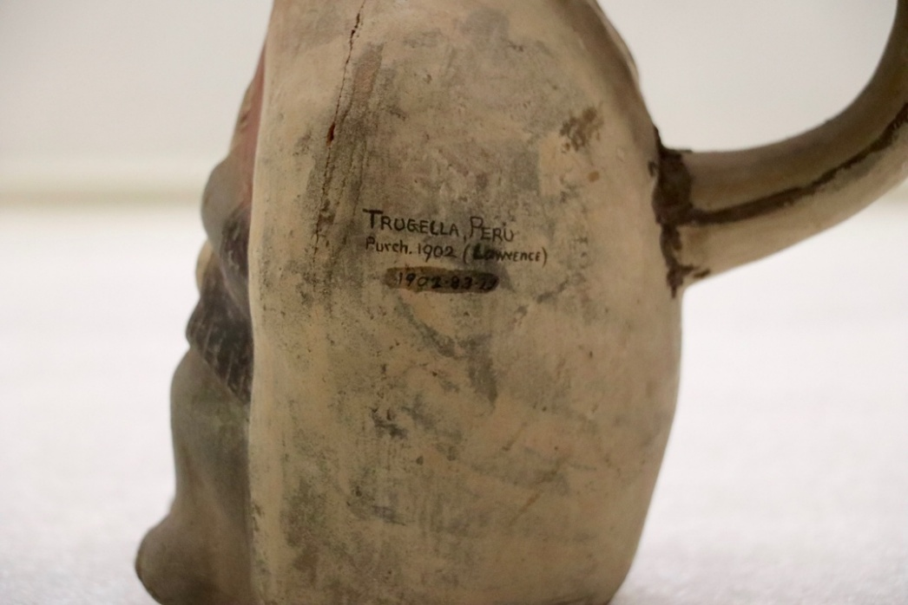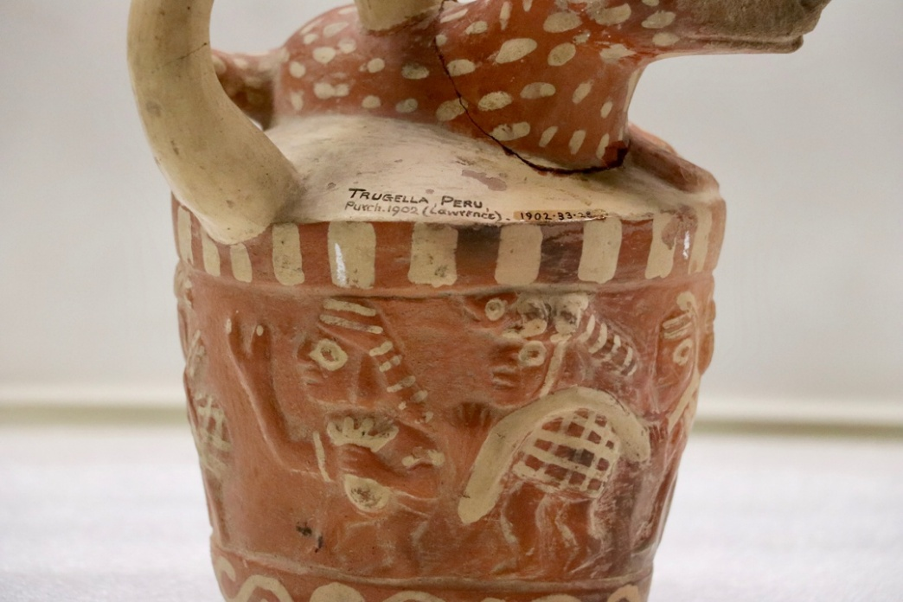
Figure 6. Close-up view of the inscriptions ‘Trugella, Peru’ on the bodies of vessels B and C. Images captured by the author.

Vessel E was donated by Augustus Henry Lane Fox, otherwise known as General Pitt-Rivers, as part of the Founding Collection. Its documentation as collected in Tumbes – a borderland shared by Perú and Ecuador – has led to a classification dilemma [Table 1]. While primary records seemingly indicate an Ecuadorian origin of this pot, the PRM’s classification encompasses both Ecuador and Perú as potential provenances (PRM 2023). This dual classification has been misleading in the accurate sociocultural attribution behind its creation. Upon finding a twin vessel at the Ethnologisches Museum, it was possible to confirm that this vessel indeed is Moche.
The lack of information on the specific social group that crafted these vessels has considerably hindered their interpretation within the museum context. As illustrated in Table 2, the PRM’s database offers scant information into the vessels’ affordances, forms and iconographies (PRM 2023). Having initially emerged within the Victorian evolutionist paradigm that materialized in typological exhibitions (Chapman 1985), the PRM has primarily emphasized the classification of these entities ‘in terms of externally defined formal or functional qualities’ (Stocking 1985: 8). Entities that once were active social actors have been grouped alongside other ‘artifacts’ with which they bear physical resemblances according to a certain viewpoint. As museum objects, the vessels have been constrained by reductionist interpretations that tend to silence their past lives and interactive potentials.

Table 2: Compilation of data from the PRM online catalogue and research findings regarding cultural group and form/depictions. Table devised by the author using available online object label information and research findings.
Vessel | Previous information on cultural group | Findings on cultural group | Previous information on form/depiction | Findings on form/depiction
A (1947.7.9) | Moche | Moche | Ceramic vessel.  Stirrup spout jar in the form of a bird | Stirrup spout vessel. From the front: owl head and body. From the sides: Anthropomorphic and zoomorphic vessel depicting the processes of life and death of humans and birds (birth, adulthood, death). From the top: a fruit or vegetable, potentially resembling a potato.
B (1902.83.29) | Chancay | Moche | Ceramic vessel in the form of an animal holding corn cobs | Stirrup spout vessel. Possibly an anthropomorphic wild camelid, sitting down and holding artifacts in its hands. The cape suggests it might be resembling a priest.
C (1902.83.28) | Chancay | Moche | Ceramic vessel. Animal lying down, at sides people carrying burdens | Stirrup spout vessel. Scene of the ritual of deer hunting. At the top, a male deer lays down. On the sides, seven human hunters carry nets and pouches. Two of them are hybridized anthropomorphic figures with the arms of a crustacean. The spout connects the hunters and the deer when the vessel is tilted.
D (1919.28.3) | Chimu or Moche | Moche | Ceramic vessel with painted decorations of birds’ heads | Stirrup spout vessel. Bottle spout upwards: bird, possibly a cormorant. Bottle spout downwards: ocean waves. Spout facing holder: sun. Notably, the vessel’s base is not flat, but rather undulates, wiggling when placed on a surface.
E (1884.67.9) | Unknown maker | Moche | Human face | Spout and handle vessel. A figure, likely a priest or a shaman, is depicted wearing a distinctive headdress.

Owing to the emphasis on functionality, the crafting techniques and iconographies of the vessels were initially regarded as insights into the evolution of form (Pitt-Rivers 1891). Today, these attributes continue to be subjected to function, seen as sources of superficial descriptive details. In their online object information label (PRM 2023) the five pots have been described as ‘ceramic vessels’, occasionally accompanied by limited notes about their depictions. These descriptions underscore the importance given to functionality, overlooking the fact that, as shown earlier through the example of Vessel E, ornamentation constitutes a fundamental element of the pots’ unique body composition. Moreover, they use a static conceptualization of the pots. As evidenced in Table 2, the descriptions reflect a fixed and singular view of the pots, operating under a logic of either/or. This perspective deviates from the Moche logic of and/with, that becomes materialized in the vessels’ multiplicity, transformation and ever-emergence.
Within these descriptions, the limitations and rigidity of monolithic Enlightenment-rooted categories come to the forefront. Vessel A has been described as ‘in form of a bird, round whose body are modelled a human face and a skull on one side and on the other a bird, part of a human face and an animal (?)’ (PRM 2023, 1947.7.9). This characterization does not encompass the full spectrum of sensations, forms and images that emerge in the engagement with the vessels. However, it sheds lights on the challenges that arise in the ontological encounter between entities from different worlds. The vessel challenges us to describe a plural and kinetic entity – a being that, in terms of De la Cadena (2019) is not only a pot and certainly, whose clay body is not only what it appears to be from a singular viewpoint.
As an entity that is one and many (a mineral and an owl and a human and a skull and a young bird and a human infant and a vegetable), Vessel A appears as alien and unfamiliar to the ‘grammar that transforms entities into individual bodies’ (De la Cadena 2019: 48). Despite the predominance of the modern Western logos in their classification and description, ‘the pots evince a stubborn insistence on communication – albeit in their own terms’ (Weismantel, 2011: 304). Emanating as dynamic, multiple and mutable entities, the Moche vessels resist and exceed the museum’s categories, underscoring the challenges arising from the intersection of two worlds.
The classification of objects based on their form and function rather than their ontological provenance materializes in the exhibition of the vessels within the ‘Pottery and Pottery Making’ display [Figure 7]. Following the pattern of other cases in the museum, this wood and glass case has four sides which feature various immobile ceramic entities from different cultural groups. Generally, the objects are arranged by geographic provenance, with approximately one third of the case dedicated to 20th-century pottery from the Pacific Islands, while the rest showcases precolonial vessels from diverse parts of Abya Yala (the American continents). Despite the spatial and temporal distances between these objects, they are gathered together to convey a narrative of ‘different cultural solutions to common problems’ (Gosden et al. 2007: 3).

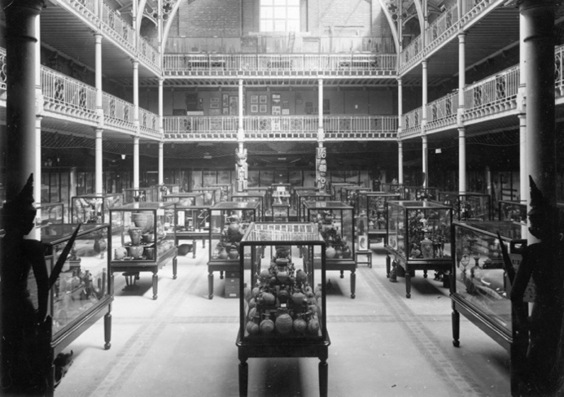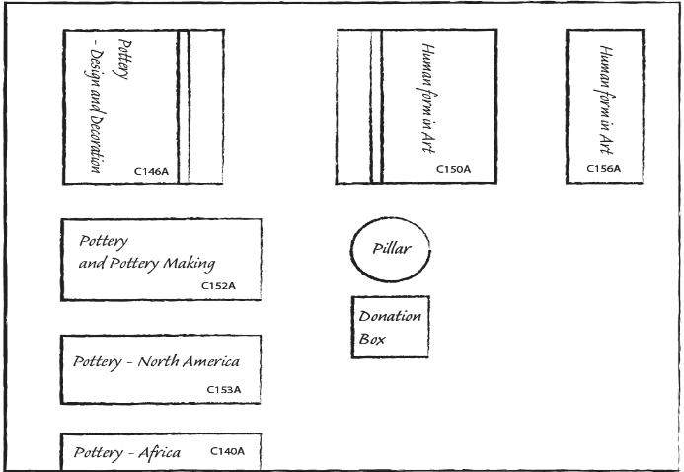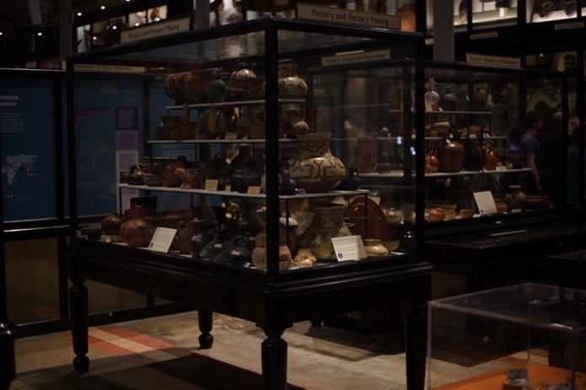
Figure 7. Three images depicting the case’s location. The first is from the late 19th century, sourced from the PRM online photograph collection (1998.267.95.3). The second is a sketch by Raimundo Pinto and the author, showing adjacent cases. The third is a photo taken by the author in 2023.

As mentioned earlier, the PRM initially adhered to a typological display. Within this classificatory system, artifacts from non-Western cultures stood as evidence of their evolutionary stages along a unitary linear scale, stretching from ‘simple’ and ‘savage’ groups to ‘complex’ and ‘civilized’ societies. At the pinnacle of this ladder stood 19th-century British Victorian Society (Van Keuren 1989, Kuper 2023). Victorian scholars were interested in the evolution of form, as illustrated by the work of British anthropologist and the PRM’s first curator, Henry Balfour, in his study of ‘Peruvian pottery’ [Figure 8]. Employing a ‘scientific scheme’, they categorized objects from various times and spaces into different types, such as pottery, tools, weapons and textiles.

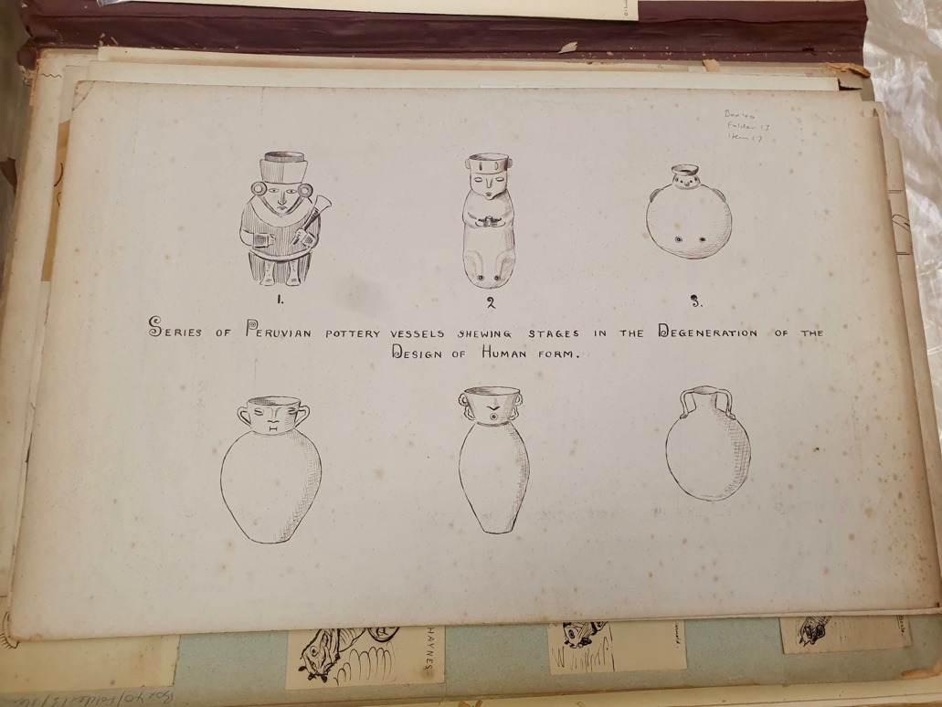
Figure 8. Balfour’s iconographic analysis sourced from the PRM archives (Mss.Balf.40.13.17). The caption states ‘series of Peruvian pottery vessels showing stages in the degeneration of the design of human form’. Image captured by the author.

Constructing the history of different forms posed a complex challenge. As noted by Pitt-Rivers himself (1891), ‘actual evidence’ pertaining to the dates of ‘prehistoric’ or ‘savage’ objects was scarce. This deficiency prompted the arrangement of objects in a manner that showcased ‘how one form has led to another’ (para. 5). Objects were identified, classified and systematically arranged by European scholars situated within a specific sociohistorical context. Within this framework, the collected pieces, whether of archaeological or ethnographic origin, were grouped indistinctively. This practice reinforced Eurocentrism and imperial dominance, valuing objects in their capacity to be fitted into predetermined categories (Basak 2011). Today, the PRM has departed from an evolutionary mindset. As expressed by Van Broekhoven (2018), the current Director of the PRM, the displays are now a ‘celebration of human creativity’ and the museum has been confronting its problematic inheritances, addressing its colonial past and becoming part of healing processes. However, the arrangement of objects based on their type, and consequently, the grouping of archaeological and ethnographic items, persists. This could likewise be interpreted as a manifestation of ‘historical othering’ (Fabian 2014), wherein modern Euro-American scholars perceive Indigenous ‘others’ as static, timeless and disconnected from history.
The focus on typology, coupled with the absence of information regarding sociocultural provenance, has resulted in a display that is not organized by ‘cultural group’, and Moche vessels being spread across different sides of the container. Instead, the display is based on aesthetic conventions rooted in Euro-American formalism, privileging certain colors, shapes and sizes. For instance, Vessel A rests on the third layer of one side, situated next to a beige hen-shaped vessel of similar dimensions and unverified provenance [Figure 9A]. This side of the case features pottery from the Fiji and Solomon Islands, alongside items that are Chimu, Chancay and Inca, as indicated by four small labels. On the right side, various black pots are grouped together, while the pots on the left side predominantly exhibit different shades of brown and beige. The accompanying information sheet highlights the origins of the pots on the right side, with particular emphasis on the black vessels, the use of molds for their crafting and their distinctive whistling features. These descriptions underscore the formal qualities of the vessels rather than their ontological aspects.
9C
9B
9A
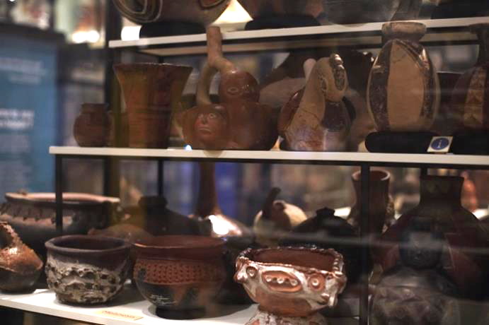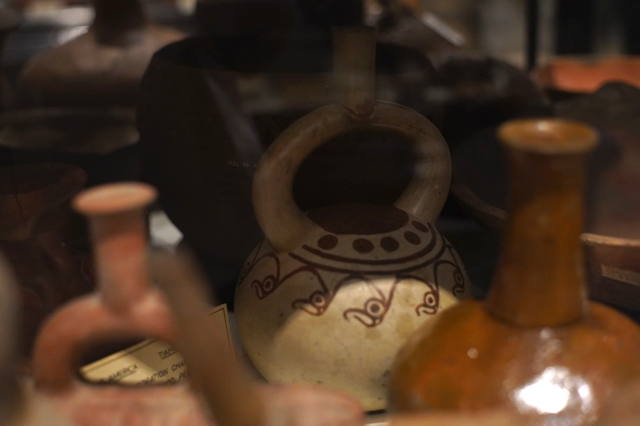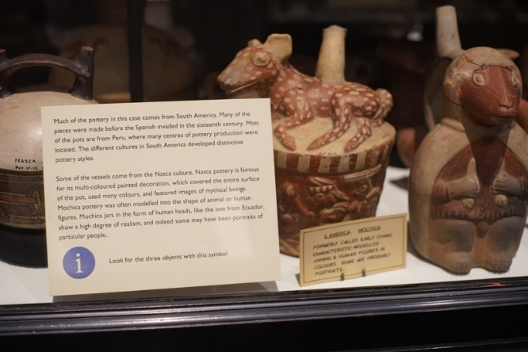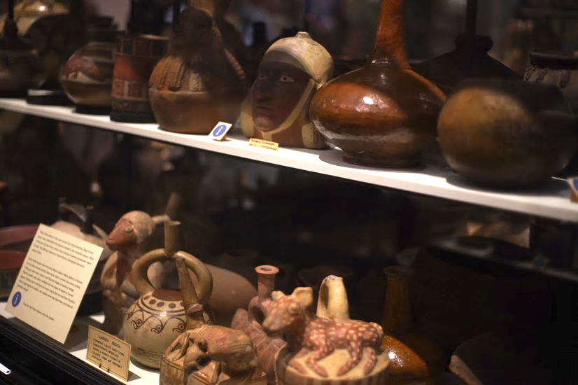
9D
Figure 9. Photos showing vessels A, B, C, D and E resting on the case, accompanied by the informational sheet. Images captured by the author.

On the parallel side of the case, vessels B and C occupy the front part of the bottom layer, positioned near other pots shaped like animals and plants [Figure 9B]. Vessel D rests on the darker rear area, less visible, and is surrounded by similarly geometrically shaped pots in shades of red [Figure 9C]. A small label designates these pots as Tiawanaku. Next to Vessel C, an informational sheet explains that many of these pots originate from precolonial South America, particularly Perú. The placard offers formal details about the Nazca and Moche pottery, emphasizing the ‘characteristic’ use of colors and animal forms in these pottery styles. Noted in the placard as a figure displaying a ‘high degree of realism’, Vessel E appears on the second layer of this side, positioned beside brown and red pots of similar dimensions and colors, that are shaped geometrically and anthropomorphically [Figure 9D]. Overall, this side predominantly features orange and red objects of Nazca, Ica and Diaguita origins, among others previously mentioned.
The arrangement of the vessels based on a specific visual aesthetic rather than cultural provenance underscores the dominance of a modern European perspective. Prioritizing qualities like color, shape and size in the display over cultural origin is a consequence of what Stocking has termed a ‘process of aestheticization’ (1985: 6). This process emerges from the universalization of European aesthetic norms and from the recontextualization of objects originating from other ontologies in the museum setting. The vessels, once dynamic entities with various social roles within the Moche world, have been distilled into an aesthetic criterion that emphasizes their visual attributes while downplaying their affordances and transformative qualities.
The result is the presentation of museum objects that are meticulously curated and grouped with other objects on display to convey a specific worldview and classification system (Larson 2007: 107). The museum continues to assign value to the vessels based on their type and their suitability to be fitted into preordained categories. Consequently, the Moche ontology is not being (re)presented; rather, what is being showcased is an interpretation that positions these entities as technological artifacts crafted by the ‘other’.

An intercultural museum: proposals to enhance museological communication and experience

The original intention of the PRM was for objects to be both research and educational tools to generate knowledge about distant others (Gosden et al. 2007). Displays were meant to be spaces in which the objects could visually communicate meanings easily and transparently to visitors (Conn 2010). However, as assessed through the OIE approach, museums are not neutral, and displays are not transparent. This dynamic is effectively depicted by Peruvian artist Sandra Gamarra in her artwork ‘Expositor’ (2021), where the arrangement of vessels becomes a conduit for a Eurocentric narrative. Gamarra’s work reveals the seemingly impartial glass case as a power device. By painting different precolonial objects onto the case surface, she highlights how, inside the case, the vessels lose their three dimensionality and appear as isolated fragments (Stanford DLCL 2021). Similar to Hallam’s (2019) concept of objects and spaces as co-constituting each other and Dudley’s notion of an object-information package (2010), Gamarra’s artwork underscores the absence of distinction between the display case and the objects when the exhibition framework narrates from a dominant perspective.
The ontological mediation in the presentation of the vessels collapses, rather than controls, the ‘equivocation’ (Viveiros de Castro 2004), reducing the possibilities of what the entity might be from alternate perspectives to a singular reading. This generates an unbalanced relation between the Western and the Moche perspectives within the museum setting. Addressing these issues does not entail silencing the museum’s perspective, but rather recognizing it as a ‘partial truth’ (Clifford 1986: 6). Consequently, there is a dire need to balance the representation of what these entities are by creating an intercultural space, where the Moche perspective, previously accessed through an OIE approach, can engage in dialogue with a Western one.
This can be achieved through aligning with what de Sousa Santos (2010) has articulated as an ‘ecology of knowledges’ and Zeitlyn (2023) has termed ‘sparse anthropology’, both of which emphasize communication through difference. Under these lenses, different perspectives are not assimilated into the dominant framework. Instead, the absence of consensus and the inherent incompleteness of entities are seen as enriching. Employing these frameworks, the vessels emerge as spaces of convergence and co-existence for diverse ontologies, engaging in a horizontal dialogue that transcends the constraints of either/or.
As previously seen, the Moche’s kinetic universe highly differs from the current static placement of the vessels within the display case. Following an interactive exploration with these entities, questions emerged: How does one categorize an entity that transforms within interaction? What criteria determines its position and which side should be showcased? As proposed by Howes and Classen (2006), integrating interactive experiences such as multimedia technologies and replicas holds significant potential. Given that sensory experiences and perception emerge from the entire body’s engagement with the environment (Ingold 2000), incorporating videos showcasing the vessels in motion and photographs capturing their various sides presents an opportunity to convey the vessels’ transformative nature while enhancing the sensory encounter.
Procuring replicas crafted by Peruvian artisans (Peruvian Whistling Bottles Vitancio 2023) and utilizing 3D printers to produce reproductions of the vessels on display could facilitate tactile, haptic and auditory interaction with the pots. Visitors could engage in movement and listen to the sounds produced when water is poured onto the vessels, either through handling or sound kiosks. This approach would offer a dynamic embodied exchange, allowing visitors to experience the vessels’ relational attributes and witness their transformations.
While visitors are active co-creators of meanings as they engage with museum objects, their sensory experiences are culturally and historically mediated (Howes and Classen 2014). Hence, it becomes essential to offer visitors an ontological and sociohistorical context for the objects they are interacting with. The assumption that objects communicate transparently had consequences, as evident in the scarcity of labels and explanations in the current display. Additionally, these few labels predominantly emphasize the vessels’ formal attributes, reflecting a modern museological perspective. Considering that contemporary museums aim to ‘tell people about things they may not know or never learned’ (Conn 2010: 18), it is imperative to provide information about the ontological framework behind the creation of these pots – what could be understood as a Moche perspective – as well as their afterlives as collection and museum objects – what might be called an institutional voice. This contextualization should encompass the pots’ existence within the Moche world, including labels that detail their social roles, transformative qualities and interactive nature. Furthermore, labels ought to encompass the historical and social frameworks that have marked their lives as museum objects (Gosden et al. 2007). These labels could explore the interesting intersections between the life of the pots within the Moche world and within the museum. For instance, they could highlight the crafting process and discuss how Balfour replicated crafting techniques to gain insights into the forms and functions of other pottery items (Gosden et al. 2007) [Table 3].
To achieve this, it may be helpful to arrange the objects according to their cultural provenance, or at the very least, employ distinct colors to signify different cultural groups. Currently, the information sheets feature a blue sign reading ‘look for the objects with this sign’ when addressing Chimu, Moche, Chancay, Nazca and Pacific Islands objects alike. This uniform marker may lead to confusion, as objects from different spaces and times share the same information marker. Employing color-coded distinctions could greatly enhance clarity.
While distinguishing cultural groups may risk reifying or essentializing them, it might also help illuminate their material and technical diversity, as well as wider aspects, such as human-environment relations and cross-cultural exchange. Moreover, the Pacific Islands objects in this case are ethnographic rather than archaeological, underscoring the importance of clarifying their provenance and avoiding conflating distinct cultural and historical contexts. Any visual differentiation should therefore be understood not as a fixed taxonomy, but as a curatorial strategy to help visitors appreciate these material and contextual differences.
In addition, to provide insights into the geographical and environmental context in which the pots originated, it would be valuable to incorporate maps offering temporal and spatial information, such as the one presented at the beginning of this paper. These maps could also serve as an opportunity to illustrate that precolonial groups were not sealed off from each other, but rather interacted and influenced one another, as Figure 10 suggests.

Table 3: Proposed labels for the ‘Pottery and Pottery Making’ case, tracing the vessels’ journeys from their original context to the present. Table devised by author using research findings.
Label focus | Associated vessel(s) | Interpretive aim
Are these just vessels? Among the pots in this case are Moche ceramics, made over a millennium ago in the deserts of today’s north coast of Perú. They were created by mixing water and minerals, yet these were not simply raw materials. For the Moche, liquids carry a vital force, while minerals emerge from long processes in which the bodies of powerful ancestors decay and become earth. These vessels also played funerary roles, used to share chicha (corn beer) with the dead or offered in their honor. As such, they form part of a broader and interconnected system. | Moche vessels (general) | Introduce the significance of the vessels within the Moche world.
Look for the map. The ceramics in this case come from different parts of the planet and diverse times. Some are 20th-century pottery from the Pacific Islands, while most are from pre-Hispanic South America. If you look closely at the pre-Hispanic vessels, you will notice differences in shape, iconography and color, as well as shared features that point to cross-cultural exchange. Crafted to be set in motion, many vessels, including Moche, Inka and Chimú, produce sound when liquids are poured. Would you want to listen? Scan the QR code. | Vessels in the ‘Pottery and Pottery Making’ case (general) |   Highlight cross-cultural exchanges and provide details on the vessels’ interactive qualities, incorporating the map shown in Figure 10 and a QR code.
Look for the white vessel with painted red bird heads. What do you see? Try looking from a different angle. Do the birds transform? Transformation was central in the world of the Moche. Not only did bodies change in time – like ours! – but the world itself was perceived as dynamic. When this vessel is in motion, the birds become ocean waves (upside down) and a sun (top view). | Vessel D | Foreground the transformative qualities of Vessel D whilst engaging visitors.
For centuries, these pre-Hispanic vessels rested in sacred huacas (burial sites). During the 19th and early 20th centuries, many were removed from tombs and entered global networks of power and exchange. Looting and collecting created major gaps in knowledge about their origins. The Pitt Rivers Museum acquired these ceramics through donations and purchases during this period. Originally, the museum followed a typological approach, organizing objects along a linear, evolutionary scale in order to show the evolution of form. Today, it seeks instead to reveal distinctions and parallels across cultures, recognizing these ceramics as responses to shared human challenges. | Precolonial ceramics in the ‘Pottery and Pottery Making’ case (general) | Explore how the vessels were unearthed and eventually arrived at the PRM.
The original intention of this museum was for objects to be both research and educational tools for generating knowledge about distant others. During the late 19th and early 20th centuries, within an evolutionary framework, Henry Balfour, the first curator of the Pitt Rivers Museum, employed a range of methods to study the evolution form. For example, through illustration, he proposed an evolutionary scheme tracing changes in ‘Peruvian pottery’. He also replicated crafting techniques to gain insights into the forms and functions of various pottery items. | Precolonial ceramics in the ‘Pottery and Pottery Making’ case (general) | Discuss early museum interpretations (Balfour), drawing on figure 8.

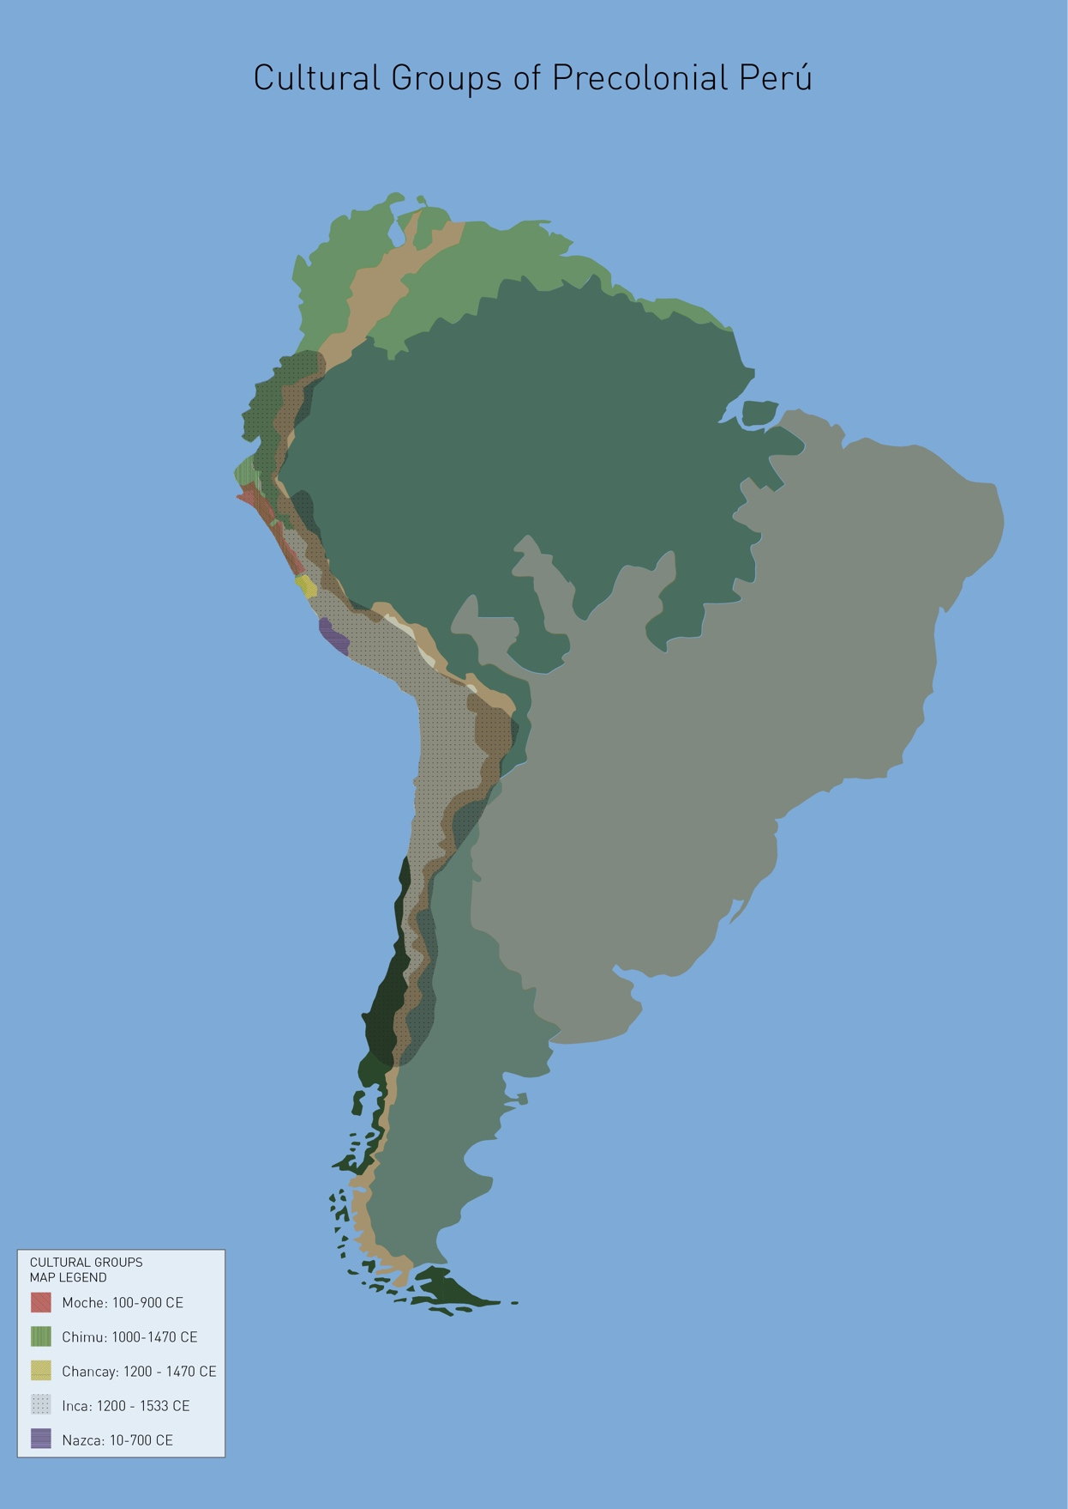
Figure 10. Geographical map indicating the temporal and spatial locations of ‘cultural groups’ in South America without borders. Although maps are an abstraction, this map offers insights into environmental aspects of the South American territory and how it might have been experienced in the past. Image by José Hassi and author.

Certainly, the proposed ideas have limitations. The vessels remain within a physical and representational structure constructed from a European perspective, hindered by epistemological and linguistic barriers. Words like ‘culture’, ‘object’, ‘artifact’, and even words such as ‘vessels’ and ‘pots’, are labels tied to particular meanings and imaginations (Mignolo and Walsh 2018). These labels shape and confine our comprehension of entities, which widely differs from the way in which the Moche understood and experienced these ceramic entities. Considering that these ‘Western’ words facilitate communication and knowledge transmission, it might be more effectively illustrated how the Moche perceived the pots as socially interconnected ‘subjects’ rather than aiming for a complete embodiment of this viewpoint. Within the museum, the vessels stand as representations of the ‘cultural traits’ of the Moche world. Reimagining them as entities that not only illustrate the principles of multiplicity, transformation and interconnectedness, but also, as beings that, like ourselves, are ontologically indivisible and emerge through praxis – exchange relationships – remains a challenge.

Final thoughts

In this paper, I explored how an ontologically informed embodied approach can provide insights into the assessment of five precolonial vessels and a critical evaluation of their presentation— and further, the representations of the Moche — at the PRM. Challenging interpretations of precolonial ceramics that rely on Western categories and thus reduce their roles to mere objects, I argued that incorporating ideas from the ontological turn within museum practice can better approximate the rich social lives these vessels held within their context of origin. Moreover, this approach provides valuable insights into the Moche world, such as the transformative and cyclical characteristics of their ontology. On the other hand, utilizing more-than-human studies as an analytical framework, I examined their current lives at the PRM and the difficulties that arise when entities from different worlds intersect. I focused on the influence of Enlightenment-rooted perspectives in the interpretation and presentation of the vessels, and the inherent resistance the pots pose to such categorizations. Through the findings of the first and second section, I illustrate how an OIE approach provides a platform to think about new forms of exhibition that align with the PRM’s efforts to create a space for dialogue, collaboration and innovation.
This approach holds significant potential contributions for museum studies. While the field has made notable efforts to ‘incorporate’ Indigenous knowledge and decolonize museum spaces (Lewis 2024, Duarte 2024), these initiatives often fall short of addressing the broader structural constructs that shape such encounters. Consequently, these endeavors risk aligning with what Walsh (2009) calls ‘relational interculturality’, which prioritizes individual contact between Indigenous and Western peoples while neglecting the socio-political and epistemological structures that perpetuate power imbalances. Integrating the ontological turn into museum anthropology advances the indigenization of museums, that is, ‘revisioning, rethinking and restructuring’ these institutions (Phillips 2022: 126). As such, it offers a lens to understand artifacts beyond ascribed meanings, revealing alternative ways of being that diverge radically from our own. What if vessels were considered socially agential entities in curatorial practice? Furthermore, applying ontological perspectives to the analysis of museum collections and exhibitions fosters the development of a genuinely intercultural approach to museum studies, one that considers ‘the transformation of structures, institutions, and social relations, and the construction of different conditions of being, thinking, knowing, learning, feeling, and living’ (Walsh 2009: 4, my translation). This does not entail silencing the museum’s perspective, rather, its aim is to create an ‘and/with’ space, where different ontologies coexist.
Attempting to integrate a Moche perspective while fostering a horizontal and collaborative dialogue with a museum perspective presents challenges. These challenges are rooted in the fact that the clay entities exist within a framework identified as the ‘colonial matrix of power’ (CMP) (Mignolo and Walsh 2018), signifying their location within the modern world. This CMP operates within the museum context, wherein the hegemonic perspective that designates these entities as individual and static objects in the form of pottery is shared by all of us – the institution, staff, scholars and visitors. However, being crafted within the Moche ontology, the Moche perspective exists not only externally, but also within the vessels themselves.
To address these issues, the difference between viewing the pots as fragments versus seeing them as fractals could serve as a departing point. Regarded as fragments, the clay entities stand as individual pieces within a larger puzzle. For scholars, approaching the Moche world from this angle involves a laborious reconstruction, where each piece must be meticulously deciphered to assemble a coherent narrative. From a museum’s perspective, considering the pots as fragments implies using them as representations that illustrate the Moche perspective. This approach could convey how the pots depict Moche principles and were crafted to exchange chicha with the deceased.
In contrast, when we consider the pots as fractals, the very idea of a puzzle dissolves. As Strathern (2004) suggests, fractals revolve around the notion of scale, wherein entities simultaneously respond to specific and broad values. As fractals, these clay entities are not solely viewed as crafted within the Moche ontology, but as integral parts of that ontology, which is embedded in their bodies. Perceiving them as fractals involves transcending our own epistemic categories and customary ways of understanding and engaging with the world. It entails learning to know beyond objectification, but as in Amerindian universes, by subjectification – that is to say, knowing through an embodied interaction with non-human entities that communicate beyond verbal means. Interacting with these vessels as entities akin to ourselves facilitates the exchange of perspectives, offering more proximity to a Moche perspective.
In this light, an OIE approach can assist scholars, museums and museum visitors in comprehending the Moche ontology by providing a space for the vessels to communicate through interaction. This process extends beyond conventional knowledge transmission; perhaps it entails an embodied process of ‘feel-thinking’ (Escobar 2014). Positioned on a spectrum between the Western and Moche views, embracing this embodied approach aligned with the Moche ontology could bring us closer to the latter. Furthermore, it offers a pathway to perceive, feel and experience beyond the limitations of our colonial modern lens.

Acknowledgements

My heartfelt thanks go to my MSc supervisor, Professor Elizabeth Hallam, whose consistent support created an enriching environment for my exploration of anthropology. I am also grateful to the lecturers of the VMMA program, as well as to Dr Chris Morton and curator Bryony Smerdon at the Pitt Rivers Museum. I owe special thanks to Dr Hugo Ikehara, who generously helped me in identifying the museum’s pots. I am thankful for the reviewers’ valuable feedback, and to Dr Chihab El Khachab and Professor David Zeitlyn, whose observations were crucial to the final version of this paper.

Bibliography

Alaica, Aleksa 2018. Partial and complete deposits and depictions: social zooarchaeology, iconography and the role of animals in Late Moche Peru, Journal of Archaeological Science 20, 864-872. doi: https://doi.org/10.1016/j.jasrep.2018.02.002.

Basak, Brishnupriya 2011. Collecting objects: situating the Indian collection (1884-1945) in the Pitt Rivers, Oxford, Studies in History 27/1, 85-109.
doi: https://doi.org/10.1177/025764301102700105.

Benson, Elizabeth 2012. The worlds of the Moche on the north coast of Peru, Austin, TX: University of Texas Press.

Blaser, Mario and Marisol De la Cadena 2017. The uncommons: an introduction, Anthropologica 59/2, 185–193. doi: https://doi.org/10.3138/anth.59.2.t01.

Boast, Robin 2011. Neocolonial collaboration: museum as contact zone revisited, Museum Anthropology 34/1, 56-70. doi: https://doi.org/10.1111/j.1548-1379.2010.01107.x.

Bone, Kaitlin 2023. Class distinctions between Moche warriors: an illustration in ceramic vessels, The University of New Mexico: Undergraduate thesis.

Chapdelaine, Claude 2011. Recent advances in Moche archaeology, Journal of Archaeological Research 19/2, 191–231. doi: https://doi.org/10.1007/s10814-010-9046-6.

Chapman, William 1985. Arranging ethnology: A. H. L. F. Pitt Rivers and the typological tradition, in George Stocking (ed.), Objects and others: essays on museums and material culture, 15-48. Madison, WI: University of Wisconsin Press.

Clifford, James 1986. Introduction: partial truths, in James Clifford and George E. Marcus (eds.), Writing culture: the politics and poetics of ethnography, 1-26. Berkeley, CA: University of California Press.

--- 1997. Museums as contact zones, in Routes: travel and translation in the late twentieth century, 188-219. Cambridge, MA: Harvard University Press.

Conklin, Beth and Lynn Morgan 1996. Babies, bodies and the production of personhood in North America and a Native Amazonian society, Ethos 24/4, 657-94. doi: https://doi.org/10.1525/eth.1996.24.4.02a00040.

Conn, Steven 2010. Do museums still need objects? Philadelphia, PA: University of Pennsylvania Press.

Cummins, Tom and Bruce Mannheim 2011. The river around us, the stream within us: the traces of the sun and Inka kinetics, RES: Anthropology and Aesthetics 59/60, 5-21. doi: https://doi.org/10.1086/RESvn1ms23647779.

Dean, Carolyn 2007. The Inka married the Earth: integrated outcrops and the making of place, The Art Bulletin 89/3, 502-518. doi: https://doi.org/10.1080/00043079.2007.10786358.

De la Cadena, Marisol 2019. Uncommoning nature: stories from the Anthropo-Not-Seen, in Penny Harvey, Christian Krohn-Hansen and Knut G. Nustad (eds.), Anthropos and the material, 143-160. Durham, NC: Duke University Press.

--- 2020. Cosmopolítica indígena en los Andes: reflexiones conceptuales más allá de la ‘política’ [Indigenous cosmopolitics in the Andes: conceptual reflections beyond the ‘political’], Tabula Rasa 33, 273-311. doi: https://doi.org/10.25058/20112742.n33.10.

De Sousa Santos, Boaventura 2010. Decolonizar el saber, reinventar el poder [Decolonizing knowledge, reinventing power], Montevideo: Trilce Extensión Universitaria.

Donnan, Christopher 1965. Moche ceramic technology, Ñawpa Pacha 3/1, 115-134. doi: https://doi.org/10.1179/naw.1965.3.1.004.

--- 2004. Moche portraits from ancient Peru, Austin, TX: University of Texas Press.

Duarte, Alice 2024. Can we accept today that the museum continues to convey colonial ideology? An analysis of two fundamental European instruments to decolonize museums, Collections 20/4, 617-642. doi: https://doi.org/10.1177/15501906241263502.

Dudley, Sandra 2010. Museum materialities: objects, engagements, interpretations, London: Routledge.

Escobar, Arturo 2014. Sentipensar con la tierra: nuevas lecturas sobre desarrollo, territorio y diferencia [Feel-thinking with the Earth: new readings on development, territory and difference], Medellin: Ediciones UNAULA.

Espinosa, Alicia, Druc, Isabelle, Millaire, Jean-François, Prieto, Gabriel, Bracamonte, Edgar and Walter Alva 2024. The chaîne opératoire as an approach to distinguish between the ceramic production of the Viru and the Moche polities on the north coast of Peru, Latin American Antiquity 35/3, 672–693. doi: https://doi.org/10.1017/laq.2023.40.

Ethnologisches Museum 2023. VA 17901 [Online object collection catalogue]. https://perma.cc/7KH4-UPJF (accessed 10 Nov 2025).

Evans, Henry, Nicolaisen, Line, Tougaard, Sara and Marianne Achiam 2020. Perspective: museums beyond neutrality, Nordic Museology 29/2, 19-25. doi: https://doi.org/10.5617/nm.8436.

Fabian, Johannes 2014 [1983]. Time and the other: how anthropology makes its object, New York: Columbia University Press.

Gamarra, Sandra 2021. Expositor [Oil and mirror painting on glass]. https://perma.cc/LHD9-3KC9 (accessed 10 Nov 2025).

Gell, Alfred 1998. Art and agency: an anthropological theory, Oxford: Oxford University Press.

Gosden, Chris, Larson, Frances and Alison Petch 2007. Knowing things: exploring the collections at the Pitt Rivers Museum 1884-1945, Oxford: Oxford University Press.

Hallam, Elizabeth 2019. Object-spaces? Sensory engagements and museum experiments, in Peter Bjerregaard (ed.), Exhibitions as research: experimental methods in museums, 109-127. London: Routledge.

Holbraad, Martin and Morten Axel Pedersen 2017. The ontological turn: an anthropological exposition, Cambridge: Cambridge University Press.

Howes, David and Constance Classen 2006. The museum as a sensecape: Western sensibilities and Indigenous artifacts, in Chris Gosden, Ruth Phillips and Elizabeth Edwards (eds.), Sensible objects: colonialism, museums and material culture, 199-222. Oxford and New York: Routledge.

--- 2014. Ways of sensing: understanding the senses in society, New York: Routledge.

Ingold, Tim 2000. The perception of the environment: essays on livelihood, dwelling and skill, London: Routledge.

Kreps, Christina 2020. Museums and anthropology in the age of engagement, London: Routledge.

Kuper, Adam 2023. The museum of other people: from colonial acquisitions to cosmopolitan exhibitions, New York: Pantheon Books.

Larson, Francis 2007. Anthropology as comparative anatomy? Journal of Material Culture 12/1, 89-112. doi: https://doi.org/10.1177/1359183507074563.

Lewis, Kara 2024. Toward centering Indigenous knowledge in museum collections management systems, Collections 20/1, 27-50.
doi: https://doi.org/10.1177/15501906241234046.

Mignolo, Walter and Catherine Walsh 2018. On decoloniality: concepts, analytics, and praxis, Durham, NC: Duke University Press.

Muro, Luis 2022. Sex, death, and life regeneration in the Moche world, 200-900 CE, in Patrick Ryan Williams, Gary M. Feinman and Luis Muro (eds.), Beyond death: beliefs, practice, and material expression, 61-64. Oxford: BAR Publishing.

--- 2023. Moche deathscapes: performance, politics, and the creation of myth in Huaca La Capilla–San José de Moro (AD 650–740), Journal of Social Archaeology 23/3, 243-263. doi: https://doi.org/10.1177/14696053231184697.

Okubadejo, Adeola 2022. Decolonization through repatriation: a new global heritage museum for Africa, University of Maryland: Ph.D. thesis.

Peers, Laura and Alison Brown (eds.) 2003. Museums and source communities: a Routledge reader, London: Routledge.

Peruvian Whistling Bottles Vitancio 2023. Vasijas silbadoras Moche [Website selling contemporary replicas of Moche whistling vessels]. https://perma.cc/BMV7-4URV (accessed 10 Nov 2025).

Phillips, Laura 2022. Teaching decolonizing and indigenizing curatorial and museum practices, Museum Worlds 10/1, 112-131. doi: https://doi.org/10.3167/armw.2022.100109

Pitt-Rivers, L. G. 1891. Typological museums, as exemplified by the Pitt Rivers Museum at Oxford, and his provincial museum at Farnham, Dorset, Journal of the Society of Arts 40, 115- 122.

Pitt Rivers Museum (PRM) 2023. 1947.7.9 [Online object collections catalogue]. https://perma.cc/W86R-CYFR (accessed 10 Nov 2025).

Pitt Rivers Museum (PRM) 2023. 1902.83.29 [Online object collections catalogue]. https://perma.cc/3JCF-ZCC5 (accessed 10 Nov 2025).

Pitt Rivers Museum (PRM) 2023. 1902.83.28 [Online object collections catalogue]. https://perma.cc/X8Z9-JACT (accessed 10 Nov 2025).

Pitt Rivers Museum (PRM) 2023. 1919.28.3 [Online object collections catalogue]. https://perma.cc/SX7S-C27G (accessed 10 Nov 2025).

Pitt Rivers Museum (PRM) 2023. 1884.67.9 [Online object collections catalogue]. https://perma.cc/7BNJ-CUMH (accessed 10 Nov 2025).

Quilter, Jeffrey 2020. Moche pottery: forms, functions, and social change, Ñawpa Pacha 41/2, 187–209. doi: https://doi.org/10.1080/00776297.2020.1844424.

Stanford DLCL 2021. Materia: ‘Engaging the Moche sex pots’ with Mary J. Weismantel & Sandra Gamarra, November 16, 2021 [YouTube video], uploaded on December 17, 2021. https://perma.cc/95U7-B9YG (accessed 15 Aug 2023).

Stocking, George (ed.) 1985. Objects and others: essays on museums and material culture, Madison, WI: University of Wisconsin Press.

Strathern, Marilyn 2004. The whole person and its artifacts, Annual Review of Anthropology 33, 1-19. doi: https://doi.org/10.1146/annurev.anthro.33.070203.143928.

Van Broekhoven, Laura 2018. Calibrating relevance at the Pitt Rivers Museum, in Jill Pellew and Lawrence Goldman (eds.), Dethroning historical reputations: universities, museums and the commemoration of benefactors, 65-79. London: University of London Press.

Van Keuren, David 1989. Cabinets and culture: Victorian anthropology and the museum context, Journal of the History of the Behavioral Sciences 25/1, 26-39.
doi: https://doi.org/10.1002/1520-6696(198901)25:1<26::AID-JHBS2300250103>3.0.CO;2-J

Vilaça, Aparecida 2005. Chronically unstable bodies: reflections on Amazonian corporalities, Journal of the Royal Anthropological Institute 11/3, 445-464. doi: https://doi.org/10.1111/j.1467-9655.2005.00245.x.

Viveiros de Castro, Eduardo 2004. Perspectival anthropology and the method of controlled equivocation, Tipití: Journal of the Society for the Anthropology of Lowland South America 2/1, 3–22. doi: https://doi.org/10.70845/2572-3626.1010.

--- 2019. Exchanging perspectives: the transformation of objects into subjects in Amerindian ontologies, Common Knowledge 25/1-3, 21-42. doi: https://doi.org/10.1215/0961754X-7299066.

Walsh, Catherine 2009. Interculturalidad crítica y educación intercultural. Ampliación de la ponencia presentada en el Seminario “Interculturalidad y Educación Intercultural” [Critical interculturality and intercultural education. Expanded version of the paper presented at the seminar “Interculturality and Intercultural Education”]. Instituto Internacional de Integración del Convenio Andrés Bello, La Paz, 9-11 March 2009.

Wali, Alaka and Robert Collins 2023. Decolonizing museums: towards a paradigm shift, Annual Review of Anthropology 52, 329-45. doi: https://doi.org/10.1146/annurev-anthro-052721-040652.

--- 2011. Obstinate things, in Barbara Voss and Eleanor Conlin (eds.), The archaeology of colonialism: intimate encounters and sexual effects, 303-320. New York: Cambridge University Press.

Weismantel, Mary 2021. Playing with things: engaging the Moche sex pots, Austin, TX: University of Texas Press.

Woloszyn, Janusz Z. 2008. Los rostros silenciosos: los huacos retrato de la cultura Moche [Silent faces: the portrait huacos of the Moche culture]. Lima: Fondo Edición de la Pontificia Universidad Católica del Perú.

Zeitlyn, David 2023. An argument for sparsity, Journal of the Royal Anthropological Institute 29/2, 347-362. doi: https://doi.org/10.1111/1467-9655.13915.

This work is copyright of the author. It has been published by JASO under a Creative Commons Attribution-NonCommercial-NonDerivatives ShareAlike License (CC BY NC ND 4.0) that allows others to share the work with an acknowledgement of the work's authorship and initial publication in this journal as long as it is non-commercial and that those using the work must agree to distribute it under the same license as the original. https://creativecommons.org/licenses/by-nc-nd/4.0/)

School of Anthropology, Universidad Diego Portales. This research is based on an MSc dissertation in Visual, Material and Museum Anthropology, University of Oxford (2023).
Following Mignolo and Walsh, ‘coloniality is constructive, not derivative, of [Western] modernity’ (2018: 4)
The two exhibited pots not included in this study (object numbers 1884.67.3 and 1884.64.26) were not chosen due to their resemblance to Vessels D and E, which were better suited to the aims of this research.
It was difficult to determine which animal is portrayed in this vessel, as different camelid species were regarded as either domestic or wild within the Moche world.
With this concept, Weismantel emphasizes that these entities were made centuries before the European colonization; that they resist colonial interpretation and have the potential to change how we think.

