THE HIDDEN FACE OF BAIKAL: PATHOGENICITY OF THE SACRED LAKE IN THE LAND OF THE SIBERIAN BURYAT

MARYAM PIRDEHGHAN

The Buryat venerate Lake Baikal as a sacred site believed to possess healing powers and to be the home of divine entities who safeguard the local population from diseases and suffering. This worldview remained intact so long as the lake’s ecological balance was perceived as unaltered. However, the Russian media's diligent endeavours to create new stories emphasizing the lake’s pathogenic potential in order to promote environmental awareness have resulted in a transformed perspective of this sacred bioregion among the Buryat. This article therefore asks what is the new symbolic image of Lake Baikal and its curative ability in the collective memory of the Buryat community, and what influence has the media exerted on it. The study utilizes ethnographic research conducted on Olkhon Island and in Ulan-Ude in Siberia and employs indigenous narratology to reach the conclusion that, by emphasizing the taboo associated with ‘pollution’ in both objective forms (carrion and faeces) and subjective forms (decay and contagion) media narratives not only challenge the prevailing perception of nature's ability to heal, they also depict it as a source of evil. Consequently, in the absence of any inherent spiritual significance, Buryat society is not only becoming detached from the ethical principles linked to Lake Baikal, it also deliberately refrains from acknowledging the lake’s pollution.

Keywords: Buryat, Lake Baikal, healing, pollution, taboo, narrative

Introduction

In 2022, during my year of fieldwork in Siberia, Russia, I faced a complex issue related to the cultural interpretation of pollution in Lake Baikal, which is considered sacred in the nature-based culture of the Buryat ethnic group, which integrates Buddhism and shamanistic beliefs. Most of the indigenous inhabitants and the shamans who proliferate in this region displayed a lack of interest in or outright denial regarding the contamination of the lake and any associated health issues, although they readily engaged in discussions on other topics. At a higher level of formality, the interview I was scheduled to do with the chief shaman of the Tengri Organization in Ulan-Ude, an institution providing shamanic services in Buryatia, was abruptly ended upon the receipt of my inquiries, some of which pertained to the issues of the lake’s contamination (хиртүүлгэ) and of associated diseases (убшэн) (Figure 1). The day prior to the interview, I received a written notification informing me that, not only had the appointment been cancelled, but I was also explicitly banned from entering Tengri and its public spaces by order of the chief shaman.

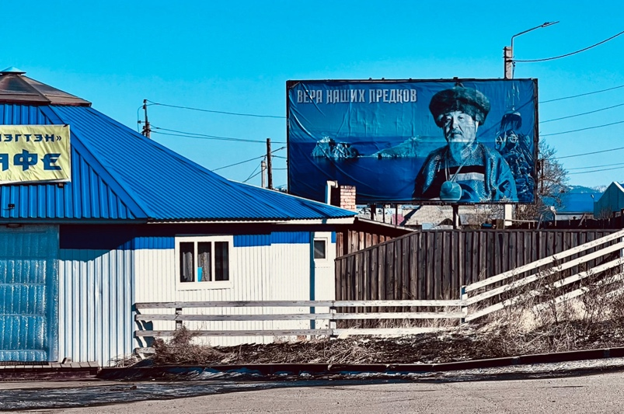
Figure 1. The picture of the Great Shaman on the entrance of the Tengri organization in Buryatia. Two images are positioned behind him: Lake Baikal, accompanied by the sacred rock, and a monument commemorating the divine rescue of Buryatia from fire. A substantial inscription in the corner of the image translates as ‘The faith of our ancestors.’ Photograph by the author.

I found this behaviour puzzling because there were numerous scholarly studies and debates on pollution in the sacred lake that were officially acknowledged by the Russian authorities themselves. The topic has even been extensively discussed by Russian activists, leading to the establishment of certain policies aimed at safeguarding the lake, a series of policies characterized by a tumultuous history.
The effort to establish these policies originates in the Soviet era, during which period omul and other fish were considered the lake’s communal resources, rather than being monopolized. In fact, emerging social organizations, such as fishing sovkhozy and kolkhozy, coupled with motorized boats and drift nets, altered predator–prey dynamics by enabling humans to extract substantial quantities of fish from the lake itself, rather than relying on fishing from the shore and waiting for fish. This altered the dynamics from predator–prey relationships to farmer–livestock interactions (Losey et al. 2008, Sukhodolov et al. 2021).
Furthermore, industrialization and pollution adversely affected fish populations in the 1950s, the Irkutsk Hydroelectric Dam serving as a principal factor by elevating Baikal’s average water level and submerging shallow spawning habitats, resulting in diminished fish yields. Moreover, some research demonstrates that global warming has exacerbated this vulnerability, endangering the population's limited aquatic habitat and territory. These conditions are also impacting lake pinnipeds, potentially resulting in the accumulation of organochlorines and heavy metals, which pose risks to both humans and ecosystems (Nakata et al. 1995, Iwata et al. 1995). Consequently, in the late 1960s, Soviet officials and scientists restricted all fishing activities in the lake to subsistence levels.
This prohibition continues, albeit with some modifications (Breyfogle 2013). As a result, the government emphasizes the preservation of Baikal and has issued Government Resolution of the Russian Federation N 435, amended by Resolution N 643 of 30 August 2001, which provides a list of prohibited activities or events within the central ecological zone (coastal strip) of Baikal’s natural hinterland:

1. Redevelopment of businesses without water-use management.
2. Provision of buildings and infrastructure for forestry, carpentry, pulp and paper, glass, porcelain, printing and construction materials.
3. Disposal and incineration of new hazardous wastes.
4. Illegal landfills.

The local population now abides by these rules, and the issue is no longer regarded as a secret in any way.
Obviously, however, just raising the issue of the sacred water being pathogenic generated widespread fear among the general public. I noticed this issue more prominently when one of my Buryat interviewees, who had a strong connection to Olkhon Island (renowned as the Mecca of shamanism), did not respond to my inquiries regarding the diseases he had witnessed surrounding the lake. Instead, he presented two images: he crafted a replica of Lake Baikal using seed shells and sent it to me, along with a note inscribed ‘the sacred lake before’ and ‘the sacred lake after’ (Figure 2). Suddenly, I became preoccupied with a question: What is the true cultural interpretation of the disease resulting from the lake’s pollution among those who avoid acknowledging or confronting it?

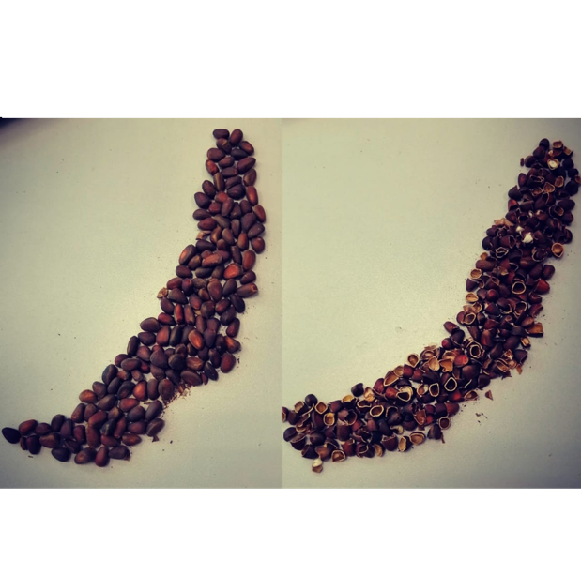
Figure 2. The interviewee created two depictions of the sacred lake, one before pollution (left) and one after (right), using seed shells, instead of providing responses to the questions.

Methodology: cognitive narratology

This study investigates the influence of the recognition of disease and the pathogenicity of the sacred lake on the Buryat community. The goal is to identify the underlying patterns that prevent the Buryat from confronting the issue.
I use cognitive narratology as a specific methodology for exploring these issues. This methodology was chosen because of a particular sociological pattern based on Peter Berger’s discussion in The Sacred Canopy (1967). According to Berger, a kind of order emerges when a specific world is created by the activities of human beings in an intertwined social and individual process he calls nomos. This order forms a normative universe in which a world of right and wrong, lawful and unlawful, valid and void, is constantly created and maintained (Cover 1982), so that actions are understandable only in relation to it. In traditional societies, the nature of nomos makes it dependent and defined on the basis of ‘religious expression’ (Berger 1967: 52). Reference to it in any form guarantees the predictability and stability of that particular society, thus maintaining a normative world standard. Religious expression is the criterion of ‘giving meaning’ to relationships and actions in the normative world. Consequently it is the main agent in shaping a definite and predictable future for the redemption of society.

However, although I draw generally on Berger’s nomos, for clarity and precision the scope of the definition of religious expression in this research is reduced to what Robert Cover (1982) recognizes as a ‘narrative’ that is inclusive of language and myth, leading to the creation of certain canons. In this account, the normative world stays on a definite and permanent path when the content and doctrines of narratives upon which that world is founded are preserved (ibid.: 4). What can cause narrative logic and structure to fail and thus disrupt nomos is called ‘anomie’. This breaks the bonds of the narratives on the basis of which actions find their meanings and, as a result, terror and chaos infiltrate all layers of society.
Adopting such a model to examine the Buryats' nature-based religious society reveals a pattern in which nomos is constructed according to the prevailing narratives of the region. Cognitive narratology was chosen as the methodology for this study because it serves as a transmedial basis for exploring the relationship between the narrative and the Buryats’ mind (Felodernik 1996).
This methodology involves ‘the study of aspects related to the mind in the act of storytelling’ and aims to construct a model of the human narrative mind’s functioning (Herman 2013). Its primary concerns are: a) the cognitive processes which lead to narrative understanding and that enable the reader (viewer or listener) to construct his or her own mental model from the world the story creates; and b) how narratives function as a means of creating meaning and as a way to structure and understand situations and events, thereby providing a framework for comprehending and interpreting the world. In this context, the process of meaning-making comprises two courses of actions: 1) constructing mental spaces; and 2) mapping relations between them. Identifying the narrative space by considering the two actions mentioned above represents the micro-level of cognitive analysis, which subsequently enables macro-level analysis through integration, ultimately resulting in the emerging story (Dancygier 2008, 2012).
Therefore, this methodology aims to elucidate the evolving narratives within Buryat society in order to portray the transition from nomos to anomie accurately. However, when discussing indigenous and nature-based societies, it is important to acknowledge that these societies prioritize ecology in their world views; that is, their ecology/nature/environment (their home) is considered a lived religion. As a result, the preservation of their normative world order is achieved through the narratives and myths that are associated with their distinct bioregion. That is why Robert Innes argues that academics must employ Indigenous narratives as theoretical frameworks to clarify the perspectives, cognitions and motivations of Indigenous populations. This approach is essential for gaining a deeper comprehension of their historical and current situations (2010). Hence, this study examines the prevalent narratives in Buryat society to uncover the disrupted order, rather than replicating them within existing frameworks.
In addition, the research utilized two approaches to data collection to characterize comprehensively the meaning of disease and healing prior to and following environmental changes, namely ethnography and media content analysis. In this regard, the optimal locations for participatory research and fieldwork concerning this issue were identified as Khuzhir on Olkhon Island and Ulan-Ude city in Buryatia, whose residents are called the Eastern and Western Buryats respectively (Figure 3). In this regard, the main stories of the sacred lake that make direct reference to the issue of healing were gathered, first, by examining books of folk and oral narratives pertaining to Baikal. The most important of these books were: Бурятские народные сказки )1973); Бурятские народные песни: песни хонгодоров (Фролова, 2002); Сказания бурят, записанные разными собирателями (1890); Сказки сибирских народов/Fairy-Tales of Siberian Folks (1992); Мифы бурят (Осиповн, 1980); Мифы и легенды о Байкале (Гудкова, 2019); Хозяин Ольхона. Байкальские сказки. Стародумов Василий Пантелеймонович (Стародумов, 2016); Девочка-лебедь и другие северные сказки (2017); Байкала-озера сказки (1988, 2 volumes).

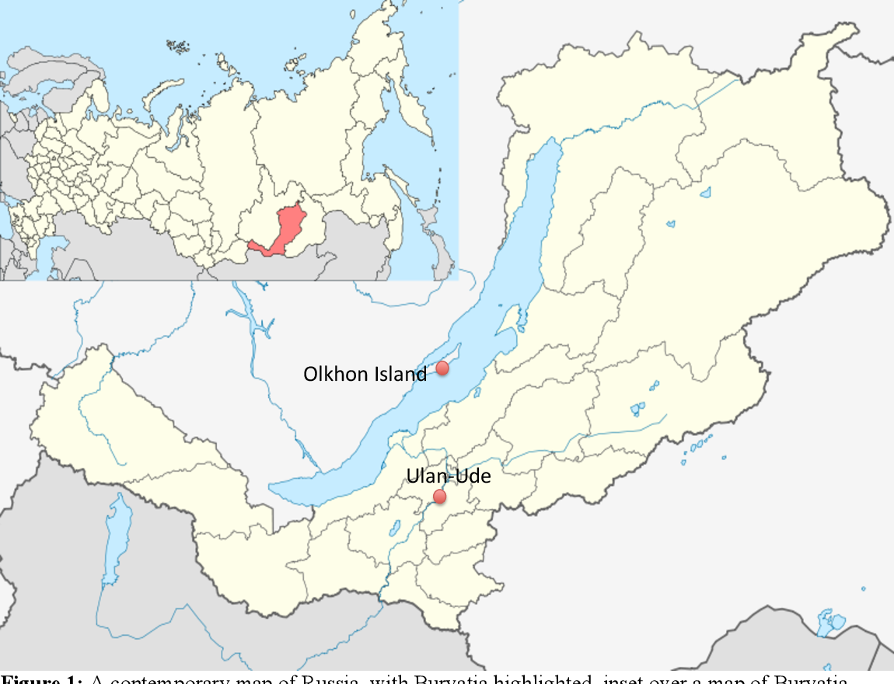
Figure 3. A modern map of Russia, featuring Buryatia highlighted, and showing Ulan-Ude and Olkhon Island, two geographical areas examined extensively in this paper.

Secondly, I evaluate the present prevalence of these stories and their cultural interpretation through in-depth and semi-structured interviews conducted with twenty ordinary shamanic–Buddhist Buryat in the region. Unlike the formal interviews referenced below, these interviewees were not chosen through prior planning. For instance, they were individuals with whom I embarked on brief excursions, employees of a restaurant I regularly patronized and, in certain instances, vendors or attendees at the residences of shamans or Buddhist temples during the ceremonies I attended. Upon categorizing the interviews and identifying those most pertinent to the research topic, I ended up with thirteen male interviewees and seven female.
Consequently, during the initial phase, ten narratives were selected from various books and collections. These choices were based on their repetition in books and interviews. Subsequently, four narratives that were particularly favoured by the Buryat community were picked. It is noteworthy that there was disagreement among them over whether the body of water being described in the narratives explicitly refers to Lake Baikal or other rivers and springs in this region. However, the majority of the interviewees believed that, irrespective of the particular characteristics of the bodies of water mentioned in the stories, there exists an inherent and significant association between Lake Baikal and the region’s bodies of water in the minds of the Buryat.
Furthermore, I conducted interviews with six shamans and energy healers, as well as sixteen lamas and specialists, in order to investigate the meaning of healing and its underlying objective.
Given the rise in reports of the lake’s deterioration, which is linked to the growing awareness of environmental issues in the current era, this study has been undertaken by analysing the media, which has a significant role in providing knowledge, manipulating memory and shaping a new social structure. Hence, a total of seven newspapers were scrutinized, including the following widely popular Russian publications: Argumenty i Fakty, Kom-somolskaya Pravda, Nezavisimaya Gazeta, Novaya Gazeta, Rossiyskaya Gazeta, and Izvestia and Lyudi Baikala (baikal-journal.ru). Important in the selection of media was their popularity ratings, regardless of their political, economic or social affiliations. Through these media, it was possible to trace the lake’s most often repeated and dominant images. Moreover, as different types of newspapers were examined, it is clear that almost all types of audience were represented. I researched the contents of newspapers published from 1 January 2015 to 1 January 2020. The research focused on these media’s images of Lake Baikal, regardless of the type of news or advertisement. Most of the newspaper content came from searching newspapers’ websites. A total of 135 pieces from newspapers were eligible for coding and analysis.

Research limitations

After extensive correspondence with the Department of Tibetan and Mongolian Studies at St. Petersburg University, I obtained permission to conduct research in Russia, specifically Siberia, for one year as a visiting researcher. Consequently, as the most effective method of acquiring objective information involved residing in the community and engaging directly with local religious organizations, I relocated to Ulan-Ude, Republic of Buryatia, with support from the dean of the Mongolian section of the Peter the Great Museum of Anthropology and Ethnography at St. Petersburg (Kunstkamera). Due to the Russo-Ukrainian war, working in the region was fraught with difficulty and danger, especially for a researcher from a Swiss university that had been blacklisted by the Russian government.
The main problem pertained to the robust affiliation between Buddhist and shamanist organizations and academic centres in the region and the Russian central government (Figure 4). The most illustrative example of this robust relationship with the central government is Ivolginsky Datsan (Иволгинский Дацан), where the lamas exhibit significant engagement with the Russian government’s political decisions in order to maintain their status as one of the four official religions of Russia, thereby safeguarding their authority. The emphasis on this relationship was so pronounced that this Datsan was the sole location in Buryatia to feature a large banner of Putin (Figure 5). Indeed, both Putin and Medvedev were bestowed with divine titles by a Grand Lama. The significance lies in the fact that, contrary to common belief, Buryatia is a religious republic not merely in appearance but also in mentality, which directly influences individuals' actions and interpretations of political and social events, as well as their subsequent adaptation of other perspectives. As a result, all matters pertaining to the war, even indirectly, rendered them circumspect in their responses.

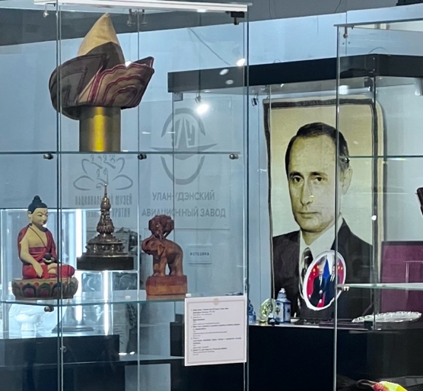
Figure 4. The National Museum of the Republic Buryatia’s History comprises two sections: socio-political history, and religion. This photograph encapsulates the history of the Republic of Buryatia, featuring a young Putin alongside the republic's Buddhist identity.
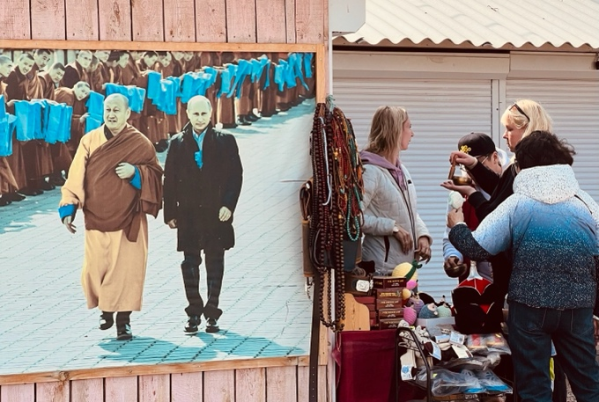
Figure 5. Banner commemorating Putin’s visit to Ivolginsky Datsan. Photograph by the author.

In addition, some specialists in Buryat culture, both at the National Museum of Buryatia and the university (though not all), declined to grant me an interview, despite direct communications from St. Petersburg University and the Konstantin Museum. The rejections of my requests exhibited a consistent theme, namely that when the war with Ukraine ends, they will greet me with open arms. Therefore, although I had written authorization to access the primary locations for my study, ethnographic research in those locations was somewhat intricate.

Background

The pathogenic nature of the water in Lake Baikal, situated in eastern Siberia and designated a UNESCO World Heritage Site in 1996, is a longstanding concern that originated approximately two decades ago, although the history of contamination extends even further back (Brown 2018, Weiner 1999). In this regard, two pathogenicity-related concerns have been identified at different levels, although they are aligned with each other within Buryat society:
First, a multitude of scientific publications in recent years, particularly since 2017, have demonstrated substantial alterations in the findings of prior research conducted in the early 2000s. Initial research has highlighted that the presence of pathogenic viruses and bacteria in surface water is negligible, and data on the fluctuation of enteroviruses throughout the year suggests that they are not present in Lake Baikal’s surface waters. This suggests that bacteria and virus particles have not accumulated in the Sacred Lake for an extended period of time (e.g., Maksimov et al. 2003). However, recent research focusing particularly on the southern region of the lake, a popular tourist destination, has documented the presence of bacteria on both the lake’s surface and bottom. This has resulted in widespread microbiological and hydrochemical pollution in various areas. Of particular concern is the detection of two hazardous and disease-causing bacteria, Enterococcus and E. coli, in the waters along the shore. These bacteria can lead to respiratory issues and bloodstream infections in both humans and animals (e.g., Pliska 2021, Zemskaya et al. 2020, Butina et al. 2019).
Secondly, through extensive interviews conducted with Buryat and Tibetan doctor-lamas in the ‌Baikal region (Figures 6 and 7), as well as traditional doctors in Ulan-Ude, a correlation has been established between the lake’s pollution and the presence of medicinal plants. Based on the findings of these doctors, who do field research in various natural sites around Baikal to gather medicinal plants, certain plants have ceased to grow due to the presence of pathogenic bacteria and the changing environment in the region, a problem that is progressively worsening each year. The significance of this stems from the coexistence of two distinct medical systems, namely the western medical system, which relies on compound drugs and chemicals, and the traditional medical systems rooted in Buddhist and Tibetan medicine.



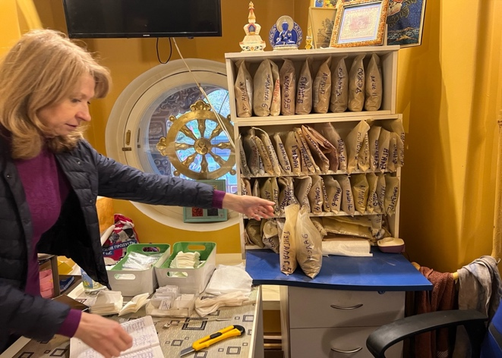
Figure 6. One of the interviewed doctor-lamas treating a lama in Ulan-Ude, Buryatia.
Figure 7. Classification of herbal remedies brought from Buryatia to the St. Petersburg Gunzechoyney Datsan. Photograph by the author.

This coexistence gives this region a profound historical significance. In fact, the traditional healing system in the Buryat region is primarily the responsibility of doctor-lamas, who promote Indo-Tibetan medicine as a vital element of Buddhist teachings and as a unique facet of the eastern heritage. According to the description of the Buddhist collection in the Museum of the History of Buryatia, this medicine flourished and developed in Transbaikalia during the mid-nineteenth century, being closely linked to the lamas. More precisely, Atsagatsky Datsan, situated in Buryatia, was the inaugural Buddhist medical institution in Russia, where the earliest texts on Tibetan medicine were produced.
Notably, in contrast to many regions globally, this traditional medicine did not arise in opposition to modern medicine but rather interacted with it from the beginning. Lamas in this traditional medical school had a professional interest in European medicine. In the early twentieth century, they made numerous visits to medical institutions and tackled many complex cases using traditional Tibetan methods, while simultaneously collaborating and sharing knowledge with various scientists and physicians throughout Russia.
This tradition of coexistence, which is fundamental to the medical school, endures in Buryatia as a strong tradition to this day. The traditional system, now with a modern appearance, is on a par with the western system, and individuals have confidence in it. Therefore, the ecological degradation of Lake Baikal and the ensuing scarcity of medicinal plants may adversely affect the long-term efficacy of the region’s secondary medical system, which is closely linked to the local population’s religious and philosophical beliefs.
Here, in relation to disease and pathogenesis, and drawing on comprehensive research conducted by anthropologists and historians specializing in infectious diseases, two overarching views have emerged. From an initial perspective, as pathogens are intricately connected to human social realms, comprehending social or cultural existence is crucial for understanding diseases. This means that, contrary to a purely biomedical perspective, it is insufficient to explain pathogenesis and infection solely through biology. Instead, one must take into account the cultural and social environments in which individuals reside (e.g., Barrett and Armelagos 2015, Singer 2014). The second perspective examines the sources of disease and contagion. It involves connecting the biological events that occur within the body to external social events, structural relationships and environmental conditions. It establishes a connection between these factors and the broader realm of economic and political forces that influence the incidence of disease. In other words, as Nancy Krieger (2021) explains in her Ecosocial theory, embodied truths, and the people’s health, disease often arises from factors such as discrimination, exploitation, injustice, prejudice and geographical factors and should not be considered a wholly natural phenomenon. (WHO 2008: 1)
Consequently, the majority of research focuses on either the impact of social and economic conditions on the understanding of diseases and their resulting suffering within the cultural context, or the interplay between biological and social factors in outbreaks of disease. However, in this region, the case shows itself from a different perspective, beyond the two approaches just mentioned. Here, the concept of disease has placed individuals in a challenging predicament when discussing their environment. Put simply, the question is how the emerging disease, as is widely reported in the media, is altering the cultural perceptions of the local population towards their sacred environment.
This issue is of particular significance within the realm of indigenous studies, as the concepts of ‘environment’ and ‘home’ fundamentally underpin the Buryats’ worldview. This nature-based worldview can be effectively summarized in terms of four principles: (1) Nature is considered the ‘other’, and everything within it is seen as ‘others’, rather than being viewed as absolute objects (Bahr 2004: 19). This implies that, drawing inspiration from Martin Buber’s philosophy (Buber 1970), the connection between Indigenous peoples and nature is founded on an ‘I-thou’ relationship, where both parties are subjects, as opposed to an ‘I-it’ relationship, where one is a subject and the other is an object. According to this correlation, it is believed that indigenous individuals attribute personhood to all entities and have a deep reverence for living beings, including plants and animals, considering them as equals to humans. (2) This helps us understand how these individuals have formed their beliefs and daily routines by engaging in a dialogue with the natural world: they are not familiar with the concept of monologue, which involves viewing the world as an object of experimentation. (3) According to this perspective, a culture of land has evolved as a unifying concept for Indigenous society, where identity and spirituality are shaped through the interaction between individuals and the land or nature. This approach places a strong emphasis on the well-being of the land and on water as a central focus. This perspective serves as the fundamental basis of the indigenous law that governs their communal existence. (4) Consequently, nature is perceived as an inherent right (Nelson 2017: 144) that serves as a foundational principle for establishing rules with incentives and penalties, rather than being a basis for advancing moral reasoning (Tucker and Grim 2017: 11).
Prior to moving forward, it is essential here to elucidate the term ‘nature-based’ in relation to religion and spirituality. This term is a general concept pertaining to indigenous religions, elaborated upon in my article ‘Transforming home: the religious heritage of Indigenous society in the age of environmental problems,’ published in Nature and Culture (2024). In summary, within the indigenous perspective, nature, regarded as a living heritage, is equivalent to home and worldview, serving as a foundation for cognition and delineating the unique spirituality of indigenous communities rooted in their respective bioregions. This does not merely signify the veneration of nature as the focal point of their religion and spirituality. Instead, it depends more on the notion that nature is viewed as a means and a pathway to attain the transcendent, in contrast to the Abrahamic religions, which are focused on events and history.
This issue is exemplified in Buryat shamanism through its principal symbol, the shamanic tree, which signifies the mental and subconscious journeys of the Buryat shaman. Upon examining the elements and symbols of this tree, it becomes evident that the indigenous fauna, specifically the seal and local otter of the Baikal region, are employed to access what is termed the ‘other reality’ for ancestral communication and the acquisition of healing remedies (Figure 8). Alternatively, consider the coat of arms of the Republic of Buryatia or the national arms which are associated with the imagery of nature and Baikal and elements of nature (Figures 9, 10 and 11). This means that the primary shamanic principle and peoples’ Buddhist identity are intrinsically linked to their particular region, which influences their spirituality accordingly.

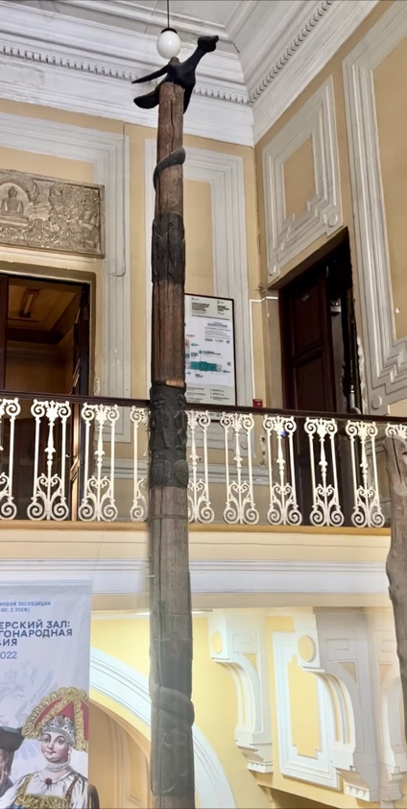
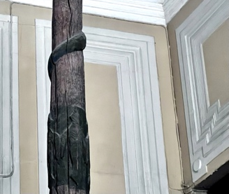
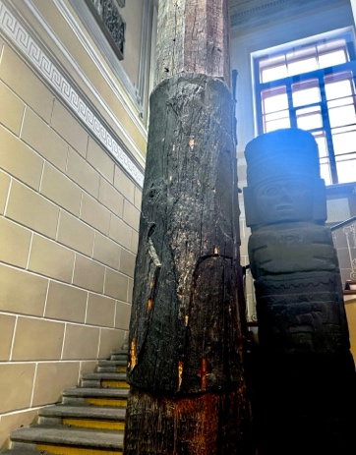
Figure 8. Buryat shamanic tree located at the Museum of Anthropology in St. Petersburg. This tree symbolizes the shaman’s transition from the mundane realm to another reality, accompanied by the animals that assist him/her on his/her journey. Native Baikal fauna, including Eurasian otter and seal, serve as the shaman’s aides on this expedition. Photographs by the author.
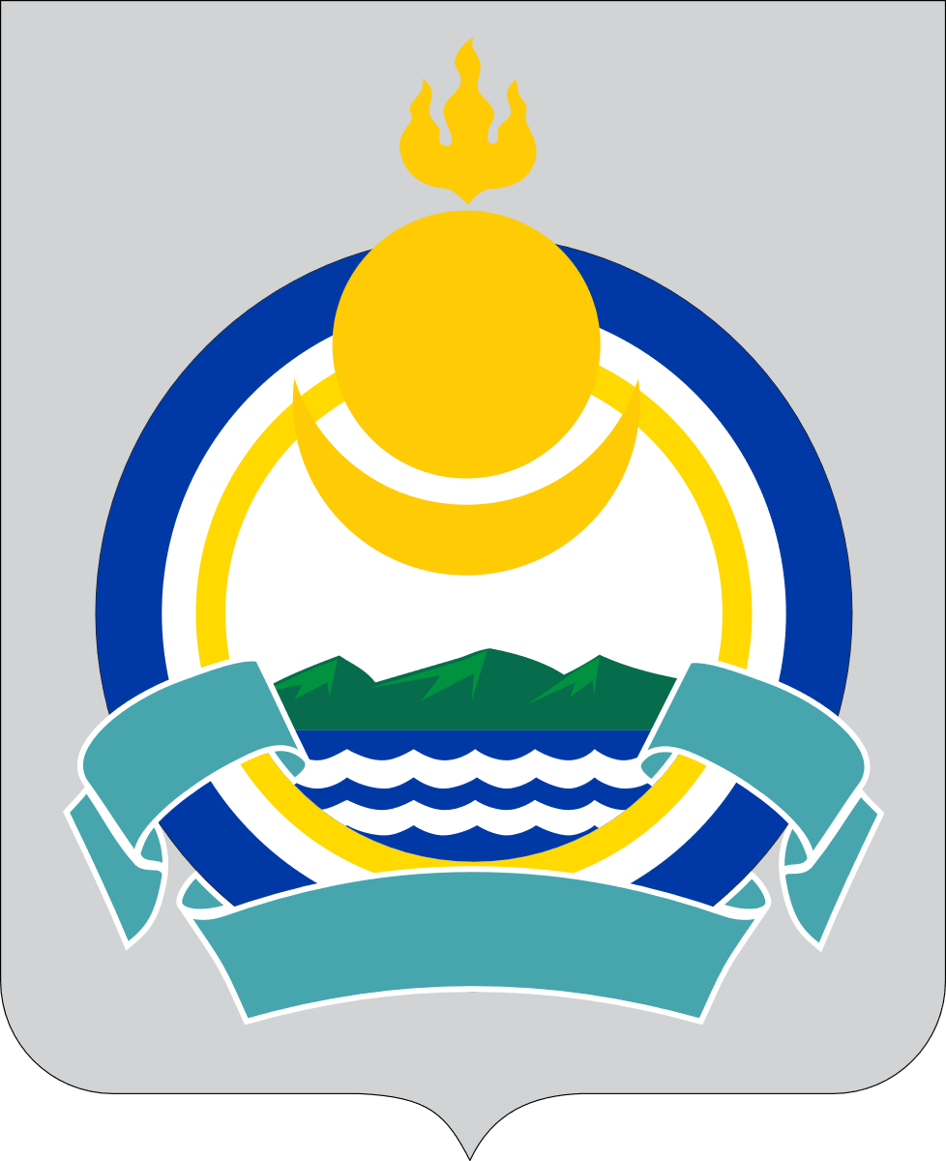
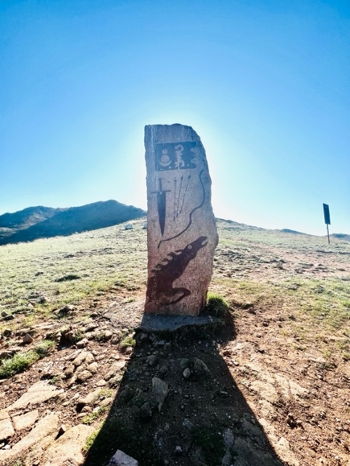

Figure 9 (left). The coat of arms of the Republic of Buryatia.
Figure 10 (middle). Moon, sun and fire emblem on a shamanic monument located in Buryatia, dating back ninety years.
Figure 11 (right). Tattoo of the moon, sun and fire on the neck of a young girl in Ulan-Ude, which she asserts symbolizes her identity. Photographs by the author.

Moreover, the article shows that that the introduction of other great religions or ideologies into an Indigenous region does not result in a singular dominant faith, but rather fosters an eclectic spirituality among the local population that preserves its indigenous essence. This applies equally to the predominant Buddhism in this region; this means that, while the Buryats engage with an international Buddhism that is characterized by clear doctrines at the government level, Buddhism in its pure form is not widespread among the Buryat.
After elucidating this study’s interpretation of the term ‘nature-based’, it is important to acknowledge that each culture has a unique perception of nature. The Buryats' understanding of nature is based on the term Baigali (байгал/ᠪᠠᠶᠢᠭᠠᠯᠢ in traditional Mongolian script), which they share with the Mongolian language. It has a linguistic connection with Lake Baikal and, as Caroline Humphrey (1999) argues, is closely associated with the term ‘baidal’, which signifies the state of existence or the way things are. Moreover, in this context, the myths of this region, in contrast to the western tradition that highlights the human stewardship of nature, portray humanity as descending from the Earth Mother and nature (Baigali), both revered as powerful forces that offer maternal protection to humans.
What is crucial here is to recognize that, fundamentally, the Baigali concept of nature includes humans, unlike the western tradition that separates between humans and nature. Essentially, humans are fundamental to the interactive system of nature, the western concept of which is aligned not with Baigali but with опчин in the Buryat language, signifying an environment devoid of human presence. As a result, the issue of the contamination and pathogenicity of nature itself, intertwined with the religious doctrines of indigenous peoples, can pose a significant challenge for them and generate a situation that lacks clarity.
Here, there is one important issue that needs to be clarified alongside this eclecticism, namely the meaning of the phrase ‘Buryat religion’.
On this subject, Buddhist interactions commenced in the sixteenth and seventeenth centuries prior to the establishment of the Russian Empire and proliferated rapidly upon the Empire’s arrival in the early eighteenth century among residents of the Selenga River in the east. In the mid-eighteenth century, Buryatia was home to eleven Russian monasteries and 150 monks, and its lamas were granted tax and duty exemptions under the Empress Elizaveta Petrovna (1983: 17). In this regard, Russian authorities who sought to regulate Buryat religious engagement internationally to bolster its Asian influence established a Buryatian Sangha endorsing Buryat beliefs. Moreover, since Moscow favoured a single Khambo Lama, numerous monasteries were faced with centralization. As a result, the Khambo Lama and the central government have consistently maintained a close association throughout Russian history.
During the Golden Age of Buddhism in Buryatia, specifically in the late nineteenth and early twentieth centuries, there was a significant proliferation of monasteries and a substantial influx of Buddhist literature and art into the region. However, they were introduced in a manner that was distinct from similar changes in Mongolia and Tibet. This mean that Buryats acquired Tibetan and Mongolian canonical texts but did not disseminate them because they wanted to modernize Buddhism in literature. They possessed greater knowledge of science, geography, cultures and the world than the so-called medieval Tibetans (Tsyrempilov 2021).
Despite the persecution and repression during the communist era from 1920 to 1980, Buryat Buddhism persisted in its practice of distinguishing itself from Tibetan Buddhism. In fact, Buryat ethno-nationalists, who have frequently sought to minimize the Buryats’ global connections and define their Buddhism as a 'Buryat' religion, rely on two archaeological pieces of evidence to prove their claim:
1) The 2002 exhumation of Dashi-Dorji Itigelov (1852-1927), the 12th Khambo Lama of the Buryats. In Buryat society, the preservation of his body is deemed to be a miracle, since it has remained in the lotus position for a whole century without decomposing. The controversy involving this Buryat lama prompted Buryat commentators to assert that they did not require foreign (Tibetan and Indian) lamas, as Dashi-Dorji Itigelov himself consistently refused to abandon his homeland, even amidst widespread violence and carnage.
2) Another significant Buddhist event was the 2002–2004 discovery of 450 Buddha statues in proximity to the ruins of Aninsk monastery. A substantial stone from the Barguzin Valley discovered in 2005 depicted Yanzhima (Sarasvati) in a dancing pose. This discovery was understood to signify that Buddhism arrived in Buryatia directly from India rather than through Tibet (Dugarova 2023).
Similar to Buddhism, Buryat shamanism has experienced modernization while preserving its traditional and ancient roots. This means that, after enduring suppression during the Soviet era, when shamanism was regarded as a vestige of primitive society, sacred sites were rehabilitated and communal ceremonies resumed in the late 1980s. During this period, shamanistic organizations were officially founded. Since the 1990s, various official shamanic organizations have emerged in Buryatia, including Böö mürgel, Lusad, Tengeri and Khukhë Munkhe Tengeri. These organizations seek to validate shamanic practices, safeguard cultural heritage and protect sacred sites by designating them as culturally significant territories.
However, shamanism has always been under pressure, not only from the repression of the former government, but also from Buddhism in the region. For example, Buddhism, which was established in Western Buryatia in the late nineteenth century, reinterpreted indigenous shamanic deities and sacred sites, and burnt shamans’ ritual artifacts and garments (Sabirov 2012). Nevertheless, these encounters were not always violent. In numerous locations, the Buryat adopted significant shamanic rituals, clan guardian cults and ethnic group protectors, and reformed some violent shamanic rituals.
Today, this situation has improved with the emergence of the so-called ‘shamanic intelligentsia’. In contrast to previous generations, numerous contemporary Buryat shamans have acquired a formal education, frequently in the humanities and social sciences, and have acquired professional experience in urban institutions. This shamanic intelligentsia engages in publishing books, contributing to documentaries and utilizing public platforms to disseminate shamanic perspectives. These practices, however, diverge from classical shamanism, which discouraged public self-promotion and mobility beyond local communities. Natalia L. Zhukovskaya (2018) considers the notion of a ‘shamanic intelligentsia’ as an innovative phenomenon of post-Soviet Russia that merged spiritual traditions with contemporary intellectual life.
Furthermore, a concern that has arisen with the emergence of new intellectuals pertains to environmental and ecological issues. Buryat shamanism serves not only as a spiritual practice, but also as an ecological and cultural safeguard. In this context, collaboration with scholars and ecologists has been one of the primary tasks, particularly by participating in scientific conferences, collaborating with ethnographers and engaging in ecological activism. For instance, shamans were instrumental in preserving the sacred landscapes of Tunkinsky National Park during the 2002 conflict with the oil company Yukos, whose activities jeopardized local ecosystems and cultural sites. Also, shamans may conduct traditional annual rituals to call on local spirits to protect these lands.
As a result, shamans’ rituals and community leadership serve as a cultural manifestation of environmental activism, safeguarding sacred sites by designating them as protected territories to avert their degradation by present-day industries. This approach guarantees cultural-ecological continuity, emphasizes a worldview in which humans, nature and spirits are interconnected, and maintains that respectful relationships with nature are deemed essential for community well-being.

Old image: great forbidden zone

The Buryats residing near the shores of Lake Baikal consist of four primary clans (historically Ulus/Улус, modern Buleg/бүлэг): the Bulagats, the Ekirites, the Khoris and the Khungodors, each named after their legendary ancestors. They have been in the Baikal region since ancient times, and their name (Buriyad) was initially recorded in The Secret History of the Mongols (Haenisch 1948: 112), a distinctive piece of Mongolian literature from the thirteenth century that focuses on the life of Genghis Khan. Within the text, they are referred to as a group of indigenous people residing in the forest who were subjugated by one of the sons of Genghis, Jochi.
There are numerous legends surrounding Baikal, primarily due to the connection between the lake and Tengri, the deity of heaven and sky, in the shamanistic mythology of the Mongol people. Certain members of the Buryat community regard Tengri as a living god who knows everything about the Buryats and actively protects them.
However, there has also been a long-standing silence regarding certain aspects of Baikal that have persisted in the region for centuries and can be traced back to the era of Genghis Khan, when the initial regulations for managing the lake may possibly have been established in a unique way.
In this regard, during the thirteenth century, when Mongols occupied the medieval state of ‘Rus’, Genghis Khan designated the area surrounding Малое Море (Small Sea), which is located between Olkhon Island and the northwest coast of Baikal, as the ‘Great Forbidden Zone’. According to legends, this area was believed to be the birthplace of Genghis Khan, and all actions that might jeopardize the purity and aesthetic appeal of the lake within this area were strictly forbidden. This included the use of Baikal’s resources for commercial activities such as hunting and fishing, as well as any presence on the lake’s beaches.
Even the Russian Cossacks, who arrived three centuries later in the sixteenth century, found Baikal to be a remarkably uninhabited area. This would be easy to comprehend if the location were either arid or swampy, abundant with vegetation or with shifting sands. However, the site had exceptional grazing areas for livestock and fertile soil for cultivation, and the Buryats inhabited the adjacent regions, while the neighbouring territories were exploited by pastoralists. This was not the result of chance or coincidence, as the Mongolian rulers established a ban on individuals living in and sharing information about this area of Baikal. Violating this restriction resulted in severe punishments for the offenders. Furthermore, in accordance with Genghis Khan’s rule, individuals who contaminated the lake, rivers or springs that fed into it were subject to capital punishment (Korsgard 2013).
These laws clearly demonstrate that during Genghis Khan’s time, Baikal had significance beyond being a source of livelihood and was regarded as both sacred and taboo (цээр), with the mystical power of mana. This perception of Baikal has driven it for centuries to possess potent, efficient, fruitful, exhilarating and terrifying energy and to manifest itself not only as a physical entity, but also as a psychological phenomenon with paternal power. When dealing with such immense power, therefore, taboos on access and close contact seemed essential for creating a regulatory structure.
However, despite subsequent adjustments to the regulations governing the exploitation of the lake and the establishment of an economic tie between the Buryat community and Baikal, the sacredness of the lake is still maintained, with reliance on the economy of mana. This economy, based on the indigenous perspective on wealth, embraces a diverse range of dimensions that extend beyond either mere monetary or financial considerations or the available accumulated assets. According to Pio and Waddock (2020), Indigenous communities frequently hold their own views on wealth, prioritizing values such as relationships, responsibility and shared well-being. This implies that the measurement of wealth extends beyond material possessions to include the preservation of cultural heritage, traditional knowledge and sustainable practices. More precisely, Indigenous wealth is closely linked with the land, resources and environment, rather than being viewed solely as a static entity or objective place. These elements are regarded as valuable assets that contribute dramatically to the community’s holistic welfare (Thompson et al. 2013).
In addition, Indigenous economies are structured in a manner that emphasizes the distribution and circulation of wealth, rather than its accumulation, as a means to uphold intergenerational well-being and to transfer knowledge and wisdom to younger generations, which is strongly tied to the land. In this regard, the notion of an ‘economy of mana’ underscores the significance of assessing value based on the quantity that flows through an individual’s possession, rather than the amount that is amassed (Vunibola et al. 2022). Therefore, the bioregion’s health holds a crucial place in Indigenous peoples’ worldviews, as it refers to both cultural and economic value, thereby influencing how they perceive and react to the external world.
Regarding the Buryats, their appreciation for this economic model is manifest in their annual rituals dedicated to the water deities, conducting communal rituals and sacrifices to venerate them (Ukhan Khats). These ceremonies are frequently aligned with seasonal occurrences or fishing periods. One of the seasonal rituals involves certain clans performing sacrifices in early August in accordance with Orthodox traditions such as Elijah’s Day. Others perform rituals in autumn, winter, or mid-May prior to the fishing season, thus highlighting the economic significance of fishing. Offerings constitute another significant aspect, with sacrificial items such as livestock, milk and airag (fermented milk) playing a vital role. In this context, fried fish serves as a customary offering, representing reverence and appreciation towards the water spirits. Ultimately, fishing rituals are upheld. Prior to fishing, fishermen performed rituals such as Sasali (‘sprinkling’), in which they present milk-based beverages to the spirit-owner of Lake Baikal to safeguard the lake and supply plentiful catches.
Consequently, Baikal has become integral to Buryat culture, primarily owing to its importance in sacred economy and Tengri teachings, and it is prominently depicted on the Republic of Buryatia’s coat of arms, which consists of a symbolic representation of the moon, sun and fire reflected on the surface of Lake Baikal (Figure 9).
In spite of that, the primary attribute of the sacred lake in the perception of the Buryat, irrespective of their proximity to or distance from the lake, and regardless of their individual religious beliefs, is effectively conveyed through the national anthem of the republic:
‘My motherland, accept the gratitude of your sons; treat us with the sacred water of Baikal; and grant us the strength to endure this arduous journey.’
This part of the anthem should be understood in the context of the Buryats’ shamanic–Buddhist culture, in which the act of offering a sacred liquid or drink is linked to the idea of healing. That means, based on the conducted interviews, that it indirectly alludes to the curative abilities of Baikal in the minds of the Buryat people. But what is the precise definition of healing and cure in this region?
On this subject, when seeking a perspective on the meaning of healing, the primary and crucial source to consult is Buryat stories. Put simply, when looking at Baikal, it is important to view it not just as a source of ecological data, but also as a repository of narratives. By examining these narratives, one can uncover the underlying patterns of the past, independent of the specific events that occurred, and establish a connection between the normative patterns of the past and the conceptual meaning of the present.

- The strong winds in the North Sea prevent an immigrant seagull from returning to its group. She makes numerous attempts to soar over the sky and reach her distant home, but all she achieves is a series of falls. She starts crying uncontrollably and making weird, soul-crushing noises, desperate to get back. But she is unaware that the villagers there view the cries of seagulls as ominous and an indication of impending tragedy, based on long-standing customs. Because of his concern for the impending calamity, the village hunter pulls out his hunting rifle and shoots the weeping bird that is looking for her home. The defenceless bird died as it fell from the sky. When the hunter, who is drawing near the corpse, notices a tear in the corner of the bird’s eye, his heart begins to hurt, and he feels regret. He hugs the dead body, heading to a spring near Baikal, whose water gives ‘life’. This spring is connected by subterranean water to the [frozen] Northern Ocean, which is the seagull’s home. The bird is healed from death by the spring water, which also gives her the power she needs to withstand the strong winds and return to her home in the North Sea.
- A woman has one daughter and two sons. The girl is taken home by a snake that kidnaps her one day in the woods. When the girl’s brothers go to the snake’s cave to try to save their sister, the reptile locks them in behind a large rock. The woman ages throughout the years without being able to get pregnant with any more children. However, one day the lake brings a pea seed to the shore close to the elderly woman. After eating it, she gets pregnant and gives birth to a son. After growing up, the boy takes part in the snake war and succeeds in saving his sister; however, when he goes to find his brothers, he finds them dead beneath a stone. He carries their corpses to the lake and uses the water of life to bring back his brothers. In the end, after many years, they all go back to the old woman’s home and reassemble as a family.
- A hunter pursues a strange bird he sees on a tree. When a malicious shaman sees him, he tells him this bird’s liver causes enormous suffering: ‘Eat this bird’s meat, but save the liver for me.’ He wants to access the bird’s powerful liver this way. But, while their father sleeps, the hunter’s son and daughter accidentally eat its liver. After discovering that his two kids have eaten the liver, the shaman grows furious and demands their livers. After hearing it, the girl alerts her brother, and they flee. For revenge, the shaman chases the girl for years. After many difficulties, the girl marries the ruler’s son, and when he has a son, the shaman disguises himself as a nurse and visits the ruler’s home. He murders the child by pretending she did it. Her body ridden with injuries, the girl is sitting on the lake when she suddenly witnesses a miracle. One worm kills another and drags it into the water. Abruptly, the lifeless worm begins to move. After realizing that the water heals when she dips her hand in it, the girl uses the water to cure her eye and the rest of her body. She also submerges her dead baby in the water, and he too comes back to life. Now healed, she is able to return to her husband, tell everyone about the shaman’s scheme, and reunite her current and former families.
- A quiet boy who is always in nature meditating, as opposed to others who were searching for a nice herd, a wife and land, decides to go after Burkhan, whose palace is located on Baikal’s shore. He passes through three lands. In each of these lands, those who discover the intention of his journey make a request to him: ‘If you see Burkhan, ask him to help us.’ The first one seeks to heal a mute girl; the second to restore the river’s flow and end the drought; and the third, a fish that had lost its ability to swim, seeks to restore it. Upon arriving at Baikal’s Burkhan Palace, the boy makes those three requests. Burkhan first heals the girl, who is mute. His next action is to replenish the dried-up river, bringing the area back to life. And finally, he restore the fish’s innate ability to return to its life philosophy, which had been forgotten.

The resulting system pertaining to Baikal, derived from extracting the primary motifs of the narratives, might be summarized as follows: 1) it revives animals; 2) it causes fertility in humans; 3) it gives life-giving and healing abilities to injured bodies; 4) it is the reviver of the natural world and of inherent skills for life. In short, the concept of cure with regard to Baikal can be understood through the aspects of revival (physical and skill), healing and fertility. Nevertheless, it is crucial to highlight that these concepts extend beyond the individual and serve a larger purpose, specifically the restoration of a wounded or suffering entity: (1) reviving in order to reunite with the members of the group, with a strong focus on returning to the homeland; (2) pregnancy and revival serve as a means to restore the lost family unit; (3) healing and revival are employed to rebuild both the previous and current family, while also revealing the truth; (4) the processes of revitalization and healing are proposed as a solution to address the issues in society. This involves the healing of muteness, removing drought and restoring existential skills.
Notably, there is an intricate and captivating overlap between these four themes and the prominent divine shamanic and Buddhist systems of the region, where healing and cure are central. According to explanations provided by two Tengri shamans in Ulan Ude (prior to the ban on my entry), who clarified the content of the posters displayed on the organization’s walls to me, healing and cure can be observed within the shamanic system, particularly through its two primary ideas:
1) The white elder, who is revered by the Buryat-Mongolian people as the protector of life, longevity and family. He is also a prominent symbol of fertility and prosperity in the region. In Buryat iconography, he is commonly portrayed as an elderly man with a lengthy white beard, holding a rosary (arkhi) and a stick adorned with a dragon’s head. He appears to be sitting next to a peach tree with a stag and a deer by his side. Within the Buryat tradition, he is associated with the belief system that provides assistance to patients and the underprivileged (Figure 12).

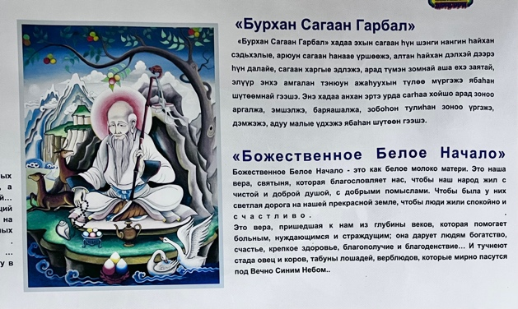
Figure 12. A poster displaying the White Elder’s responsibilities in both the Russian and Buryat languages is prominently displayed on one of the walls of the Tengri Organization (Assembly of Shamans) in Ulan-Ude. Photograph by the author.

2) The thirteen northern ‘Noyons’ or ‘Khatufs’ play an important role in the Baikal region’s system of gods and are considered to be the descendants of 99 Tengri, under the leadership of the eternal blue sky. Here, according to the doctrine and plan of Esege Malan Tengeri, God the Creator and the 99 Tengris, the earth was intricately woven. Thirteen Noyons (sons of God), righteous heroes and khans, were summoned by the Fathers (Tengris) to undertake a paramount mission: to descend from heaven to earth along with their wives, to procreate the Buryat-Mongol people, to safeguard them and to ensure their eternal survival. Thirteen celestial khans carried out the mandate of the Tengris. They selected the revered Lake Baikal as their terrestrial residence, establishing themselves along its banks and founded the Buryat people. They support every inhabitant of Siberia and the Far East, irrespective of nationality and religion, as well as being the protectors of the homeland and the sacred Lake Baikal.
Furthermore, they are thought to guide individuals in tracing their genealogies and histories, establishing a connection with the spirits of their ancestors and forebearers. The fundamental aspect of these thirteen Noyons is that their presence around Baikal safeguards people from disease, difficulties and misfortunes, while bestowing upon them physical, mental and spiritual fortitude, as well as endurance. They also protect Mother Earth and the animal kingdom. The prevailing belief among the residents near the lake is that these Noyons facilitate a connection to superior deities who alleviate all forms of ‘sickness and suffering’ (Figure 13).

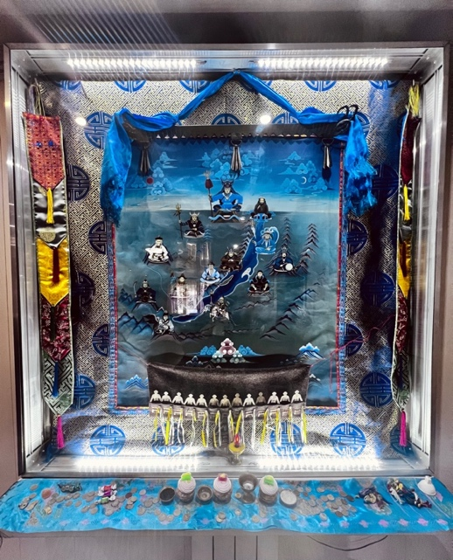
Figure 13. Thirteen Noyons have gathered around Lake Baikal with the purpose of safeguarding the local population against diseases and problems. Tengri Organization in Ulan-Ude. Photograph by the author.

Additionally, the symbolic use of these Noyons and gods is prevalent in water-related shamanic rituals around Lake Baikal, particularly the Predbaikal Buryat, who reside nearby. In this regard, a ritual called Ukhan Budlya (cleansing water) entails invoking the protection of mythical entities such as ‘youths resembling reeds’ and ‘maidens like mushrooms’ to safeguard the health of infants. An additional ritual, Ukhan Tarim (water incantation), is conducted to cure the ill, invoking help from celestial blacksmiths referred to as the ‘White Western Ones’. These rituals frequently employ consecrated Baikal water infused with Siberian juniper and thyme leaves. This water is dispersed or administered with a herb or reed broom for the purposes of blessings and healing. The essential point here is how this idea of healing works among the people.
The crucial aspect to consider is that shamans serve as the main agents between this idea and individuals, relying on their own philosophy and methods. According to one of the interviewees, who was a Buryat energy healer (Figures 14 and 15), the term ‘shaman’ in Buryati originates from a word that signifies the act of removing evil forces from an individual in order to safeguard and restore his or her health, similar to the process of vomiting. This means that, when an individual vomits, all evil and pathogenic substances will be expelled from his or her body.
However, when addressing this pollution and evil, it is necessary to realize that, within the shamanic healing framework, healing encompasses more than just the current moment. In this context, an individual’s existence is viewed as a written book that the shaman reads by dipping into the energy pole of ‘another reality’, where the past, present and future gather together; that is, the cure of a person’s disease takes into account their own life and the lives of their ancestors, based on the divine system and the significance of genealogy. Furthermore, due to the coexistence of Buddhist ideas and shamanism in this region, the entirety of one’s existence encompasses all his or her reincarnations as well. As she emphasized, ‘They (shamans) read thoughts, they can see into the future, and they see a person’s life completely; it depends on his or her age and the number of rebirths.’
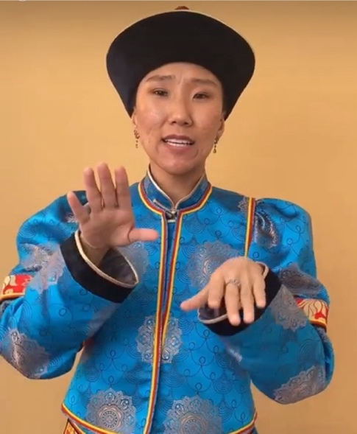
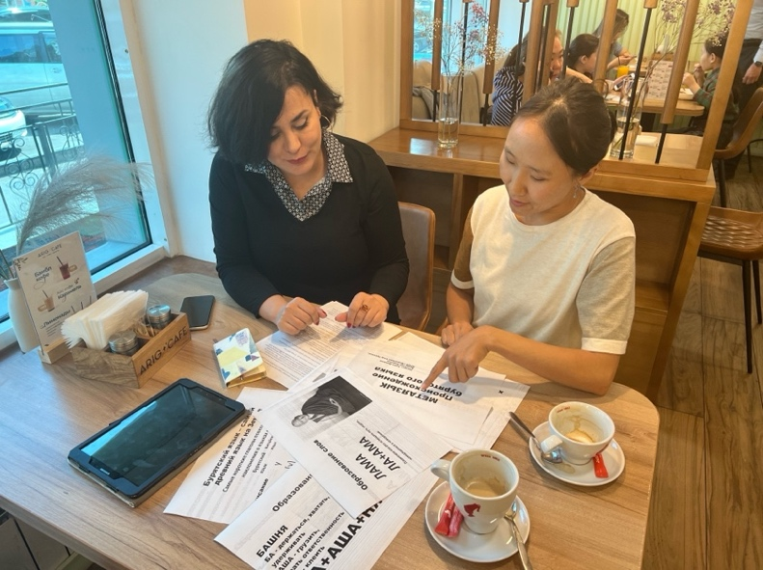
Figures 14 and 15. An energy healer from the Buryat community is elucidating certain terms in the Buryat language to me.

This concept of healing in Buryat shamanism, as also demonstrated by Manduhai Buyandelgeryan’s research (2007), includes a broader and more nuanced perspective so that it extends to addressing the past traumas experienced by individuals. She shows that Buryat shamanic therapeutic practices encompass not only individual healing, but also the restoration of society and historical reconstruction. This can be seen as a form of reconstructing the past following the suppression of religion and political violence during the socialist era, which signifies the communal enhancement and revitalization of cultural heritage.
Additionally, the Buddhist culture in the area reinforces this concept of healing and its associated connotations by incorporating these themes into its teachings, though it does so using a more intricate and dynamic philosophical approach that emphasizes the significance of family bonds and methods for reducing suffering. Cure in this context embraces a holistic approach that extends beyond the personal and physical dimensions to encompass the spiritual and cultural aspects. It not only includes an individual’s mental and physical health, but also addresses the broader social and spiritual balance, emphasizing the interplay between an individual’s health and their connection to society and the spiritual realm (Zhanaev 2022).
Thus, it is evident that all four themes in the stories pertaining to Baikal and their objectives are a direct reflection of the characteristics associated with the role of gods and religious beliefs in addressing the concept of healing. This image of Baikal, which has been deeply ingrained in the Buryat religious ideology for many generations, provided the indigenous community with a framework in which to view and regard the sacred lake as a fundamental aspect of health. The crucial matter here is that this perception established a standard of behaviour upon which specific sets of values and anti-values were delineated. Put simply, health was regarded as a value, while anything that the sacred lake inherently opposed in the narratives, such as death, illness and infertility, was deemed an anti-value, representing the negative outcomes of a lack of health.

New image: the pathogenicity of sacred water

The topic of pollution in Lake Baikal has garnered significant attention from journalists, literary writers and activists throughout the years. They have emphasized that ecological issues will have a direct impact on people’s daily lives and threaten the meaning of the lake-bioregion as a home (Chivilikhin 1963, Rasputin et al. 1989). Their idea was deeply interconnected with an uncertain future and unfamiliar relationships, and it highlighted the potential for the lake to undergo undesirable changes in the future (e.g., as discussed in Rasputin et al. 1989).
However, since 2006, this situation has become less pronounced, as Russia’s relations with international environmental organizations have deteriorated and nearly ceased due to the Russian authorities’ perception of international interference in a domain that is considered a matter of national security. From the government's viewpoint, the outcry from these foreign environmental organizations has engendered scepticism regarding the government’s dedication to safeguarding the environment, which is intrinsically linked to national identity, potentially fostering a basis for social unrest. Consequently, throughout this period, the majority of the news focused on the lake’s aesthetic appeal and opportunities for exploration, presenting any issues as resolvable. Even after 2010, the media heavily promoted the lake for commercial and touristic reasons while also suppressing the release of negative news about it.
Surprisingly, from 2015 to 2017, there was an unusual focus on the lake’s challenges, accompanied by a critical stance towards the government. This raised the question of the purpose of Lake Baikal: is it to serve as the world’s largest reservoir of pure water or as a tourist attraction? The prevailing narrative emphasizes the necessity of safeguarding Baikal from over-exploitation, highlighting that this sacred bioregion and the real scientific understanding of it have fallen victim to administrative and financial misconceptions. Newspapers adopt two approaches in this context: 1) utilize the lake extensively for maximum benefit; and 2) acquire comprehensive knowledge regarding the life-cycle of Lake Baikal to safeguard it from over-exploitation or potential destruction. The crucial aspect here is that the perception of ‘Baikal as an inexhaustible resource’ is nearly diminishing during this time. Indeed, the ‘insolent civilization’ is believed to have placed Baikal in a state of ecological emergency. On this subject, the media’s focus on the issue of rescue culminated in an emphasis on three intertwined factors: 1) a decrease in the lake’s water level; 2) the tourism boom; and 3) fish and seal mortality.
In this regard, the lake’s water level is declining due to Mongolia’s construction of dams on the rivers that feed into Baikal, along with power plants and dams in Irkutsk province. These years have seen a proliferation of expert discussions and managerial disputes in the media about this issue, particularly regarding the conflict between the Republic of Buryatia and the Irkutsk Oblast. The media have persistently investigated who profits from the scarcity of water and whether a truly critical threshold exists. In fact, initial alarming reports regarding the reduced depth of Lake Baikal emerged in the adjacent region of Buryatia and in residents’ fears of the extensive desiccation of wells because of the reduction in the lake’s water level.
During a public meeting held on 12 January 2015, President Vyacheslav Nagovitsyn instructed the Minister of Natural Resources to examine media allegations about the depletion of water in coastal wells, the occurrence of fires in peat bogs and the decline of fish populations in the Selenga, among other issues. The leader of Buryatia attributed this specifically to the declining water level of Lake Baikal, holding the hydroelectric power plants in the Angara region responsible for allegedly draining the lake’s water. The Buryat authorities dispatched a communication to Yuri Chaika, the Prosecutor General of the Russian Federation, regarding the ‘catastrophic consequences for the lake’s ecosystem’. In this context, Alexander Lebov, Deputy Minister of Natural Resources of Buryatia, informed the media: ‘If Baikal’s water level falls below the critical threshold, approximately 27,000 residents lacking access to a centralized water supply may face water scarcity.’
Nevertheless, scientists in Irkutsk contended that the problem of shortages of water was intentionally overstated by certain individuals. Valery Sinyukovich, a prominent expert at the Institute of Limnology SB RAS, provided a commentary on the situation: ‘The establishment of a hydroelectric power station will enable people to manage the water flow in the lake, taking their interests into account while conserving nature.’
The prevailing narrative pertains to the response of the Russian government, which instituted a high alert in the Irkutsk region and Buryatia owing to the critically low water levels in the lake. The media consistently asserts that the issues affecting the lake are caused by humans, noting that Lake Baikal’s water level has decreased by 40 cm, representing 68 percent of its normal capacity, and it predicts a further decline in fish populations compared to previous years. The groundwater level is declining significantly as well, potentially severing the water supply to populated regions. This is attributed to the Angara River, the sole outlet of Lake Baikal, which has also been reduced in depth, jeopardizing urban operations.
However, water scarcity is not the sole issue facing Lake Baikal, and it may not even be the most severe one. Experts from the Russian Academy of Sciences indicate that water scarcity results in alterations in pollutant concentrations and a reduction in mineral flows, potentially impacting production processes and the stability of the lake’s water column (Sorokovikova et al. 2010). This has serious consequences for the ecological condition and evolutionary dynamics of the organisms residing in Lake Baikal, disturbing the millennia-old equilibrium of its system. The result of this situation is the proliferation of harmful and potentially lethal Spirogyra algae in the lake, which now occupies nearly 60% of the Baikal’s shoreline. This stems from the release of untreated sewage from villages, augmented by phosphate-rich detergents, introducing phosphorus levels two to five times greater than those from human faeces, combined with laundry detergent, into the lake. The phosphorus influx into aquatic environments accelerates algal growth, thereby disturbing the natural ecosystem.
This is the point at which the discourse surrounding detergents and algae is amplified in the media and where the production of algae has placed the lake on the brink of an environmental catastrophe. This sensitivity extends to the degree that interpretations, resolutions and even prohibitions on the importation of detergents into Baikal are reported in newspapers. In a report, the Ministry of Natural Resources and the Government of the Irkutsk Region stressed that they are conducting extensive scientific research to evaluate the effects of phosphate-containing detergents on the lake’s ecosystem.
The crucial aspect is that, in contrast to earlier times, it is claimed that a cleaning system for Baikal cannot be established within one or two years, and as Mikhail Alexandrovich Grachev states in an interview with Rossiyaskaya Gazeta (2017.05.12), the evil spirits generated by worsening sanitary conditions at the shoreline will persist in the lake. These images have constructed a broader narrative, accompanied by dramatic headlines and exaggerated forecasts in media portrayals, consistently suggesting that the lake is either vanishing or being transformed into a vast swamp, an uninhabitable lake devoid of non-human species. Alexandrovich further characterizes this situation as follows: ‘Baikal has never faced such a perilous assault in its history. Scientific discoveries have indicated the emergence of toxic specimens, particularly among blue-green algae (...).’ One significant outcome of these conditions in the scientific literature is the disruption of the food chain in Lake Baikal, impacting fish and seals.
Conversely, some contend that these losses occur intermittently in the lake as part of a repetitive and cyclical pattern (Fagel et al. 2006). In this context, according to the remarks of the head of the Institute of Siberian Studies in the media:

Scientists, while investigating the causes of the mass mortality of Baikal seals (nerpa) during 1987-1988, established the potential for these animals to be infected with morbilliviruses (canine distemper), despite the initial ambiguity regarding the cause. In fact, in 1987-1988, approximately 6,000 animals perished. Initially, they attributed the blame to the Baikal Paper Mill, followed by general pollution. Ultimately, through molecular biology over a span of six months, they successfully demonstrated that these seals were afflicted with canine distemper. Pinnipeds were not previously impacted by this morbillivirus. The epidemic has ceased, and a layer of immunity has emerged. So far, divine mercy has prevented a recurrence. This marked the inaugural extensive alteration in Lake Baikal documented in the scientific literature. The task was arduous yet fruitful for the entire team.

However, the account of widespread fish and seal fatalities, coupled with the devastation of underwater coral reefs, was frequently depicted as a consequence of pollution, supported by images of seal carcasses on the shore and dead fish floating on the water’s surface.
Another concern regarding the pollution of the lake, alongside chemicals and environmental changes, is the influx of tourists (two million annually), which has led to significant criticism of all tourist-related activities due to the exponential rise in garbage and domestic sewage, factors that contribute to the proliferation of cyanobacteria and spirogyra. In this regard, the most incisive criticisms are directed at the Chinese, who are frequently associated with headlines like ‘the Chinese are taking Baikal,’ highlighting that the tourism sector has introduced unforeseen challenges for the Russian economy.
Journalistic reports on the matter emphasize the appeal of sectors of Lake Baikal’s shores that are allocated to foreigners, particularly the Chinese, leading to dissatisfaction among the locals. This discontent has culminated in a petition from Angarsk residents opposing ‘Chinese-style interference,’ which has garnered over 57,000 signatures on the Change.org platform. Yulia Ivants, the petition’s author, cautions that, if this trend persists, the coastal villages of Baikal will inevitably become a province of China within five to ten years.
Furthermore, the issue of tourists at Baikal, characterized as wild creatures lacking comprehension of ‘what Baikal is’, is evident during this period. For instance, at the Herd of Winds festival, covered by the media in Buguldeika, Director Sergei Provoznikov asserted that this area of the Baikal region remains pristine and unpolluted, unlike Baikalsk or Olkhon. He states, ‘the last thing we desire is for uncivilized tourists to arrive and impose their preferences for recreation, as has occurred on the Small Sea and Olkhon, where ecological issues are now pervasive along the entire coastline.’
On this subject, Alexander Anisimov, the head of the local administration, acknowledges that tourism could alleviate the economic difficulties faced by the villagers of the Baikal region, as they are unable to sustain themselves through fishing due to a lack of fishing quotas. However, he stresses his desire to prevent the village from becoming a mere exploitative hub for Russian tourism.
A prominent theme in the newspaper narratives from 1987-1988 is the insoluble nature of the issues, or the difficulties in resolving them. Consequently, readers frequently encounter reports that, while accepting efforts made for the health of Baikal, these initiatives merely serve to spotlight the persistent problem of Baikal pollution, which cannot be swiftly rectified. For example, on World Cleanup Day, divers from the Irkutsk Centre, the Ministry of Emergency Situations and volunteers collected garbage from the depths of Baikal near the village of Listvyanka. One diver stated that the accumulated garbage in this area cannot be eradicated in a single day of cleaning. The participants in this effort stated that the primary objective was to highlight the issue of Baikal pollution and promote mindful tourism.
Alternatively, the largest volunteer event, 360 Minutes for Baikal, involved 1,500 volunteers simultaneously cleaning up litter from 28 locations along the shoreline. They also believed that the participation of hundreds of volunteers in the clean-up constitutes merely half of the challenge. Conducting clean-up efforts without adequate communication with local authorities and business representatives is frequently problematic. This means that collaboration with the authorities is essential, as garbage collection constitutes an intermediate phase rather than a conclusive one.
Additionally, the themes of ‘rescue’ or ‘being saved’ are continually being reinforced through news regarding the allocation of state funds for the preservation of Baikal, with terms such as ‘Pearl of Siberia,’ ‘Sacred Lake’ and ‘the glorious sea’ frequently juxtaposed with the contrasting phrase ‘dangerous and toxic waters’, particularly in light of the state of emergency declared by the Ministry of Natural Resources in 2015. In this regard, according to the ministerial website, the Government of the Russian Federation allocated 576 million roubles in subsidies to the three Baikal regions for the protection of Lake Baikal under the Environmental Protection Program. This funding aimed to ensure the lake’s necessary protection and to mitigate the adverse effects of pollution sources on the ecological system of the Baikal natural territory, including the reconstruction of treatment plants and wastewater disposal systems.
In 2017, the pollution of Lake Baikal reached a critical level, prompting a response from the Russian government. After years of opposing reports on the lake’s condition, Vladimir Putin expressed regret over its considerable pollution and declared the lake a priority for the government he led. On this point, the media coverage also began to highlight the importance of numerous government initiatives aimed at rescue operations in the region by repeatedly mentioning the distribution of government funds. For instance, there was a focus on implementing a ‘Commission for Baikal’ to demonstrate an ongoing commitment to managing the environmental issues confronting the region and to act on government suggestions for water conservation zoning as a strategy to safeguard Lake Baikal. The significance of monitoring the health of the environment and engaging with the local population was underscored. However, in the present scenario, a recurring enquiry, both explicitly and implicitly, was posed: Why, despite the expenditure of billions of dollars on the preservation of Lake Baikal, has the lake’s environmental condition remained unresolved, and why have the recommendations from the commissions on Baikal merely shifted from one protocol to another?
Furthermore, the Chamber of Commerce of the Russian Federation determined that the allocation of 8.4 billion roubles from the budget for 2015-2018 for the Federal Target Program (FTP), ‘Protection of Lake Baikal and Social and Economic Development of the Baikal Natural Territory’, had been ineffective. Even inspectors reported that the environmental condition of Lake Baikal has not improved in the past three years; rather, it has further declined, and this decline and sense of futility had become increasingly apparent in the accounts of loss and catastrophe. Examples include the image of the transformation of Baikal into an aquarium and the extinction of the August Baikal yellow goby population, a primary food source for Omul. Here, the newspapers, emphasizing the economic transformations resulting from the collapse of factories and the fishing industry in the region, along with the ensuing transition to tourism, popularized two terms in media discourse regarding Baikal: garbage and sewage.
(1) Garbage. The discussion surrounding garbage in Baikal and on its shores has become more focused on unprocessed garbage and landfills in the media. In this context, four landfills in the Baikal region are receiving media attention due to their incomplete status or lack of functionality post-commissioning, despite 232.2 million roubles being allocated to these projects. Currently, there is no centralized facility for the processing of urban solid waste in the Irkutsk region or the Republic of Buryatia. Consequently, this government initiative, which started in 2013 and was projected for completion by 2020, has yet to commence, resulting in the imprudent expenditure of four billion roubles in federal funds.
(2) Sewage. The prevailing discourse regarding Baikal recently suggests that the main factor contributing to its pollution is not climate change or the local population residing along its shores in three regions, but rather the release of inadequately treated sewage. This sewage either enters Baikal directly or infiltrates it via contaminated sludge, which, exacerbated by recurrent flooding in southern Irkutsk, permeates the Baikal ecosystem, which has more potable water than any other reservoir and was a symbol of the gods’ mercy, who had decided never to dry it up.
Although Order No. 63 of the Ministry of Natural Resources of the Russian Federation, enacted in 2010, had established stringent standards for wastewater treatment prior to discharge into Lake Baikal, local authorities contend that these regulations are so rigorous that adherence is nearly unattainable. Indeed, modern technologies that enable compliance with these standards are costly in both construction and operation, potentially resulting in a significant increase in tariffs for the local population. Therefore, the Ministry of Natural Resources of the Russian Federation started to contemplate the possibility of easing the standards. Nevertheless, the proposed changes, released on the website regul.gov.ru, have elicited a negative response from the scientific community. They asserted that for various types of pollutant, the standards will escalate from 3.5 to 38 times, potentially resulting in catastrophic effects.
The salient aspect of these narratives and protests, both nationally and globally, is the emergence of bacterial contamination and diseases, indicating a deterioration in the lake’s epidemiological health. In this context, although the news centred on exploration expeditions, the emphasis shifted from the lake’s wonders or discoveries of oil to the presence of human faeces, which were discovered even in the centre of the lake during explorations. This situation has resulted from the proliferation of leisure boats discharging human waste into the water, as well as ships traversing the entire 600-kilometer length of the lake to release their sewage, in addition to tourist accommodation lacking adequate sewage systems or facilities.
The issue of fuel transfer across various sections of the lake further exacerbated this pathogenic situation, involving a method whereby ships replenish the tanks of smaller vessels by opening fuel tankers, which is highly uneconomic. In fact, two issues prominently reported in the media significantly damaged Baikal’s reputation: the non-potability of its coastal waters, and the emergence of two hazardous bacteria, enterococcus and E. coli, which can impact lung health and lead to blood infections. Hence, media discourse extended beyond the preservation of the lake, illustrating a narrative of death and disease.

Emerging story: the evil lake

It is obvious that every scientific fact or government initiative that is presented as a narrative or commentary in the media about the Buryats’ bioregion is translated in their minds through the lens of their worldview. In other words, the assessment of the pollution-induced developments in Baikal relies on a worldview that is rooted in nature and the shamanic-Buddhist divine system. Hence, the primary concern here is to shift from examining the objective characteristics of environmental issues and their impacts on the sacred lake to focusing on the psychological aspects, specifically the cultural considerations that are tied to spirituality or religion as the foundation of this society’s social order.
The main issue that should be noted here is the fact that the pathogenic nature of Baikal is derived from the presence of chemicals or toxic elements in its water. The term ‘poison’, which possesses the capacity to induce poisoning, can be interpreted as a focal danger. The depiction of poison as a symbol of death or a major departure from harmony and balance is frequently juxtaposed with water or milk, which are symbolic of vitality, fertility and abundance in the natural realm (Ferreira et al. 2013: 286-289).
This theme and contrast are distinctly evident in Buryatia and Olkhon. The Buryats frequently discuss the healing qualities of natural mineral springs, referred to as arshans, and Baikal, for various treatments such as baths, rinses and drinking. This tradition is documented as early as the eighteenth century, highlighting the sanctification of water-related sites. For instance, the waters of the lake were believed to have healing properties and were employed to treat rabies by immersing the afflicted individuals in the lake. Similarly, repeated bathing in cold mountain streams was employed for the treatment of animals, including horses suffering from tick bites.
Moreover, these waters are utilized in fertility rituals. On two occasions, I experienced this attitude due to my childlessness, which was atypical for the interviewers. In this regard, Marina, a shaman from Buryatia, accompanied me to a spring fountain in the city centre (Figure 16) following a personal conversation, asserting:

If you place a coin next to the statue in this spring, which we believe is connected to Baikal by underground waters, you will have conceived by next year’s spring. According to folklore, your voice will travel to Baikal and promote pregnancy if you offer something to this spring.
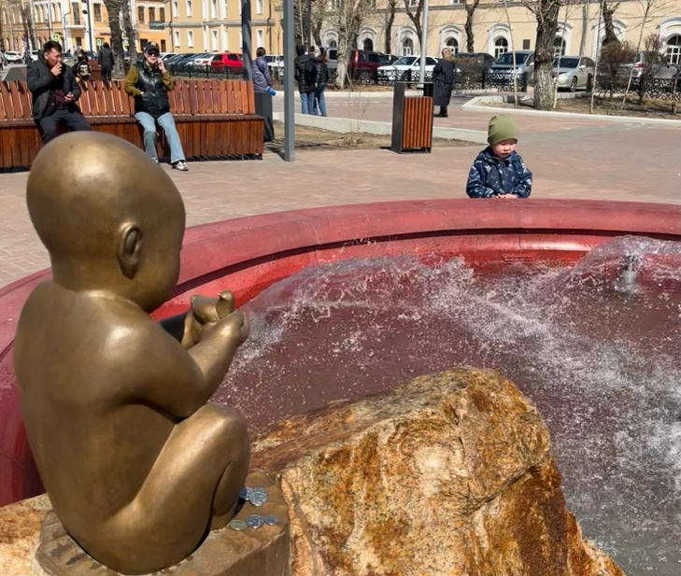
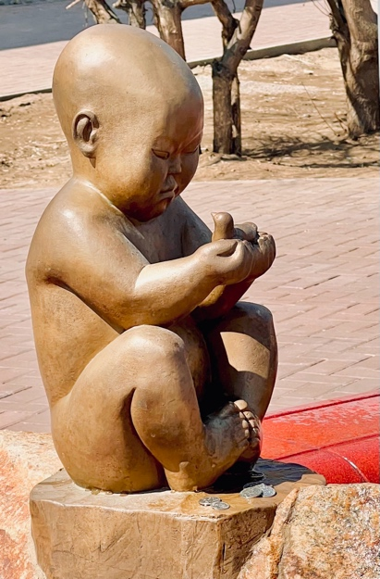
Figure 16. Fertility Spring. Photograph by the author.

I encountered a comparable situation during my visit to the women’s Datsan for a formal interview. Initially, my interviewee exhibited reluctance and a pronounced conservatism due to the war and my affiliation with a Western university; however, upon discovering my Iranian familial background, a nation historically allied with Russia, the High Lama entirely altered his perspective. He became much more amicable, referring to me as a ‘friend’ and even inviting me to remain for the afternoon’s fertility ceremony following the interview, as I was 36 years old and without children (Figure 17). At the conclusion of the ceremony, one of the female lamas provided me with a remedy: ‘We call this Baikal milk, which comes from animals that drink water from Lake Baikal and the area around it. This is usually given during private ceremonies to women who can’t have children.’
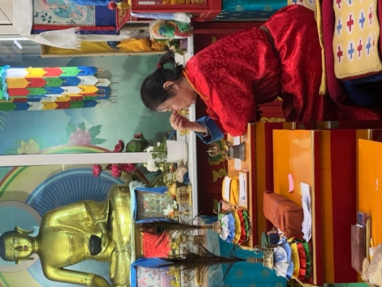
Figure 17. In an interview with the Grand Lama of Zungon Darzhaling Datsan, only female Buddhist datsan in Russia. Photograph captured by the author.

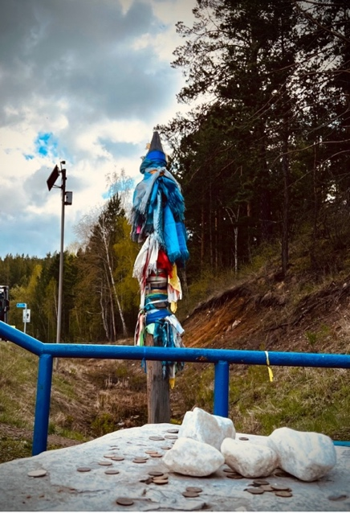
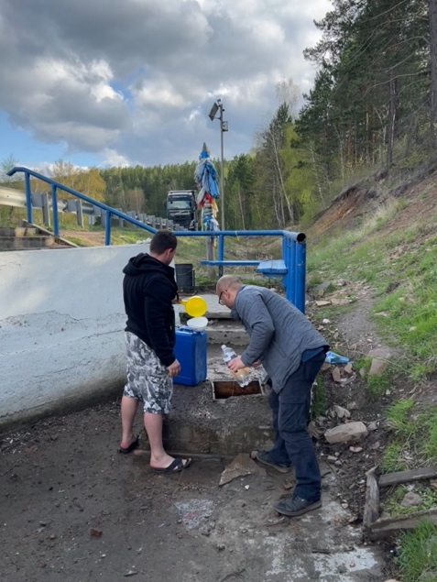
Figures 18 and 19: The subsequent poem was inscribed on a sign to describe the spring:
Hymn: ‘Arig Us (Ариг Ус)’/ We were born and raised on this land, which we call home/ As we begin the day, we remind ourselves that our native land will provide us with strength/ It provided us with the sacred water and brought us joy, peace, and happiness/ Arig Us will assist you in shaking off the burden of doubts from your soul/ Begin your day with positive feeling, breaking through the clouds of greyness/ We remember the day and moment when the living spring provided us with sacred water to drink/ It gave us happiness and a smile. Photographs by the author.

Additionally, during another excursion, I conversed with drivers near one of the arshans adjacent to Baikal. One of them parked by the road, replenished water containers and left a coin in the water source. The driver said that many individuals seek water from this sacred spring in their quest for healing and that the holy spirits will punish anyone who defiles these waters or steals the coins (Figures 18 and 19).
Nonetheless, the narrative propagated by the media involves the amalgamation of toxins with these healing waters, which are held to be both fertile and restorative. The crucial aspect here is that the integration of these two disparate categories in human cognition creates a compelling image and emerging story that indicates the erosion of the purity boundaries of the Buryats’ nature-based worldview. Indeed, this association of poisons and toxins is grounded in the historical connection between hazardous substances and taboos, despite their historical ties to medicine and mysticism (Cole 1998: 119).
In this context, the consensus from the interviews with lamas and shamans is that the idea of taboo in this region is linked to anything that disturbs the natural balance. This ‘anything’ may encompass food, particular activities, atypical behaviour or feelings, or even abstract notions such as colour. By observing taboos, Buryats demonstrate reverence for the spiritual realm and preserve their connection to it, which is crucial for their capacity to conduct healing, divination and other practices.
What is noteworthy is that the narratives presented in the media, which can be categorized into different levels, precisely illustrate this disruption of harmony caused by toxic substances: 1) industrial materials that have caused the deaths of animals and plants, emphasizing the idea of corpse and death; 2) garbage related to the process of rendering water undrinkable, emphasizing decay in its own nature; and 3) faeces, which are associated with the transmission of dangerous viruses and the growth of diseases in humans, emphasizing the idea of contagion. Clearly, these themes contrast starkly with the internalized narrative motifs in Buryat society regarding Baikal, which are founded on the three principles of revival, healing and fertility.
In addition, these themes correspond exactly to the original indigenous meaning of a taboo that can be associated with three fundamental aspects of emotional significance: a) the existence of danger; b) the potential for contagion; and c) the notion of untouchability (Malinowski 1931: 39). Indeed, the media debate, by promoting these three emotions both directly and indirectly, has created a revised perception of the Sacred Lake that fundamentally embodies chronic anxiety. This anxiety, which is caused by the violation of the established boundaries reflected in the first internalized image of the Baikal, inadvertently prompted the question among the Buryat as to where the boundary is between us and this ‘entity’, which is no longer the one we know. Therefore, the Buryat encounter an unbridgeable gap, a hiatus in knowledge, in their lack of ability to effectively control the environment.
This situation is clearly reflected in remarks and expressions of concern from several residents near Baikal. As one stated: ‘You can’t sense chemicals or radiation when you walk by the lake. But put swimming there out of your head. Only God knows what will happen to you with unknown diseases.’ As is obvious, there is anxiety about the lake’s pathogenicity. This issue sometimes becomes so strong that the source of common genetic diseases in the region, such as having extra limbs, is attributed to Baikal pollution: ‘It sounds impossible to forget the sacred lake’s breathtaking landscape, but you can't overlook flesh monsters in this region! It seems like a nightmare to have a baby with twenty limbs.’
There is a serious matter at issue here. Regarding the notion of taboo, there is always a ritual linked to it that seeks to restore the state of purity and certainty regarding boundaries that have been violated as a result of taboo (Douglas 2002), as well as reinstating the main narrative and metaphor to their initial position while simultaneously preventing the formation of new narratives surrounding their circumstances. Therefore, taboo-purifying rituals function to uphold the prevailing and predominantly fundamental narratives in religious societies. These rituals serve as guardians of nomos, or social order, 1) by providing a framework and mitigating potential risks and crises, and 2) by acting as a unifying force that aids in arranging a number of practical endeavours for dealing with existential anxiety about changes and losses (Leach 1964: 158). As a result, purification rituals act as a means of rescue.
It is essential to note that we are confronting an issue that society is unable to manage. As a result, people continuously rely on government officials and their rescue actions, as demonstrated by the growing rescue narrative in the newspapers. In this context, Marina Shaman, during a conversation on the Siberian separatists, highlighted a noteworthy issue that is pertinent to the topic of purification and rescue:

It is impossible to separate from Russia. At least for us, it is a significant loss because we cannot cope with our nature on our own. Many of our care systems are funded by the central government, and many of our environmental problems are solved by the central government, even if the results are often poor, but it is still preferable to local officials who are constantly at odds with one another.

The main issue concerning Baikal and the Buryat lies in their status as an indigenous, nature-centric society, where the infiltration of toxins and poisons (taboo substances) is progressively eroding the ecological integrity of their bioregion. This region has historically served as a cornerstone for healing practices and as a repository of shared beliefs and values. It is faced with irreversible destruction, despite government attempts at remediation, which remain confined to mere warnings or symbolic gestures. However, it is crucial to note that the media has transformed Baikal from a proactive, healing entity into a passive, ailing object awaiting help, thereby diverting the Buryats' attention from the lake’s usefulness linked to their religious identity to a dependent entity lacking the power of mana. This signifies an assault on Baikal’s previous image as a healer. In essence, Baikal has acted as a site for the physical and spiritual healing of the Buryat and their territory, establishing a paradigm wherein the sacred lake is expected to provide rescue, rather than one in which we are tasked with its preservation. Consequently, the Buryat are undergoing a condition of formlessness that diverges from the normal structure of their traditional knowledge, resulting in narratives that starkly contradict the original portrayal, in which disease and suffering were perceived as anti-values.
Nevertheless, the story does not conclude at this point. The media significantly harmed prior narratives as a source of knowledge by emphasizing the pathogenicity associated with toxic substances in the water. This is attached to the mythological and metaphorical quality of benevolence, which is central to healing, revival and fertility associated with Baikal in the Buryat collective memory. In other words, the image of Baikal transcends the mere loss or diminishment of its inherent characteristics; rather, it emphasizes a rebellion by Baikal as a dangerous force, shifting from a bastion of good to a source of evil. The consequence of this image has been a shift from the moral imperative of preserving Baikal to the imperative of protecting humans from its harmful effects. As a result, the media narratives have directly altered the Buryats' cognitive framework by influencing their perception of their position in relation to Baikal and by questioning the past and the entity responsible for their healing.

Conclusion

There is a prevalent view that the portrayal of pollution in the media might influence individuals’ perceptions of the hazards linked to it and their inclination to adopt safety precautions. In other words, those who perceive themselves as being directly impacted by contamination are more likely to comprehend the dangers that accompany it, leading them to respond promptly to early warnings and take preventive measures (Wang et al. 2021). Contrary to expectations, despite the growing attention from the media and their narratives about the polluted Baikal, the indigenous Buryat society, which relies on the lake for its traditional healing practices and therapeutic system, has not shown an increase in its efforts to address pollution. In fact, the Buryat have actively chosen to remain silent, particularly regarding the issue of pathogenic contamination.
This awkward situation, which is characterized by contradictory elements, can be traced back to the existence of what is a broken narrative. On this subject, the belief in the three attributes of healing, revival and fertility, which are aligned with the shamanic-Buddhist belief system of the Baikal region and regulate the norms of interaction with their bioregion, is inadvertently targeted by Russian newspapers, pushing academic findings on ‘contaminated matter’ to a subjective and interpretive level. It is vital to highlight that this phenomenon extends beyond the media’s dramatic interpretation. It also undergoes a secondary transformation when it enters the Buryat collective memory, based on their traditional knowledge. In this context, the water environment, which has long played a role in alleviating various forms of suffering (economic, spiritual, social) and restoring damaged units (familial and historical) through its powers of healing, is now revealed as an entity inside which decay occurs, and the risk of death and disease contagion has become inherent, particularly when it is touched. This is precisely the crux of the argument. The Baikal storyline can be encapsulated in this image: transitioning from a state of touchability for healing purposes to becoming untouchable due to its harmful nature and contagiousness, thereby portraying a silent taboo. Hence, the broken narrative can be attributed to the condition of anomie, leading to the disintegration of the view of Baikal as the symbol of a therapeutic gathering of deities or a system dedicated to seeking healing. Furthermore, the lack of a mechanism to regulate or manage this change has exacerbated the predicament for the Buryat, a society faced with the absence of the purifying ritual that traditionally eradicates taboos and upholds or restores social equilibrium by mitigating the dangers. Consequently, although the Buryats are located geographically in a region undergoing substantial transformation, they feel spiritually disconnected from the ecosystem they are part of and have a sense of alienation from the formerly healing Lake Baikal.

Bibliography

Bahr, Ann Marie 2004. Indigenous religions, New York: Chelsea House.

Barrett, Ron and George J. Armelagos 2013. An unnatural history of emerging infections, Oxford: Oxford University Press.

Berger, Peter 1967. The sacred canopy: elements of a sociology of religion, New York: Anchor.

Breyfogle, Nicholas B. 2013. The fate of fishing in tsarist Russia: the human-fish nexus in Lake Baikal, Sibirica: Interdisciplinary Journal of Siberian Studies 12/2, 1-29. doi:10.3167/sib.2013.120201.

Brown, Kate 2018. Saving the sacred sea: the power of civil society in an age of authoritarianism and globalization, Oxford: Oxford University Press.

Butina, Tatyana V., Bukin, Yurij S., Krasnopeev, Andrey S., Belykh, Olga I., Tupikin, Aleksey E., Kabilov, Marsel R., Sakirko, Maria V. and Sergey I. Belikov 2019. Estimate of the diversity of viral and bacterial assemblage in the coastal water of Lake Baikal, FEMS Microbiol Lett 366/9, fnz094. doi:10.1093/femsle/fnz094.

Buber, Martin 1970. I and thou, New York: Charles Scribner’s Sons.

Buyandelgeriyn, Manduhai 2007. Dealing with uncertainty: shamans, marginal capitalism, and the remaking of history in postsocialist Mongolia, American Ethnologist 34/1, 127-147. doi:10.1525/ae.2007.34.1.127.

Chivilikhin, Vladimir 1963. Светлое Око Сибир [The bright eye of Siberia], October Magazine H 4, 151–172.

Cole, Leonard A. 1998. The poison weapons taboo: biology, culture, and policy, Politics and the Life Sciences 17/2, 119-132. doi:10.1017/s0730938400012119.

Cover, Robert 1982. Nomos and narrative, Harvard Law Review 97/4, 4–64.

Dancygier, Barbara 2008. The text and the story: levels of blending in fictional narratives, mental spaces in discourse and interaction, in Todd Oakley and Anders Hougaard (eds.), Mental Spaces in Discourse and Interaction, 51–78. Amsterdam: John Benjamins.

--- 2012. The language of stories: a cognitive approach, Cambridge: Cambridge University Press.

Douglas, Mary 2002. Purity and danger: an analysis of concepts of pollution and taboo, Abingdon: Routledge.

Dugarova, Esuna 2023. Buddhism, power, identity: the transnational Buryat Buddhist living tradition, Europe Asia Studies 75/10, 1744–1774. doi: 10.1080/09668136.2023.2242605.

Fagel, Devon M., Ganat, Yosif, Silbereis, John, Ebbitt, Timothy, Stewart, William, Zhang, Heping, Ment, Laura R. and Flora M. Vaccarino 2006. Cortical neurogenesis enhanced by chronic perinatal hypoxia, Exp Neurol 199/1, 77-91. doi: 10.1016/j.expneurol.2005.04.006.

Felodernik, Monika 1996. Toward a natural narratology, London: Routledge.

Ferreira, Celio, Boholm, Åsa and Ragnar Löfstedt 2013. From vision to catastrophe: a risk event in search of images, in Paul Slovic (ed.), Risk, media and stigma: understanding public challenges to modern science and technology, 283-300. Abingdon: Routledge.

Haenisch, Erich 1948. Die Geheime Geschichte der Mongolen, Leipzig: Otto Harrassowitz.

Herman, David 2013. Storytelling and the sciences of mind, Cambridge, MA: MIT Press.

Humphrey, Caroline 1999. The end of nomadism, Durham: Duke University Press.

Innes, Robert Alexander 2010. Introduction: Native Studies and Native cultural preservation, revitalization, and persistence, American Indian Culture and Research Journal 34/2, 1-9. doi: 10.17953/aicr.34.2.y13028v6060344w9.

Iwata, Hisato, Tanabe, Shinsuke, Ueda, Kazuhiko and Ryo Tatsukawa 1995. Persistent organochlorine residues in air, water, sediments, and soils from the Lake Baikal region, Russia, Environmental Science & Technology 29/3, 792–801. doi.org/10.1021/es00003a030.

Korsgard, Ingrid 2013. Keeping the eye of Siberia luminous: environmentalism on Lake Baikal in a transitioning society, Macalester German and Russian Studies Honors Projects.

Krieger, Nancy 2021. Ecosocial theory, embodied truths, and the people’s health, Oxford: Oxford University Press.

Leach, Edmund R. 1964. Anthropological aspects of language: animal categories and verbal abuse in William A. Lessa and Evon Z. Vogt (eds.), Reader in comparative religion: an anthropological approach, New York: Harper and Row Publishers.

Losey, Robert J., Nomokonova, Tatiana and Olga I. Goriunova 2008. Fishing ancient Lake Baikal, Siberia: inferences from the reconstruction of harvested perch (Perca fluviatilis) size, Journal of Archaeological Science 35/3, 577–90. doi:10.1016/j.jas.2007.05.005.

Malinowski, Bronislaw 1931. The role of magic and religion in William A. Lessa and Evon Z. Vogt (eds.), Reader in comparative religion: an anthropological approach, New York: Harper and Row Publishers.

Maksimov, V. V., Astaf'ev, V. A., Dukhanina, A. V., Kraĭkivskaia, O. V., Mamontova, L. M., Shchetinina, E. V. and E. D. Savilov 2003. Indikatsiia patogennykh virusov v vode ozera Baĭkal i ego pritokakh [Indications of pathogenic viruses in water of Lake Baikal and its tributaries], Gig Sanit MarApr/2, 15-8. Russian. PMID: 12861681.

Nakata, H., Tanabe, S., Tatsukawa, R., Amano, M., Miyazaki, N. and E. A. Petrov 1995. Persistent organochlorine residues and their accumulation kinetics in Baikal seal (Phoca sibirica) from Lake Baikal, Russia, Environmental Science & Technology 29/11, 2877-2885. doi: 10.1021/es00011a026.

Nelson, Melissa K. 2017. North America: Native ecologies and cosmovisions renew treaties with the Earth and fuel Indigenous movements, in Willis Jenkins, Mary Evelyn Tucker and John Grim (eds.), Routledge handbook of religion and ecology, 138-147. Abingdon: Routledge.

Pio, Edwina and Sandra Waddock 2020. Invoking indigenous wisdom for management learning, Management Learning 52/3, 328-346. doi:10.1177/1350507620963956.

Pirdehghan, Maryam 2023. Disarticulated nomos, Anthropological Journal of European Cultures 32/2, 108-133. doi: 10.3167/ajec.2023.d.

--- 2024. Transforming home, Nature and Culture 19/2, 135-160. doi: 10.3167/nc.2024.190202.

Pliska, A. A., Batomunkuev, A. S. and D. A. Ponomarev 2021. Microorganisms of Lake Baikal and their pathogenic properties, IOP Conference Series: Earth and Environmental Science 677, 052034. doi: 10.1088/1755-1315/677/5/052034.

Rasputin, Valentin 1989. Siberia on fire: stories and essays, translated by Gerald Mikkelson and Margaret Winchell. DeKalb, IL: Northern Illinois University Press.

Sabirov, Rustam 2012. Buddhism in the Russian Republic of Buryatia: History and Contemporary Developments, in Bruce M. Knauft and Richard Taupier (eds.) Mongolians after Socialism: Politics, Economy, Religion, 235-248. Ulaanbaatar: Admon Press.

Sorokovikova, L. M., Sinyukovich, V.N. and I. V. Tomberg 2010. Chemical runoff of the Selenga River under conditions of low water content, Russian Meteorology and Hydrology 35/10, 700–705. doi:10.3103/S1068373910100080.

Singer, Merrill 2014. Anthropology of infectious disease, Abingdon: Routledge.

Sukhodolov, Alexander P., Fedotov, Andrei P., Makarov, Mikhail M., Kolesnikova, Alina V., Sukhodolov, Yakov A. and Polina G. Sorokina 2021. Eco-legal and economic aspects of developing Malomorsky fishing area of Lake Baikal, Aquaculture and Fisheries 6/5: 530–34. doi:10.1016/j.aaf.2021.02.007.

Thompson, Sharon L., Chenhall, Richard D. and Julie K. Brimblecombe 2013. Indigenous perspectives on active living in remote Australia: a qualitative exploration of the socio-cultural link between health, the environment and economics. BMC Public Health 13/1, 473. doi:10.1186/1471-2458-13-473.

Tsyrempilov, Nikolay 2021. Under the shadow of white Tara: Buriat Buddhists in imperial Russia, Leiden: Verlag Ferdinand Schöningh.

Tucker, Mary Evelyn and John Grim 2017. The movement of religion and ecology, in Willis Jenkins, Mary Evelyn Tucker and John Grim (eds.), Routledge handbook of religion and ecology, 1-13. Abingdon: Routledge.

Vunibola, Suliasi and Matthew Scobie 2022. Islands of Indigenous innovation: reclaiming and reconceptualising innovation within, against and beyond colonial-capitalism, Journal of the Royal Society of New Zealand 52/1, 4-17. doi:10.1080/03036758.2022.2056618.

Wang, Qiang, Su, Min, Zhang, Min and Rongrong Li 2021. Integrating digital technologies and public health to fight COVID-19 pandemic: key technologies, applications, challenges and outlook of digital healthcare, International Journal of Environmental Research and Public Health 18/11, 6053. doi:10.3390/ijerph18116053.

Weiner, Douglas R. 1999. A little corner of freedom: Russian nature protection from Stalin to Gorbachev, Berkeley, CA: University of California Press.

WHO Commission on Social Determinants of Health, World Health Organization 2008. Closing the gap in a generation: health equity through action on the Social Determinants of Health. Geneva: World Health Organization, Commission on Social Determinants of Health.

Zemskaya Tamara I., Pedro J. Cabello-Yeves, Olga N. Pavlova and Francisco Rodriguez-Valera 2020. Microorganisms of Lake Baikal: the deepest and most ancient lake on Earth, Applied Microbiology and Biotechnology 104/14, 6079-6090. doi: 10.1007/s00253-020-10660-6.

Zhanaev, Ayur 2022. A heap of leaves or fellow travellers: kinship and family life in the Buddhist texts for the Buryat laity (nineteenth to early twentieth centuries), Inner Asia 24. doi:10.1163/22105018-02302029.

Zhukovskaya, Natalia 2018. Шаманы и шаманки Бурятии: их мистический опыт и мои экспедиционные исследования. Часть 1. Oriental Studies 39/5, 97–109. doi:10.22162/2619-0990-2018-39-5-97-109

N/A. Байкала-озера сказки 1988. Ирку́тск: Восточно-Сибирское книжное издательство.

N/A. Сказания бурят, записанные разными собирателями 1890. Ирку́тск: Типография К.И. Витковской.

Баранниковой, Е.В. 1973. Бурятские народные сказки: волшебно-фантастические. Москва: Академия Наук СССР.

Гудкова, Екатерина 2019. Мифы и легенды о Байкале, Retrieved March 6, 2023, from https://www.culture.ru/materials/198868/mify-i-legendy-o-baikale

Мантатов, В. В. (ed.) 1983. ЛАМАИЗМ в БУРЯТИИ XVIII – НАЧАЛА XX ВЕКА: Структура и социальная роль культовой системы. Издательство “Наука”. Сибирское отделение.

Осиповн, Шаракшинова 1980. Мифы бурят, Ирку́тск: Восто́чно-Сиби́рское кни́жное изда́тельство.

Санги, Владимир 2017. Девочка-лебедь и другие северные сказки. Saint Petersburg: Rech.

Стародумов, Василий 2016. Хозяин Ольхона. Байкальские сказки, Санкт-Петербург: БХВ.

Фролова, Г. 2002. Бурятские народные песни: песни хонгодоров, Улан-Удэ: бурятский научный центр со ран.

This work is copyright of the author.

It has been published by JASO under a Creative Commons Attribution-NonCommercial-NonDerivatives ShareAlike License (CC BY NC ND 4.0) that allows others to share the work with an acknowledgement of the work's authorship and initial publication in this journal as long as it is non-commercial and that those using the work must agree to distribute it under the same license as the original. https://creativecommons.org/licenses/by-nc-nd/4.0/)

Department of Religious Studies, University of Zurich, Zurich, Switzerland, Kantonsschulstrasse1, 8001 Zurich. Tel: +41 44 634 47 18. Email: maryam.pirdehghan@uzh.ch
The methodology encompasses a broad domain that investigates the relationship between narrative and mind, not only in written texts, but also in oral narratives and other storytelling mediums, including interpersonal communication, film, radio news broadcasts, digital communication and virtual spaces.
In the classification of lamas in Buryatia, three groups can be identified: philosophers, physicians, and astrologers.
Interestingly, even the prevalence of shamanic beliefs in Buryatia was evident during my interviews with lamas, as those outside Buryatia typically exhibited significant resistance to shamanic concepts. In contrast, Buryat lamas not only lacked such resistance, they often hailed from shamanic lineages and were amenable to moderate interpretations of shamanism.
Natalia L. Zhukovskaya’s two-part article, ‘Male and female shamans of Buryatia: their mystical experiences and the author's field research’ (2018), meticulously examines the approaches and healing practices of contemporary shamans.
Scientists and researchers, including Grigory Galazy, Valentin Rasputin, Eugene Simonov, Mikhail Krondlin, Irina Orlova, Oleg Timoshkin, Sergei Shapkaev, Mikhail Gorbachev, Arkady Ivanov and Irina Panteleeva have criticized the condition of Lake Baikal from 1950 to 2020.
My paper, ‘Disarticulated nomos,’ published in the Anthropological Journal of European Cultures (2023), analyzes media coverage of the sacred lake from 2006 onward, illustrating how the media constructs varying dominant narratives about Baikal during different periods, and how these narratives damage the original perception of Baikal among the Buryat people.
The Interdepartmental Commission directed the Ministry of Industry and Trade, in collaboration with the Ministry of Natural Resources, to disseminate information in newspapers regarding the preparation of amendments to the draft technical regulations of the Customs Union concerning the safety of synthetic detergents and household chemicals. Accordingly, they must implement a restriction on the import of detergents containing phosphates exceeding 0.5 to Lake Baikal and the Baikal region starting in 2018.

